Homework 1 Student Name: **Adithya Suresh, C18590622**

AuE 8930: Machine Perception and Intelligence

Instructor: Dr. Bing Li, Clemson University, Department of Automotive Engineering

* Refer to Syllabus for homework grading, submission and plagiarism policies;

* Submission to Canvas (Due: Tues. Feb. 4, 2020 11:59 pm), including:

* This document (with answers), and with your program results/visualization;
* A .zip file of source code (and data if any) with names indicating question number;

1. Visualize continuous period signal x(t) = 2 + 3 * cos (500  t) + 2 * cos (1000  t) + 3 * sin (2000  t) in time-domain (axis: Amplitude and t) and visualize its digital Fast Fourier transform (axis: Amplitude and f). Given Sampling frequency as 1K HZ. (5 points)

1. Visualize discrete signal x(k) = 0 for k [0 499] and = 1 for k  [500 1000) s (sampling frequency as 1M HZ) in time-domain (Amplitude over t) and visualize its digital Fast Fourier transform (Amplitude over f), find its -3dB (called half-power) bandwidth frequencies (f_low, f_high) in frequency spectrum. (10 points)

1. For discrete signal x(k) = 20 for k [0 499], add a normally distributed random noise n(k) (mean 0, variance 1) to the signal, and get x(k) = x(k) + n(k). Then, apply a normalized (mean 0, standard deviation 1) [Gaussian kernel](http://dev.theomader.com/gaussian-kernel-calculator/) (windows size 3 and 11 respectively as a low pass filter, then rescale all elements to make sure the sum is 1) to perform convolution y(k) = x(k)  h(k) (h presents the impulse response, and in this case it’s the filter) by using basic arithmetic operations only.
2. Visualize both x(k) and x(k) in one figure (10 points)
3. Visualize both x(k), and y(k) based on kernel window size 3 in one figure (10 points)
4. Visualize both x(k), and y(k) based on kernel window size 11 in one figure (5 points)

Tip: You may consider using zero-padded for edges during convolution operation

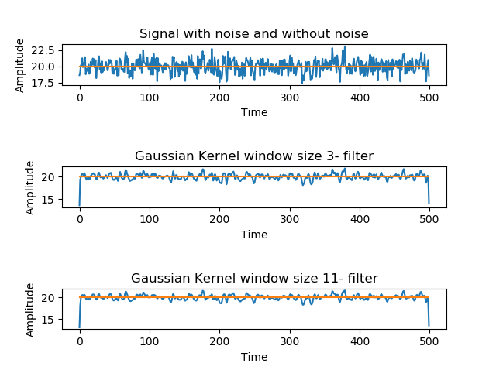

1. Find an online open dataset (such as but not limited to [ASTYX](https://www.astyx.com/development/astyx-hires2019-dataset.html), [KITTI](http://www.cvlibs.net/datasets/kitti/), [NUSCENES](https://www.nuscenes.org/)) containing 2D (or 3D) Radar data and its labelling, and pick up partial data from Radar dataset.
2. Visualize a continuous time frames (like a few seconds) for the Radar data in drawing visualization as a video; (5 points)
3. Visualize objects by its labelled data on the above visualization; (15 points)

The dataset visualization is done and attached in the zip file.

1. 2~3 pages of survey on a particular 1D physical signal related to vehicles (40 points), (such as: 1D Radar, vibration/friction/temperature/speed/… signals). The grading of this question is based on the contents which the survey covers:

- The importance of this signal measurement (5 points);

- The challenges of measuring this physical signal data (5);

- Existing solutions of measuring this physical signal (15);

- Existing problems of measuring this physical signal (5);

- There will be other grading factors (such as novelty, organization, et al) (10);

* You are encouraged to include any drawing/table in the report;

* Attention: Survey a particular 1D signal, not survey/compare multiple 1D signals.

* Attention: use “…” [1] to cite any sentence you literally copied and use … [1] to cite a content you referred to, with reference list in the end;

**Importance of measuring the 1-D RADAR signal:**

One dimensional radar signal is used in many places like in National Weather Service, Topographical profile detection and in the autonomous vehicles. The radar data can provide fast and accurate results depending on the type of job that needs to be performed with the radar sensor. This helps in providing reliability with the measurement in the distance and direction to the object, it’s velocity and some signatures. The accuracy is the order of meters down to decimeters using the phase modulation over time which is also called as the Doppler frequency. With this method, the radar can predict the 1-D radar signal containing the radial velocity with high accuracy. Generally, the target classification is done using the signal strength like the influencing parameters as the radar cross section, etc. It is greatly important to measure the 1D radar signals because they provide a basic platform even when considered for transforms from 1 dimensional to 3 dimensional using Convolutional Neural Networks.

**Figure 1. 1D radar signal process flow for measurement and processing**

**Challenges faced during measuring the 1D radar data:**

**Interference:**

The challenges for measuring the 1 D radar signal include the interference involved in radar measurements which pose a real challenge for the radar designers and operators. Any form of interference in the radar systems creates a distracting noise or false information which leads to false tracks and misleading the proper object detection. This indeed creates an overload of unwanted data which makes it nearly impossible to analyze and measure the desired data. In order to avoid such problems with 1 D radar signals, it is advisable to create an optimal simulation of the set scenario and avoid the interference by proper calibration and tuning.

**Figure 2. 1D radar interference**

**Noise:**

Signal noise is an internal source of random variations in the signal, which is generated by all electronic components. Noise generally occurs as random variations superimposed on the desired echo signal received in the 1 D radar receiver. There are many variations to the noises such as shot noise, flicker noise, thermal noise, etc.

**Clutter:**

The clutter is the radio frequency echoes returning from the targets which are uninteresting to the radar operators. Clutters are also created by long radar waveguide between the transceiver and the antenna. Clutters are considered as passive interference source, since it happens only in response to radar signals sent by the radar.

**Jamming and Deception:**

Radar jamming refers to the radio frequency signals originating from sources outside the radar, transmitting in the radar’s frequency and thereby masking targets of interest. Jamming is problematic to radar since the jamming signal only needs to travel one way whereas the radar echoes travel two ways and are therefore significantly reduced in power by the time, they return to the radar receiver.

**Existing solutions of measuring the 1 D radar signal:**

The solutions to measure the 1D radar data are made by the 1D radars which help in accurate data measurement for distance calculations and object detection and they are:

**Long-range universal distance measurements:**

LPR- 1D is a radar-based distance sensor used for very long-distance measurements. This sensor can be used to consistently deliver the reliable measurements even in harsh environmental conditions[1]. These types of sensors are most used in cranes, autonomous cars and rail-bound vehicles to support optimization and collision avoidance mechanisms. The LPR- 1D measures the distance between two objects using two sensor units. These distance data are then stored in all connected measurement units and is accessible during the real-time applications. The sensor can be optionally functioned using seven dry-contact switch relays. These types of sensors provide facility for telemetry since the data transfer is the main priority here for avoiding the collisions.

**Robust Radar Sensor technology for distance measurements:**

Symeo’s 1D sensors enable precise distance measurements with single pair of sensors for instance. Two sensors can also be used to sufficiently track the location of an open pit with centimeter accuracy and in real-time over a distance of more than 1,000 meters [2]. The distance to wide variety of reflective targets can be precisely measured using this method. This technology helps in operating the interference-free in outdoor environments even if the sensors are exposed to heat from Sun, heavy precipitation and fog, etc. Local positioning radar sensors operate in the ISM radio bands. Adjacent wireless data networks can be run at the same time without any risk of interference due to sensor fusion.

**Figure 3. Distance measurement using LPR- 1D radar sensor**

**Indurad 1 D radar sensor for distance measurements:**

The iLDR was developed to provide solution to the 1 D Radar technology as single-point high focus and high range positioning sensor for automating shotcrete machines and in automobiles. The high measurement rate of 1600 Hz helps to detect the objects at up to 400 meters and coupled with a parabolic antenna which can help in the detection of the range up to 1,000 meters. The USP of this sensor helps in the working during all weather conditions [3].

**Problems for measuring the 1 D radar signal:**

There are various problems in measuring the 1D radar data such as target masking and track losses, fluctuations in track accuracies, degraded target characteristics and false tracks. They are:

**Target masking and track losses:**

The large surface vessels present in the vicinity of one another targets will create a track loss and a point in time [4]. This is also the indication of insufficient dynamic range and poor clutter rejection techniques.

**Fluctuation in track accuracies:**

Generally, a radar system possesses track elevation accuracies in the milli-radians order, but when the targets are travelling at low elevations less than one bandwidth, the fluctuations become large. During this, the signal to noise ratio become so low that there is no target detection in the multipath nulls.

**Degraded Target characteristics:**

The Doppler spread spectrum of frequencies when analyzed at any time point in time, there will be signals with least signal strength compared to the main signal from the start or the reference signal. These signals create a degraded target characteristic during the visualization.

**False tracks:**

The maintenance of large databases of tracks while reporting with very low false tracks is nearly impossible. This is frequent since the formation of false tracks on unwanted targets such as broken branches of tree on the pathway, etc. are swarming the already existing saturated surveillance picture.

# References

|  |  |
| --- | --- |
| [1] | S. A. Positioning. [Online]. Available: https://www.symeo.com/en/products/distance-measurement/lpr-1d/index.html. |
| [2] | S. A. Positioning. [Online]. Available: https://www.symeo.com/en/applications/distance-measurement/index.html. |
| [3] | I. Technology. [Online]. Available: https://indurad.com/technology/sensors/ildr |
| [4] | 1. r. signal. [Online]. Available: https://www.mushko.com/files/brochures/95Airborne%20Radar%20Article_final_06Mushko.pdf. |