

DATABASE

SPECIFICATIONS

Project or System Name
Database design Concepts- Project Milestones

Student name and email
Adithya Vinod- avv5502@psu.edu
Sneha Kumble Manohara- skm6622@psu.edu

School of Graduate Professional Studies
Information Science Department
IN SC 521 - Introduction to Database Concepts

Month, 2022

Document Control

Work carried out by:
Name | Email Address | Other
Adithya Vinod | avv5502@psu.edu
Sneha Kumble Manohara | skm6622@psu.edu

Revision Sheet

Release No. | Date | Revision Description
1. | 10/30/2022 | Data Requirements
2. | 11/06/2022 | Conceptual Design
3. | 11/13/2022 | Logical Design
4. | 11/20/2022 | Normalization

DATABASE SPECIFICATIONS

TABLE OF CONTENTS

Document Control i
Work carried out by: i
Revision Sheet i
Milestone 1: Data Requirements 1
Purpose 1
Outcomes 1
Student contribution 1
System Name or Title 1
Core requirements 2
Milestone 2: Conceptual Design 2
Purpose 2
Outcomes 2
Student contribution 2
Entity Relationship Diagram 2
Assumptions and Constraints 3
Milestone 3: Logical Design 4
Purpose 4
Outcomes 4
Student contribution 4
Entity Relationship Diagram 4
Assumptions and Constraints 5
Milestone 4: Normalization and 6
Milestone 5: Physical Design 6
Purpose 6
Outcomes 6
Student contribution 6
Assumptions and Constraints 6
Naming Conventions 6
Tables 6
Examples of values 6
Notes 6
Milestone 6: SQL queries and 8
Purpose 8
Outcomes 8
Student contribution 8

Milestone 1: Data Requirements
Purpose:
Gather the data requirements from a software specifications document. This information will be stored in the database.
Outcomes:
A set of core business requirements that elicits the information to be stored in the database.

System Name or Title
Next Generation Restaurant Application.

Core requirements

No. | Requirement | Referenced page in SRS | Referenced Section in SRS | Referenced Paragraph in Section
DR1 | The database should contain information about customers, like their name, date of birth, phone number, customer type. | 3  3  6  11 | 1.2  1.2  2.3  3.5 | 1  2  2  3.5.3.3
DR2 | The database should contain information about table layout, table name, table type, table shape and size, occupancy, status. | 3  5  5  50 | 1.2  2.1  2.2  9.1 | 1.2.1  2.2.1  Point 7  9.1.4a.3
DR3 | The database should contain information about orders such as order type example: dine-in, to-go order. | 3  19 | 1.2  8.1 | 1.2.6  8.1.1
DR4 | The database should contain information about staff details like their date of birth, shift and schedule. | 5  8 | 2.1  3.1 | 2  3.1.2
DR5 | The database should contain private information about customers payment card details and bank account details in an encrypted form. | 13  13 | 5.3  5.3 | 5.3.1  5.3.2
DR6 | The database should contain information about bar orders. | 10 | 3 | 3.5.1.10
DR7 | The database should contain information about gratuities that employees get. | 9 | 3.5 | 3.5.1.5
DR8 | The database should contain information about menu items and ingredients | 4  7 | 1.2  2.3 | 1.2.9  Table (Servers)
DR9 | The database should contain information related to reservations like reservation date and time, party size, table assigned. | 12  12  10 | 3.5  3.6  3.5.3 | 3.5.6  3.6.2  3.5.3.2
DR10 | The database should contain information about user types, date of birth, usernames and hashed password.  User types include, servers, host/hostess, kitchen staff, management members. | 7  10  13  13 | 2.3  3.5.3  5.1  5.2 | Table  3.5.3.1  5.1.1  5.2.1
DR11 | Database should contain information about drinks with different codes and frequency for drinks analysis | 65 | 9.16 | 1

Milestone 2: Conceptual Design

Diagram
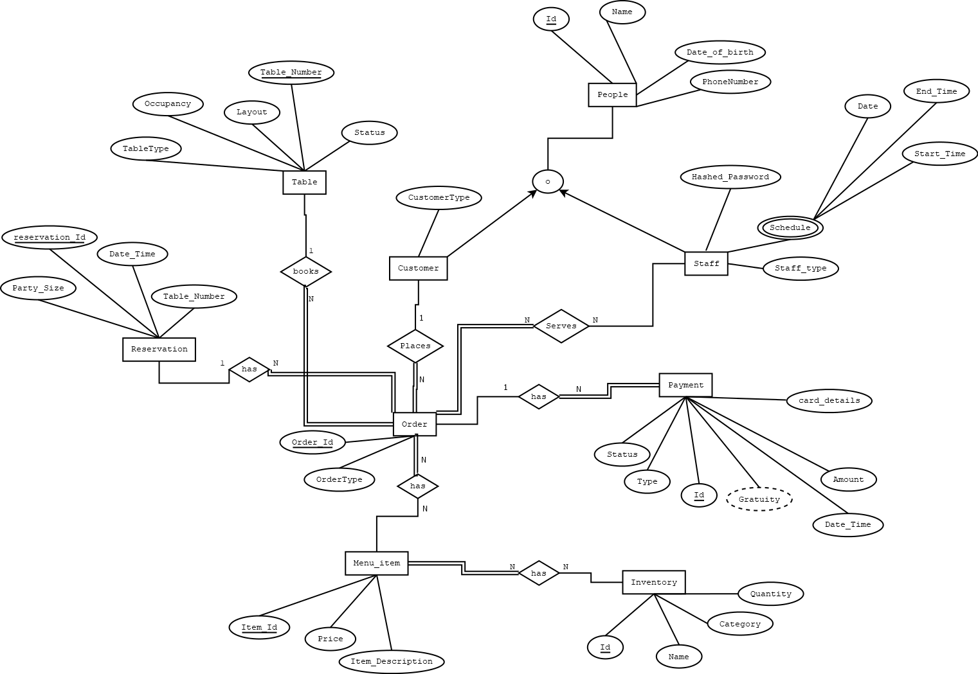

Assumptions and Constraints
A: Customers can reserve their own table. If all tables are occupied, he/she will be added to the wait queue.
A: Queueing system is based on the date and time of the reservations.
A: Order Type includes Food Orders or Bar Orders.
A: Staff Type includes servers, host/hostess, kitchen staff, management members.
A: Staff member can be a customer also.
A: Each server (staff) takes order placed by the customer.
A: Kitchen staff manages the inventory.
A: The gratuities associated with a customer/order is linked to the corresponding staff member.
A: Payment stores total order amount and gratuities amount.
A: For each card payment done by customer, encrypted card detail is stored.
C: Menu will have only those items which can be prepared from the current inventory.
C: Alcoholic beverage will only be served to customers whose age is greater than 21 years.
C: Alcoholic beverage will be served only by staff whose age is more than 21 years.

Milestone 3: Logical Design

Entity Relationship Diagram
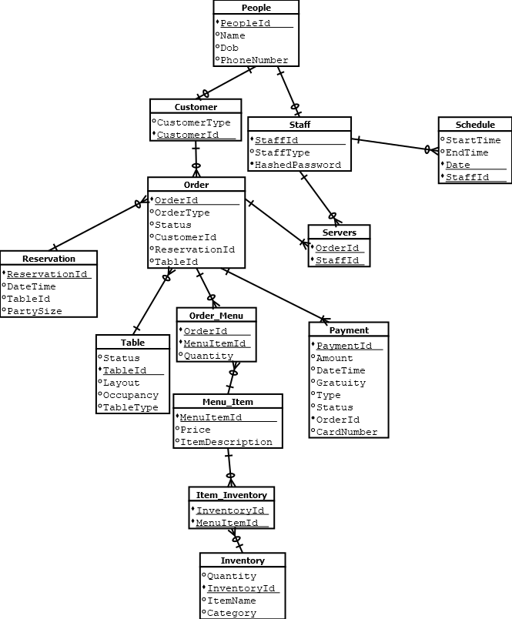

Entity name: People
Attributes:
PeopleId, Name, Dob, PhoneNumber
Functional dependencies:
PeopleId → Name, Dob, PhoneNumber;
Attributes not in FD | Attributes on the left | Attributes on both sides | Attributes on the right side
 | PeopleId |  | Name, Dob, PhoneNumber

Attribute closures (if any):
PeopleId + = PeopleId, Name, Dob, PhoneNumber

Unique keys: the key for this table is/are
PeopleId

Entity name: Customer
Attributes:
CustomerId, CustomerType
Functional dependencies:
CustomerId → CustomerType
Attributes not in FD | Attributes on the left | Attributes on both sides | Attributes on the right side
 | CustomerId |  | CustomerType

Attribute closures :
CustomerId + = CustomerId, CustomerType

Unique keys: the key for this table is/are
CustomerId

Entity name: Staff
Attributes:
StaffId, StaffType, HashedPassword
Functional dependencies:
StaffId → StaffType, HashedPassword

Attributes not in FD | Attributes on the left | Attributes on both sides | Attributes on the right side
 | StaffId |  | StaffType, HashedPassword

Attribute closures :
StaffId + = StaffId, StaffType, HashedPassword

Unique keys: the key for this table is/are
StaffId

Entity name: Schedule
Attributes:
Date, StaffId, StartTime, EndTime
Functional dependencies:
Date, StaffId→ StartTime, EndTime
Attributes not in FD | Attributes on the left | Attributes on both sides | Attributes on the right side
 | Date, StaffId |  | StartTime, EndTime

Attribute closures :
Date, StaffId + = Date, StaffId, StartTime, EndTime

Unique keys: the key for this table is/are
Date, StaffId

Entity name: Order
Attributes:
OrderId, OrderType, Status, CustomerId, ReservationId, TableId

Functional dependencies:
OrderId → OrderType, Status, CustomerId, ReservationId, TableId

Attributes not in FD | Attributes on the left | Attributes on both sides | Attributes on the right side
 | OrderId |  | OrderType, Status, CustomerId, ReservationId, TableId

Attribute closures :
OrderId+ = OrderId, OrderType, Status, CustomerId, ReservationId, TableId

Unique keys: the key for this table is/are
OrderId

Entity name: Reservation
Attributes:
ReservationId, DateTime, TableId, PartySize
Functional dependencies:
ReservationId → DateTime, TableId, PartySize

Attributes not in FD | Attributes on the left | Attributes on both sides | Attributes on the right side
 | ReservationId |  | DateTime, TableId, PartySize

Attribute closures :
ReservationId + = ReservationId, DateTime, TableId, PartySize

Unique keys: the key for this table is/are
ReservationId

Entity name: Table
Attributes:
TableId, Status, Layout, Occupany, TableType
Functional dependencies:
TableId → Status, Layout, Occupany, TableType
Attributes not in FD | Attributes on the left | Attributes on both sides | Attributes on the right side
 | TableId |  | Status, Layout, Occupany, TableType

Attribute closures :
TableId + = TableId, Status, Layout, Occupany, TableType

Unique keys: the key for this table is/are
TableId

Entity name: Menu_item
Attributes:
MenuItemId, Price, ItemDescription
Functional dependencies:
MenuItemId → Price, ItemDescription
Attributes not in FD | Attributes on the left | Attributes on both sides | Attributes on the right side
 | MenuItemId |  | Price, ItemDescription

Attribute closures :
MenuItemId + = MenuItemId, Price, ItemDescription

Unique keys: the key for this table is/are
MenuItemId

Entity name: Inventory
Attributes:
InventoryId, Quantity, ItemName, Category
Functional dependencies:
InventoryId → Quantity, ItemName, Category
ItemName → Category, Quantity
Attributes not in FD | Attributes on the left | Attributes on both sides | Attributes on the right side
 | InventoryId | ItemName | Quantity, Category

Attribute closures :
InventoryId + = InventoryId, Quantity, ItemName, Category
ItemName += ItemName , Quantity, Category

Unique keys: the key for this table is/are
Id

Entity name: Payment
Attributes:
PaymentId, Amount, DateTime, Gratuity, Type, Status, OrderId, CardDetails
Functional dependencies:
PaymentId → Amount, DateTime, Gratuity, Type, Status, OrderId, CardDetails
OrderId → Gratuity
Attributes not in FD | Attributes on the left | Attributes on both sides | Attributes on the right side
 | PaymentId | OrderId | Amount, DateTime, Gratuity, Type, Status, CardDetails

Attribute closures :
PaymentId + = PaymentId, Amount, DateTime, Gratuity, Type, Status, OrderId, CardDetails

Unique keys: the key for this table is/are
PaymentId

Assumptions and Constraints

Only card payments are allowed.
- Each staff takes order placed by the customer.
- Cooking staff will not serve visiting order.
- Customers can order items which are not in the menu.
- Gratuity can derived from the orderId.

Milestone 4: Normalization and

Milestone 5: Physical Design

Assumptions and Constraints
A: Customers can reserve their own table. If all tables are occupied, he/she will be added to the wait queue.
A: Queueing system is based on the date and time of the reservations.
A: Order Type includes Food Orders or Bar Orders.
A: Staff Type includes servers, host/hostess, kitchen staff, management members.
A: Staff member can be a customer also.
A: Each server (staff) takes order placed by the customer.
A: Kitchen staff manages the inventory.
A: The gratuities associated with a customer/order is linked to the corresponding staff member.
A: Payment stores total order amount and gratuities amount.
A: For each card payment done by customer, encrypted card detail is stored.
A: Only card payments are allowed.
A: Each staff takes order placed by the customer.
A: Cooking staff will not serve visiting order.
A: Customers can order items which are not in the menu.
A: Gratuity can be derived from the orderId.
C: Menu will have only those items which can be prepared from the current inventory.
C: Alcoholic beverage will only be served to customers whose age is greater than 21 years.
C: Alcoholic beverage will be served only by staff whose age is more than 21 years.

Naming Conventions

Discuss the naming standards and conventions that you have used for table creation.
The naming convention we are following is as follows:
- All table names follow Sentence Case and Multi worded Tables are separated by an underscore. For example, Order Menu table is called Order_Menu.
- Attributes follow Camel Case. For example, Customer Type will be called CustomerType.

Tables

 | Name of the table | People
 | Description | People are a combination of both Customers and Staff Members.
 | Attribute | Description |  | Type | Examples of values | Notes
 | PeopleId | Id of the Person |  | number | 123 | Unique, Not Null
 | Name | Name of the Person |  | varchar | Jack David | Not Null
 | Dob | Dob of the Person |  | date | 01/01/1996 | Can be Null
 | PhoneNumber | Phone number of the Person |  | number | 6192832312 | Can be Null
 | Functional Dependencies and Keys
 | Functional dependencies | PeopleId → Name, PhoneNumber, Dob
 | Candidate keys | PeopleId
 | Normalization
 | 1NF | Yes | PeopleId is unique and all attributes have only single values.
 | 2NF | Yes | 1NF + non-key attributes are fully functional dependent on the primary key.
 | 3NF | Yes | 2NF + Not contain any transitive partial dependency.
 | BCNF | Yes | 3NF + Every functional dependency X → Y, X is the super key of the table.
 | Physical Design
 | Primary Key | PeopleId
 | Foreign Keys | -
 | SQL Code | CREATE TABLE People  (  PeopleId NUMBER(10) PRIMARY KEY,  Name VARCHAR2(50) NOT NULL,  Dob DATE,  PhoneNumber NUMBER(10)  );
 | Count of records in the table

 | Name of the table | Customer
 | Description | Customer is someone who visits the restaurant.
 | Attribute | Description |  | Type | Examples of values | Notes
 | CustomerId | Id of the Customer |  | number | 122 | Unique, Not Null
 | CustomerType | Type of the Customer |  | varchar | Walk-in | Not Null
 | Functional Dependencies and Keys
 | Functional dependencies | CustomerId → CustomerType
 | Candidate keys | CustomerId
 | Normalization
 | 1NF | Yes | CustomerId is unique and all attributes have only single values.
 | 2NF | Yes | 1NF + non-key attributes are fully functional dependent on the primary key.
 | 3NF | Yes | 2NF + Not contain any transitive partial dependency.
 | BCNF | Yes | 3NF + Every functional dependency X → Y, X is the super key of the table.
 | Physical Design
 | Primary Key | CustomerId
 | Foreign Keys | -
 | SQL Code | CREATE TABLE Customer  (  CustomerId NUMBER(10) PRIMARY KEY,  CustomerType VARCHAR2(50) NOT NULL  );
 | Count of records in the table

 | Name of the table | Staff
 | Description | Staff is a person that works for our restaurant.  There are many types of staff: Hosts, Waiter, Chef, Owner, etc.
 | Attribute | Description |  | Type | Examples of values | Notes
 | StaffId | Id of the staff |  | number | 4311 | Unique, Not Null
 | StaffType | Type of the staff |  | varchar | host, waiter, chef | Not Null
 | HashedPassword | Hashed passwords of the staff |  | varchar | qWasRe2wtOy | Not Null
 | Functional Dependencies and Keys
 | Functional dependencies | StaffId → StaffType, HashedPassword
 | Candidate keys | StaffId
 | Normalization
 | 1NF | Yes | StaffId is unique and all attributes have only single values.
 | 2NF | Yes | 1NF + non-key attributes are fully functional dependent on the primary key.
 | 3NF | Yes | 2NF + Not contain any transitive partial dependency.
 | BCNF | Yes | 3NF + Every functional dependency X → Y, X is the super key of the table.
 | Physical Design
 | Primary Key | StaffId
 | Foreign Keys | -
 | SQL Code | CREATE TABLE Staff  (  StaffId NUMBER(10) PRIMARY KEY,  StaffType VARCHAR2(50) NOT NULL,  HashedPassword VARCHAR2(255) NOT NULL  );
 | Count of records in the table

 | Name of the table | Schedule
 | Description | Stores the daily schedule of each staff member.
 | Attribute | Description |  | Type | Examples of values | Notes
 | StaffId | Id of the staff |  | number | 4312 | Not Null
 | Date | Date of the schedule |  | date | host, server, chef | Not Null
 | StartTime | Start time of the staff schedule |  | time | 14:00 | Not Null
 | EndTime | End time of the staff schedule |  | time | 20:00 | Not Null
 | Functional Dependencies and Keys
 | Functional dependencies | (Date, StaffId) → StartTime, EndTime
 | Candidate keys | (Date, StaffId)
 | Normalization
 | 1NF | Yes | The combination of StaffId and ScheduleDate is unique, and all attributes have only single values.
 | 2NF | Yes | 1NF + non-key attributes are fully functional dependent on the primary key.
 | 3NF | Yes | 2NF + Not contain any transitive partial dependency.
 | BCNF | Yes | 3NF + Every functional dependency X → Y, X is the super key of the table.
 | Physical Design
 | Primary Key | (Date, StaffId)
 | Foreign Keys | StaffId
 | SQL Code | CREATE TABLE Schedule  (  StaffId NUMBER(10) NOT NULL,  Date DATE NOT NULL,  StartTime TIMESTAMP WITH LOCAL TIME ZONE NOT NULL,  EndTime TIMESTAMP WITH LOCAL TIME ZONE NOT NULL, CONSTRAINT pk_schedule_id PRIMARY KEY (StaffId, Date), CONSTRAINT fk_schedule_staff_id FOREIGN KEY(StaffId) REFERENCES Staff(StaffId)  );
 | Count of records in the table

 | Name of the table | Order
 | Description | Details of the order placed by the customer.
 | Attribute | Description |  | Type | Examples of values | Notes
 | OrderId | Id of the order |  | number | 3214 | Unique, Not Null
 | CustomerId | Id of the customer |  | number | 125 | Not Null
 | ReservationId | Id of the reservation |  | number | 121 | Not Null
 | TableId | Id of the table |  | number | 12 | Not Null
 | Status | Status of the order |  | varchar | Served, Cancelled | Not Null
 | OrderType | Type of the order |  | varchar | Bar Order | Not Null
 | Functional Dependencies and Keys
 | Functional dependencies | OrderId → CustomerId, ReservationId, TableId, Status, OrderType
 | Candidate keys | OrderId
 | Normalization
 | 1NF | Yes | OrderId is unique, and all attributes have only single values.
 | 2NF | Yes | 1NF + non-key attributes are fully functional dependent on the primary key.
 | 3NF | Yes | 2NF + Not contain any transitive partial dependency.
 | BCNF | Yes | 3NF + Every functional dependency X → Y, X is the super key of the table.
 | Physical Design
 | Primary Key | OrderId
 | Foreign Keys | CustomerId, ReservationId, TableId
 | SQL Code | CREATE TABLE Order  (  OrderId NUMBER(10) PRIMARY KEY,  CustomerId NUMBER(10) NOT NULL,  ReservationId NUMBER(10) NOT NULL,  TableId NUMBER(10) NOT NULL,  Status VARCHAR2(50) NOT NULL,  OrderType VARCHAR(10) NOT NULL,  CONSTRAINT fk_order_customer_id FOREIGN KEY(CustomerId) REFERENCES Customer(CustomerId),  CONSTRAINT fk_order_reservation_id FOREIGN KEY(ReservationId) REFERENCES Reservation(ReservationId),  CONSTRAINT fk_order_table_id FOREIGN KEY(TableId) REFERENCES RTable(TableId),  );
 | Count of records in the table

 | Name of the table | Reservation
 | Description | Stores the reservation details.
 | Attribute | Description |  | Type | Examples of values | Notes
 | ReservationId | Id of the Reservation |  | number | 126 | Unique, Not Null
 | DateTime | Date and time of the reservation |  | date | 12-24-2022 17:30:00 | Not Null
 | TableId | Id for the Table |  | number | 11 | Can be Null  (Unsuccessful Reservation)
 | PartySize | Number of people in the reservation |  | number | 7 | Can be Null  (Unsuccessful Reservation)
 | Functional Dependencies and Keys
 | Functional dependencies | ReservationId → DateTime, TableId, PartySize
 | Candidate keys | ReservationId
 | Normalization
 | 1NF | Yes | ReservationId is unique, and all attributes have only single values.
 | 2NF | Yes | 1NF + non-key attributes are fully functional dependent on the primary key.
 | 3NF | Yes | 2NF + Not contain any transitive partial dependency.
 | BCNF | Yes | 3NF + Every functional dependency X → Y, X is the super key of the table.
 | Physical Design
 | Primary Key | ReservationId
 | Foreign Keys | -
 | SQL Code | CREATE TABLE Reservation  (  ReservationId NUMBER(10) PRIMARY KEY,  DateTime TIMESTAMP WITH LOCAL TIME ZONE NOT NULL,  PartySize NUMBER(2),  TableId NUMBER(2)  );
 | Count of records in the table

 | Name of the table | Servers
 | Description | Stores the details about which staff serves the order.
 | Attribute | Description |  | Type | Examples of values | Notes
 | OrderId | Id of the Order |  | number | 324 | Not Null
 | StaffId | Id of the Staff |  | number | 121 | Not Null
 | Functional Dependencies and Keys
 | Functional dependencies
 | Candidate keys | (OrderId, StaffId)
 | Normalization
 | 1NF | Yes | The combination of StaffId and OrderId is unique, and all attributes have only single values.
 | 2NF | Yes | 1NF + non-key attributes are fully functional dependent on the primary key.
 | 3NF | Yes | 2NF + Not contain any transitive partial dependency.
 | BCNF | Yes | 3NF + Every functional dependency X → Y, X is the super key of the table.
 | Physical Design
 | Primary Key | (OrderId, StaffId)
 | Foreign Keys | OrderId, StaffId
 | SQL Code | CREATE TABLE Servers  (  StaffId NUMBER(10) NOT NULL,  OrderId NUMBER(10) NOT NULL,  CONSTRAINT pk_servers_id PRIMARY KEY (StaffId, OrderId), CONSTRAINT fk_server_staff_id FOREIGN KEY(StaffId) REFERENCES Staff(id),  CONSTRAINT fk_server_order_id FOREIGN KEY(OrderId) REFERENCES Order(id)  );
 | Count of records in the table

 | Name of the table | RTable
 | Description | Table details in the Restaurant.
 | Attribute | Description |  | Type | Examples of values | Notes
 | TableId | Id of the Order |  | number | 324 | Unique, Not Null
 | Status | Status of the table |  | number | 121 | Not Null
 | Layout | Layout of the table |  | varchar | Centre, corner | Not Null
 | Occupancy | Maximum occupancy of the table |  | number | 6 | Not Null
 | TableType | Type of the table |  | varchar | Rectangle | Not Null
 | Functional Dependencies and Keys
 | Functional dependencies | TableId→ Status, Layout, Occupancy, TableType
 | Candidate keys | TableId
 | Normalization
 | 1NF | Yes | TableId is unique, and all attributes have only single values.
 | 2NF | Yes | 1NF + non-key attributes are fully functional dependent on the primary key.
 | 3NF | Yes | 2NF + Not contain any transitive partial dependency.
 | BCNF | Yes | 3NF + Every functional dependency X → Y, X is the super key of the table.
 | Physical Design
 | Primary Key | TableId
 | Foreign Keys | -
 | SQL Code | CREATE TABLE RTABLE  (  TableId NUMBER(10) PRIMARY KEY,  Status VARCHAR2(50) NOT NULL,  Occupancy NUMBER(2) NOT NULL,  Layout VARCHAR2(50) NOT NULL ,  TableType VARCHAR2(10) NOT NULL  );
 | Count of records in the table

 | Name of the table | Payment
 | Description | Payment details for the transaction.
 | Attribute | Description |  | Type | Examples of values | Notes
 | PaymentId | Id of the Payment |  | number | 324 | Not Null
 | Amount | Amount paid by the customer |  | number | 50 | Not Null
 | DateTime | Data and time of transaction |  | datetime | 01-12-2022 1:00:00 | Not Null
 | Gratuity | Gratuity offered to the staff |  | number | 2 | Can be Null
 | Type | Mode of the payment |  | varchar | Credit Card | Not Null
 | Status | Status of the payment |  | varchar | Success | Not Null
 | OrderId | Id of the order |  | number | 21 | Not Null
 | CardNumber | Encrypted Card Number |  | varchar | xxxxxxxxxx7868 | Not Null
 | Functional Dependencies and Keys
 | Functional dependencies | PaymentId → Amount, DateTime, status, Gratuity, Status, Type, OrderId, CardNumber
 | Candidate keys | PaymentId
 | Normalization
 | 1NF | Yes | PaymentId is unique, and all attributes have only single values.
 | 2NF | Yes | 1NF + non-key attributes are fully functional dependent on the primary key.
 | 3NF | Yes | 2NF + Not contain any transitive partial dependency.
 | BCNF | Yes | 3NF + Every functional dependency X → Y, X is the super key of the table.
 | Physical Design
 | Primary Key | PaymentId
 | Foreign Keys | OrderId
 | SQL Code | CREATE TABLE Payment  (  PaymentId NUMBER(10) PRIMARY KEY,  OrderId NUMBER(10) NOT NULL,  DateTime TIMESTAMP WITH LOCAL TIME ZONE NOT NULL,  Type VARCHAR2(50) NOT NULL,  Status VARCHAR2(50) NOT NULL,  Amount FLOAT(5) NOT NULL,  Gratuity FLOAT(5),  CardNumber VARCHAR2(255) NOT NULL,  CONSTRAINT fk_payment_order_id FOREIGN KEY(OrderId) REFERENCES Order(OrderId),  );
 | Count of records in the table

 | Name of the table | Order_Menu
 | Description | Stores the Menu items and their respective quantities.
 | Attribute | Description |  | Type | Examples of values | Notes
 | OrderId | Id of the Order |  | number | 324 | Not Null
 | MenuItemId | Id of the Menu item |  | number | 121 | Not Null
 | Quantity | Quantity of items ordered |  | number | 3 | Not Null
 | Functional Dependencies and Keys
 | Functional dependencies | (OrderId, MenuItemId) → Quantity
 | Candidate keys | (OrderId, MenuItemId)
 | Normalization
 | 1NF | Yes | The combination of OrderId and ItemId is unique, and all attributes have only single values.
 | 2NF | Yes | 1NF + non-key attributes are fully functional dependent on the primary key.
 | 3NF | Yes | 2NF + Not contain any transitive partial dependency.
 | BCNF | Yes | 3NF + Every functional dependency X → Y, X is the super key of the table.
 | Physical Design
 | Primary Key | (OrderId, MenuItemId)
 | Foreign Keys | OrderId, MenuItemId
 | SQL Code | CREATE TABLE Order_Menu  (  MenuItemId NUMBER(10) NOT NULL,  OrderId NUMBER(10) NOT NULL,  Quantity Number(2) NOT NULL,  CONSTRAINT pk_ordermenu_id PRIMARY KEY (MenuItemId, OrderId), CONSTRAINT fk_ordermenu_menuitem_id FOREIGN KEY(MenuItemId) REFERENCES Menu_Item(MenuItemId),  CONSTRAINT fk_ordermenu_order_id FOREIGN KEY(OrderId) REFERENCES Order(id)  );
 | Count of records in the table

 | Name of the table | Menu_Item
 | Description | Stores the Menu details served by the restaurant.
 | Attribute | Description |  | Type | Examples of values | Notes
 | MenuItemId | Id of the Menu item |  | number | 32 | Unique, Not Null
 | Price | Cost of the menu item |  | number | 32 | Not Null
 | ItemDescription | Description of the menu item |  | varchar | Pasta | Not Null
 | Functional Dependencies and Keys
 | Functional dependencies | MenuItemId → Price, ItemDescription
 | Candidate keys | MenuItemId
 | Normalization
 | 1NF | Yes | ItemId is unique, and all attributes have only single values.
 | 2NF | Yes | 1NF + non-key attributes are fully functional dependent on the primary key.
 | 3NF | Yes | 2NF + Not contain any transitive partial dependency.
 | BCNF | Yes | 3NF + Every functional dependency X → Y, X is the super key of the table.
 | Physical Design
 | Primary Key | MenuItemId
 | Foreign Keys | -
 | SQL Code | CREATE TABLE MENU_ITEM  (  MenuItemId NUMBER(10) PRIMARY KEY,  Price FLOAT(5) NOT NULL,  ItemDescription VARCHAR2(200) NOT NULL ,  );
 | Count of records in the table

 | Name of the table | Item_Inventory
 | Description | Stores the inventory items for each menu item.
 | Attribute | Description |  | Type | Examples of values | Notes
 | MenuItemId | Id of the Menu item |  | number | 32 | Not Null
 | InventoryId | Id of Inventory item |  | number | 3421 | Not Null
 | Functional Dependencies and Keys
 | Functional dependencies
 | Candidate keys | (MenuItemId, InventoryId)
 | Normalization
 | 1NF | Yes | The combination of InventoryId and ItemId is unique, and all attributes have only single values.
 | 2NF | Yes | 1NF + non-key attributes are fully functional dependent on the primary key.
 | 3NF | Yes | 2NF + Not contain any transitive partial dependency.
 | BCNF | Yes | 3NF + Every functional dependency X → Y, X is the super key of the table.
 | Physical Design
 | Primary Key | (MenuItemId, InventoryId)
 | Foreign Keys | MenuItemId, InventoryId
 | SQL Code | CREATE TABLE Item_Inventory  (  MenuItemId NUMBER(10) NOT NULL,  InventoryId NUMBER(10) NOT NULL,  CONSTRAINT pk_item_inventory_id PRIMARY KEY (MenuItemId, InventoryId),  CONSTRAINT fk_iteminventory_menuitem_id FOREIGN KEY(MenuItemId) REFERENCES Menu_Item(MenuItemId),  CONSTRAINT fk_iteminventory_inventory_id FOREIGN KEY(InventoryId) REFERENCES Inventory(InventoryId)  );
 | Count of records in the table

 | Name of the table | Inventory
 | Description | Stores the inventory of the items.
 | Attribute | Description |  | Type | Examples of values | Notes
 | InventoryId | Id of the Inventory item |  | number | 323987 | Unique, Not Null
 | Quantity | Quantity of the inventory item |  | number | 100 | Not Null
 | ItemName | Name of the inventory item |  | varchar | Pepper | Not Null
 | Category | Category of the inventory item |  | varchar | Spice | Not Null
 | Functional Dependencies and Keys
 | Functional dependencies | InventoryId → Quantity, ItemName, Category
 | Candidate keys | InventoryId
 | Normalization
 | 1NF | Yes | InventoryId is unique, and all attributes have only single values.
 | 2NF | Yes | 1NF + non-key attributes are fully functional dependent on the primary key.
 | 3NF | Yes | 2NF + Not contain any transitive partial dependency.
 | BCNF | Yes | 3NF + Every functional dependency X → Y, X is the super key of the table.
 | Physical Design
 | Primary Key | InventoryId
 | Foreign Keys | -
 | SQL Code | CREATE TABLE Inventory  (  InventoryId NUMBER(10) PRIMARY KEY,  ItemName VARCHAR2(50) NOT NULL,  Category VARCHAR2(50) NOT NULL,  Quantity NUMBER(10) NOT NULL  );
 | Count of records in the table

Milestone 6: SQL queries and

Note: Please make sure you add/have 25 records in each table, on average.

Query 1
English version | Most ordered drinks
Source for the query need in the SRS document | SRS document, page 65, section 9.16.
SQL sentence | SELECT itemdescription, Sum(QUANTITY) as total_qty  FROM MENU_ITEM  INNER JOIN ORDER_MENU  ON ORDER_MENU.menuitemid = MENU_ITEM.menuitemid  WHERE MENU_ITEM.menuitemid > 18  GROUP BY itemdescription  ORDER BY total_qty desc;
Example of returned rows (cropped screen caption) | 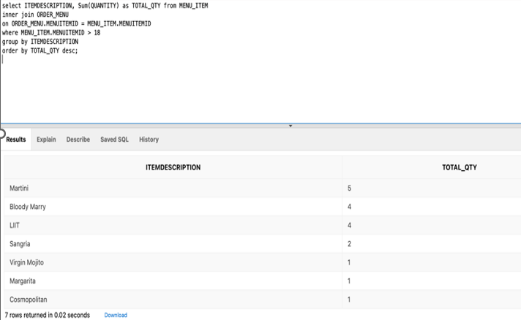

Query 2
English version | Display name of employees with maximum gratuity
Source for the query need in the SRS document | SRS document, page 9, section 3.5.1.5.
SQL sentence | SELECT staff.staffid, name ,sum(gratuity) as total_grat FROM payment  INNER JOIN rorder ON rorder.orderid = payment.orderid  INNER JOIN servers ON servers.orderid = rorder.orderid  INNER JOIN staff ON staff.staffid = servers.staffid  INNER JOIN people ON people.peopleid = staff.staffid  GROUP BY staff.staffid, name  ORDER BY total_grat DESC;
Example of returned rows (cropped screen caption) | 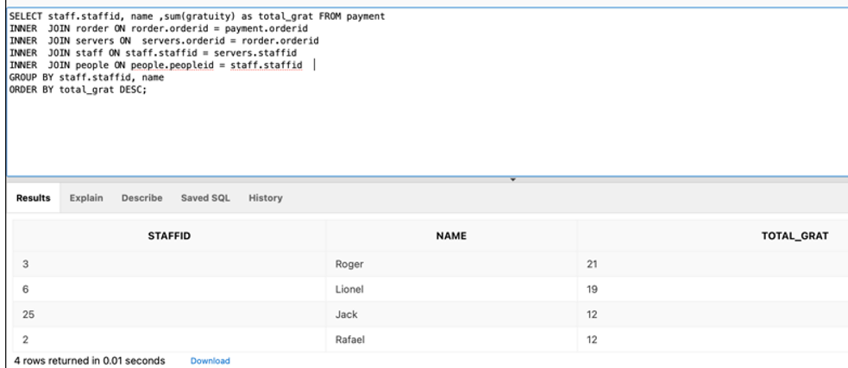

Query 3
English version | Display order details and status where the table gets more than the average party size.
Source for the query need in the SRS document | SRS document, page 54, section 9.5 point 2.
SQL sentence | SELECT orderid, ordertype, rorder.status  FROM RORDER  INNER JOIN rtable ON rorder.tableid = rtable.tableid  WHERE occupancy <  (SELECT AVG(partysize)  FROM rorder INNER JOIN reservation ON reservation.reservationid = rorder.reservationid);
Example of returned rows (cropped screen caption) | 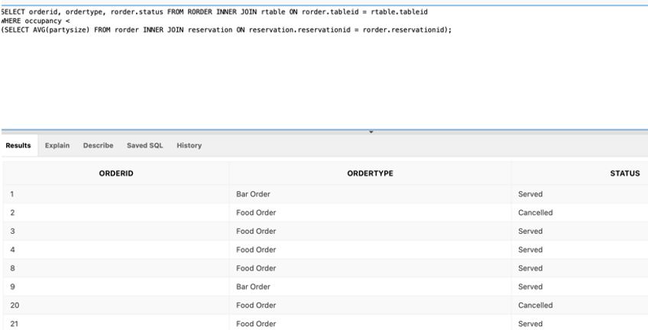

Query 4
English version | Find Staff who are working in second shift on Nov 7th
Source for the query need in the SRS document | SRS document, page 3, section 1.2 point 5.
SQL sentence | SELECT s.staffid, p.name  FROM STAFF s  INNER JOIN PEOPLE p on p.peopleid = s.staffid  INNER JOIN SCHEDULE sch on sch.staffid = s.staffid  WHERE SCH.StartTime BETWEEN '07-NOV-22 02.00.00.000000 PM' AND '07-NOV-22 11.00.00.000000 PM';
Example of returned rows (cropped screen caption) | 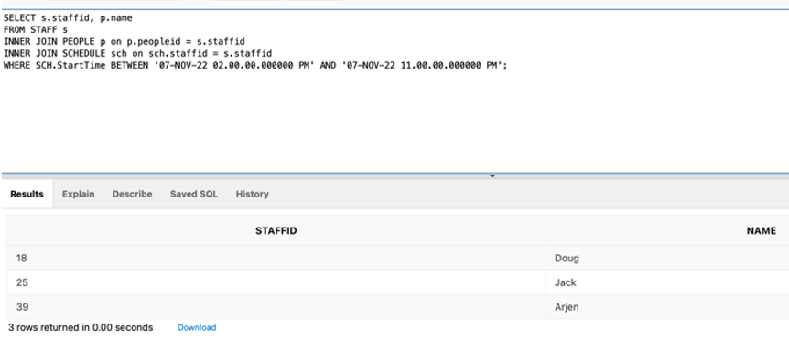

Query 5
English version | Display the name of staff who served food to tables with capacity more than 6
Source for the query need in the SRS document | SRS document, page 10, section 3.5, 3.5.3.2 point.
SQL sentence | SELECT staff.staffid, name, rtable.tableid, occupancy  FROM rtable  INNER JOIN rorder ON rtable.tableid = rorder.tableid  INNER JOIN servers ON servers.orderid = rorder.orderid  INNER JOIN staff ON staff.staffid = servers.staffid  INNER JOIN people ON people.peopleid = staff.staffid  WHERE rtable.tableid in (SELECT tableid FROM rtable WHERE occupancy > 6) ;
Example of returned rows (cropped screen caption) | 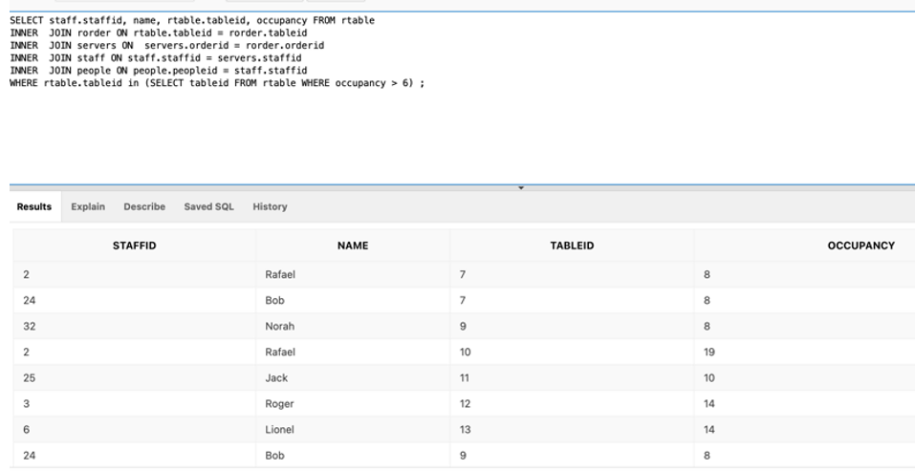

Query 6
English version | Find the order and order type where a payment has been declined and later transacted successfully
Source for the query need in the SRS document | SRS document, page 6, section 2.3, third point.
SQL sentence | SELECT rorder.orderid, ordertype, COUNT(*)  FROM payment  INNER JOIN rorder on rorder.orderid = payment.orderid  GROUP BY rorder.orderid, ordertype HAVING COUNT(*) >1 ;
Example of returned rows (cropped screen caption) | 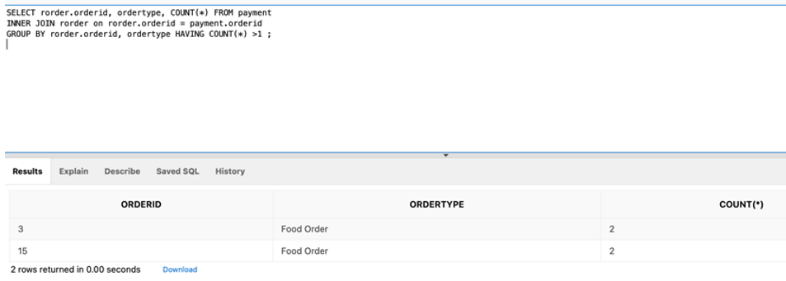

Query 7
English version | Find the orders where customers want either small tables that seat 4 or lesser or circular tables
Source for the query need in the SRS document | SRS Document, Page 5, section 2.2, first point.
SQL sentence | SELECT orderid, rorder.status, rorder.tableid  FROM rorder  JOIN rtable ON rorder.tableid= rtable.tableid  WHERE tabletype = 'Rectangle'  UNION  SELECT orderid, rorder.status, rorder.tableid FROM rorder  JOIN reservation ON rorder.reservationid= reservation.reservationid  WHERE partysize < 4;
Example of returned rows (cropped screen caption) | 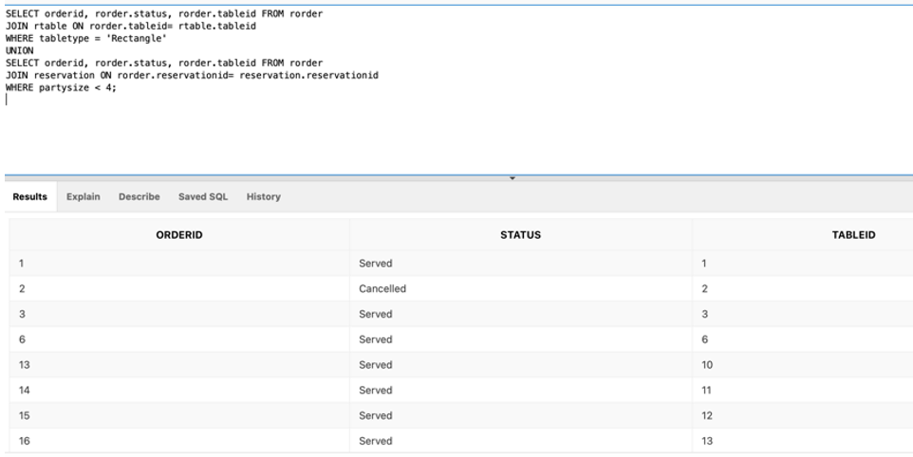

Query 8
English version | Select inventory items and their quantity that are oils or items that are grains
Source for the query need in the SRS document | SRS Document, Page 7, Table, fifth point.
SQL sentence | SELECT itemname, quantity  FROM inventory  WHERE itemname LIKE '%Oil%' OR category = 'Grain';
Example of returned rows (cropped screen caption) | 