Week 25

Name:
Mobile:

Personal Development Workouts
- Finish reading the next 50 pages of the book “Rich Dad Poor Dad” by Robert Kiyosaki and prepare an audio note on each chapter.
aud2.opus
In the next 50 pages of Rich Dad Poor Dad, Robert Kiyosaki explains the difference between assets and liabilities, emphasising that assets generate income while liabilities drain money. He stresses the importance of financial literacy, as schools teach how to work for money but not how to make money work for you. Kiyosaki introduces the "Cashflow Quadrant," categorising ways people earn money into Employee (E), Self-Employed (S), Business Owner (B), and Investor (I). He also discusses how the wealthy use corporations to reduce taxes and protect wealth. Kiyosaki advises working to learn new skills, not just for a paycheck, and taking calculated risks to build wealth.

Technical Workouts
- Complete your project according to the instructions.
This week, I worked on improving the user experience and adding important features to the TicketHive project. I added a feature that fetches the user's current location automatically, making it easier for them to find nearby theaters and movies. I also gave users the option to select a location, which then shows them the relevant theaters and movies in that area. To make navigation easier, I implemented search, sort, filter, and pagination across the site, so users can easily find what they’re looking for. I started working on the seat layout configuration, allowing users to choose seats when booking, but this feature is still in progress. I also integrated the Google Places Autocomplete API, which helps users quickly find and select a location. Additionally, I began implementing the OLA Places API to improve location accuracy. Overall, it was a productive week with significant progress in adding useful features and improving the user interface.

Miscellaneous Workouts
- Practice typing for at least one hour each day. Finish as many chapters as possible as you can. Don’t spend more than an hour each day.
- Prepare a topic for the tech seminar. Record and upload it on youtube as an unlisted video.
- Conduct a Feedback session by the end of this week.
- Prepare your progress video for the last week. Record and upload it on youtube as an unlisted video..
reaching level 361 in TypingClub is a significant achievement. It indicates a high level of proficiency in typing skills, showcasing my dedication and consistent effort in improving my typing speed and accuracy. Reaching this level suggests that I likely mastered various typing exercises and challenges, honing my keyboarding skills to a level where I can efficiently and accurately type different types of content.
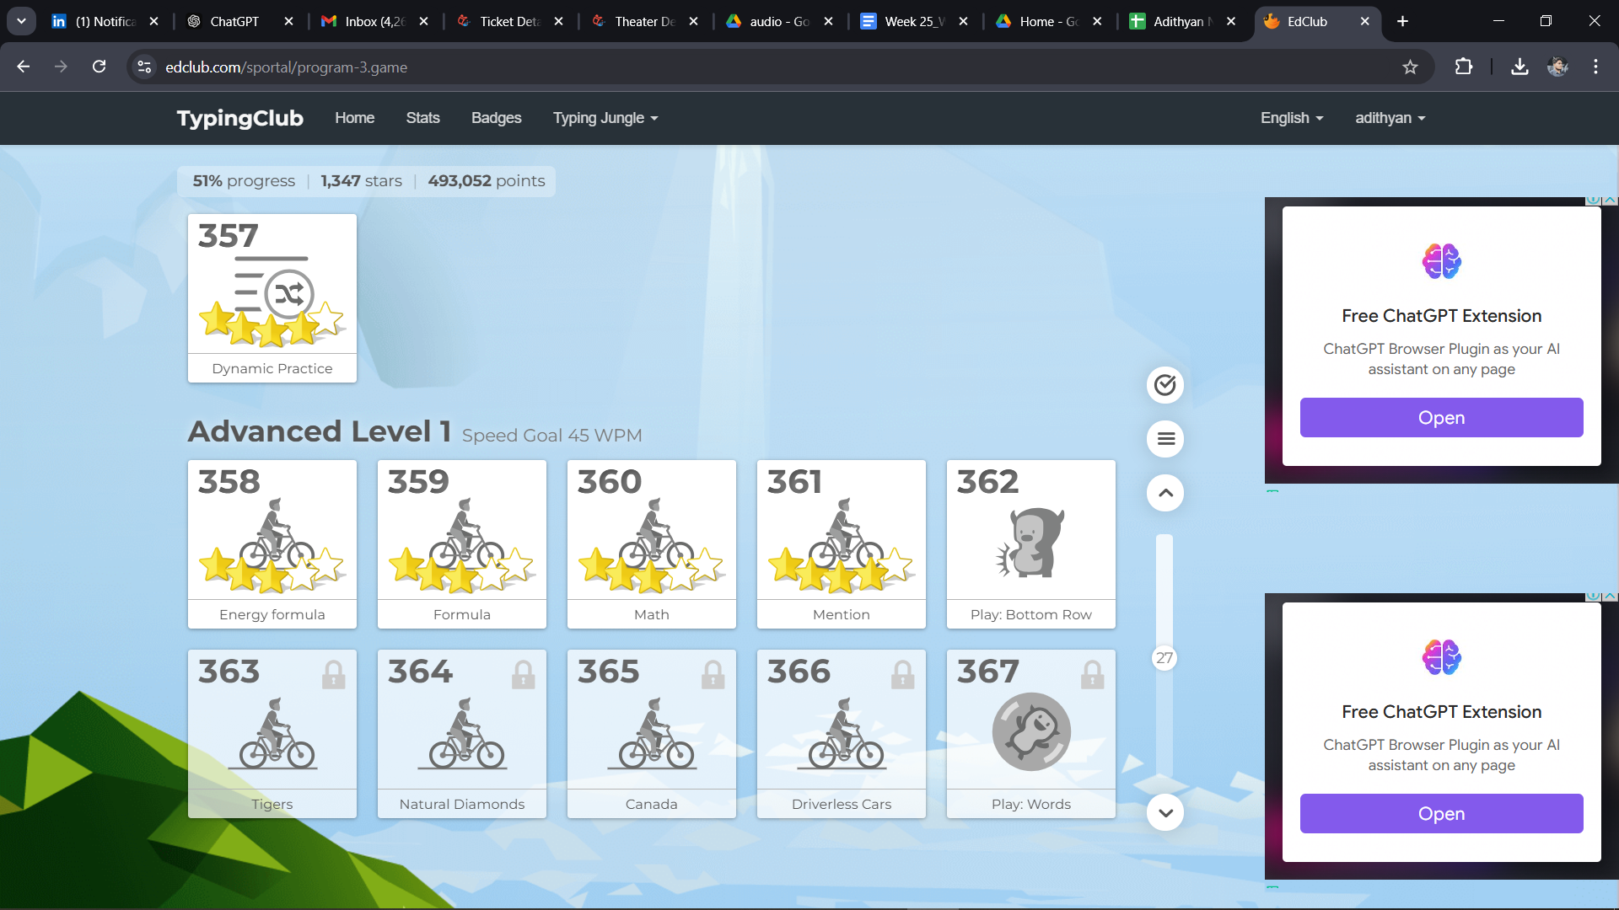
Write a short description about this task
Link to your seminar video
Link to the document containing notes for your feedback session
Write a short description about this task
Link to your progress video

