AI-Driven Semantic Middleware for an Interactive 2D Digital Twin: A Prototype Framework for Real-Time Campus Emergency Evacuation Simulation
Sandhya N  Department of AIML  Dayananda Sagar Academy of Technology and Management  Bengaluru, India  hodaiml@dsatm.edu.in | Adithyan P  Department of AIML  Dayananda Sagar Academy of Technology and Management  Bengaluru, India  adithyan18902005@gmail.com | Amrutha Varshni G R  Department of AIML  Dayananda Sagar Academy of Technology and Management  Bengaluru, India  amruthavarshni2005@gmail.com
Apoorva Ganga M S
Department of AIML
Dayananda Sagar Academy of Technology and Management
Bengaluru, India
msapoorvaganga@gmail.com

Abstract— Emergency evacuation in campus and institutional buildings still largely relies on static maps and manual planning, which cannot assimilate real-time conditions from the heterogeneous Building Management System (BMS), Fire Alarm System (FAS) and Internet-of-Things (IoT) sensors that a modern facility already produces. A recent structured literature survey conducted by this team identified semantic interoperability between such heterogeneous building systems as the most consistently reported barrier to closed-loop Digital Twin (DT) evacuation systems, alongside the isolation of accessibility-aware guidance from mainstream routing engines. This paper proposes and describes, at the design and prototype-methodology level, an AI-driven semantic middleware that ingests deliberately heterogeneous, schema-inconsistent synthetic sensor streams and maps them onto a common building ontology inside a Digital Twin state manager. The Digital Twin drives a graph-based dynamic routing engine (Dijkstra/A*) and an occupant-agent evacuation simulator, all rendered on an interactive, floor-plan-accurate 2D visualisation of an actual campus building rather than a generic dashboard. We present the layered architecture, the simulation workflow, the semantic-mapping methodology, the occupant model, the intended technology stack, an evaluation protocol built around mapping accuracy, entity-matching accuracy and latency, and an explicit failure-handling and fail-safe design. Consistent with the prototype stage of this work, no field measurements are reported; instead, the paper documents a reproducible methodology and a set of research metrics intended to be populated once the system is implemented and exercised.
Keywords— Digital Twin; Semantic Interoperability; AI Middleware; Emergency Evacuation; Building Information Modelling; Dynamic Routing; Agent-Based Simulation; Fire Safety Engineering; Human-Computer Interaction; Campus Safety.
I. INTRODUCTION
Institutional and campus buildings continue to rely on static evacuation plans, laminated floor maps at stairwells, and periodic fire drills. These artefacts cannot incorporate the real-time signals that already exist inside most modern buildings: temperature and smoke readings from the Fire Alarm System (FAS), occupancy and HVAC telemetry from the Building Management System (BMS), and ad hoc Internet-of-Things (IoT) sensor deployments. A Digital Twin (DT) that continuously mirrors building state offers, in principle, a route to real-time, adaptive evacuation guidance. In practice, however, these systems are procured from different vendors, expose different data schemas, and are rarely wired into a single, semantically consistent representation of the building.
This paper builds directly on a structured thematic literature survey conducted by the same authors [1], which reviewed twenty scholarly works on Digital Twin technology for emergency evacuation and consolidated six evidence-grounded research gaps. Of these, the survey identified the absence of live, automated semantic integration across BMS, FAS, Computerised Maintenance Management Systems (CMMS) and Building Information Modelling/Industry Foundation Classes (BIM/IFC) representations as the most pervasive and foundational barrier, and separately identified the architectural isolation of accessibility-aware guidance from the core evacuation-routing engine. This paper operationalises those two findings into a concrete system design and prototype methodology.
Rather than proposing another purely conceptual architecture, this work describes a demonstrable, presentation-ready simulation framework: a college building is modelled as an interactive two-dimensional (2D) floor plan; synthetic BMS, FAS and IoT feeds are generated with deliberately inconsistent field names and units; an AI-assisted semantic middleware maps these heterogeneous feeds onto a common ontology; and the resulting unified Digital Twin state drives hazard detection, dynamic graph-based routing, and animated occupant evacuation, all visible in real time from a single “Start Simulation” control. The contributions of this paper are: (i) a layered system architecture in which semantic interoperability is a first-class, testable component rather than an assumption; (ii) a methodology for AI-assisted schema mapping with explicit, measurable accuracy metrics; (iii) an interactive, floor-plan-accurate 2D Digital Twin concept decoupled from hard-coded UI, so that the underlying building data model can be reused independently of the visualisation; (iv) an explicit failure-handling and fail-safe layer that defines safe fallback behaviour when mapping confidence or synchronisation is compromised; and (v) a reproducible evaluation protocol that a subsequent implementation phase can populate with measured results.
The remainder of this paper is organised as follows. Section II reviews related work and restates the specific research gap this paper targets. Section III defines the problem statement and design objectives. Section IV presents the proposed system architecture. Section V details the interactive 2D Digital Twin concept. Section VI describes the fire/evacuation simulation workflow. Section VII presents the AI semantic middleware methodology. Section VIII describes occupant simulation. Section IX lists the implementation technology stack. Section X defines the experimental methodology and evaluation metrics. Section XI describes failure handling and safety boundaries. Section XII summarises the expected contribution. Section XIII discusses limitations and future work, and Section XIV concludes the paper.
II. RELATED WORK AND RESEARCH GAP
A. Digital Twin Architectures for Evacuation
Prior work has formalised closed-loop Digital Twin architectures for fire safety, typically organised as multimodal sensing, DT synchronisation, AI-driven analytics, routing, physical actuation and feedback [2], and has benchmarked such implementations using dual Integration-Readiness/Technology-Readiness rubrics across real deployments including airports, tunnels and stadium venues [3]. These studies establish that the conceptual layering is well understood, but [2] and [3] both note that the systems studied integrate a small, fixed set of already-compatible data sources rather than an open, extensible set of heterogeneous building systems.
B. Dynamic Signage, Behavioural Validation and Perception
Controlled virtual-reality experiments have shown that dynamic, Digital-Twin-driven exit signage measurably reduces evacuation time and cognitive hesitation relative to static signage [4], [5], and eye-tracking studies have produced actionable, evidence-based sign-placement guidance for smoke conditions [5]. Vision-driven perception pipelines using YOLO-family object detectors have been shown to synchronise a Digital Twin with a physical space at sub-90 ms latency [6]. These results validate individual layers of a DT evacuation system (actuation, perception) but, as in Section II-A, assume that sensor and building data already arrive in a single, internally consistent format.
C. Agent-Based and Accessibility-Aware Simulation
Large language model-integrated agent-based modelling has demonstrated natural-language scenario control over tens of thousands of simulated occupants [7], and demographically realistic synthetic populations have been used to study crisis-communication framing during simulated hurricane evacuations [8]. Separately, smartphone-based assistive applications have been proposed for visually impaired occupants during fire emergencies [9]. Across this literature, behavioural and accessibility research is consistently simulation- or app-level work that is not wired into the same closed-loop routing engine used for the general occupant population.
D. Research Gap Targeted by This Paper
Our survey [1] consolidated these observations into six research gaps: (A) no PINN surrogate has been trained or validated on fire/evacuation-specific data; (B) no study validates DT behaviour under simultaneous, interacting hazards; (C) no reviewed system demonstrates live, automated semantic integration of heterogeneous BMS/FAS/CMMS/BIM-IFC data sources; (D) no jurisdiction provides a formal regulatory equivalence pathway for AI-driven evacuation guidance; (E) accessibility-focused guidance tools remain architecturally isolated from the core DFS routing engine; and (F) no study reports real-occupant, multi-site evacuation validation. This paper targets Gap C as its primary contribution — an AI-assisted semantic middleware that performs live schema mapping and entity resolution as a first-class architectural component — and designs the routing layer so that Gap E (accessibility-aware routing) can be added as a downstream extension without re-architecting the system, as discussed in Section XIII.
TABLE I. RESEARCH GAPS FROM [1] AND THE SCOPE ADOPTED BY THIS PAPER.
Research Gap | Existing Limitation | Position of This Paper
A. PINN for fire/evacuation | Adjacent-domain only | Not addressed (future work)
B. Multi-hazard validation | Hazards evaluated independently | Not addressed (future work)
C. Semantic interoperability | No live automated integration demonstrated | Primary target of this paper
D. Regulatory equivalence | No formal pathway in most jurisdictions | Out of scope
E. Accessibility–DFS integration | Developed in isolation from DFS routing | Architecturally reserved, not yet implemented
F. Real-world validation at scale | Simulation/VR only | Simulation-only prototype (this paper)
III. PROBLEM STATEMENT AND OBJECTIVES
Problem statement: a campus building's BMS, FAS and ad hoc IoT sensors expose heterogeneous schemas, identifiers and units that describe the same physical spaces using incompatible vocabularies. No reviewed system demonstrates an AI-assisted layer that automatically discovers, maps and validates these heterogeneous fields into a single Digital Twin representation capable of driving real-time dynamic evacuation routing, and no reviewed system pairs this with an interactive, floor-plan-accurate 2D interface suitable for live, non-technical demonstration.
Design objectives:
O1: Define a common building ontology (rooms, corridors, exits, sensors, hazard states) capable of representing heterogeneous source schemas.
O2: Design an AI-assisted semantic mapper that proposes field-to-ontology mappings with a confidence score, plus a validation layer that accepts, flags or rejects each mapping.
O3: Build an interactive 2D Digital Twin that renders an actual campus floor plan from a data model decoupled from the user interface.
O4: Implement graph-based dynamic routing that recomputes safe paths as hazard state changes, and an occupant-agent simulator that visualises evacuation on the same map.
O5: Define a reproducible evaluation protocol — mapping accuracy, entity-matching accuracy, end-to-end latency and evacuation-time comparison against a static-routing baseline — that a subsequent implementation phase can populate with measured results.
IV. PROPOSED SYSTEM ARCHITECTURE
The proposed system follows a modular, layered architecture (Fig. 1) so that each concern — sensing, semantic mapping, twin state, hazard reasoning, routing, occupant behaviour and presentation — can be developed, tested and replaced independently. A synthetic-sensor layer stands in for physical BMS/FAS/IoT hardware during the prototype stage, publishing heterogeneous readings on a schedule or in response to an operator-triggered scenario. The AI semantic middleware (Section VII) consumes these readings and proposes mappings onto a common building ontology; a validation layer applies confidence thresholds and rule-based sanity checks before any mapping is allowed to update the Digital Twin state manager, which holds the authoritative, per-room representation of temperature, smoke, occupancy and hazard classification.

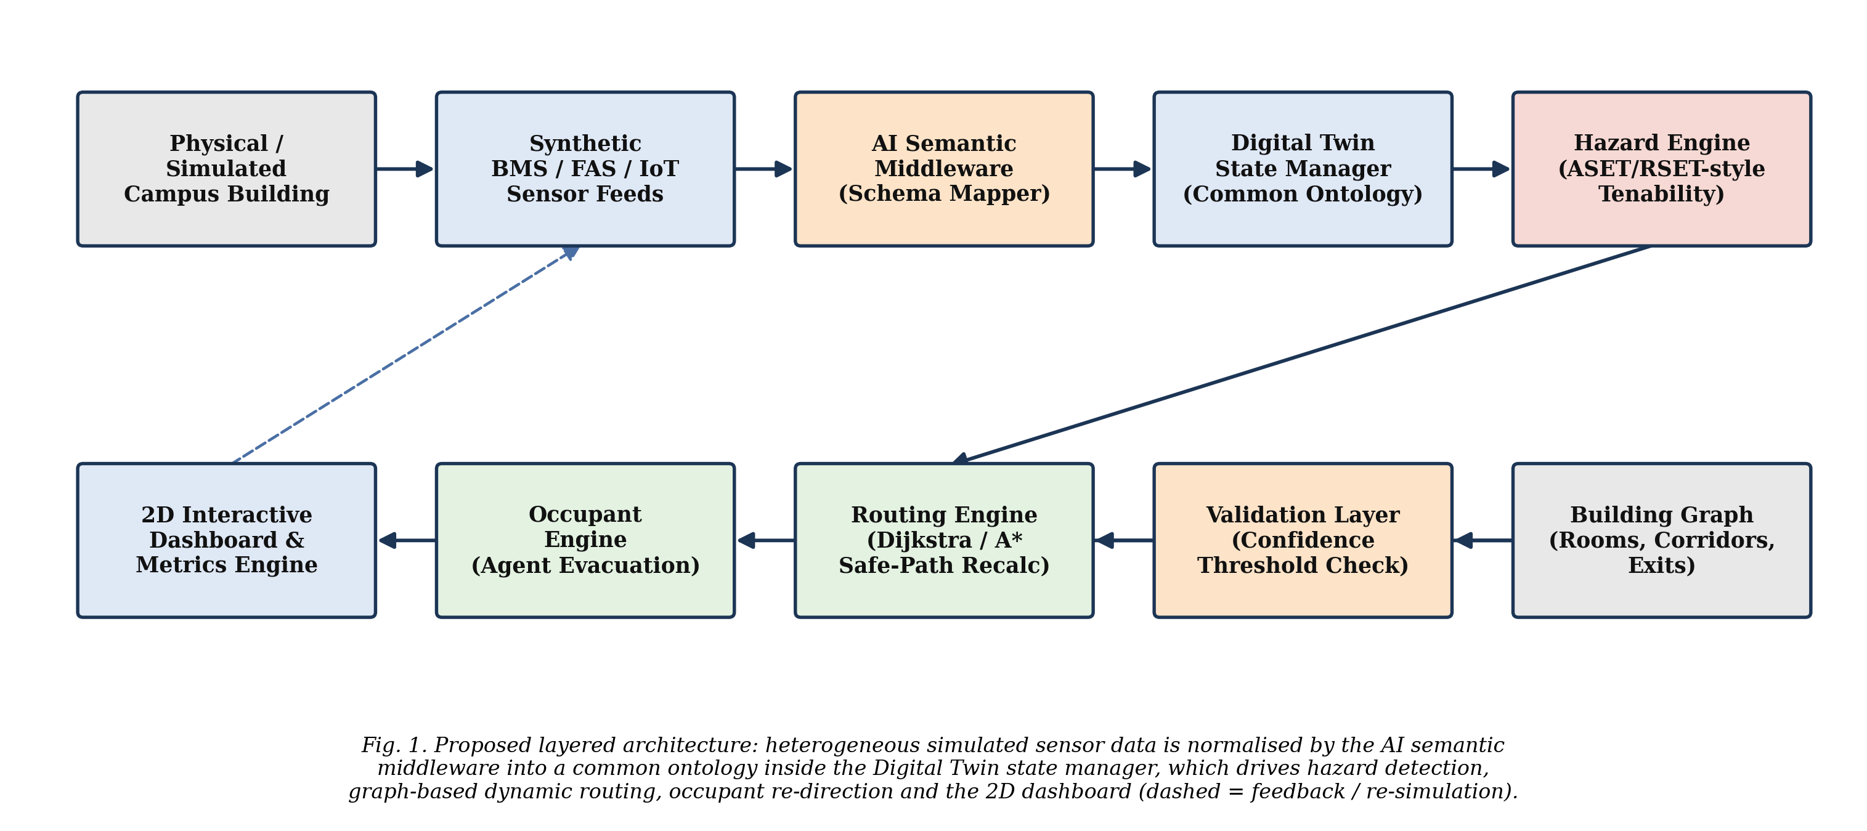

The Digital Twin state feeds a hazard engine that classifies each room and corridor as safe, degraded or unsafe using threshold logic inspired by Available/Required Safe Egress Time (ASET/RSET) reasoning [2], [3]. Hazard classification is passed to a routing engine that operates over an explicit building graph (rooms, corridors and exits as nodes; connections as weighted edges) and penalises or removes edges through unsafe nodes before recomputing shortest paths. The occupant engine consumes the recomputed paths to update each simulated occupant's evacuation state, and the 2D interactive dashboard renders the entire pipeline live while a metrics engine logs the quantities defined in Section X. The dashed feedback path in Fig. 1 represents the continuous re-simulation loop: each new sensor reading can trigger a fresh pass through the same pipeline.
V. INTERACTIVE 2D DIGITAL TWIN CONCEPT
A central design decision is to visualise an actual campus floor — not a generic building silhouette — as an interactive 2D map, because a floor plan the audience recognises makes the causal chain from sensor to routing decision immediately legible. The floor plan, rooms, sensor placements, exits and the building graph are stored as a JSON-based data model that is entirely decoupled from the rendering layer, so that the same interface can be re-pointed at a different building or floor by editing data rather than code.
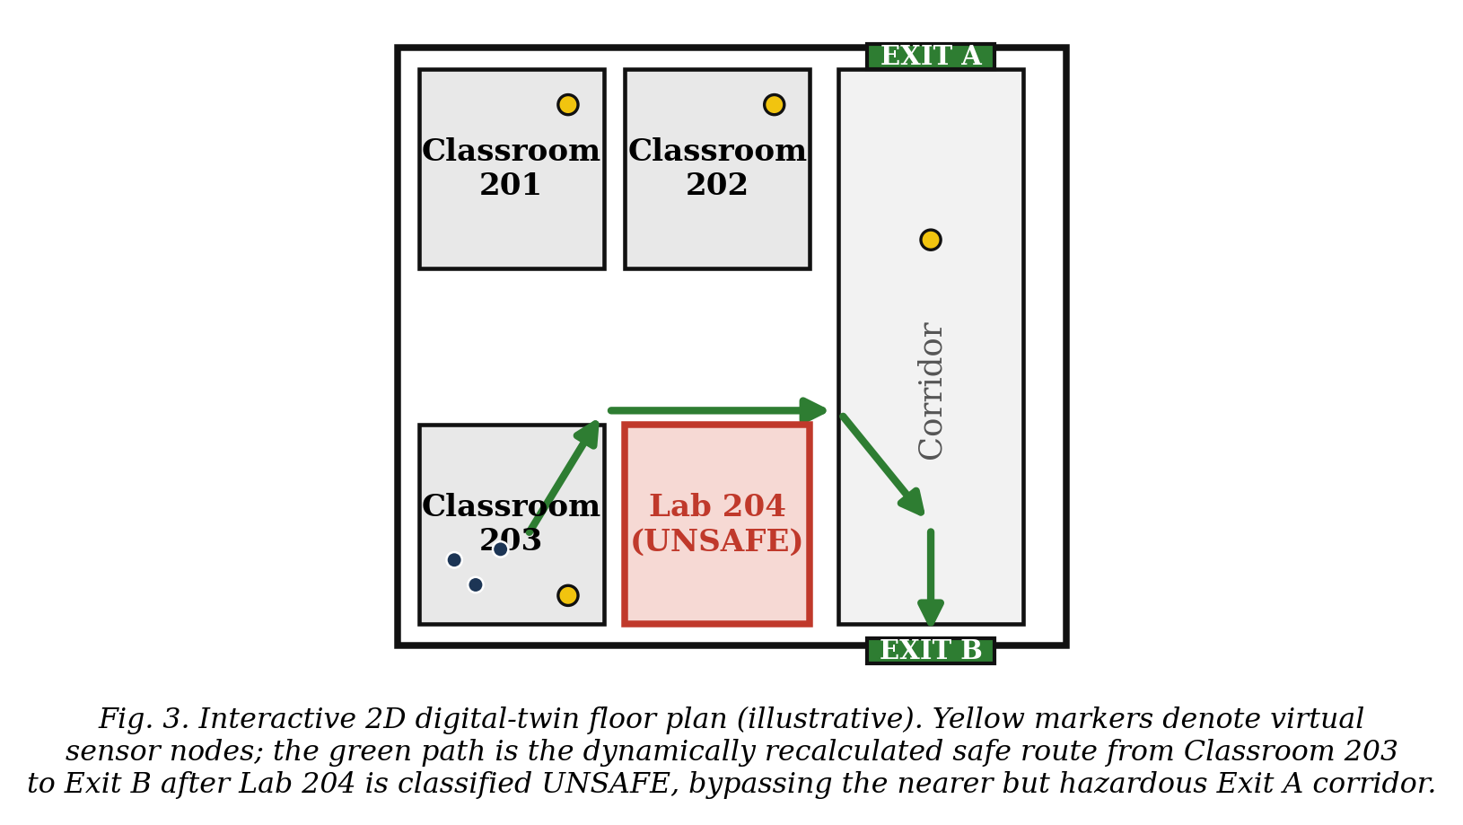
As illustrated in Fig. 3, each room is drawn to approximate scale with its sensor nodes overlaid; occupant agents are rendered as small markers inside rooms and corridors. The dashboard is organised into coordinated panels: the 2D floor plan itself, a live sensor-feed panel showing raw heterogeneous readings as they arrive, a semantic-middleware panel showing proposed field mappings and their confidence scores, and a results panel that fills in as the metrics engine logs data. A single “Start Simulation” control triggers the entire pipeline described in Section VI, so that a non-technical observer — such as an evaluating faculty member — can watch the causal sequence from sensor emission to occupant evacuation without needing to inspect code or logs.
VI. FIRE/EVACUATION SIMULATION WORKFLOW
Fig. 2 summarises the closed-loop workflow executed on every simulation tick. A scenario trigger (either an operator action or a scheduled event) designates a hazard zone and onset time. The synthetic sensor layer then emits heterogeneous BMS/FAS/IoT readings for the affected and surrounding zones. These readings pass through semantic mapping and validation (Sections VII) before updating the Digital Twin state. The hazard engine re-classifies affected rooms and corridors, the routing engine recomputes safe paths over the building graph, and the occupant engine re-directs any agents whose previously assigned path now traverses an unsafe node. The dashboard renders each of these steps as they occur, and the metrics engine appends a timestamped record for every state transition, mapping decision and route recalculation.
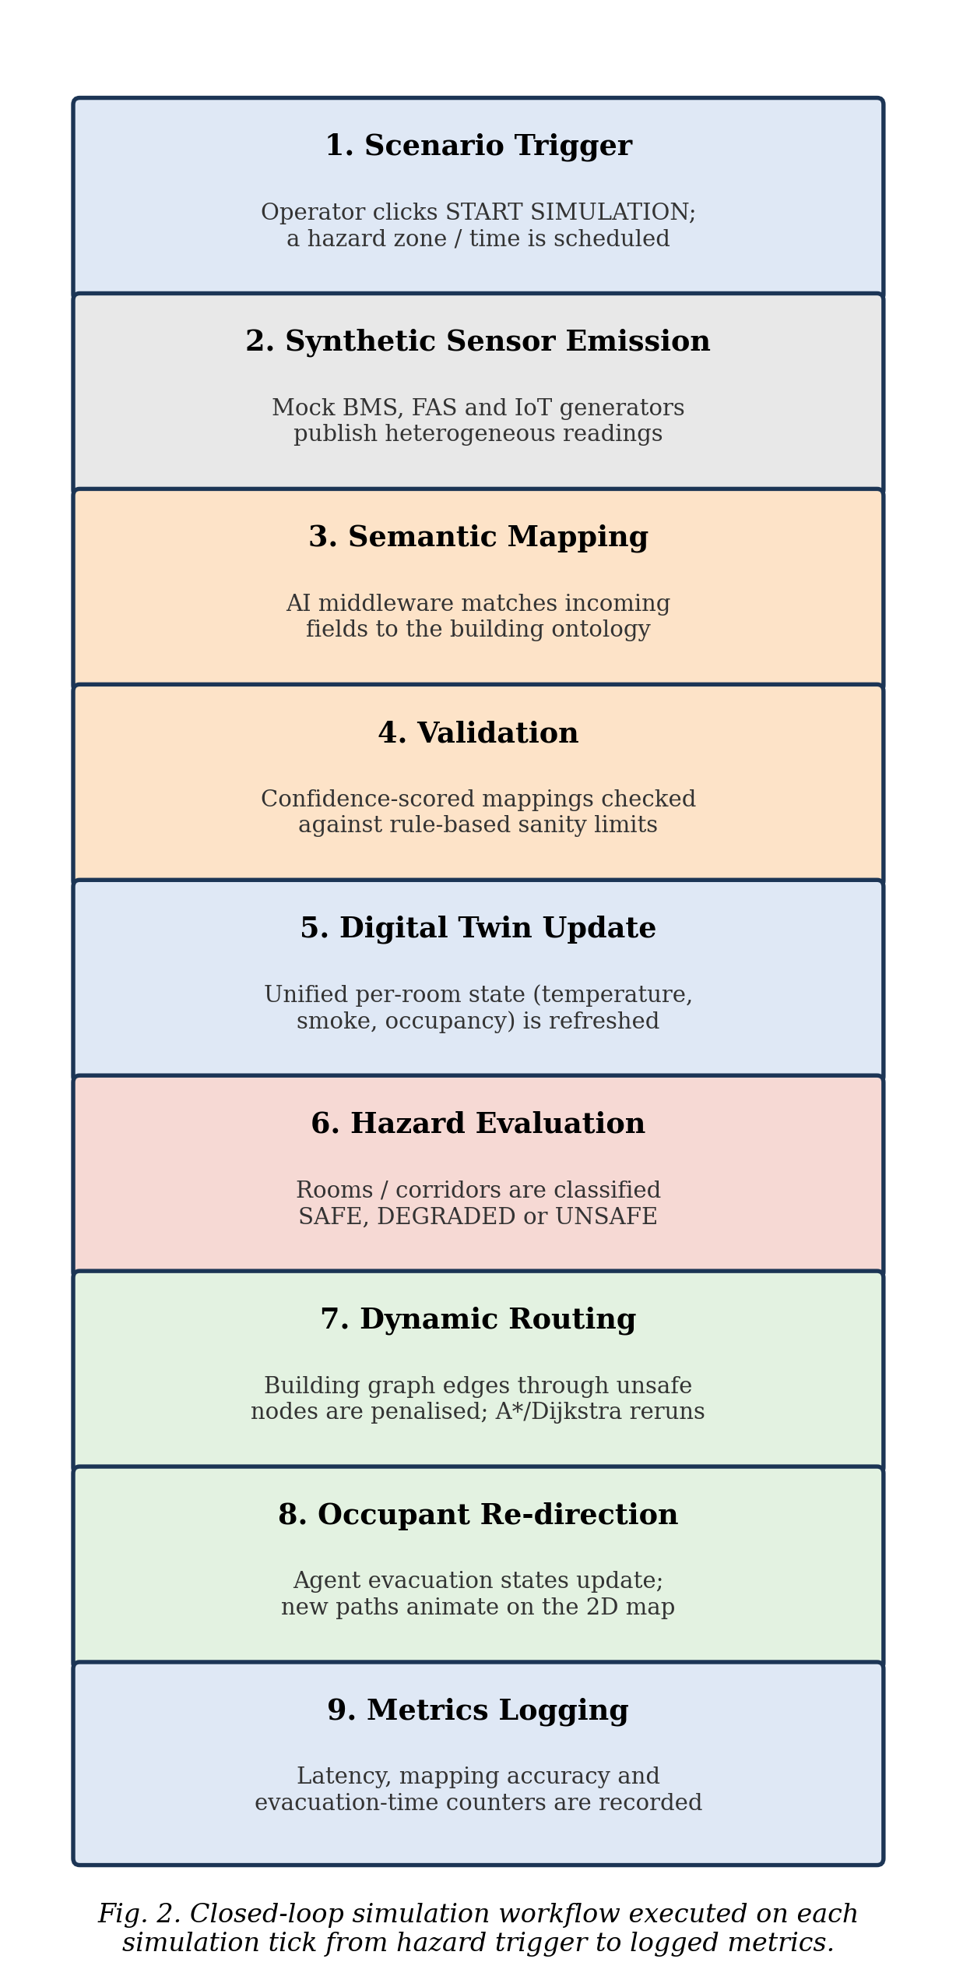
This workflow is deliberately deterministic and reproducible: for a fixed scenario definition and a fixed random seed governing synthetic sensor noise, the sequence of hazard classifications, routing decisions and occupant paths is repeatable, which is a prerequisite for the evaluation protocol in Section X.
VII. AI SEMANTIC MIDDLEWARE METHODOLOGY
The semantic middleware is the component that directly addresses Gap C. Three synthetic source systems are generated, each exposing the same underlying facts (room identity, temperature, smoke concentration, occupancy count) under a deliberately different schema: a BMS-style feed keyed by numeric zone codes and Celsius temperature fields, a FAS-style feed keyed by alarm-panel loop identifiers with a binary smoke/no-smoke flag, and an IoT-style feed publishing JSON payloads over topic names that encode room numbers as free text. This mirrors the schema fragmentation documented across CMMS, CAFM, BMS and FAS platforms in the reviewed literature [1], [2].
For each incoming field, the middleware proposes a mapping onto the common building ontology using a combination of (i) an embedding-based similarity comparison between the source field name/description and the ontology's canonical field names, and (ii) rule-based heuristics for well-known patterns (units, identifier formats). Each proposed mapping carries a confidence score. A validation layer compares this score against a configurable acceptance threshold: mappings above the threshold are applied to the Digital Twin state automatically; mappings below the threshold are queued for manual confirmation rather than silently applied, and are logged as low-confidence events. This mirrors, at the data-integration layer, the same safety-first philosophy that fail-safe signage reversion applies at the actuation layer [10] (see also Section XI).
Two metrics are defined against a ground-truth mapping table prepared for each synthetic source: mapping accuracy, the proportion of fields the middleware maps to the correct ontology field, and entity-matching accuracy, the proportion of readings correctly attributed to the correct physical room or device. Both are reported per source system in Section X, together with the latency between a reading's arrival and its accepted (or queued) mapping.
VIII. OCCUPANT SIMULATION
Occupants are modelled as lightweight agents placed inside rooms according to a configured nominal capacity. Each agent holds a simple state machine — idle, aware, moving, evacuated or blocked — and an assigned path computed by the routing engine over the building graph. When the hazard engine reclassifies a node the agent's current path traverses, the agent's path is recomputed and its state is updated to reflect re-direction; agents whose only remaining paths traverse unsafe nodes are marked blocked, which is itself a metric of interest (Section X). Walking speed is drawn from a bounded random distribution per agent to avoid perfectly synchronised, visually unrealistic movement on the 2D map.
The reviewed behavioural literature documents substantially more complex phenomena than this prototype implements — herd-following under incorrect majority routes, demographic effects such as slower egress for older occupants, and drone-assisted guidance for irrational crowd behaviour [4], [7], [8]. The current occupant model does not reproduce these effects; it is restricted to individually rational agents that always adopt the routing engine's current recommendation. Extending the occupant engine with a herd-behaviour or demographic-risk layer, informed by this literature, is identified as future work in Section XIII rather than claimed as a present capability.
IX. IMPLEMENTATION TECHNOLOGY STACK
Table II lists the technology stack adopted for the prototype implementation. The stack favours widely available, open-source components so that the system can be run and demonstrated on a single laptop without external infrastructure, consistent with the presentation-oriented goal described in Section V.
TABLE II. IMPLEMENTATION TECHNOLOGY STACK BY COMPONENT.
Component | Adopted Technology / Approach
Frontend / 2D visualisation | HTML5 Canvas/SVG-based rendering with a JSON-driven floor-plan data model; coordinated panels for the floor plan, sensor feed, semantic-mapping view and results
Backend / application server | Python with the FastAPI framework; a WebSocket channel pushes simulation-tick updates to the frontend in real time
Digital Twin / building graph | In-memory per-room state manager; NetworkX-based building graph with Dijkstra and A* shortest-path routing
Semantic layer | Embedding-based field-similarity matching plus rule-based heuristics; a lightweight ontology of building/room/sensor/hazard concepts inspired by IFC and RDF/OWL modelling practice [11], [12]
Sensor / scenario simulation | Synthetic BMS, FAS and IoT generators; a configurable fire/hazard scenario engine driving zone-level escalation
Data layer | JSON definitions for building, rooms, sensors and exits, decoupled from the UI; optionally persisted to PostgreSQL for multi-session logging
Metrics engine | Structured logging of mapping accuracy, entity-matching accuracy, latency and evacuation-time counters (Section X)
X. EXPERIMENTAL METHODOLOGY AND EVALUATION METRICS
The evaluation protocol is designed around three synthetic source systems (Section VII), each exposing a distinct field count and naming convention against a prepared ground-truth mapping table, and a small library of fire-scenario definitions (single-zone ignition, corridor-blocking escalation) applied to the college-floor building graph. For each scenario, the system is run twice under identical random seeds: once with dynamic Digital Twin-guided routing enabled, and once with routing frozen to the nearest-exit static baseline, so that the two conditions differ only in the routing strategy.
The following metrics are defined for collection once the implementation described in Sections IV–IX is exercised; consistent with the design-stage nature of this paper, no measured values are reported here, and this omission is stated candidly rather than filled with illustrative numbers:
TABLE III. DEFINED EVALUATION METRICS AND THEIR COMPUTATION.
Metric | Definition
Mapping accuracy | Correctly mapped fields ÷ total fields, per source system
Entity-matching accuracy | Readings correctly attributed to the correct room/device ÷ total readings
Sensor-to-Digital-Twin latency | Time from reading emission to accepted Digital Twin state update
Route recalculation time | Time from a hazard reclassification event to a new safe path being available
Mean / maximum evacuation time | Elapsed simulated time for all / the last occupant to reach an exit, dynamic vs. static baseline
Unsafe-route selections | Count of occupants whose active path traversed a node later reclassified unsafe
This protocol intentionally mirrors the honest-reporting posture of prior work in this research group, which explicitly separated functionally validated behaviour from quantitative metrics not yet instrumentally measured [13]. We adopt the same discipline here: the contribution of this paper is the architecture and the measurement protocol, not fabricated or illustrative performance figures.
XI. FAILURE HANDLING AND SAFETY BOUNDARIES
Because an evacuation-facing system must never fail in a way that is worse than providing no guidance at all, the architecture defines an explicit fail-safe boundary at each layer that can fail independently, following the fail-safe reversion principle documented for dynamic exit-sign systems in the reviewed literature [10]. Table IV summarises the failure conditions considered, their detection mechanism, the system's designed response, and the residual limitation that remains even after the safeguard is applied.
TABLE IV. FAILURE CONDITIONS, DETECTION, DESIGNED RESPONSE AND RESIDUAL LIMITATIONS.
Failure Condition | Detection | Response | Residual Limitation
Low-confidence semantic mapping | Confidence score below acceptance threshold | Mapping queued for manual review; last known-good value retained in Digital Twin state | Stale value may be used until a reviewer confirms or corrects the mapping
Middleware/Digital Twin desynchronisation | Heartbeat timeout between components | Routing engine reverts to the static nearest-exit baseline map | Reversion loses any hazard information gathered after the last synchronised update
Conflicting sensor readings | e.g., FAS reports smoke while BMS reports normal temperature for the same room | Conservative combination rule: any credible hazard indicator marks the room degraded | May increase false-positive hazard classifications, a deliberately accepted trade-off
Routing engine finds no safe path | All paths from a node traverse unsafe nodes | Occupant agent marked blocked and flagged on the dashboard for manual intervention | Prototype does not yet model rescue/shelter-in-place guidance for blocked occupants
A design-level implication of Table IV is that every automated decision the middleware or routing engine makes has a defined, safer fallback rather than an undefined failure mode; this is treated as a non-negotiable design boundary rather than a feature to be added after the core pipeline works.
XII. EXPECTED CONTRIBUTION
This paper's expected contribution, once implemented and evaluated, is: (i) a working demonstration that semantic interoperability across heterogeneous building-system schemas can be treated as a measurable, first-class component of a Digital Twin rather than an assumed precondition, directly addressing Gap C from [1]; (ii) a reusable common ontology and AI-assisted mapping methodology, with defined accuracy metrics, that is independent of any single building or sensor vendor; (iii) an interactive, floor-plan-accurate 2D Digital Twin interface, decoupled from its underlying data model, suitable both as a low-cost research demonstrator and as a teaching artefact; (iv) an explicit failure-handling and fail-safe layer establishing safety-first fallback behaviour at every automated decision point; and (v) a reproducible evaluation protocol that later phases of this project, or other researchers, can use to report comparable, non-fabricated performance figures.
XIII. LIMITATIONS AND FUTURE WORK
This paper describes a design and prototype-methodology stage of work and has corresponding limitations. First, the system as described operates on synthetic sensor data for a single campus floor rather than live hardware; no claim is made about performance against real building IoT deployments until such an integration is built and tested. Second, the occupant model (Section VIII) does not yet reproduce herd behaviour or demographic risk factors documented in the behavioural literature. Third, the architecture reserves, but does not yet implement, an accessibility-aware routing layer addressing Gap E; adding occupant-specific mobility constraints to the routing engine is a natural next phase given the existing graph-based design. Fourth, Gaps A (evacuation-specific PINN surrogates), B (simultaneous multi-hazard validation), D (regulatory equivalence) and F (real-occupant, multi-site validation) identified in [1] are explicitly out of scope for this paper and are left for future phases of this project or for other researchers. Fifth, the evaluation protocol in Section X has been defined but not yet executed; reporting measured results against this protocol is the immediate next step following implementation.
Planned future work therefore includes: replacing synthetic sensor generators with real BMS/FAS/IoT hardware feeds from a pilot floor; extending the occupant engine with demographic and herd-behaviour parameters; adding an accessibility-constrained routing mode; and, once single-hazard performance is characterised, extending the scenario engine to simultaneous, interacting hazards as called for by Gap B.
XIV. CONCLUSION
Building on our own structured survey of Digital Twin technology for emergency evacuation [1], this paper has proposed a layered architecture in which an AI-driven semantic middleware treats interoperability across heterogeneous BMS, FAS and IoT schemas as a measurable, first-class component rather than an assumed precondition. The design pairs this middleware with a graph-based dynamic routing engine, a lightweight occupant simulator, and an interactive, floor-plan-accurate 2D Digital Twin suitable for live demonstration. An explicit failure-handling layer defines safe fallback behaviour at every automated decision point, and a reproducible evaluation protocol — covering mapping accuracy, entity-matching accuracy, latency and evacuation-time comparison — is defined for the implementation phase that follows this paper. Consistent with the honesty this research group has applied to its prior prototype work [13], no field results are claimed here; the contribution of this paper is a defensible, implementable architecture and methodology directly targeting Gap C of the reviewed literature, with a clear, staged path toward the remaining gaps.
REFERENCES
[1] Sandhya N, Adithyan P, Amrutha Varshni G R, and Apoorva Ganga M S, “State-of-the-Art in Digital Twin Technologies for Emergency Evacuation Systems,” Dept. of AIML, Dayananda Sagar Academy of Technology and Management, Bengaluru, India, 2026 (unpublished survey).
[2] “Responsive Architecture in Practice: BIM/DT/AI/IoT for Dynamic Fire Evacuation — A Comparative Case Study Analysis,” MDPI Sustainability, 2026. [Online]. Available: https://www.mdpi.com/2071-1050/18/12/5920
[3] “Integration Readiness and Technology Readiness Assessment of Dynamic Fire-Safety Digital Twin Systems,” arXiv:2503.16850, 2025. [Online]. Available: https://arxiv.org/pdf/2503.16850
[4] “Sustainable Development Through Dynamic Emergency Evacuation Signage: A BIM- and VR-Based Analysis of Passenger Behaviour,” MDPI Sustainability, 2025. [Online]. Available: https://www.mdpi.com/2071-1050/17/6/2626
[5] “Assessment of Visual Effectiveness of Metro Evacuation Signage in Fire and Flood Scenarios: A VR-Based Eye-Movement Experiment,” MDPI Buildings, 2025. [Online]. Available: https://www.mdpi.com/2075-5309/15/20/3771
[6] “A Dynamic Digital Twin System with Robotic Vision for Emergency Management,” MDPI Electronics, 2026. [Online]. Available: https://www.mdpi.com/2079-9292/15/3/573
[7] “Generative AI-Powered Digital Twins for Crowd Management in Large-Scale Events,” MDPI Applied Sciences, 2026. [Online]. Available: https://www.mdpi.com/2076-3417/16/16/8092
[8] “Digital twin simulations of theory-driven crisis messaging during hurricane evacuations in synthetic populations: a Miami-Dade County case study,” Frontiers in Artificial Intelligence, 2026. [Online]. Available: https://www.frontiersin.org/journals/artificial-intelligence/articles/10.3389/frai.2026.1715883/full
[9] “Assistive Mobile Application for Fire Emergency Evacuation of Visually Impaired People,” MDPI Sensors, 2026. [Online]. Available: https://www.mdpi.com/1424-8220/26/5/1572
[10] “Safe Evacuation Framework with Intelligent Dynamic Exit Sign System and Demonstration in Tunnel Fire,” Journal of Safety Science and Resilience, 2025. [Online]. Available: https://www.researchgate.net/publication/387947810
[11] buildingSMART International, “Industry Foundation Classes (IFC) Specification.” [Online]. Available: https://technical.buildingsmart.org/standards/ifc/
[12] W3C, “SPARQL 1.1 Query Language,” W3C Recommendation, 2013. [Online]. Available: https://www.w3.org/TR/sparql11-query/
[13] Sandhya N, Krisha P T, Siri A Shetty, and Vidyashree G, “Design and Implementation of an ESP32-Based Wearable Personal Safety Badge with GPS Tracking and Dual GSM–LoRa Emergency Communication,” Dept. of AIML, Dayananda Sagar Academy of Technology and Management, Bengaluru, India, 2026 (unpublished).
[14] E. W. Dijkstra, “A note on two problems in connexion with graphs,” Numerische Mathematik, vol. 1, pp. 269–271, 1959.
[15] P. E. Hart, N. J. Nilsson, and B. Raphael, “A formal basis for the heuristic determination of minimum cost paths,” IEEE Trans. Syst. Sci. Cybern., vol. 4, no. 2, pp. 100–107, 1968.

