# Route Demo for Hybrid Multi-Component Audio

## Usage:

### After a System Restart:

1. Ensure that system is connected to a wired LAN (internet connectivity not required).
2. Open the Chrome browser, both sender and receiver UI tabs will open.
3. Note in the Sender UI page: the IP address of the interface.
4. Click the gear icon in the upper-right corner of the receiver UI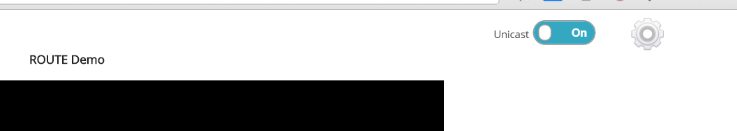
5. Check that the IP address matches the IP address in the sender interface. If it is different, input the correct value and click “Set”.
6. Also click the “Initial Configuration” button.
7. Click the Browser back button to go back to the main receiver UI page.

### Running the Demo:

On the Sender interface:

* Select the desired Ad-insertion time.
* Turn the service slider to “on”.

On the receiver demo page, turning the Unicast slider to “on” position enables the playback of multi-component audio, as shown in figure below.

Note: if the slider position is changed during playback, automatic retune will happen, this is by design.



In the player controls, there is a gear icon, selecting it will show the available audio options as shown in figure below. By default, using broadcast only (Unicast disabled), both channels will show a single audio track (English). When the Unicast slider is turned to “on”, a second Italian audio track will appear in options for Tears of Steel (Channel 1). Selecting it will change the audio language. The default audio language selected after a tune-in is English.

