**Case study: Thinking-tester**

**Recorded and replayed:**

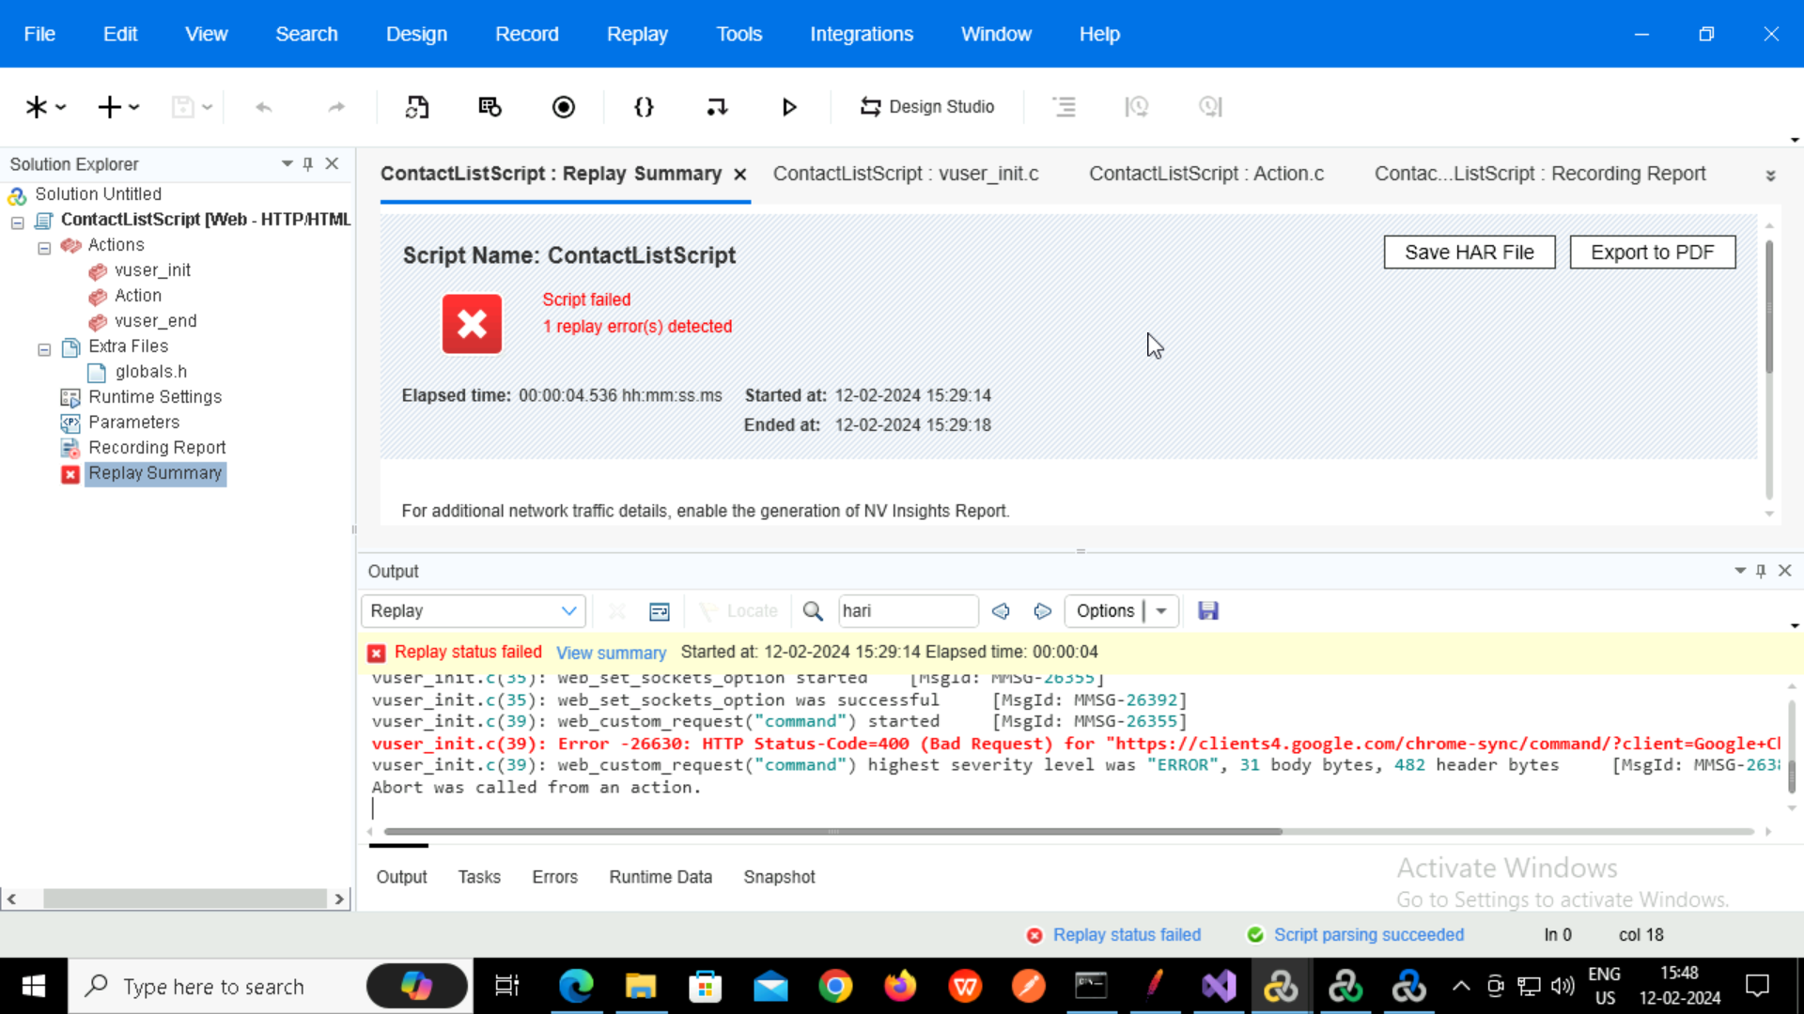

**Parameterisation**

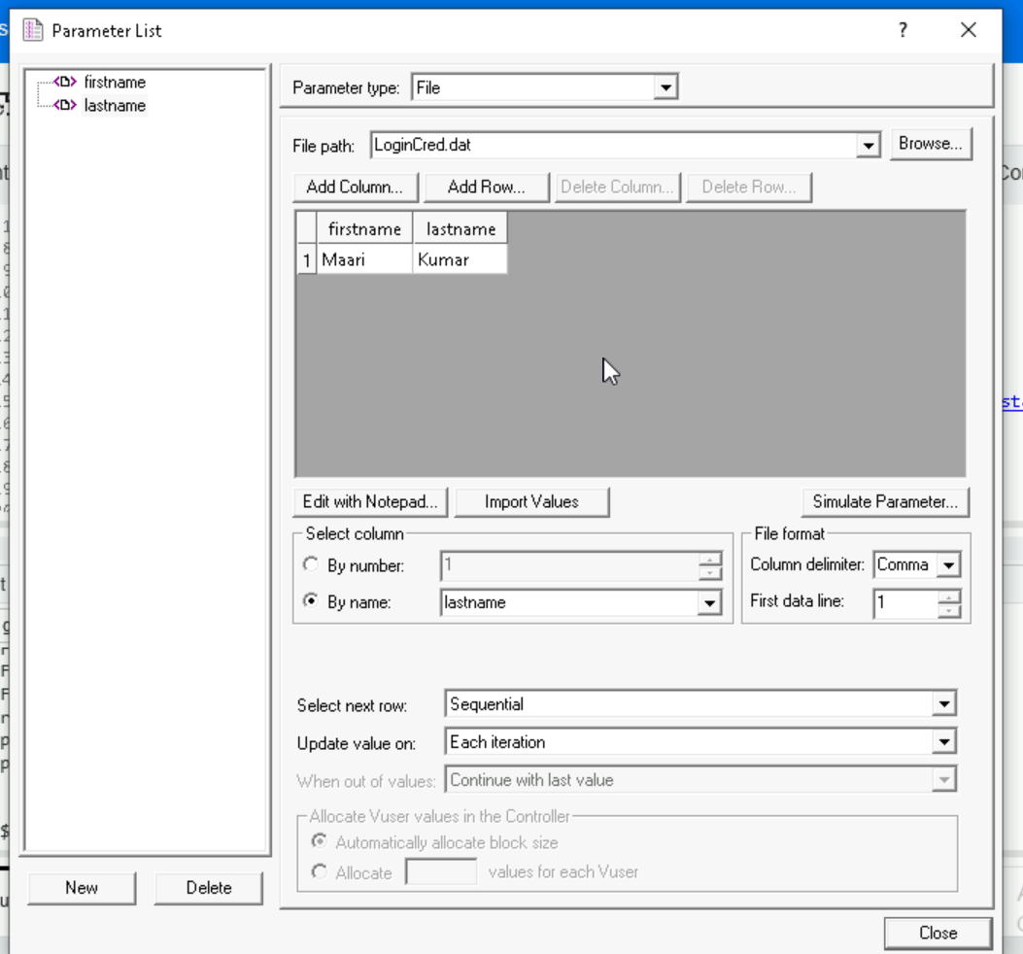

**Graphs in controller**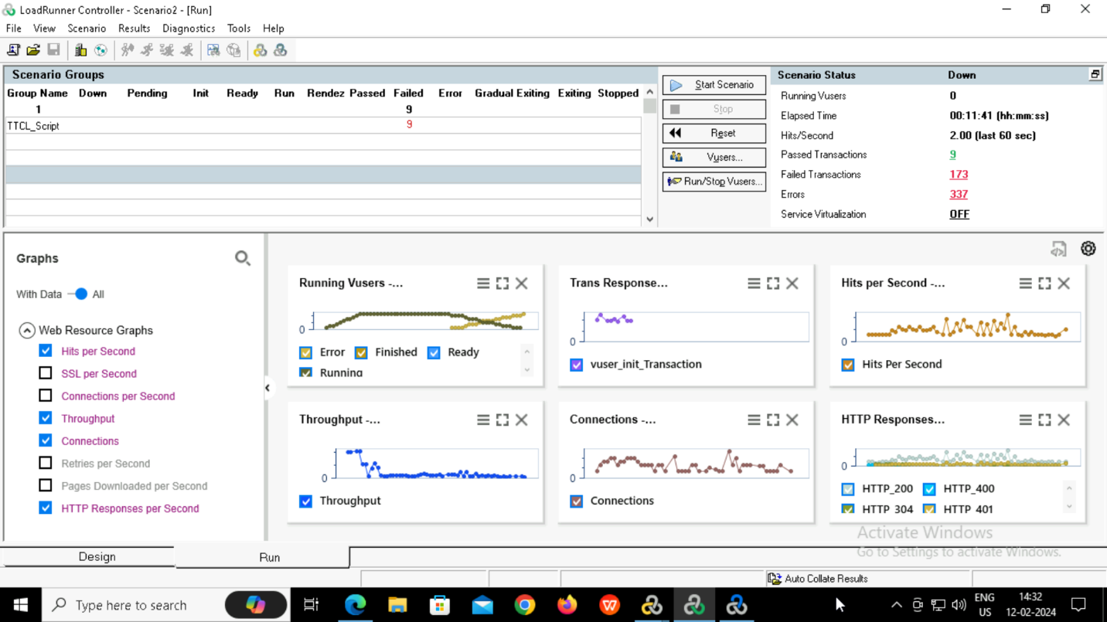

**Graphs in Analysis**