UrbanRoof AI
Detailed Diagnostic Report
Generated using Artificial Intelligence
Inspection + Thermal Report Analysis

1. Executive Summary
The inspection revealed high severity issues with dampness, efflorescence, and spalling of paint at various locations, including the hall, bedrooms, and bathrooms. Water ingress or condensation is the root cause of these issues. Additionally, there are minor issues with gaps in tile joints and cracks on external walls. It is recommended to investigate and rectify the water ingress or condensation issues, re-paint affected areas, and re-tile areas with gaps in tile joints. Furthermore, cracks on external walls require investigation and repair.

Overall Condition : The property has several structural and water ingress issues that require immediate attention.

Priority Actions
- Investigate and rectify water ingress or condensation issues
- Re-paint affected areas
- Re-tile areas with gaps in tile joints
- Investigate and repair cracks on external walls

2. Property Issue Summary

Issue Distribution
Issue | Occurrences
IMAGE 10: GAPS BETWEEN TILE JOINTS OF BALCONY | 1
IMAGE 10: GAPS BETWEEN TILE JOINTS OF BALCONY ...................................................... 35 | 1
IMAGE 11: CRACKS ON EXTERNAL WALL OF MASTERBEROOM | 1
IMAGE 11: CRACKS ON EXTERNAL WALL OF MASTERBEROOM ........................................... 35 | 1
IMAGE 12: HOLLOWNESS AND VEGETATION GROWTH OBSERVED ON TERRACE SURFACE, GAPS OBSERVED BETWEEN TILE JOINTS OF BATHROOM IN MASTERBEDROOM-2 | 1
IMAGE 12: HOLLOWNESS AND VEGETATION GROWTH OBSERVED ON TERRACE SURFACE, GAPS OBSERVED BETWEEN TILE JOINTS OF BATHROOM IN MASTERBEDROOM-2 36 | 1
IMAGE 1: DAMPNESS, EFFLORESCENCE & SPALLING OF PAINT AT THE CEILING OF HALL (GROUND FLOOR) | 1
IMAGE 1: DAMPNESS, EFFLORESCENCE & SPALLING OF PAINT AT THE CEILING OF HALL (GROUND FLOOR) ................................................................................................................ 27 | 1
IMAGE 2: DAMPNESS AT THE SKIRTING LEVEL & WALL CORNER OF BEDROOM (GROUND FLOOR). | 1
IMAGE 2: DAMPNESS AT THE SKIRTING LEVEL & WALL CORNER OF BEDROOM (GROUND FLOOR). 28 | 1
IMAGE 3: MILD SEEPAGE AT THE SKIRTING LEVEL OF COMMON BATHROOM PASSAGE AREA (GROUND FLOOR) | 1
IMAGE 3: MILD SEEPAGE AT THE SKIRTING LEVEL OF COMMON BATHROOM PASSAGE AREA (GROUND FLOOR) ....................................................................................................... 29 | 1
IMAGE 4: DAMPNESS & PAINT SPALLING AT SKIRTING LEVEL & AREA NEAR THE WINDOW IN MASTER BEDROOM (1 ST FLOOR). | 1
IMAGE 4: DAMPNESS & PAINT SPALLING AT SKIRTING LEVEL & AREA NEAR THE WINDOW IN MASTER BEDROOM (1 ST FLOOR)....................................................................... 30 | 1
IMAGE 5: DAMPNESS & PAINT SPALLING AT SKIRTING LEVEL & AREA NEAR WINDOW IN MASTER BEDROOM (1 ST FLOOR). | 1
IMAGE 5: DAMPNESS & PAINT SPALLING AT SKIRTING LEVEL & AREA NEAR WINDOW IN MASTER BEDROOM (1 ST FLOOR). .......................................................................................... 31 | 1
IMAGE 6: DAMPNESS & PAINT SPALLING AT SKIRTING LEVEL & CEILING IN MAS TER B EDROOM – 2 (1 ST FLOOR) | 1
IMAGE 6: DAMPNESS & PAINT SPALLING AT SKIRTING LEVEL & CEILING IN MAS TER B EDROOM – 2 (1 ST FLOOR) ..................................................................................................... 32 | 1
IMAGE 7: GAPS IN TILE JOINTS OF MASTER BEDROOM BATHROOM (1 ST FLOOR) | 1
IMAGE 7: GAPS IN TILE JOINTS OF MASTER BEDROOM BATHROOM (1 ST FLOOR) ............ 33 | 1
IMAGE 8: CRACKS ON EXTERNAL WALL ........................................................................... 34 | 1
IMAGE 8: CRACKS ON EXTERNAL WALL Source: Urbanroof Pvt. Ltd. | 1
IMAGE 9: GAPS BETWEEN TILE JOINTS OF COMMON BATHROOM | 1
IMAGE 9: GAPS BETWEEN TILE JOINTS OF COMMON BATHROOM .................................... 34 | 1
Images | 1

Severity Distribution
Severity | Count
Critical | 0
High | 13
Medium | 0
Low | 0
Unknown | 6

3. Area-wise Observations

CEILING (HALL)

Observation 1
Issue | IMAGE 1: DAMPNESS, EFFLORESCENCE & SPALLING OF PAINT AT THE CEILING OF HALL (GROUND FLOOR)
Description | IMAGE 1: DAMPNESS, EFFLORESCENCE & SPALLING OF PAINT AT THE CEILING OF HALL (GROUND FLOOR)
Severity | Medium
Root Cause | Water ingress or condensation issue
Recommendation | Investigate and repair the water ingress or condensation issue, and apply a suitable waterproofing coating to the ceiling
Similarity Score | Not Matched
Matched Observation | Not Available
Evidence | IMAGE 1: DAMPNESS, EFFLORESCENCE & SPALLING OF PAINT AT THE CEILING OF HALL (GROUND FLOOR)

Inspection Image
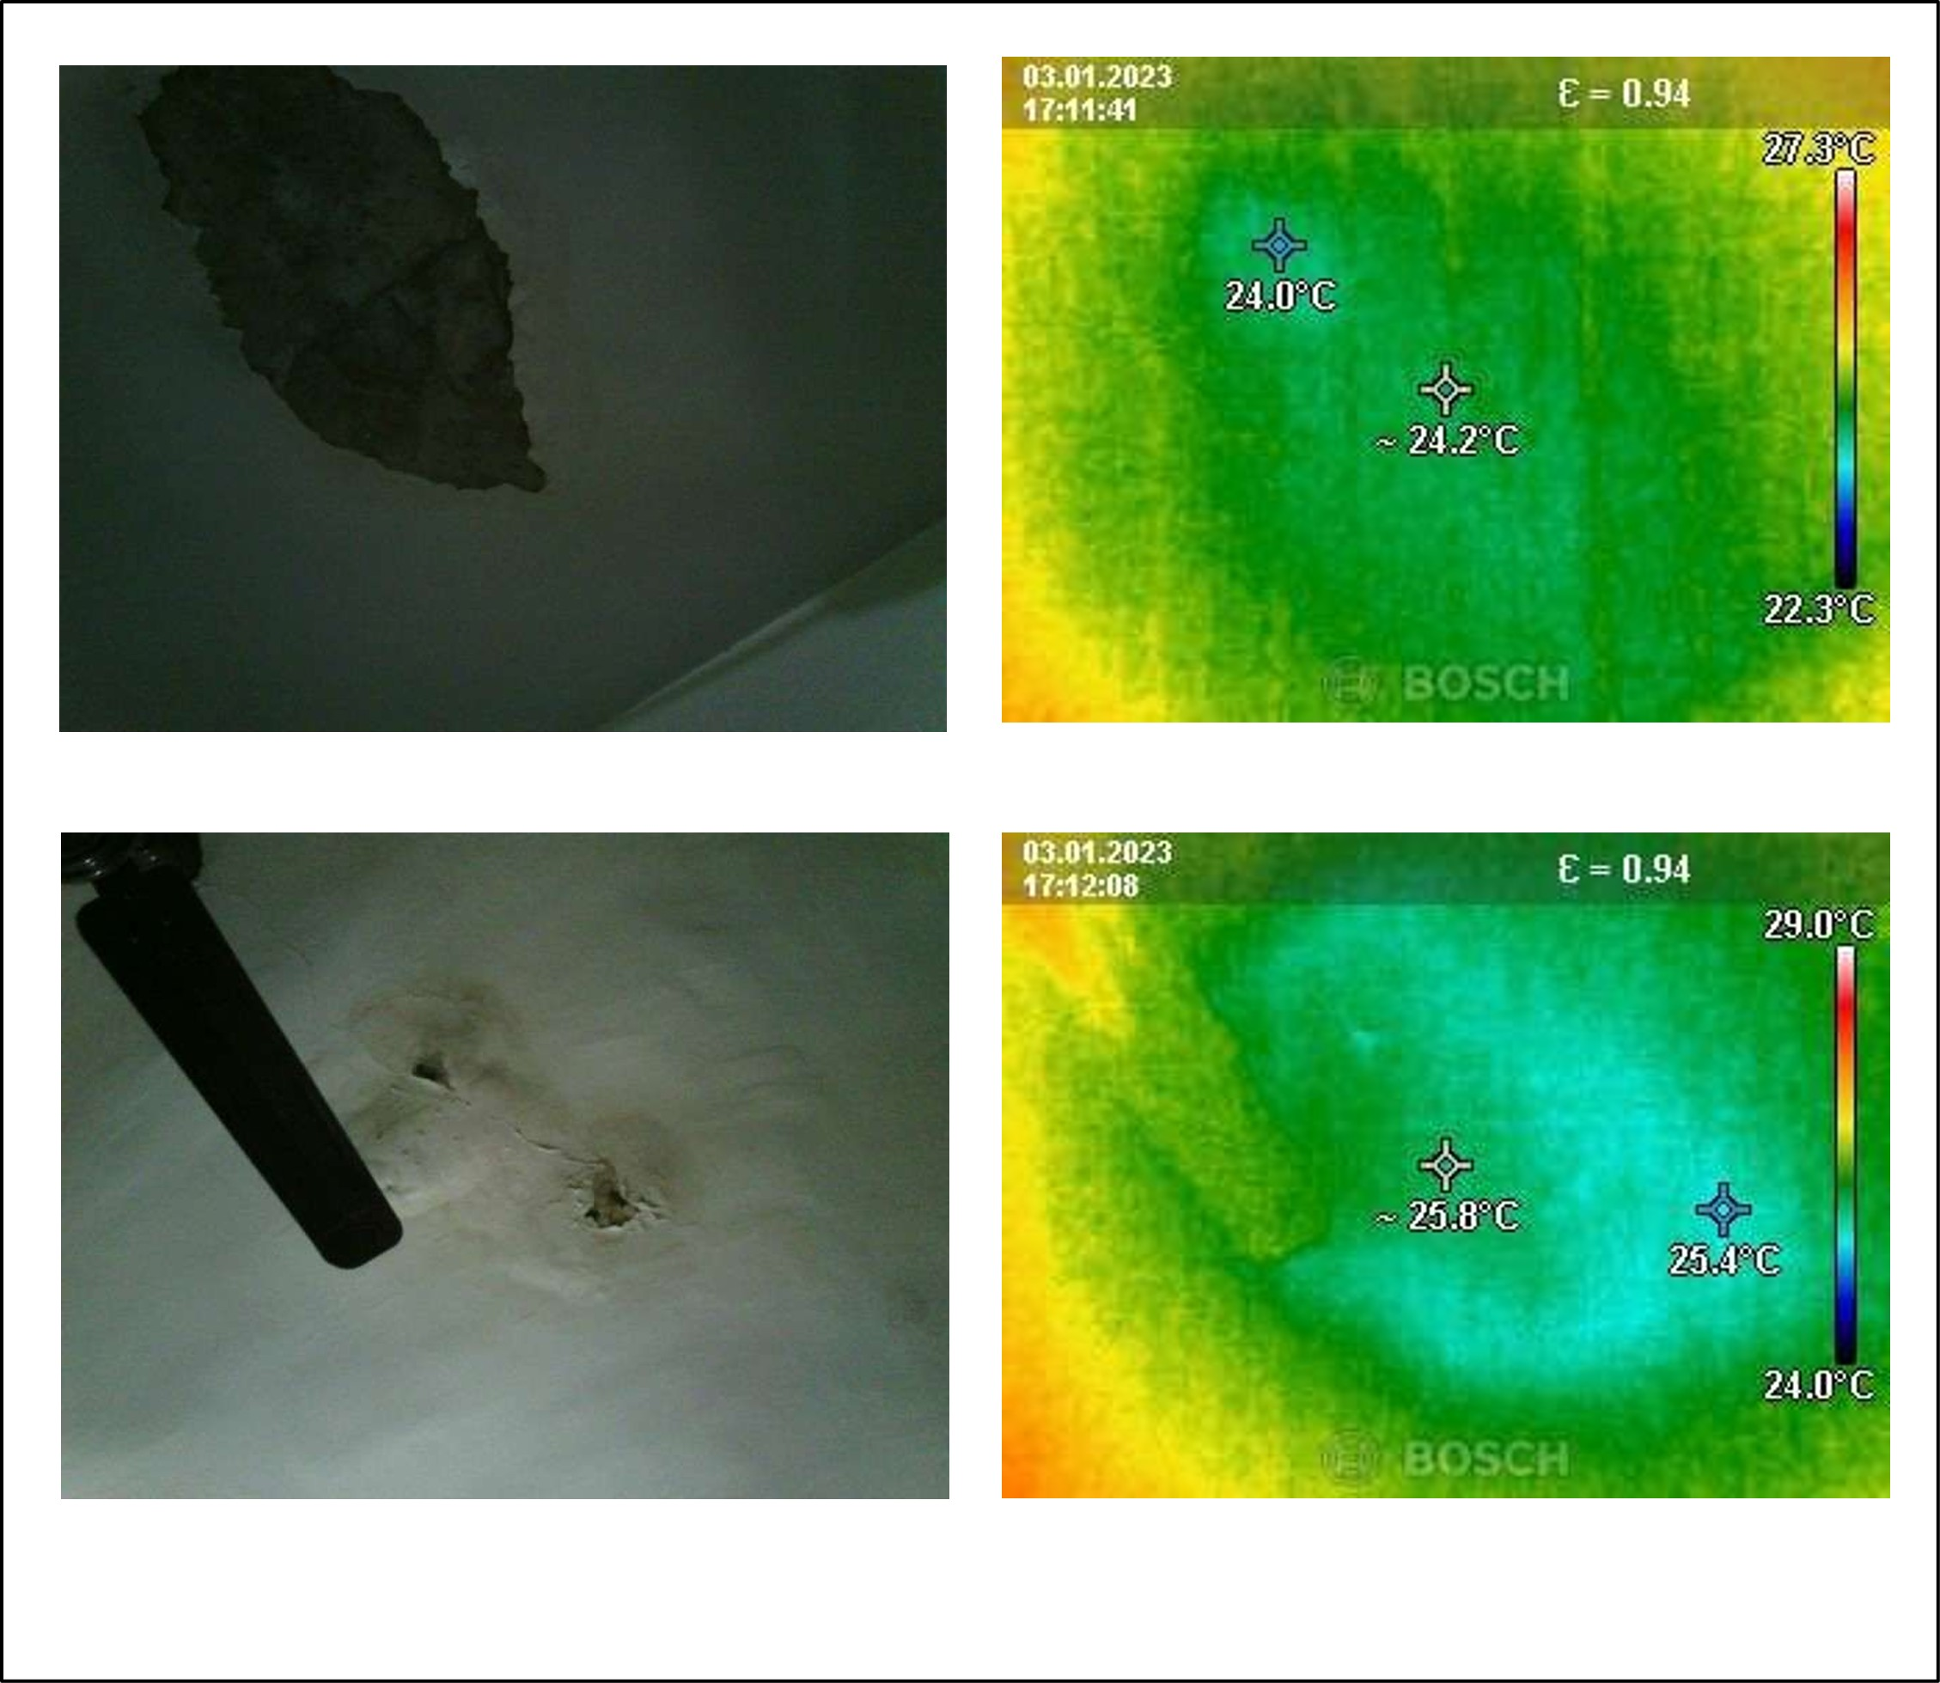

COMMON BATHROOM

Observation 1
Issue | IMAGE 9: GAPS BETWEEN TILE JOINTS OF COMMON BATHROOM
Description | IMAGE 9: GAPS BETWEEN TILE JOINTS OF COMMON BATHROOM
Severity | Low
Root Cause | Not Available
Recommendation | Not Available
Similarity Score | Not Matched
Matched Observation | Not Available
Evidence | IMAGE 9: GAPS BETWEEN TILE JOINTS OF COMMON BATHROOM

Inspection Image
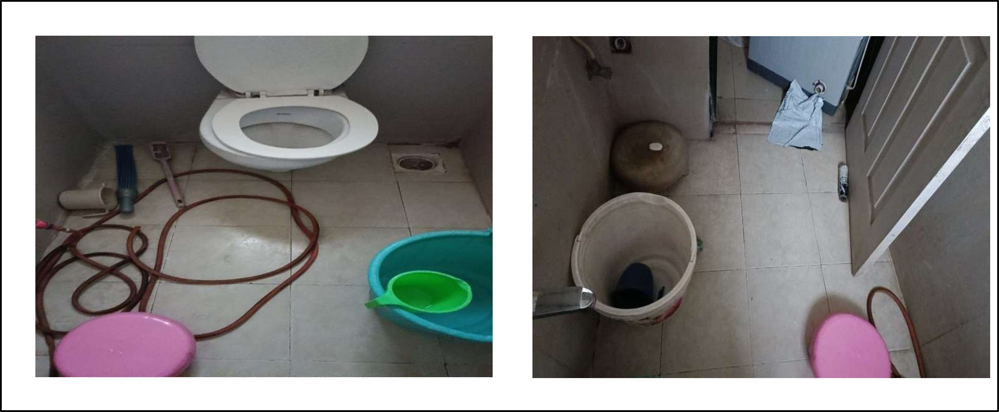

EXTERNAL WALL

Observation 1
Issue | IMAGE 8: CRACKS ON EXTERNAL WALL Source: Urbanroof Pvt. Ltd.
Description | IMAGE 8: CRACKS ON EXTERNAL WALL Source: Urbanroof Pvt. Ltd.
Severity | High
Root Cause | Not Available
Recommendation | Not Available
Similarity Score | Not Matched
Matched Observation | Not Available
Evidence | IMAGE 8: CRACKS ON EXTERNAL WALL Source: Urbanroof Pvt. Ltd.

Inspection Image
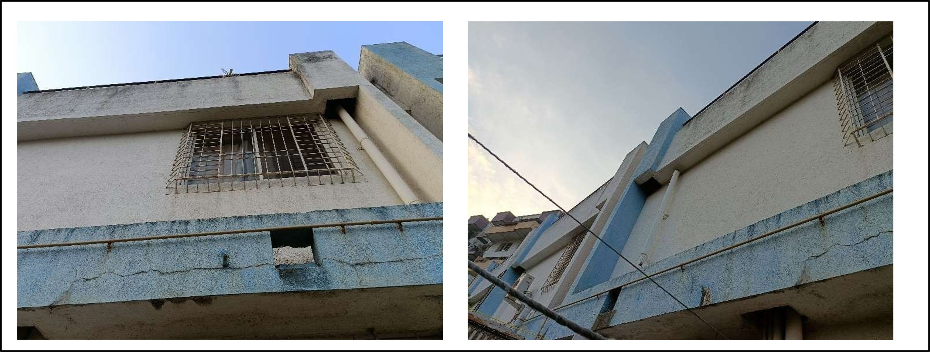

Observation 2
Issue | IMAGE 11: CRACKS ON EXTERNAL WALL OF MASTERBEROOM
Description | IMAGE 11: CRACKS ON EXTERNAL WALL OF MASTERBEROOM
Severity | High
Root Cause | Not Available
Recommendation | Not Available
Similarity Score | Not Matched
Matched Observation | Not Available
Evidence | IMAGE 11: CRACKS ON EXTERNAL WALL OF MASTERBEROOM

Inspection Image
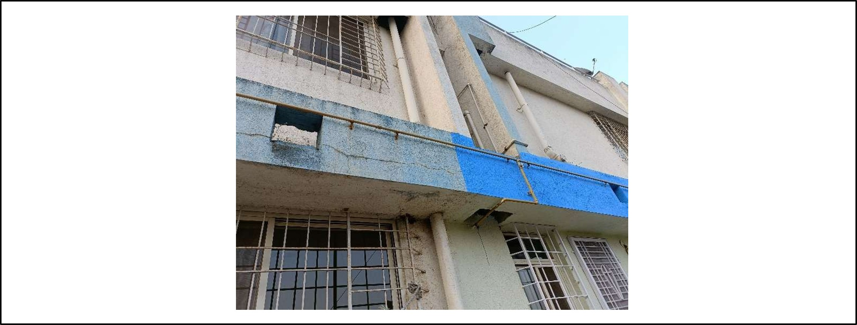

General

Observation 1
Issue | Images
Description | Images
Severity | Low
Root Cause | Not Available
Recommendation | Not Available
Similarity Score | Not Matched
Matched Observation | Not Available
Evidence | Images

Inspection Image
Image Not Available

Observation 2
Issue | IMAGE 1: DAMPNESS, EFFLORESCENCE & SPALLING OF PAINT AT THE CEILING OF HALL (GROUND FLOOR) ................................................................................................................ 27
Description | IMAGE 1: DAMPNESS, EFFLORESCENCE & SPALLING OF PAINT AT THE CEILING OF HALL (GROUND FLOOR) ................................................................................................................ 27
Severity | Medium
Root Cause | Water ingress or condensation issue
Recommendation | Investigate and rectify the water ingress or condensation issue, and re-paint the ceiling with a water-resistant paint
Similarity Score | Not Matched
Matched Observation | Not Available
Evidence | IMAGE 1: DAMPNESS, EFFLORESCENCE & SPALLING OF PAINT AT THE CEILING OF HALL (GROUND FLOOR) ................................................................................................................ 27

Inspection Image


Observation 3
Issue | IMAGE 2: DAMPNESS AT THE SKIRTING LEVEL & WALL CORNER OF BEDROOM (GROUND FLOOR). 28
Description | IMAGE 2: DAMPNESS AT THE SKIRTING LEVEL & WALL CORNER OF BEDROOM (GROUND FLOOR). 28
Severity | Medium
Root Cause | Water ingress or condensation issue
Recommendation | Investigate and rectify the source of dampness, consider applying a waterproofing treatment to the affected area
Similarity Score | Not Matched
Matched Observation | Not Available
Evidence | IMAGE 2: DAMPNESS AT THE SKIRTING LEVEL & WALL CORNER OF BEDROOM (GROUND FLOOR). 28

Inspection Image
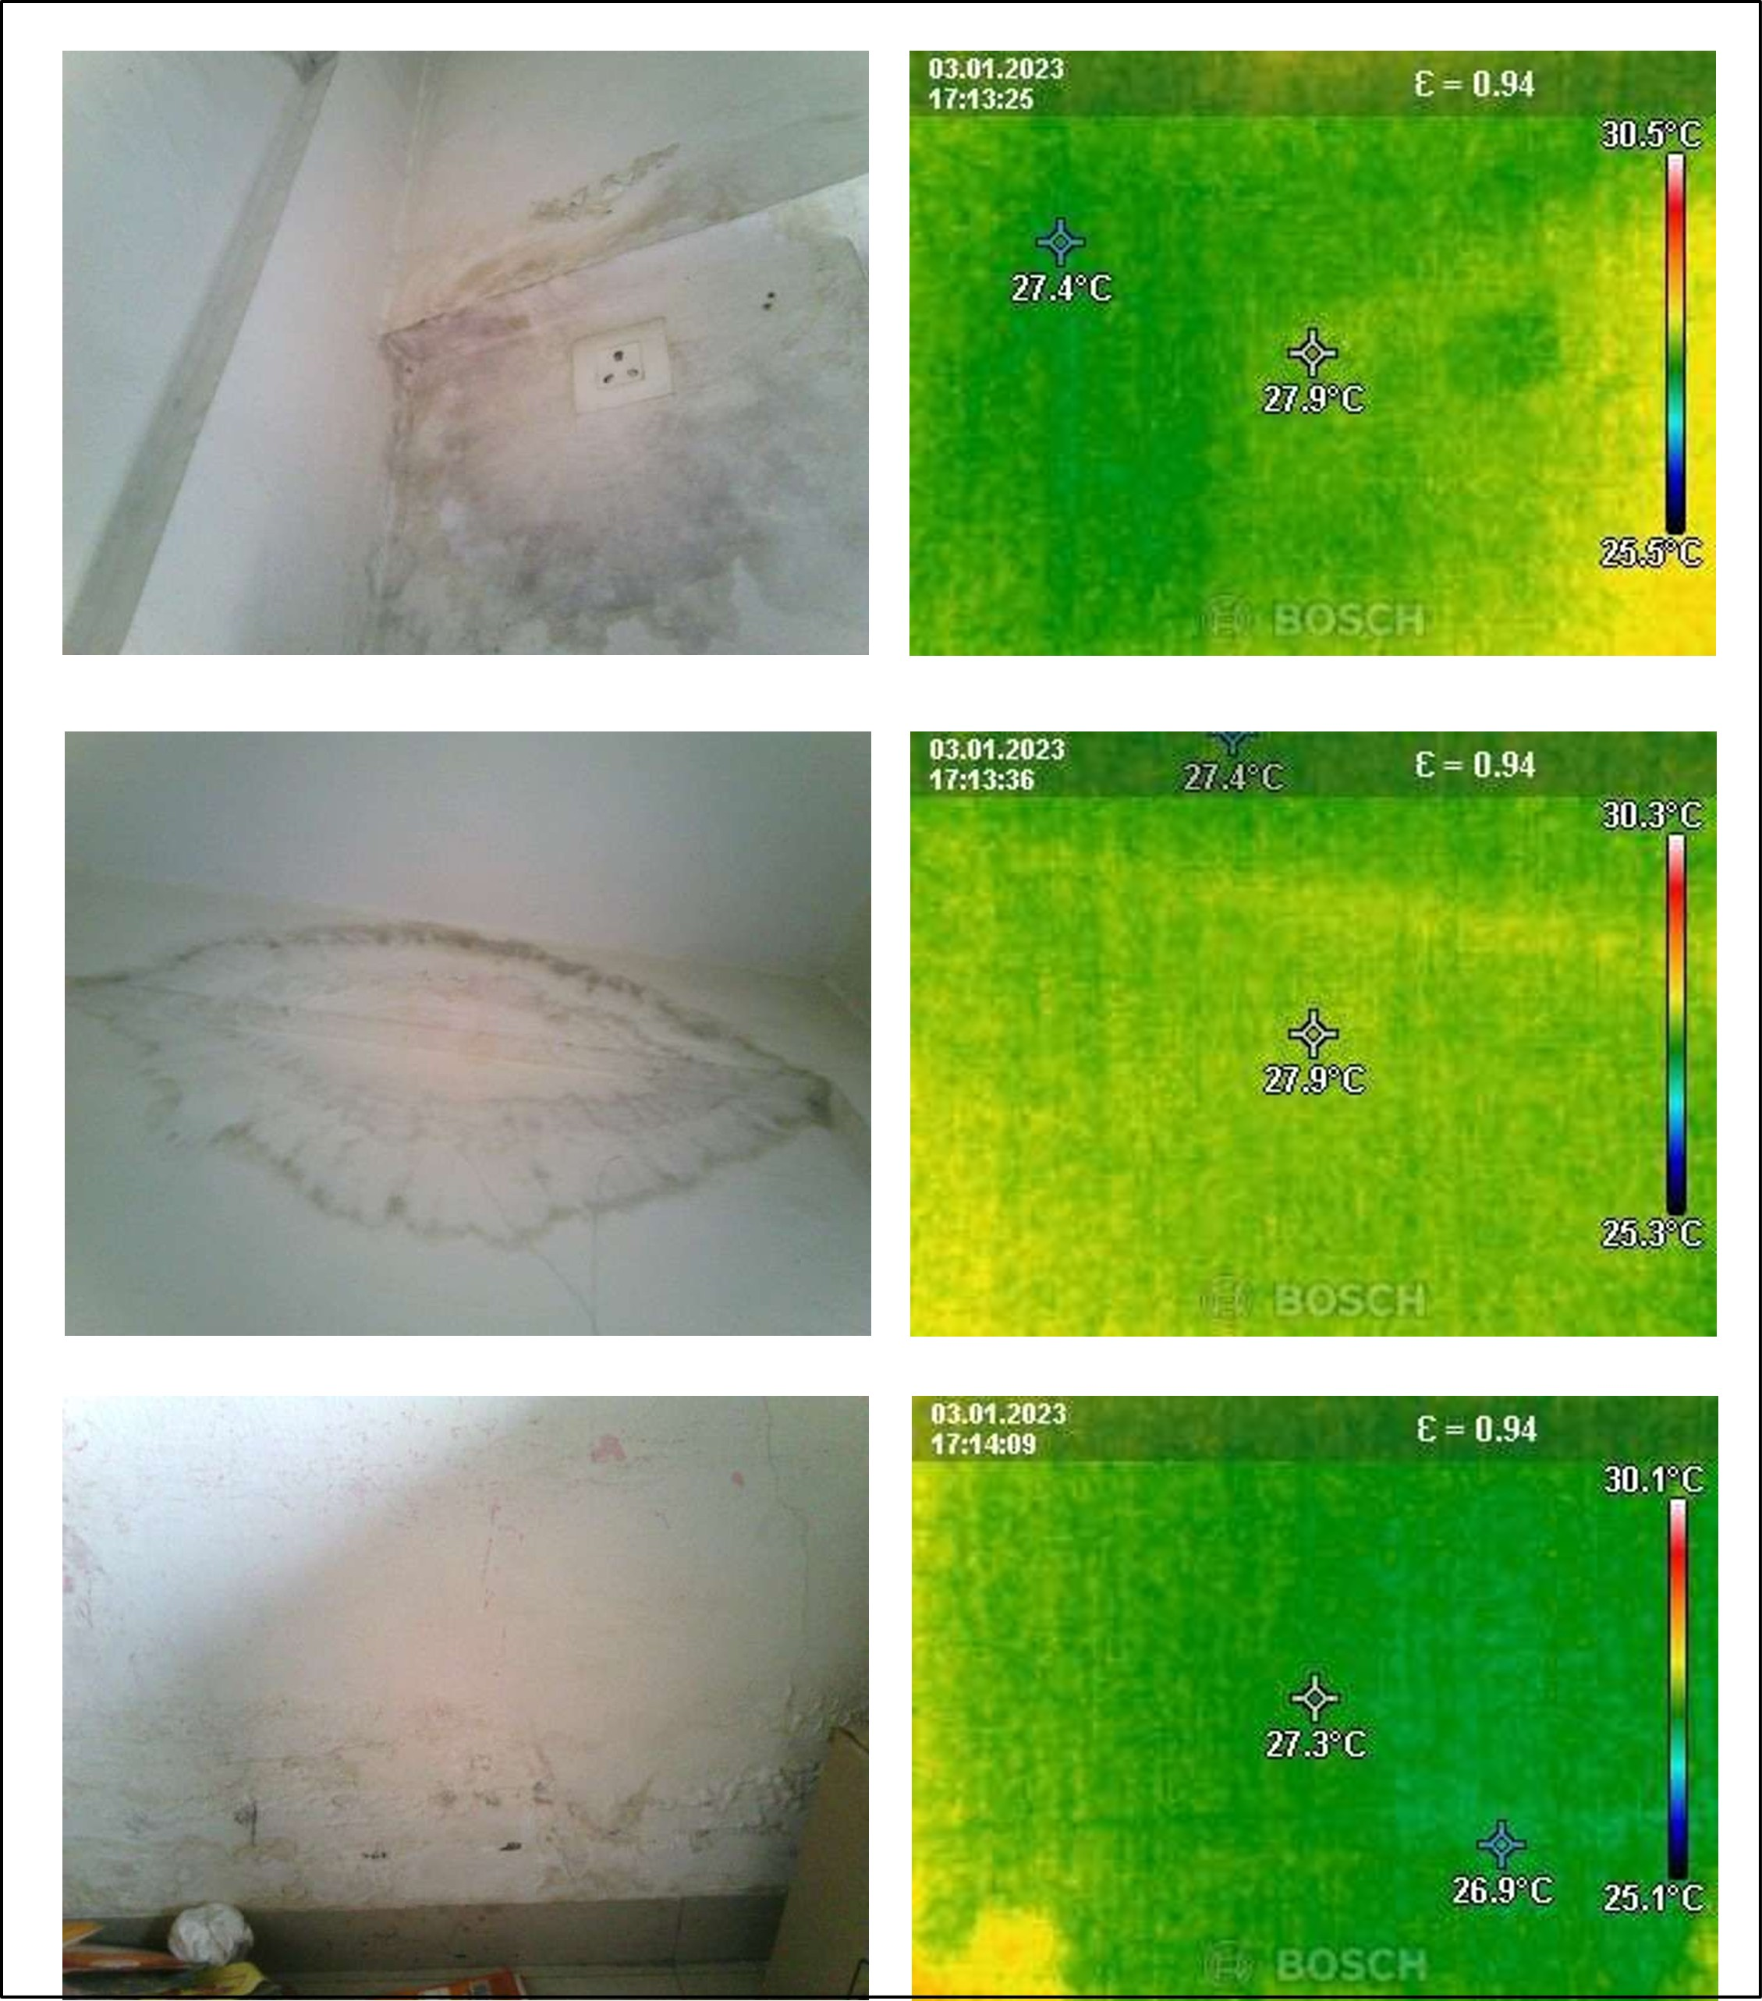

Observation 4
Issue | IMAGE 3: MILD SEEPAGE AT THE SKIRTING LEVEL OF COMMON BATHROOM PASSAGE AREA (GROUND FLOOR) ....................................................................................................... 29
Description | IMAGE 3: MILD SEEPAGE AT THE SKIRTING LEVEL OF COMMON BATHROOM PASSAGE AREA (GROUND FLOOR) ....................................................................................................... 29
Severity | High
Root Cause | Water ingress through the skirting level
Recommendation | Investigate and rectify the water ingress issue
Similarity Score | Not Matched
Matched Observation | Not Available
Evidence | IMAGE 3: MILD SEEPAGE AT THE SKIRTING LEVEL OF COMMON BATHROOM PASSAGE AREA (GROUND FLOOR) ....................................................................................................... 29

Inspection Image
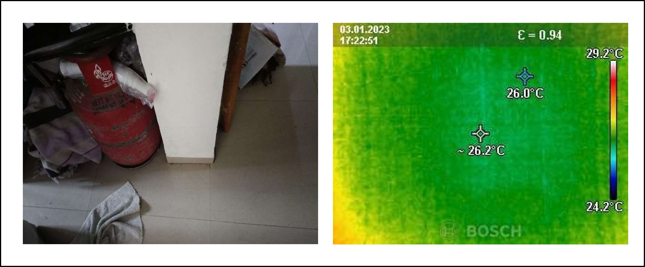

Observation 5
Issue | IMAGE 4: DAMPNESS & PAINT SPALLING AT SKIRTING LEVEL & AREA NEAR THE WINDOW IN MASTER BEDROOM (1 ST FLOOR)....................................................................... 30
Description | IMAGE 4: DAMPNESS & PAINT SPALLING AT SKIRTING LEVEL & AREA NEAR THE WINDOW IN MASTER BEDROOM (1 ST FLOOR)....................................................................... 30
Severity | Medium
Root Cause | Water ingress or condensation issue
Recommendation | Investigate and repair the source of dampness and repaint the affected area
Similarity Score | Not Matched
Matched Observation | Not Available
Evidence | IMAGE 4: DAMPNESS & PAINT SPALLING AT SKIRTING LEVEL & AREA NEAR THE WINDOW IN MASTER BEDROOM (1 ST FLOOR)....................................................................... 30

Inspection Image
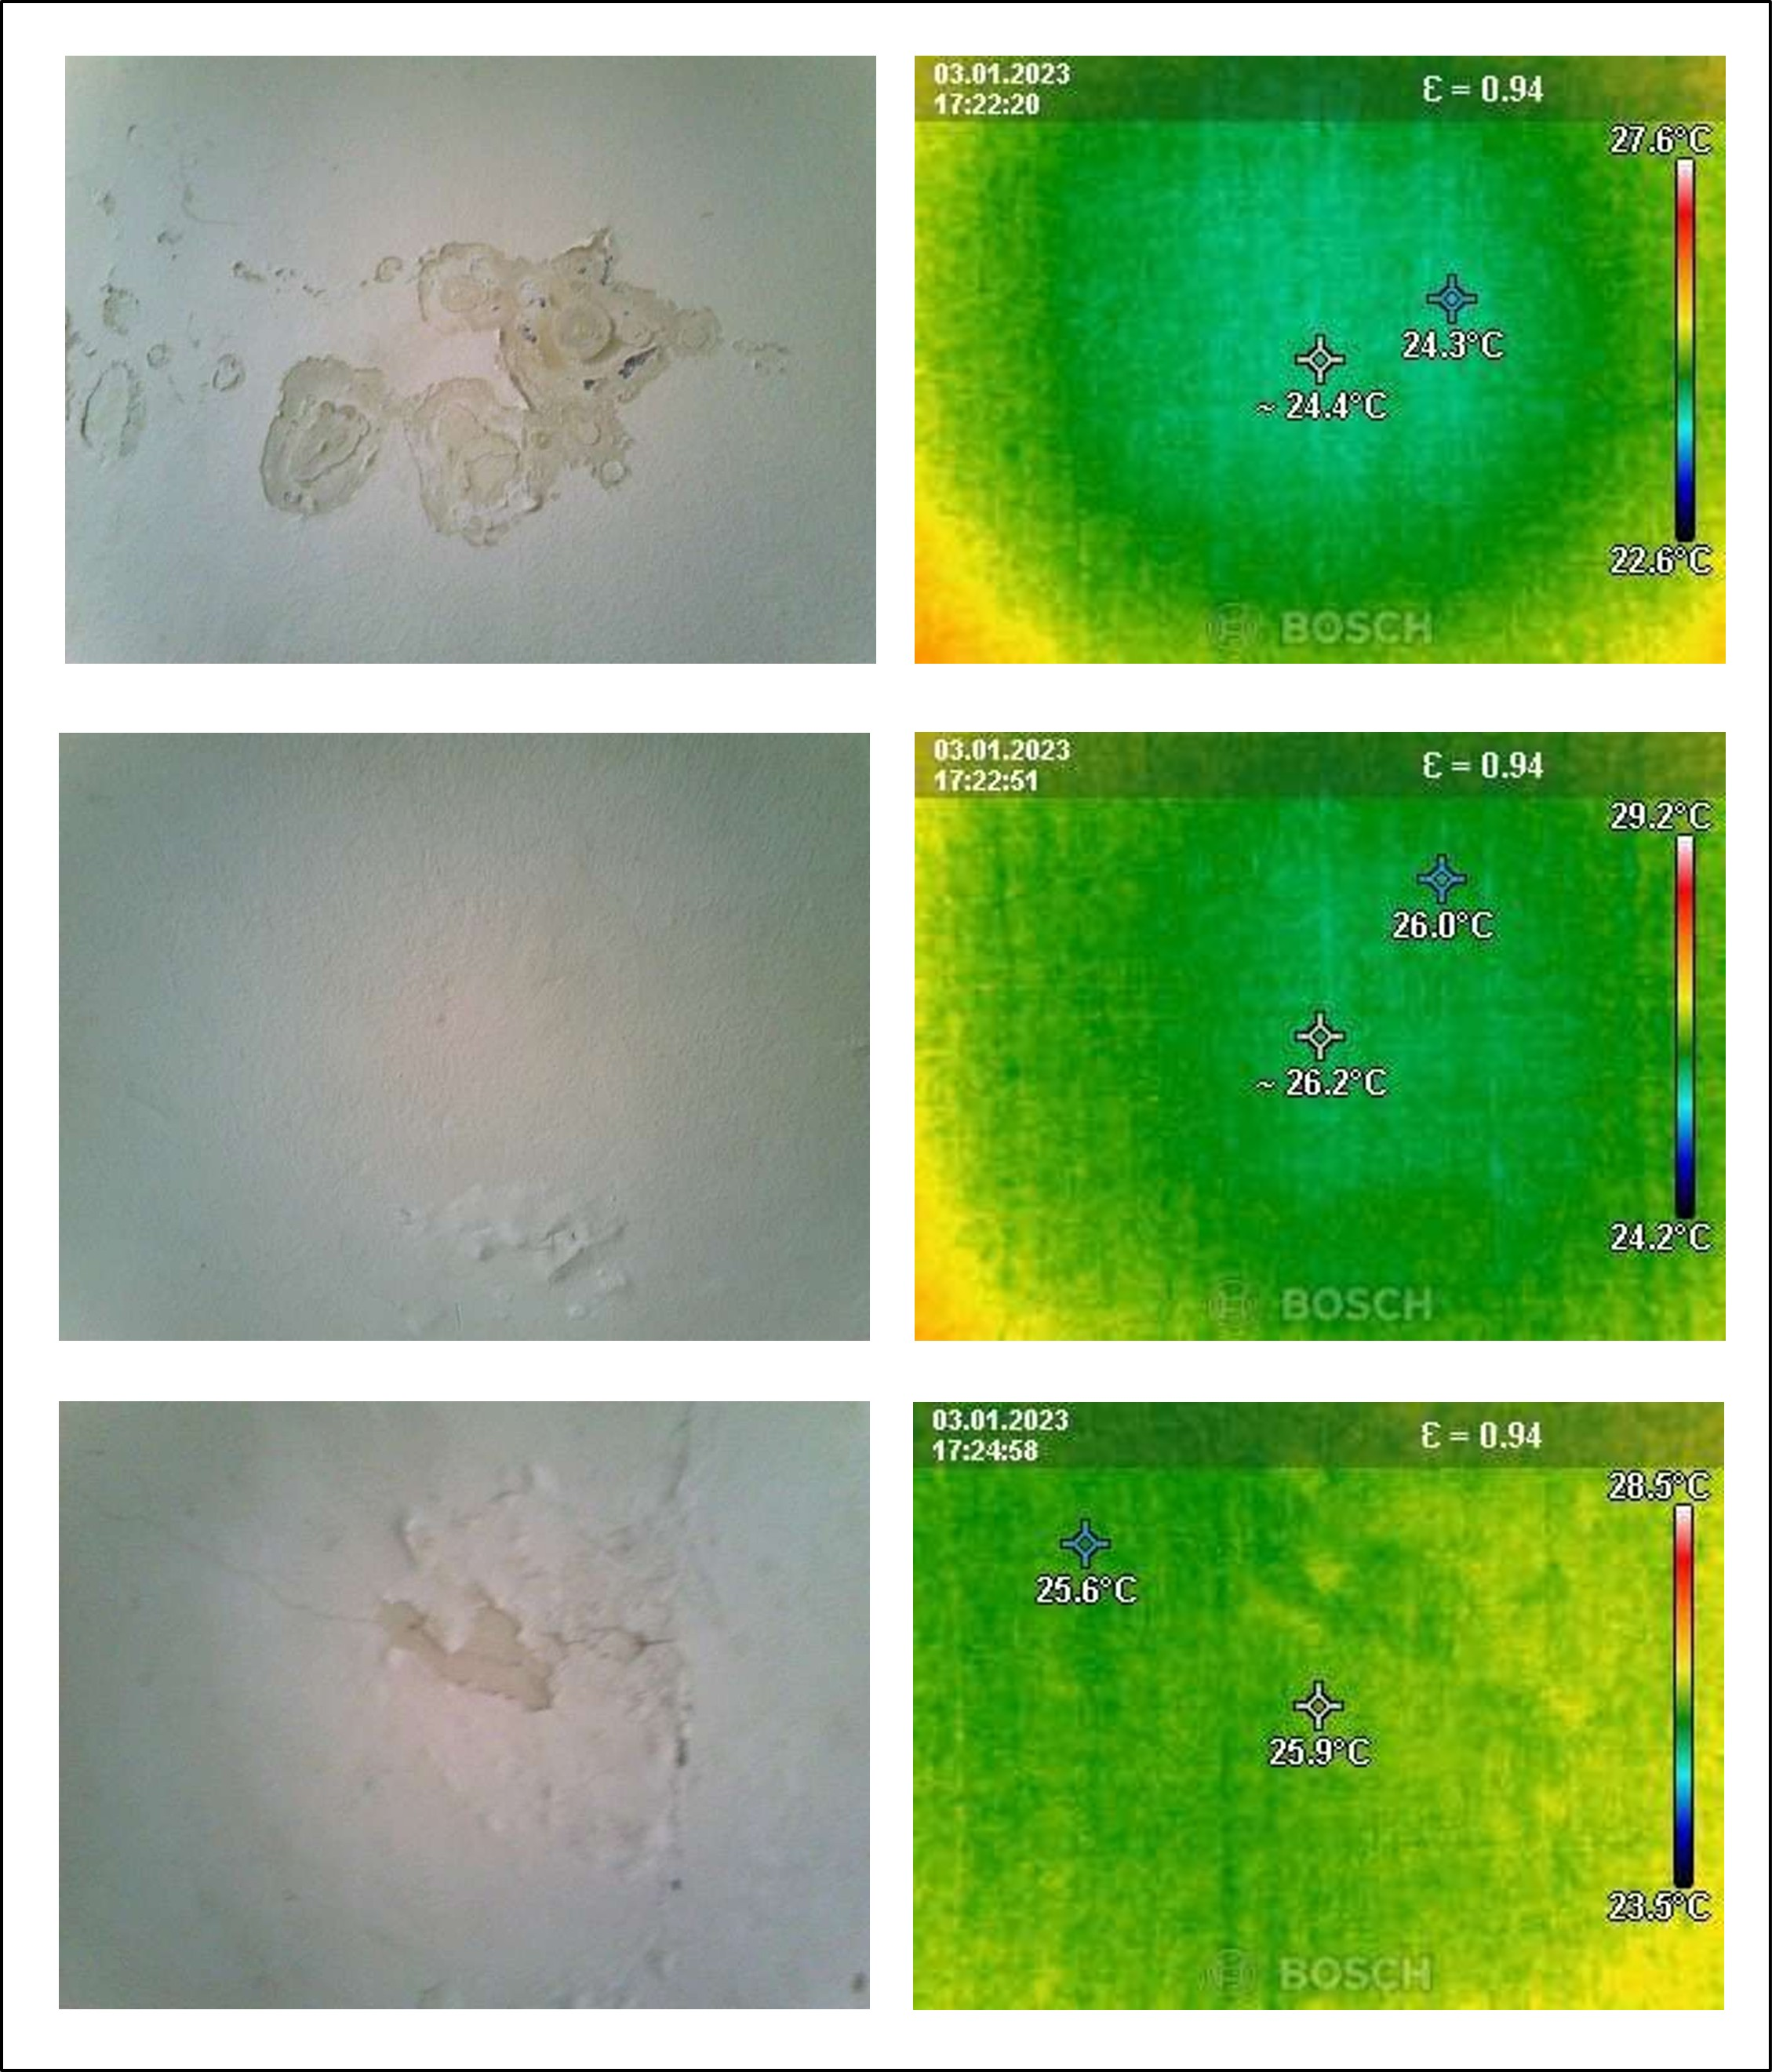

Observation 6
Issue | IMAGE 5: DAMPNESS & PAINT SPALLING AT SKIRTING LEVEL & AREA NEAR WINDOW IN MASTER BEDROOM (1 ST FLOOR). .......................................................................................... 31
Description | IMAGE 5: DAMPNESS & PAINT SPALLING AT SKIRTING LEVEL & AREA NEAR WINDOW IN MASTER BEDROOM (1 ST FLOOR). .......................................................................................... 31
Severity | Medium
Root Cause | Water ingress or condensation issue
Recommendation | Investigate and repair the source of dampness, and re-paint the affected area
Similarity Score | Not Matched
Matched Observation | Not Available
Evidence | IMAGE 5: DAMPNESS & PAINT SPALLING AT SKIRTING LEVEL & AREA NEAR WINDOW IN MASTER BEDROOM (1 ST FLOOR). .......................................................................................... 31

Inspection Image
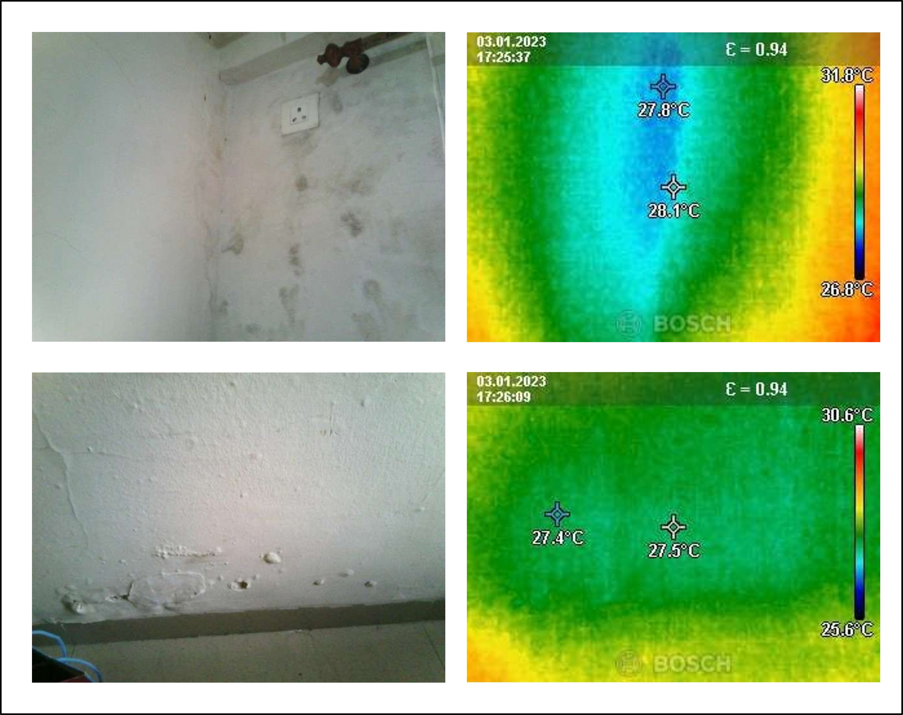

Observation 7
Issue | IMAGE 6: DAMPNESS & PAINT SPALLING AT SKIRTING LEVEL & CEILING IN MAS TER B EDROOM – 2 (1 ST FLOOR) ..................................................................................................... 32
Description | IMAGE 6: DAMPNESS & PAINT SPALLING AT SKIRTING LEVEL & CEILING IN MAS TER B EDROOM – 2 (1 ST FLOOR) ..................................................................................................... 32
Severity | Medium
Root Cause | Water ingress or condensation issue
Recommendation | Investigate and rectify the source of dampness, and repaint the affected area
Similarity Score | Not Matched
Matched Observation | Not Available
Evidence | IMAGE 6: DAMPNESS & PAINT SPALLING AT SKIRTING LEVEL & CEILING IN MAS TER B EDROOM – 2 (1 ST FLOOR) ..................................................................................................... 32

Inspection Image
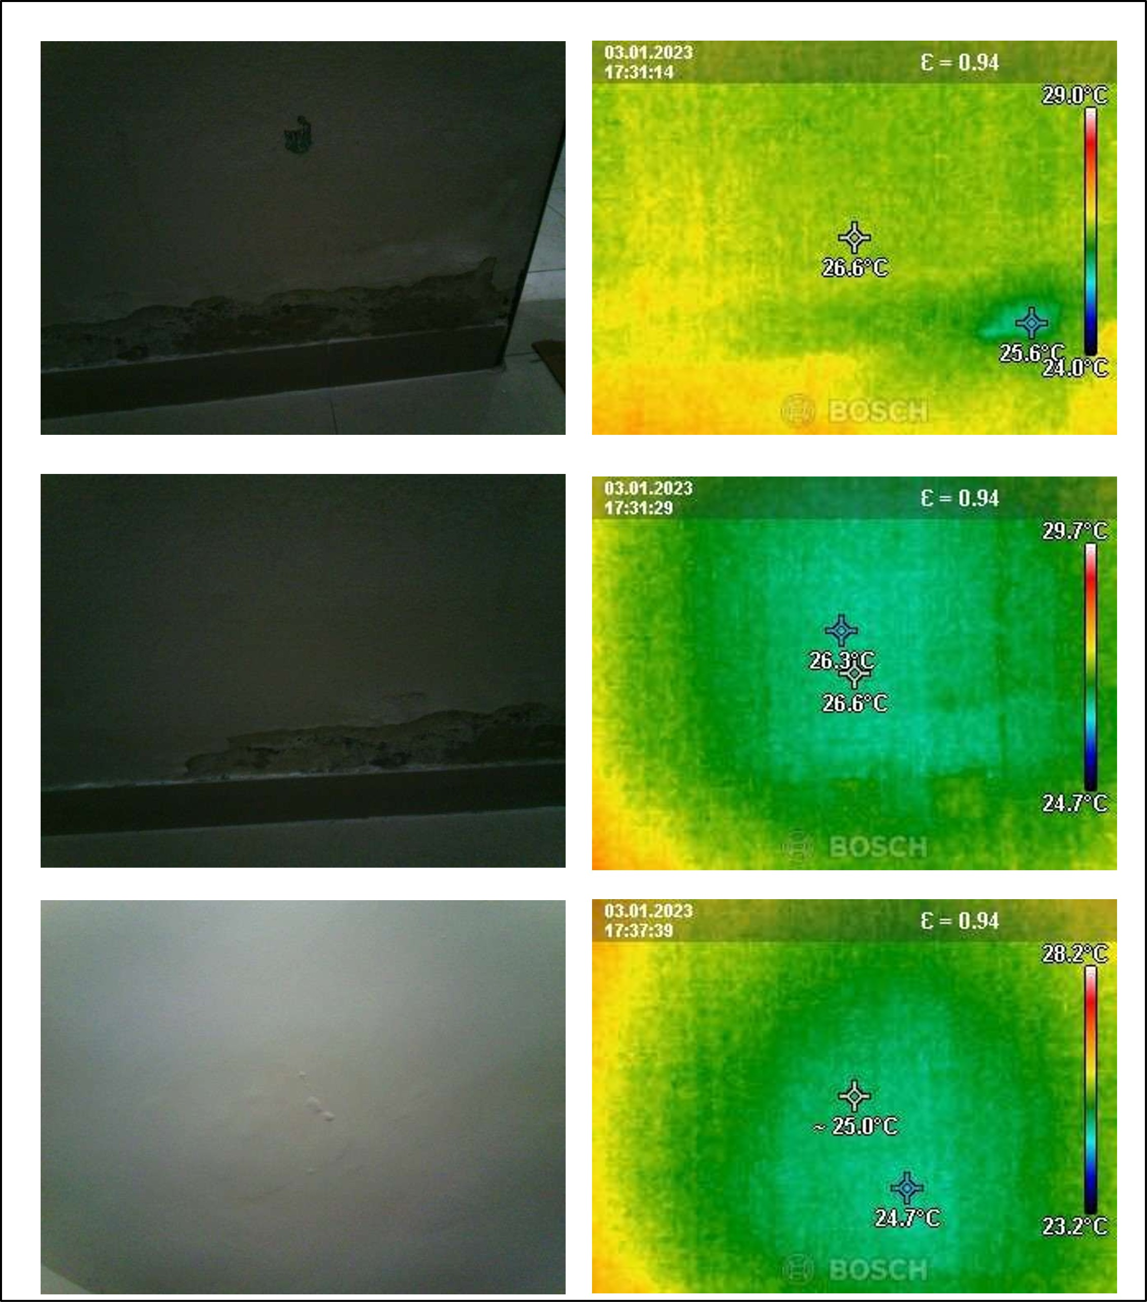

Observation 8
Issue | IMAGE 7: GAPS IN TILE JOINTS OF MASTER BEDROOM BATHROOM (1 ST FLOOR) ............ 33
Description | IMAGE 7: GAPS IN TILE JOINTS OF MASTER BEDROOM BATHROOM (1 ST FLOOR) ............ 33
Severity | Low
Root Cause | Poor workmanship or inadequate tile installation
Recommendation | Re-tile the affected area and ensure proper joint sealing
Similarity Score | Not Matched
Matched Observation | Not Available
Evidence | IMAGE 7: GAPS IN TILE JOINTS OF MASTER BEDROOM BATHROOM (1 ST FLOOR) ............ 33

Inspection Image
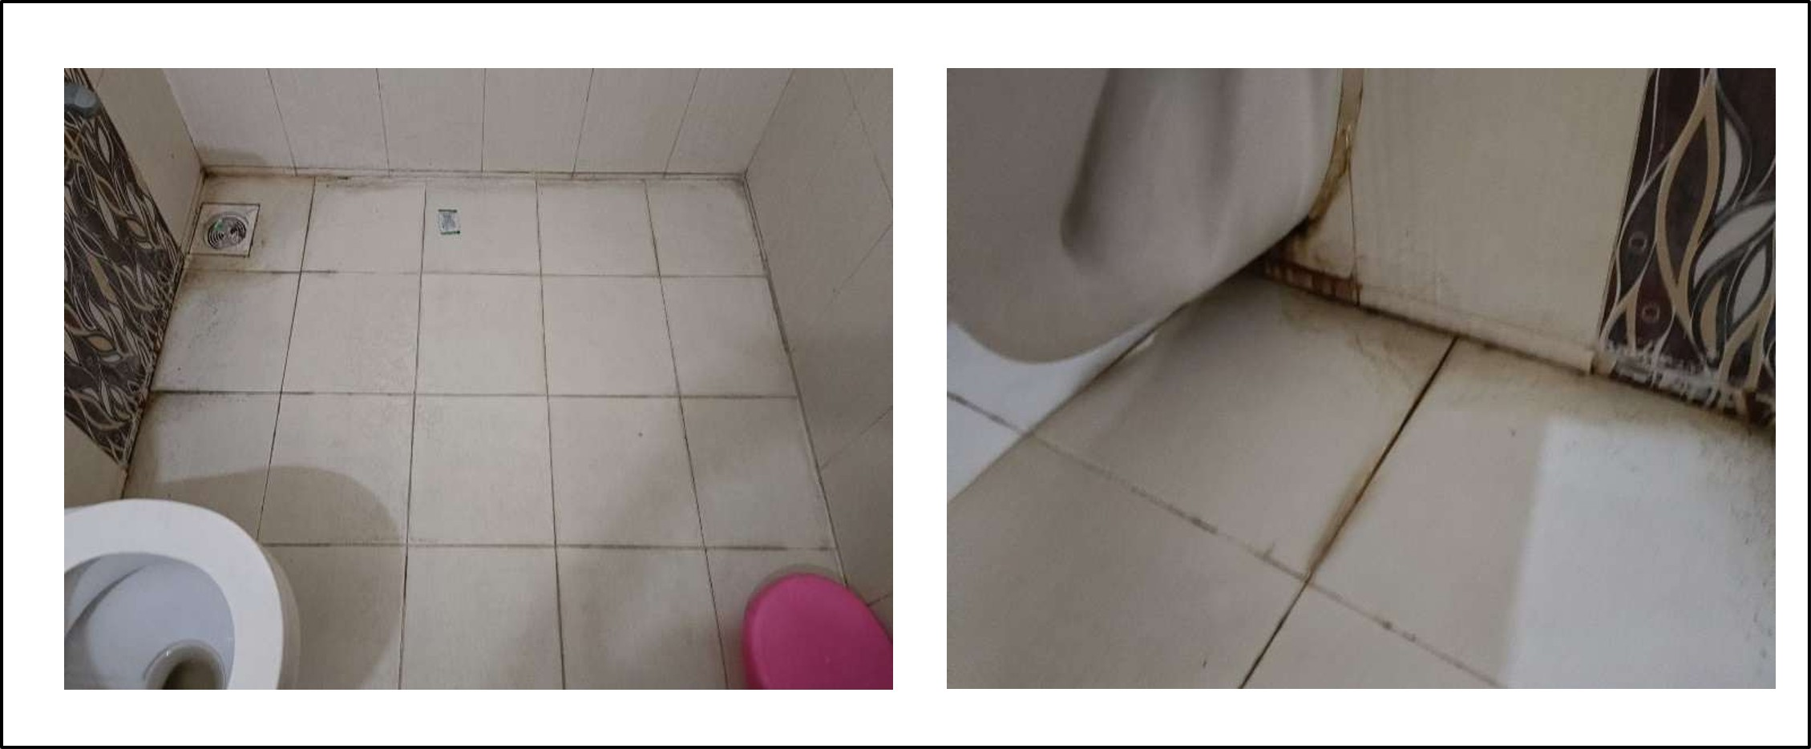

Observation 9
Issue | IMAGE 8: CRACKS ON EXTERNAL WALL ........................................................................... 34
Description | IMAGE 8: CRACKS ON EXTERNAL WALL ........................................................................... 34
Severity | High
Root Cause | Structural damage or settlement
Recommendation | Investigate and repair cracks on external wall
Similarity Score | Not Matched
Matched Observation | Not Available
Evidence | IMAGE 8: CRACKS ON EXTERNAL WALL ........................................................................... 34

Inspection Image


Observation 10
Issue | IMAGE 9: GAPS BETWEEN TILE JOINTS OF COMMON BATHROOM .................................... 34
Description | IMAGE 9: GAPS BETWEEN TILE JOINTS OF COMMON BATHROOM .................................... 34
Severity | Low
Root Cause | Poor workmanship or inadequate tile installation
Recommendation | Re-tile the affected area and ensure proper joint spacing and grouting
Similarity Score | Not Matched
Matched Observation | Not Available
Evidence | IMAGE 9: GAPS BETWEEN TILE JOINTS OF COMMON BATHROOM .................................... 34

Inspection Image


Observation 11
Issue | IMAGE 10: GAPS BETWEEN TILE JOINTS OF BALCONY ...................................................... 35
Description | IMAGE 10: GAPS BETWEEN TILE JOINTS OF BALCONY ...................................................... 35
Severity | Low
Root Cause | Poor workmanship or inadequate tile installation
Recommendation | Re-tile the balcony area to ensure proper joint spacing and sealing
Similarity Score | Not Matched
Matched Observation | Not Available
Evidence | IMAGE 10: GAPS BETWEEN TILE JOINTS OF BALCONY ...................................................... 35

Inspection Image
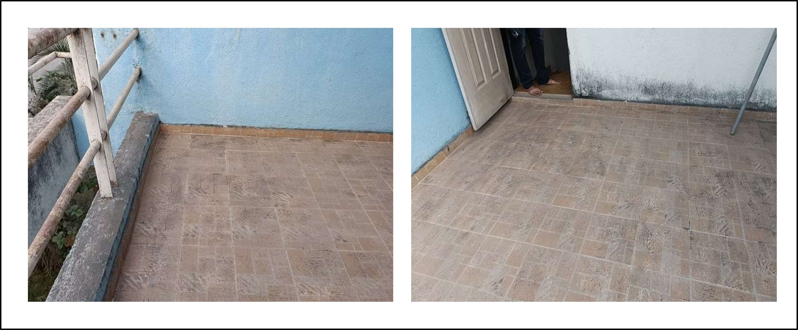

Observation 12
Issue | IMAGE 11: CRACKS ON EXTERNAL WALL OF MASTERBEROOM ........................................... 35
Description | IMAGE 11: CRACKS ON EXTERNAL WALL OF MASTERBEROOM ........................................... 35
Severity | High
Root Cause | Structural damage due to external factors
Recommendation | Investigate and repair cracks on external wall of master bedroom
Similarity Score | Not Matched
Matched Observation | Not Available
Evidence | IMAGE 11: CRACKS ON EXTERNAL WALL OF MASTERBEROOM ........................................... 35

Inspection Image


Observation 13
Issue | IMAGE 12: HOLLOWNESS AND VEGETATION GROWTH OBSERVED ON TERRACE SURFACE, GAPS OBSERVED BETWEEN TILE JOINTS OF BATHROOM IN MASTERBEDROOM-2 36
Description | IMAGE 12: HOLLOWNESS AND VEGETATION GROWTH OBSERVED ON TERRACE SURFACE, GAPS OBSERVED BETWEEN TILE JOINTS OF BATHROOM IN MASTERBEDROOM-2 36
Severity | Medium
Root Cause | Water ingress and poor maintenance
Recommendation | Inspect and repair terrace surface, seal tile joints in bathroom
Similarity Score | Not Matched
Matched Observation | Not Available
Evidence | IMAGE 12: HOLLOWNESS AND VEGETATION GROWTH OBSERVED ON TERRACE SURFACE, GAPS OBSERVED BETWEEN TILE JOINTS OF BATHROOM IN MASTERBEDROOM-2 36

Inspection Image
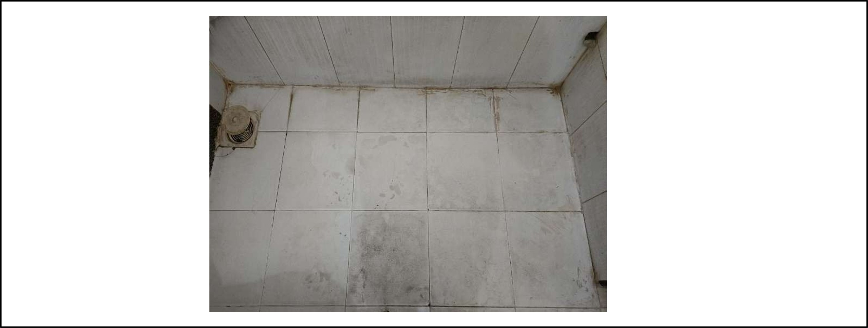

MASTER BEDROOM BATHROOM (1 ST FLOOR)

Observation 1
Issue | IMAGE 7: GAPS IN TILE JOINTS OF MASTER BEDROOM BATHROOM (1 ST FLOOR)
Description | IMAGE 7: GAPS IN TILE JOINTS OF MASTER BEDROOM BATHROOM (1 ST FLOOR)
Severity | Low
Root Cause | Poor workmanship or inadequate tile installation
Recommendation | Re-tile the affected area and ensure proper joint sealing
Similarity Score | Not Matched
Matched Observation | Not Available
Evidence | IMAGE 7: GAPS IN TILE JOINTS OF MASTER BEDROOM BATHROOM (1 ST FLOOR)

Inspection Image


OPEN BALCONY

Observation 1
Issue | IMAGE 10: GAPS BETWEEN TILE JOINTS OF BALCONY
Description | IMAGE 10: GAPS BETWEEN TILE JOINTS OF BALCONY
Severity | Low
Root Cause | Not Available
Recommendation | Not Available
Similarity Score | Not Matched
Matched Observation | Not Available
Evidence | IMAGE 10: GAPS BETWEEN TILE JOINTS OF BALCONY

Inspection Image


SKIRTING AND CEILING-WALL CORNER (BEDROOM)

Observation 1
Issue | IMAGE 2: DAMPNESS AT THE SKIRTING LEVEL & WALL CORNER OF BEDROOM (GROUND FLOOR).
Description | IMAGE 2: DAMPNESS AT THE SKIRTING LEVEL & WALL CORNER OF BEDROOM (GROUND FLOOR).
Severity | Medium
Root Cause | Water ingress or condensation issue at the skirting level and wall corner of the bedroom
Recommendation | Investigate and rectify the water ingress or condensation issue, and consider applying a waterproofing treatment to the affected area
Similarity Score | Not Matched
Matched Observation | Not Available
Evidence | IMAGE 2: DAMPNESS AT THE SKIRTING LEVEL & WALL CORNER OF BEDROOM (GROUND FLOOR).

Inspection Image


SKIRTING LEVEL (MASTER BEDROOM)

Observation 1
Issue | IMAGE 5: DAMPNESS & PAINT SPALLING AT SKIRTING LEVEL & AREA NEAR WINDOW IN MASTER BEDROOM (1 ST FLOOR).
Description | IMAGE 5: DAMPNESS & PAINT SPALLING AT SKIRTING LEVEL & AREA NEAR WINDOW IN MASTER BEDROOM (1 ST FLOOR).
Severity | Medium
Root Cause | Water ingress or condensation issue
Recommendation | Investigate and repair the skirting level and area near the window in the master bedroom to prevent further dampness and paint spalling.
Similarity Score | Not Matched
Matched Observation | Not Available
Evidence | IMAGE 5: DAMPNESS & PAINT SPALLING AT SKIRTING LEVEL & AREA NEAR WINDOW IN MASTER BEDROOM (1 ST FLOOR).

Inspection Image


SKIRTING LEVEL (PASSAGE AREA)

Observation 1
Issue | IMAGE 3: MILD SEEPAGE AT THE SKIRTING LEVEL OF COMMON BATHROOM PASSAGE AREA (GROUND FLOOR)
Description | IMAGE 3: MILD SEEPAGE AT THE SKIRTING LEVEL OF COMMON BATHROOM PASSAGE AREA (GROUND FLOOR)
Severity | High
Root Cause | Waterproofing failure or inadequate drainage
Recommendation | Investigate and repair waterproofing system, and ensure proper drainage in the common bathroom passage area
Similarity Score | Not Matched
Matched Observation | Not Available
Evidence | IMAGE 3: MILD SEEPAGE AT THE SKIRTING LEVEL OF COMMON BATHROOM PASSAGE AREA (GROUND FLOOR)

Inspection Image


SKIRTING LEVEL AND CEILING OF MASTER BEDROOM -2(1 ST

Observation 1
Issue | IMAGE 6: DAMPNESS & PAINT SPALLING AT SKIRTING LEVEL & CEILING IN MAS TER B EDROOM – 2 (1 ST FLOOR)
Description | IMAGE 6: DAMPNESS & PAINT SPALLING AT SKIRTING LEVEL & CEILING IN MAS TER B EDROOM – 2 (1 ST FLOOR)
Severity | Medium
Root Cause | Water ingress or condensation issue
Recommendation | Investigate and rectify the source of dampness and water ingress, and apply a suitable waterproofing treatment to the affected area.
Similarity Score | Not Matched
Matched Observation | Not Available
Evidence | IMAGE 6: DAMPNESS & PAINT SPALLING AT SKIRTING LEVEL & CEILING IN MAS TER B EDROOM – 2 (1 ST FLOOR)

Inspection Image


STAIRCASE AREA

Observation 1
Issue | IMAGE 4: DAMPNESS & PAINT SPALLING AT SKIRTING LEVEL & AREA NEAR THE WINDOW IN MASTER BEDROOM (1 ST FLOOR).
Description | IMAGE 4: DAMPNESS & PAINT SPALLING AT SKIRTING LEVEL & AREA NEAR THE WINDOW IN MASTER BEDROOM (1 ST FLOOR).
Severity | Medium
Root Cause | Water ingress or condensation issue
Recommendation | Investigate and repair the dampness and paint spalling issue, and consider upgrading the waterproofing system or improving ventilation in the area.
Similarity Score | Not Matched
Matched Observation | Not Available
Evidence | IMAGE 4: DAMPNESS & PAINT SPALLING AT SKIRTING LEVEL & AREA NEAR THE WINDOW IN MASTER BEDROOM (1 ST FLOOR).

Inspection Image


TERRACE AND MASTER BEDROOM-2 BATHROOM

Observation 1
Issue | IMAGE 12: HOLLOWNESS AND VEGETATION GROWTH OBSERVED ON TERRACE SURFACE, GAPS OBSERVED BETWEEN TILE JOINTS OF BATHROOM IN MASTERBEDROOM-2
Description | IMAGE 12: HOLLOWNESS AND VEGETATION GROWTH OBSERVED ON TERRACE SURFACE, GAPS OBSERVED BETWEEN TILE JOINTS OF BATHROOM IN MASTERBEDROOM-2
Severity | Medium
Root Cause | Not Available
Recommendation | Not Available
Similarity Score | Not Matched
Matched Observation | Not Available
Evidence | IMAGE 12: HOLLOWNESS AND VEGETATION GROWTH OBSERVED ON TERRACE SURFACE, GAPS OBSERVED BETWEEN TILE JOINTS OF BATHROOM IN MASTERBEDROOM-2

Inspection Image


4. Severity Assessment
Severity | Count | Percentage
Critical | 0 | 0.0%
High | 6 | 24.0%
Medium | 12 | 48.0%
Low | 7 | 28.0%
Unknown | 0 | 0.0%

Several high severity defects were identified. Repair should be prioritized.

5. Recommended Actions

Immediate Actions
- Inspect and repair image 11: cracks on external wall of masterberoom in EXTERNAL WALL.
- Inspect and repair image 8: cracks on external wall source: urbanroof pvt. ltd. in EXTERNAL WALL.
- Investigate and rectify the water ingress issue
- Investigate and repair cracks on external wall
- Investigate and repair cracks on external wall of master bedroom
- Investigate and repair waterproofing system, and ensure proper drainage in the common bathroom passage area

Planned Maintenance
- Inspect and repair image 12: hollowness and vegetation growth observed on terrace surface, gaps observed between tile joints of bathroom in masterbedroom-2 in TERRACE AND MASTER BEDROOM-2 BATHROOM.
- Inspect and repair terrace surface, seal tile joints in bathroom
- Investigate and rectify the source of dampness and water ingress, and apply a suitable waterproofing treatment to the affected area.
- Investigate and rectify the source of dampness, and repaint the affected area
- Investigate and rectify the source of dampness, consider applying a waterproofing treatment to the affected area
- Investigate and rectify the water ingress or condensation issue, and consider applying a waterproofing treatment to the affected area
- Investigate and rectify the water ingress or condensation issue, and re-paint the ceiling with a water-resistant paint
- Investigate and repair the dampness and paint spalling issue, and consider upgrading the waterproofing system or improving ventilation in the area.
- Investigate and repair the skirting level and area near the window in the master bedroom to prevent further dampness and paint spalling.
- Investigate and repair the source of dampness and repaint the affected area
- Investigate and repair the source of dampness, and re-paint the affected area
- Investigate and repair the water ingress or condensation issue, and apply a suitable waterproofing coating to the ceiling

Routine Monitoring
- Inspect and repair image 10: gaps between tile joints of balcony in OPEN BALCONY.
- Inspect and repair image 9: gaps between tile joints of common bathroom in COMMON BATHROOM.
- Inspect and repair images in General.
- Re-tile the affected area and ensure proper joint sealing
- Re-tile the affected area and ensure proper joint spacing and grouting
- Re-tile the balcony area to ensure proper joint spacing and sealing

6. Additional Notes
- Inspection observations were correlated with thermal evidence where available.
- Severity has been assigned using rule-based AI analysis.
- Recommendations are advisory and should be verified by a qualified structural engineer.
- Thermal anomalies do not always indicate structural defects and require engineering judgement.
- Total observations analysed : 25

7. Missing Information
- General: Root cause unavailable.
- General: Recommendation unavailable.
- EXTERNAL WALL: Root cause unavailable.
- EXTERNAL WALL: Recommendation unavailable.
- COMMON BATHROOM: Root cause unavailable.
- COMMON BATHROOM: Recommendation unavailable.
- OPEN BALCONY: Root cause unavailable.
- OPEN BALCONY: Recommendation unavailable.
- EXTERNAL WALL: Root cause unavailable.
- EXTERNAL WALL: Recommendation unavailable.
- TERRACE AND MASTER BEDROOM-2 BATHROOM: Root cause unavailable.
- TERRACE AND MASTER BEDROOM-2 BATHROOM: Recommendation unavailable.

8. Building Health Score
Building Health Score : 0/100
Overall Building Condition : Critical

9. Appendix
ID | Area | Issue | Severity | Matched
0 | General | Images | Low | -
1 | General | IMAGE 1: DAMPNESS, EFFLORESCENCE & SPALLING OF PAINT AT THE CEILING OF HALL (GROUND FLOOR) ................................................................................................................ 27 | Medium | -
2 | General | IMAGE 2: DAMPNESS AT THE SKIRTING LEVEL & WALL CORNER OF BEDROOM (GROUND FLOOR). 28 | Medium | -
3 | General | IMAGE 3: MILD SEEPAGE AT THE SKIRTING LEVEL OF COMMON BATHROOM PASSAGE AREA (GROUND FLOOR) ....................................................................................................... 29 | High | -
4 | General | IMAGE 4: DAMPNESS & PAINT SPALLING AT SKIRTING LEVEL & AREA NEAR THE WINDOW IN MASTER BEDROOM (1 ST FLOOR)....................................................................... 30 | Medium | -
5 | General | IMAGE 5: DAMPNESS & PAINT SPALLING AT SKIRTING LEVEL & AREA NEAR WINDOW IN MASTER BEDROOM (1 ST FLOOR). .......................................................................................... 31 | Medium | -
6 | General | IMAGE 6: DAMPNESS & PAINT SPALLING AT SKIRTING LEVEL & CEILING IN MAS TER B EDROOM – 2 (1 ST FLOOR) ..................................................................................................... 32 | Medium | -
7 | General | IMAGE 7: GAPS IN TILE JOINTS OF MASTER BEDROOM BATHROOM (1 ST FLOOR) ............ 33 | Low | -
8 | General | IMAGE 8: CRACKS ON EXTERNAL WALL ........................................................................... 34 | High | -
9 | General | IMAGE 9: GAPS BETWEEN TILE JOINTS OF COMMON BATHROOM .................................... 34 | Low | -
10 | General | IMAGE 10: GAPS BETWEEN TILE JOINTS OF BALCONY ...................................................... 35 | Low | -
11 | General | IMAGE 11: CRACKS ON EXTERNAL WALL OF MASTERBEROOM ........................................... 35 | High | -
12 | General | IMAGE 12: HOLLOWNESS AND VEGETATION GROWTH OBSERVED ON TERRACE SURFACE, GAPS OBSERVED BETWEEN TILE JOINTS OF BATHROOM IN MASTERBEDROOM-2 36 | Medium | -
13 | CEILING (HALL) | IMAGE 1: DAMPNESS, EFFLORESCENCE & SPALLING OF PAINT AT THE CEILING OF HALL (GROUND FLOOR) | Medium | -
14 | SKIRTING AND CEILING-WALL CORNER (BEDROOM) | IMAGE 2: DAMPNESS AT THE SKIRTING LEVEL & WALL CORNER OF BEDROOM (GROUND FLOOR). | Medium | -
15 | SKIRTING LEVEL (PASSAGE AREA) | IMAGE 3: MILD SEEPAGE AT THE SKIRTING LEVEL OF COMMON BATHROOM PASSAGE AREA (GROUND FLOOR) | High | -
16 | STAIRCASE AREA | IMAGE 4: DAMPNESS & PAINT SPALLING AT SKIRTING LEVEL & AREA NEAR THE WINDOW IN MASTER BEDROOM (1 ST FLOOR). | Medium | -
17 | SKIRTING LEVEL (MASTER BEDROOM) | IMAGE 5: DAMPNESS & PAINT SPALLING AT SKIRTING LEVEL & AREA NEAR WINDOW IN MASTER BEDROOM (1 ST FLOOR). | Medium | -
18 | SKIRTING LEVEL AND CEILING OF MASTER BEDROOM -2(1 ST | IMAGE 6: DAMPNESS & PAINT SPALLING AT SKIRTING LEVEL & CEILING IN MAS TER B EDROOM – 2 (1 ST FLOOR) | Medium | -
19 | MASTER BEDROOM BATHROOM (1 ST FLOOR) | IMAGE 7: GAPS IN TILE JOINTS OF MASTER BEDROOM BATHROOM (1 ST FLOOR) | Low | -
20 | EXTERNAL WALL | IMAGE 8: CRACKS ON EXTERNAL WALL Source: Urbanroof Pvt. Ltd. | High | -
21 | COMMON BATHROOM | IMAGE 9: GAPS BETWEEN TILE JOINTS OF COMMON BATHROOM | Low | -
22 | OPEN BALCONY | IMAGE 10: GAPS BETWEEN TILE JOINTS OF BALCONY | Low | -
23 | EXTERNAL WALL | IMAGE 11: CRACKS ON EXTERNAL WALL OF MASTERBEROOM | High | -
24 | TERRACE AND MASTER BEDROOM-2 BATHROOM | IMAGE 12: HOLLOWNESS AND VEGETATION GROWTH OBSERVED ON TERRACE SURFACE, GAPS OBSERVED BETWEEN TILE JOINTS OF BATHROOM IN MASTERBEDROOM-2 | Medium | -

