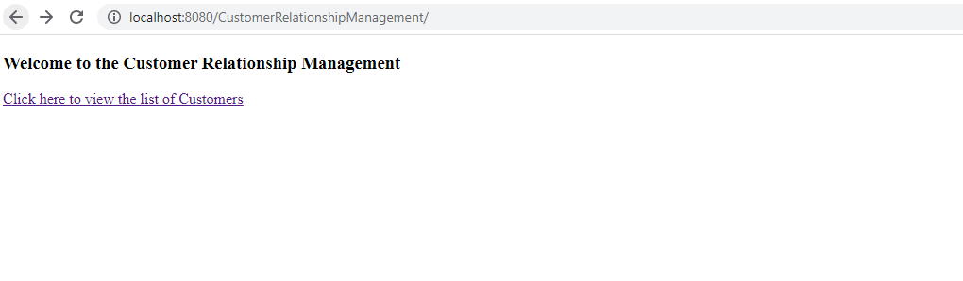

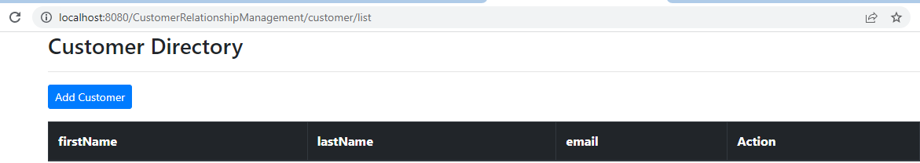

Adding the record:

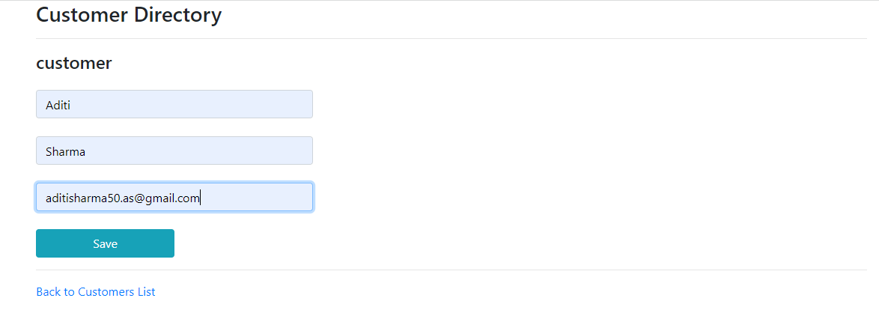

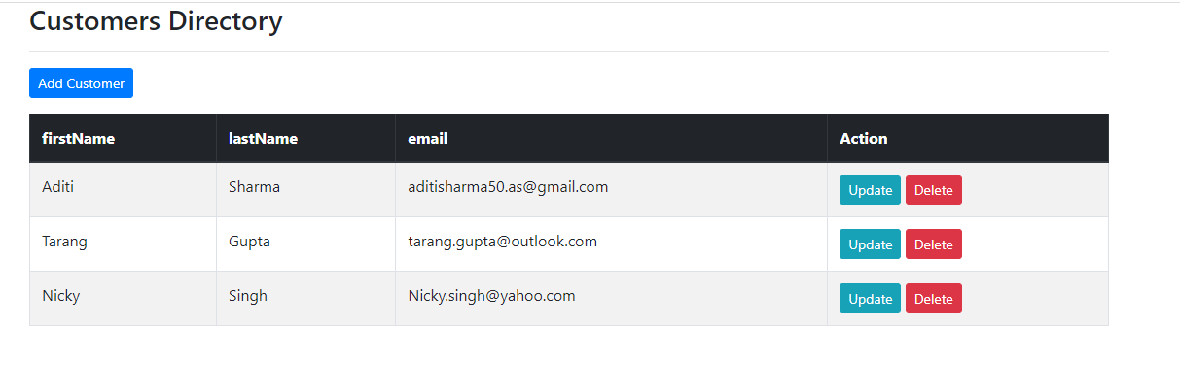

Deleting the record:

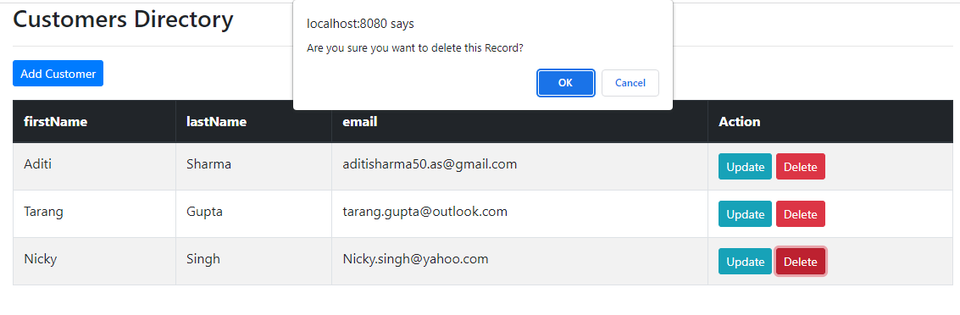

Record deleted:

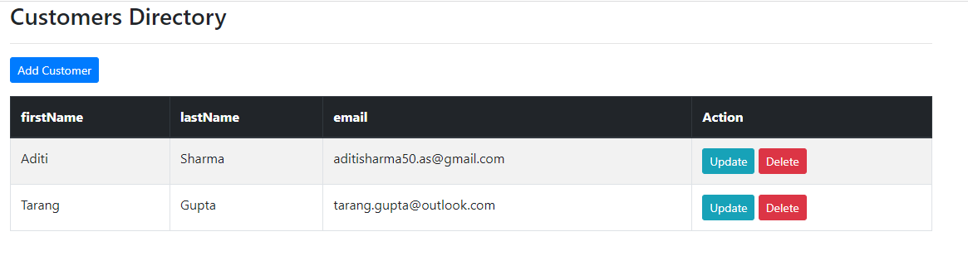

Updating the record:

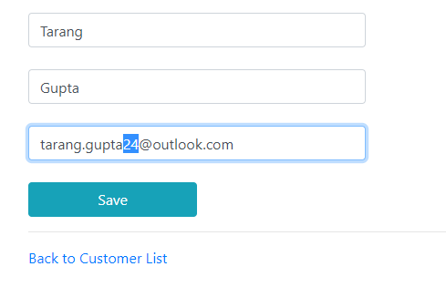

Record updated:

