Lab 4- Circular Queue
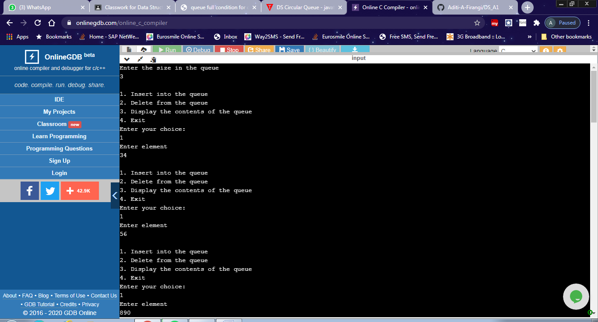
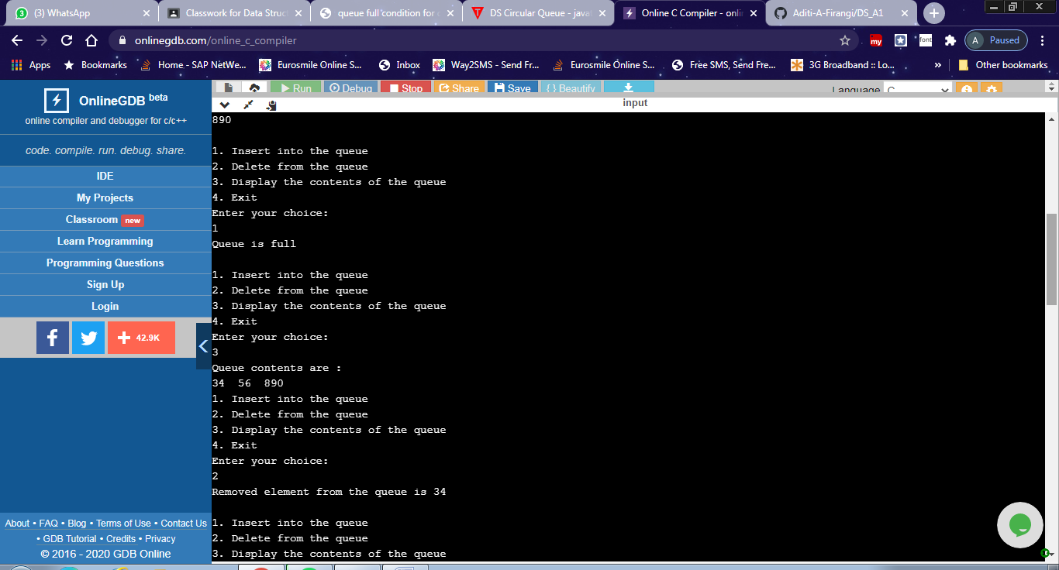
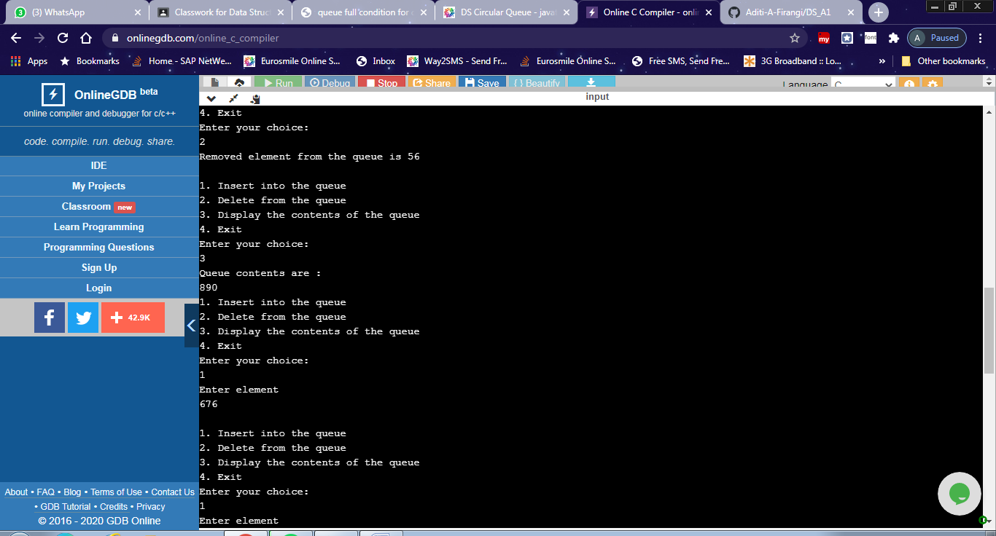

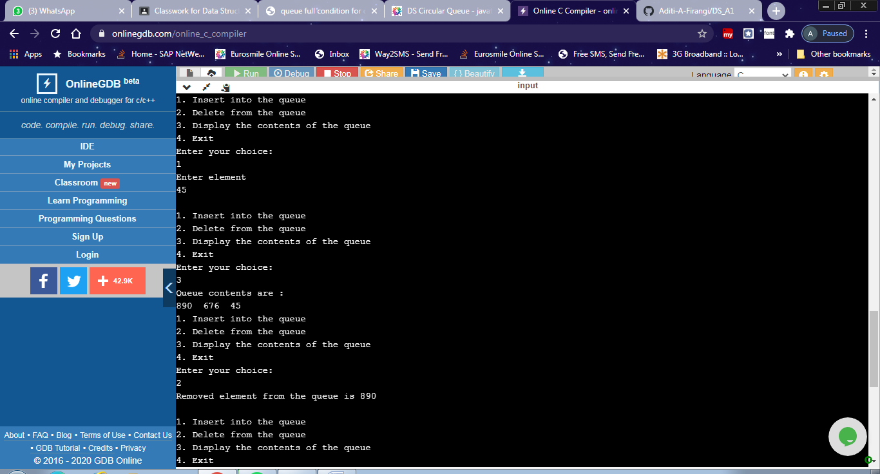

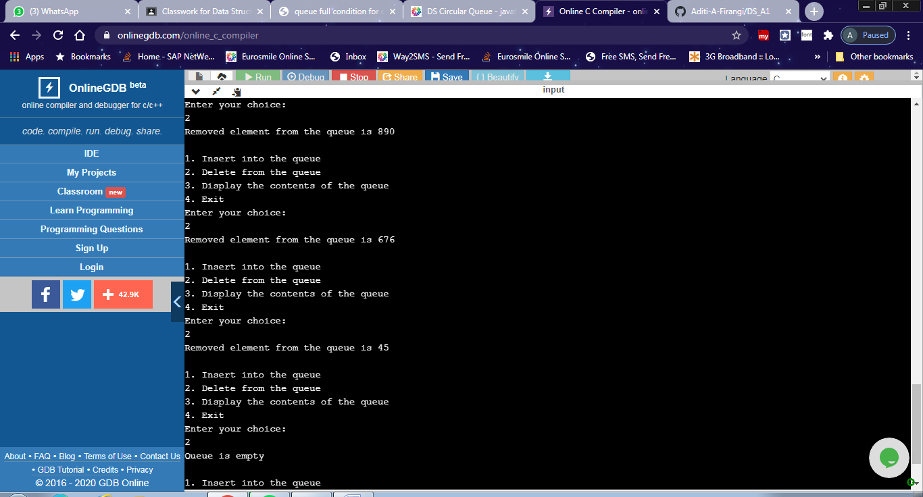
#include<stdio.h>
#include <stdlib.h>

int front=-1;
int rear=-1;
int queue[20];
int max;

void enque(int);
void deque();
void display();
int main()
{
int choice,item;
printf("Enter the size of the queue\n");
scanf("%d",&max);
do{
printf(“\n1.Insert element \n2.Delete element \n3.Display contents \n4.Exit\n “);
printf("Enter your choice:\n");
scanf("%d",&choice);
switch(choice)
{
case 1: if(((front==0 && rear==max-1))||(front==rear+1))
{
printf("Queue is full\n");
}
else
{
printf("Enter element\n");
scanf("%d",&item);
enque(item);
}
break;
case 2: deque();break;
case 3: display();
break;
case 4: exit(0);
default: printf("\nInvalid choice\n");
}
} while (choice!=4);
return 0;
}

void enque(int ele)
{

rear=(rear+1)%max;
queue[rear]=ele;
if(front ==-1)
front=0;
return;
}
void deque()
{
int item;
if((front==-1)&&(rear==-1))
{
printf("Queue is empty\n");
return;
}
else
{
item=queue[front];

if(front==rear)
{
front=-1;
rear=-1;
}
else
{
front=(front+1)%max;
}
}
printf("Removed element from the queue is %d\n",item);
return;
}

void display()
{
int i;
if(((front==-1)&&(rear==-1)))
{
printf("Queue is empty\n");
return;
}
else
{
printf("Queue contents are : \n");
for(i=front;i!=rear;i=(i+1)%max)
{
printf("%d ", queue[i]);
}
printf("%d ",queue[rear]);
return;
}
}

