Lab 4- Circular Queue
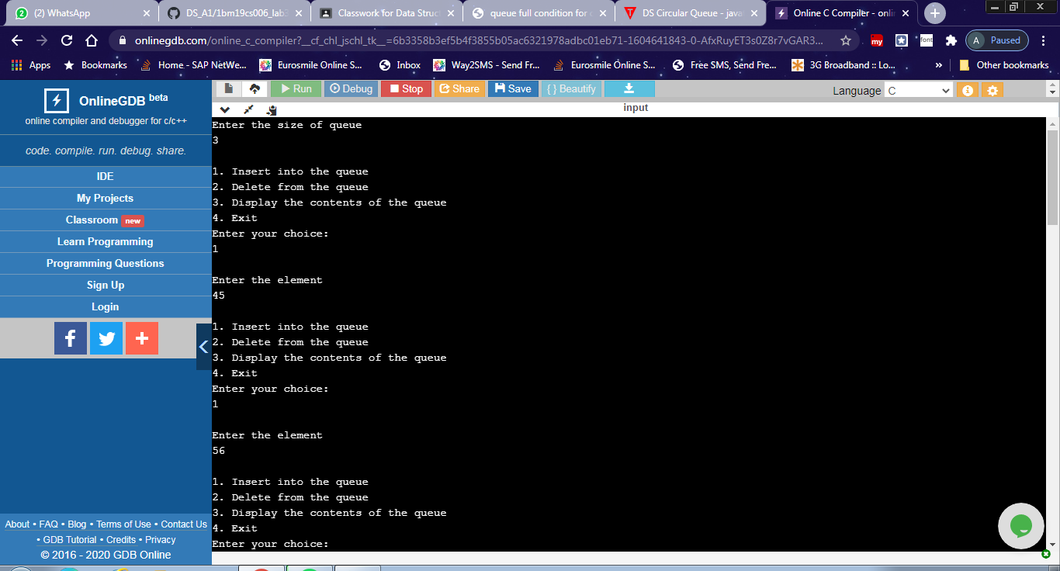
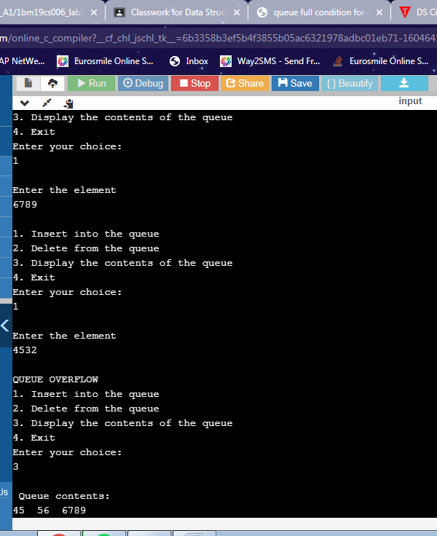
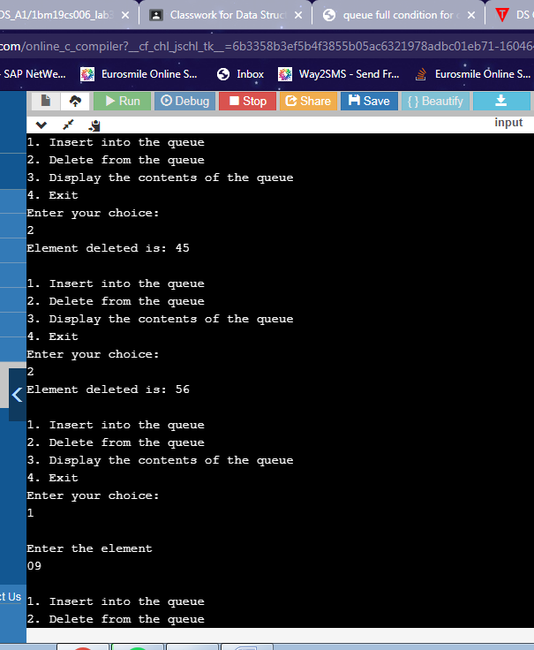
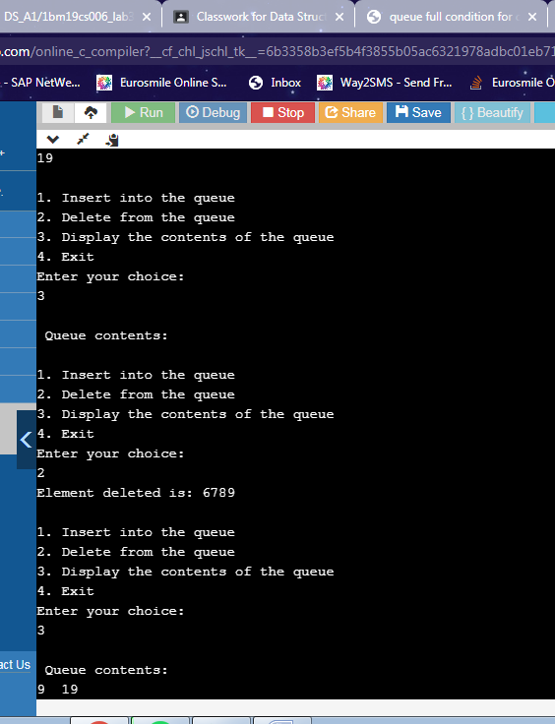
#include <stdio.h>
#include<stdlib.h>

void insert();
void delete();
void display();
int front = -1, rear = -1;
int queue[20];
int maxsize;
void main ()
{
int choice;
printf("Enter the size of queue\n");
scanf("%d",&maxsize);
do{
printf("\n1. Insert into the queue\n");
printf("2. Delete from the queue\n");
printf("3. Display the contents of the queue\n");
printf("4. Exit\n");
printf("Enter your choice:\n");
scanf("%d",&choice);
switch(choice)
{
case 1:
insert();
break;
case 2:
delete();
break;
case 3:
display();
break;
case 4:
exit(0);
break;
default:
printf("\nEnter valid choice\n");
}
} while(choice!=4);
}
void insert()
{
int item;
printf("\nEnter the element\n");
scanf("%d",&item);
if((rear+1)%maxsize == front)
{
printf("\nQUEUE OVERFLOW");
return;
}
else if(front == -1 && rear == -1)
{
front = 0;
rear = 0;
}
else if(rear == maxsize -1 && front != 0)
{
rear = 0;
}
else
{
rear = (rear+1)%maxsize;
}
queue[rear] = item;

}
void delete()
{
int item;
if(front == -1 & rear == -1)
{
printf("\nQUEUE UNDERFLOW\n");
return;
}
printf("Element deleted is: %d\n",queue[front]);
if(front == rear)
{
front = -1;
rear = -1;
}
else if(front == maxsize -1)
{
front = 0;
}
else
front = front + 1;
}

void display()
{
int i;
if(((front==-1)&& (rear==-1))|| (front==rear))
{

printf("Queue is empty\n");return;

}
else
{
printf("\n Queue contents:\n");
for(i=front;i<=rear;i++)
printf("%d ", queue[i]);
}
}

