Lab 6—Deletion in linked list
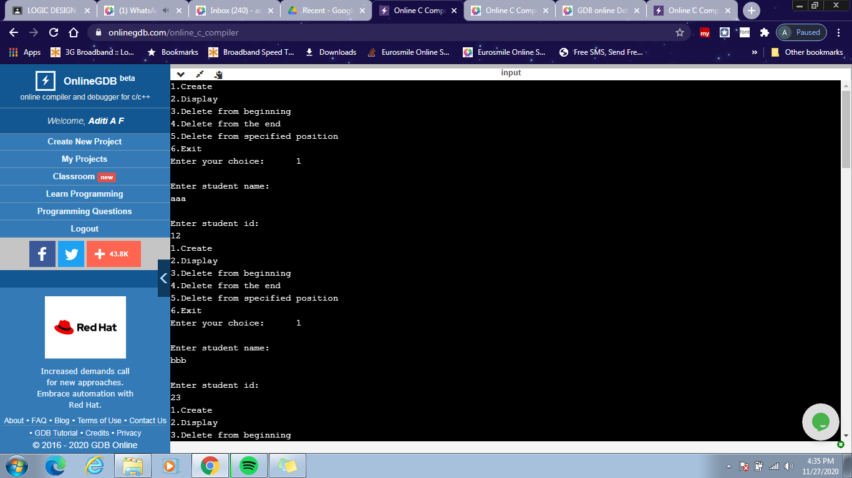
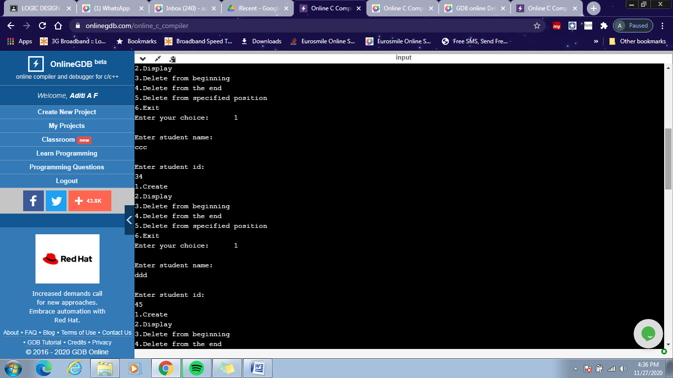
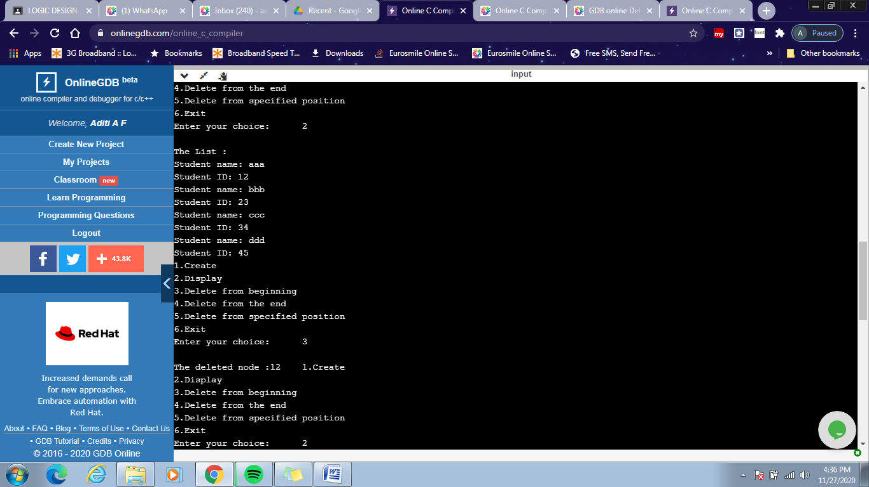
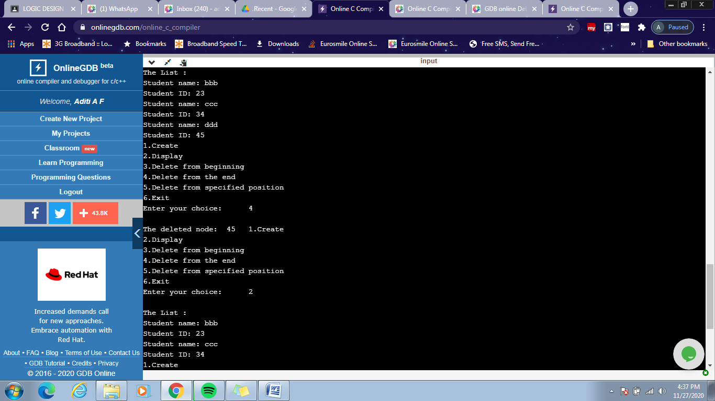
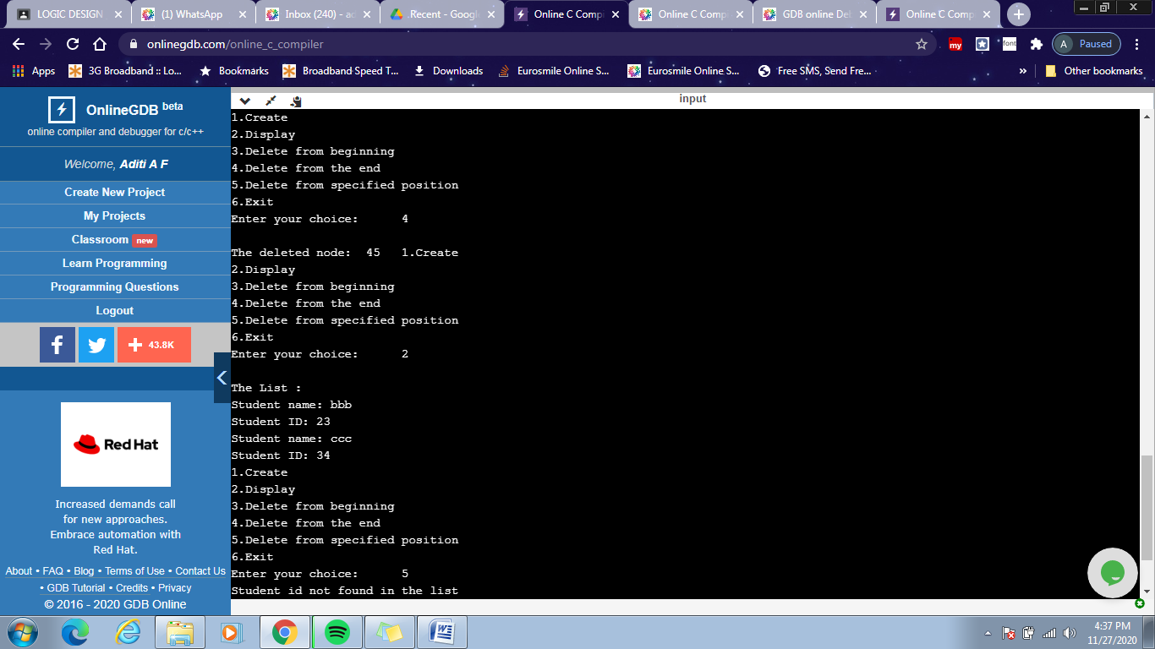
#include <stdio.h>
#include<stdlib.h>
void create();
void delete_begin();
void delete_end();
void delete_pos();
void display();
struct node
{
char name[100];
int id;
struct node *next;
};
struct node *head=NULL;
int main()
{
int choice;
do{

printf("1.Create \n");
printf("2.Display \n");
printf("3.Delete from beginning \n");
printf("4.Delete from the end \n");
printf("5.Delete from specified position \n");
printf("6.Exit \n");
printf("Enter your choice: \t");
scanf("%d",&choice);
switch(choice)
{
case 1: create();
break;
case 2: display();
break;
case 3: delete_begin();
break;
case 4: delete_end();
break;
case 5: delete_pos();
break;

case 6: exit(0);
break;
}
}while(choice!=6);
return 0;
}
void create()
{
struct node *temp,*ptr;
temp=(struct node *)malloc(sizeof(struct node));
printf("\nEnter student name: \n");
scanf("%s",temp->name);
printf("\nEnter student id: \n");
scanf("%d",&temp->id);
temp->next=NULL;
if(head==NULL)
{
head=temp;
}
else
{
ptr=head;
while(ptr->next!=NULL)
{
ptr=ptr->next;
}
ptr->next=temp;
temp->next=NULL;
}
}
void display()
{
struct node *ptr;
if(head==NULL)
{
printf("\nList is empty\n");
return;
}
else
{
ptr=head;
printf("\nThe List : \n");
while(ptr!=NULL)
{
printf("Student name: %s\n", ptr->name);
printf("Student ID: %d\n", ptr->id);
ptr=ptr->next ;
}
}
}

void delete_begin()
{
struct node *ptr;

if(head==NULL)
{
printf("\nList is Empty\n");
return;
}
else
{
ptr=head;
head=head->next ;
printf("\nThe deleted node :%d\t",ptr->id);
free(ptr);
}
}
void delete_end()
{
struct node *temp,*ptr;
if(head==NULL)
{
printf("\nList is Empty\n");
exit(0);
}
else if(head->next ==NULL)
{
ptr=head;
head=NULL;
printf("\nThe deleted node: %d\t",ptr->id);
free(ptr);
}
else
{
ptr=head;
while(ptr->next!=NULL)
{
temp=ptr;
ptr=ptr->next;
}
temp->next=NULL;
printf("\nThe deleted node: %d\t",ptr->id);
free(ptr);
}
}
void delete_pos()
{
int ele;
struct node *temp,*ptr;
if(head==NULL)
{
printf("\nThe List is Empty\n");
return;
}
temp=head;
if(head->id==ele)
{
head=head->next;
printf("Successfully deleted the id from the list.\n");
return;
}
while (temp->next!=NULL)
{
if(temp->next->id==ele)
{
ptr=temp->next;
if(ptr->next==NULL)
temp->next=NULL;
else
temp->next=ptr->next;
}
else
temp=temp->next;
}
if(ptr==NULL)
{
printf("Student id not found in the list\n");
return;
}
printf("Successfully deleted id from the list.\n");
}

