Lab 12—Tree operations
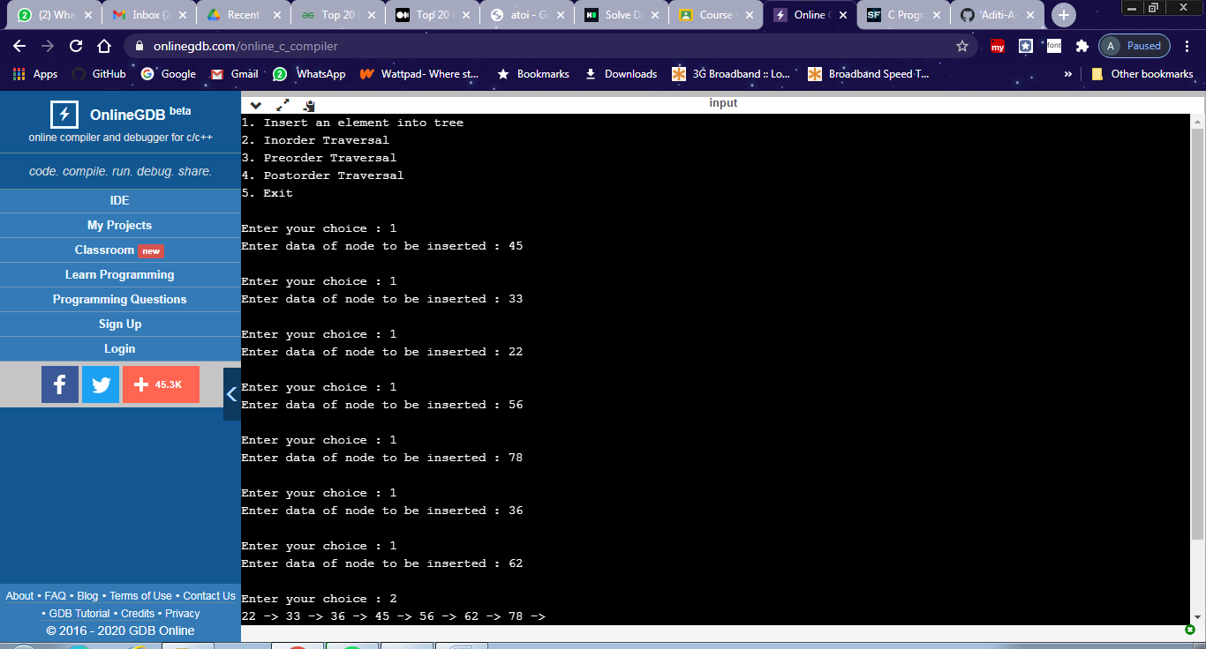
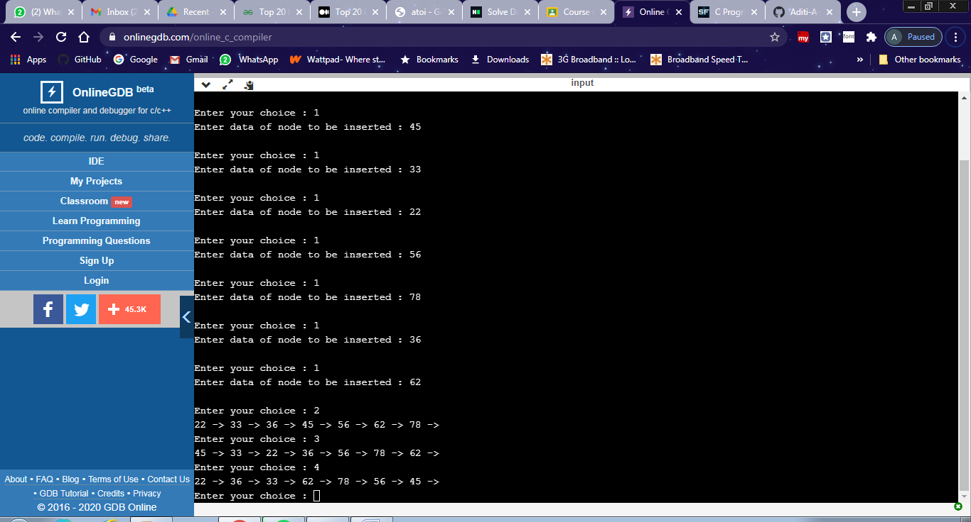

#include<stdio.h>
#include<stdlib.h>
struct tree
{
int value;
struct tree *l;
struct tree *r;
}*root = NULL, *temp = NULL, *t2, *t1;

void insert();
void inorder(struct tree *t);
void search(struct tree *t);
void preorder(struct tree *t);
void postorder(struct tree *t);
void search1(struct tree *t,int data);

int flag = 1;

int main()
{
int ch;
printf("1. Insert an element into tree\n");
printf("2. Inorder Traversal\n");
printf("3. Preorder Traversal\n");
printf("4. Postorder Traversal\n");
printf("5. Exit\n");
do
{
printf("\nEnter your choice : ");
scanf("%d", &ch);
switch (ch)
{
case 1:
insert();
break;
case 2:
inorder(root);
break;
case 3:
preorder(root);
break;
case 4:
postorder(root);
break;
case 5:
exit(0);
break;
}
}while(ch!=5);
return 0;
}

void insert()
{
int data;

printf("Enter data of node to be inserted : ");
scanf("%d", &data);
temp = (struct tree *)malloc(1*sizeof(struct tree));
temp->value = data;
temp->l = temp->r = NULL;

if (root == NULL)
root = temp;
else
search(root);
}

void search(struct tree *t)
{
if ((temp->value > t->value) && (t->r != NULL))
search(t->r);
else if ((temp->value > t->value) && (t->r == NULL))
t->r = temp;
else if ((temp->value < t->value) && (t->l != NULL))
search(t->l);
else if ((temp->value < t->value) && (t->l == NULL))
t->l = temp;
}

void search1(struct tree *t, int data)
{
if ((data>t->value))
{
t1 = t;
search1(t->r, data);
}
else if ((data < t->value))
{
t1 = t;
search1(t->l, data);
}

}

void inorder(struct tree *t)
{
if (root == NULL)
{
printf("Tree empty\n");
return;
}
if (t->l != NULL)
inorder(t->l);
printf("%d -> ", t->value);
if (t->r != NULL)
inorder(t->r);
}

void preorder(struct tree *t)
{
if (root == NULL)
{
printf("Tree empty");
return;
}
printf("%d -> ", t->value);
if (t->l != NULL)
preorder(t->l);
if (t->r != NULL)
preorder(t->r);
}

void postorder(struct tree *t)
{
if (root == NULL)
{
printf("Tree empty ");
return;
}
if (t->l != NULL)
postorder(t->l);
if (t->r != NULL)
postorder(t->r);
printf("%d -> ", t->value);
}

