Lab 7—Sort, Reverse and Concatenate 2 singly linked lists
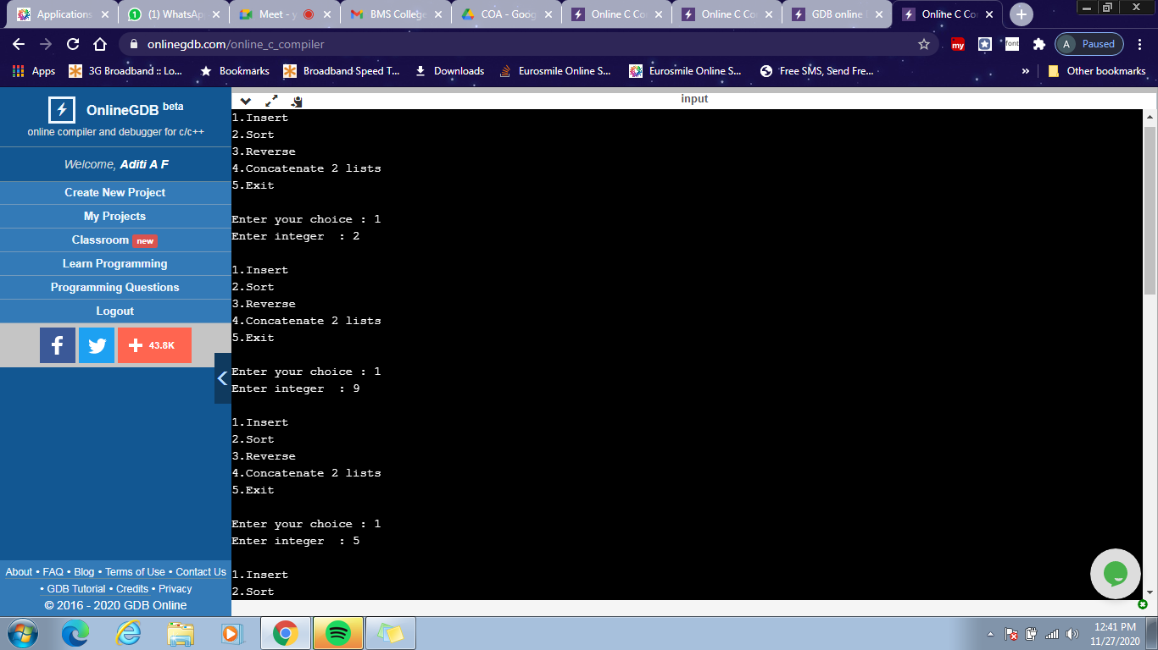
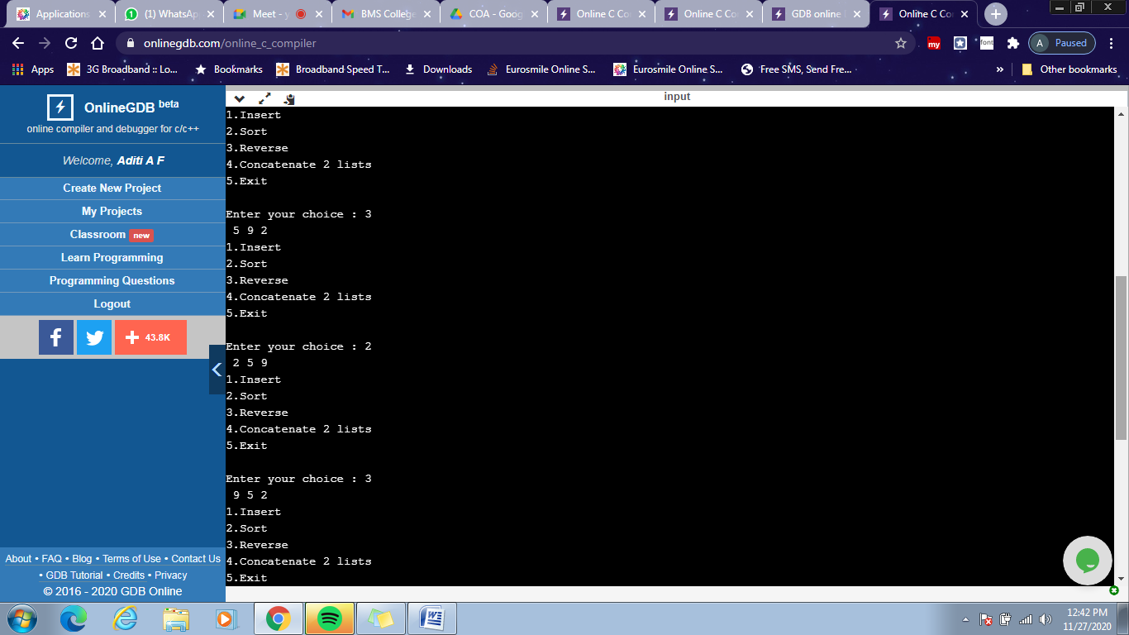
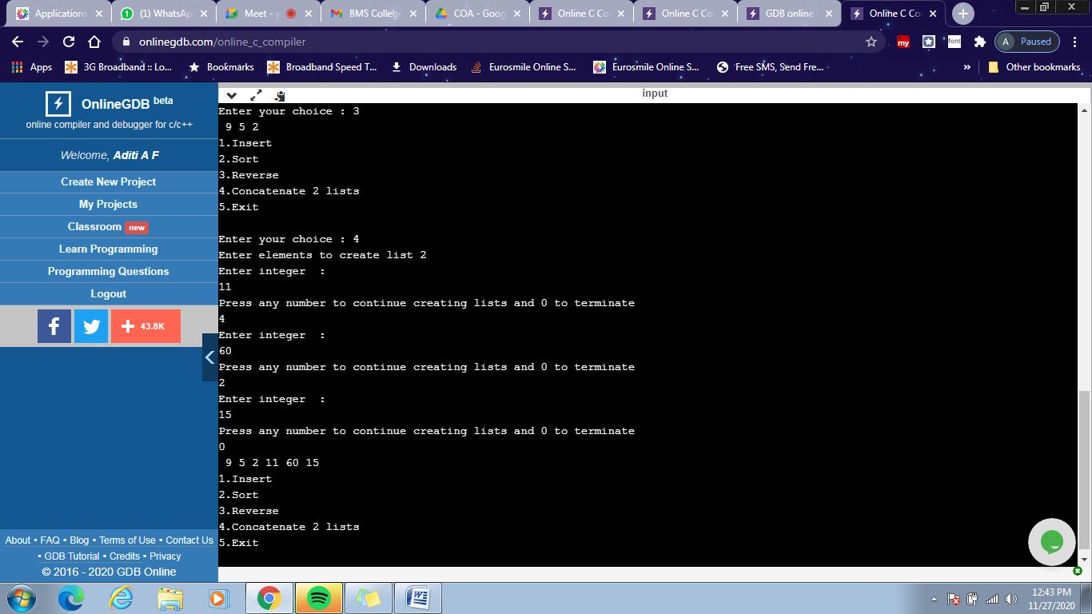

#include <stdio.h>
#include <stdlib.h>
#include <string.h>
struct node
{
int data;
struct node *next;
};
struct node *head= NULL;
struct node *head2= NULL;
int c=0;
void Insert()
{
struct node *newnode;
struct node *temp;
int n;
printf("Enter integer : ");
scanf("%d",&n);
newnode=(struct node*)malloc(sizeof(struct node));
newnode->data =n;
if (head==NULL)
{
newnode->next=NULL;
head=newnode;
c++;
}
else
{
temp=head;
while(temp->next!=NULL)
{
temp=temp->next;
}
temp->next=newnode;
newnode->next=NULL;
c++;
}
}
void Insert2()
{
struct node *newnode;
struct node *temp;
int n,y;
printf("Enter elements to create list 2\n");
do
{
printf("Enter integer : \n");
scanf("%d",&n);
newnode=(struct node*)malloc(sizeof(struct node));
newnode->data =n;
if (head2==NULL)
{
newnode->next=NULL;
head2=newnode;
c++;
}
else
{
temp=head2;
while(temp->next!=NULL)
{
temp=temp->next;
}
temp->next=newnode;
newnode->next=NULL;
c++;
}
printf("Press any number to continue creating lists and 0 to terminate\n");
scanf("%d",&y);
}while(y!=0);
}

void Sort()
{
int swap, i;
struct node *ptr1;
struct node *lptr = NULL;
if (head == NULL)
return;

do
{
swap = 0;
ptr1 = head;

while (ptr1->next != lptr)
{
if (ptr1->data > ptr1->next->data)
{
int temp = ptr1->data;
ptr1->data = ptr1->next->data;
ptr1->next->data = temp;
swap = 1;
}
ptr1 = ptr1->next;
}
lptr = ptr1;
}
while (swap);
}

void Reverse()
{
struct node* prev = NULL;
struct node* current = head;
struct node* next = NULL;
while (current != NULL) {
next = current->next;
current->next = prev;
prev = current;
current = next;
}
head= prev;
}

void concat()
{
struct node *ptr;
if(head==NULL)
{
head=head2;
}
if(head2==NULL)
{
head2=head;
}
ptr=head;
while(ptr->next!=NULL)
ptr=ptr->next;
ptr->next=head2;
}
void display1()
{
struct node *ptr;
ptr=head;
int i=1;
if(ptr==NULL)
{
printf("Linked list is empty!\n");
}
else
{
while(ptr!= NULL)
{
printf(" %d",ptr->data);
i++;
ptr=ptr->next;
}
}
}
void display2()
{
struct node *ptr;
ptr=head2;
int i=1;

if(ptr==NULL)
{
printf("Linked list is empty!\n");
}
else
{
while(ptr!= NULL)
{
printf(" %d",ptr->data);
printf("\n");
i++;
ptr=ptr->next;
}
}
}

int main()
{
int choice,pos;
do
{
printf("\n1.Insert \n2.Sort \n3.Reverse \n4.Concatenate 2 lists \n5.Exit\n");
printf("\nEnter your choice : ");
scanf("%d",&choice);
switch(choice)
{
case 1:
Insert();
break;

case 2:
Sort();
display1();
break;

case 3:
Reverse();
display1();
break;

case 4:
Insert2();
concat();
display1();
break;

case 5: exit(0);
break
}
}while(choice!=5);
return 0;
}

