Lab 9—Doubly linked list
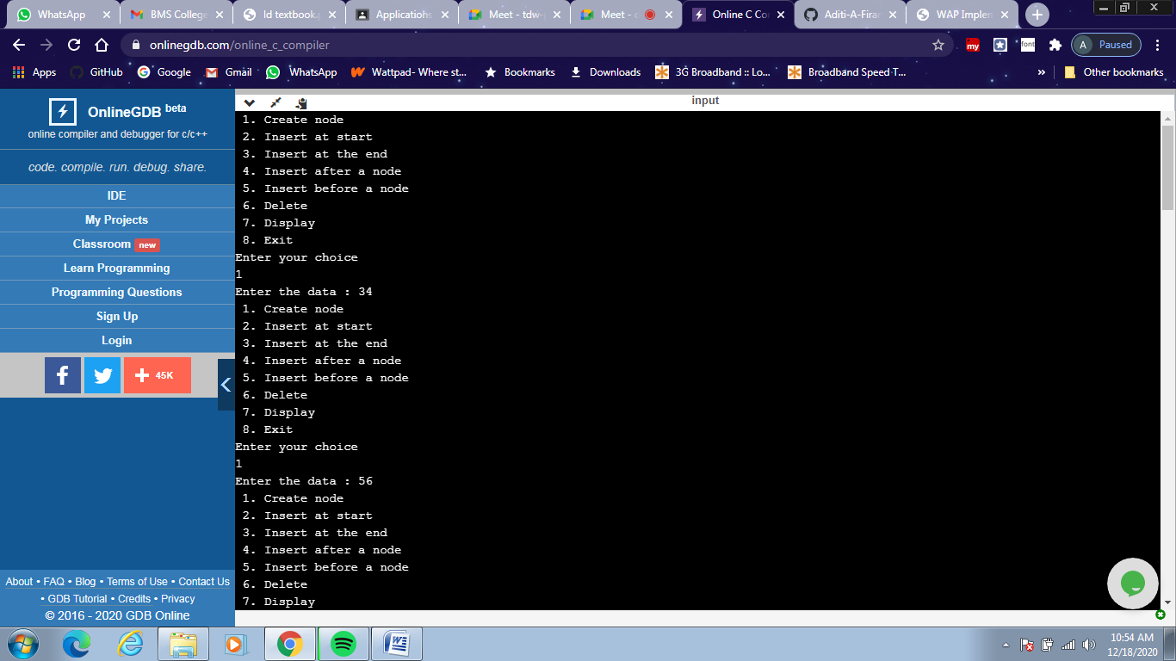
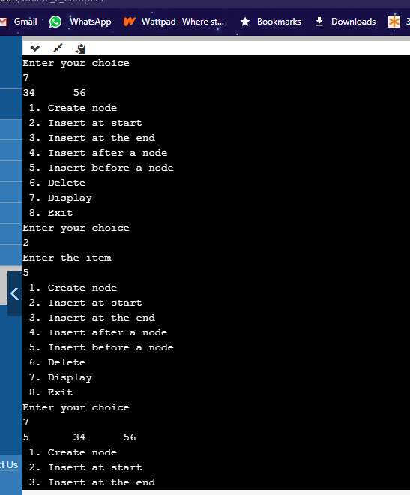
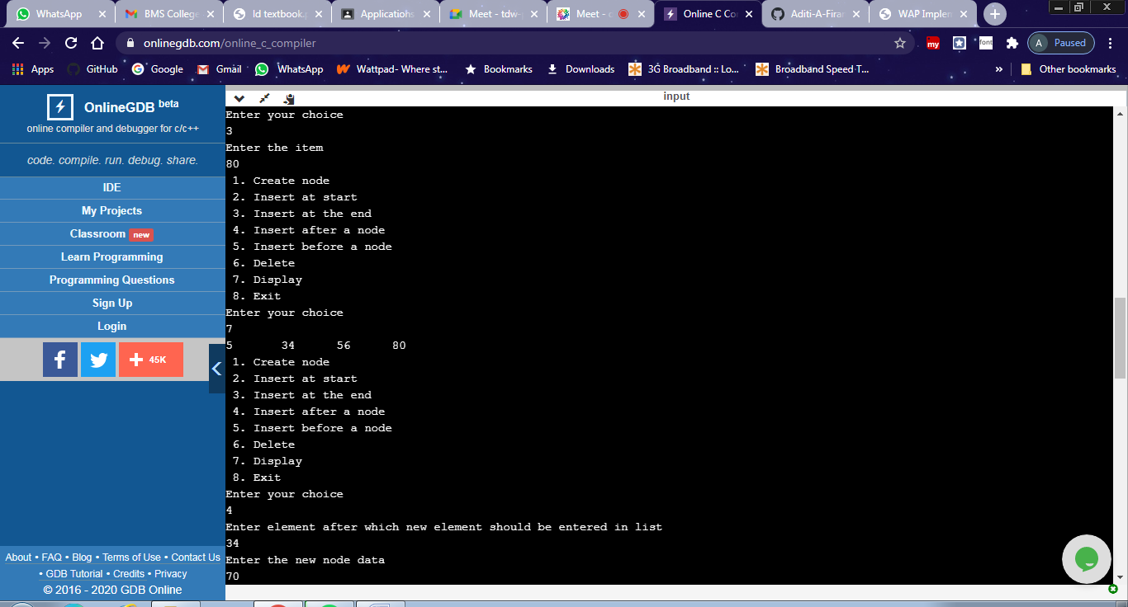
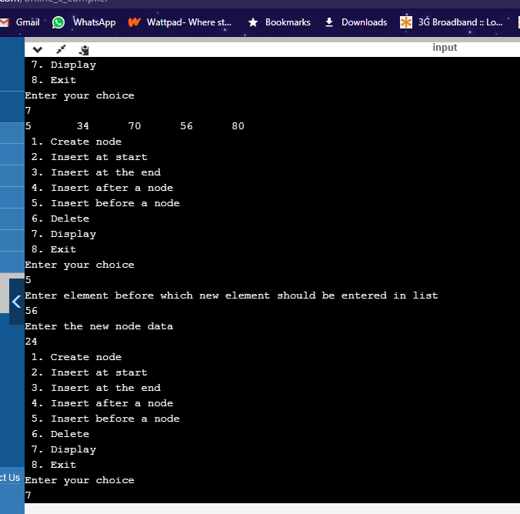
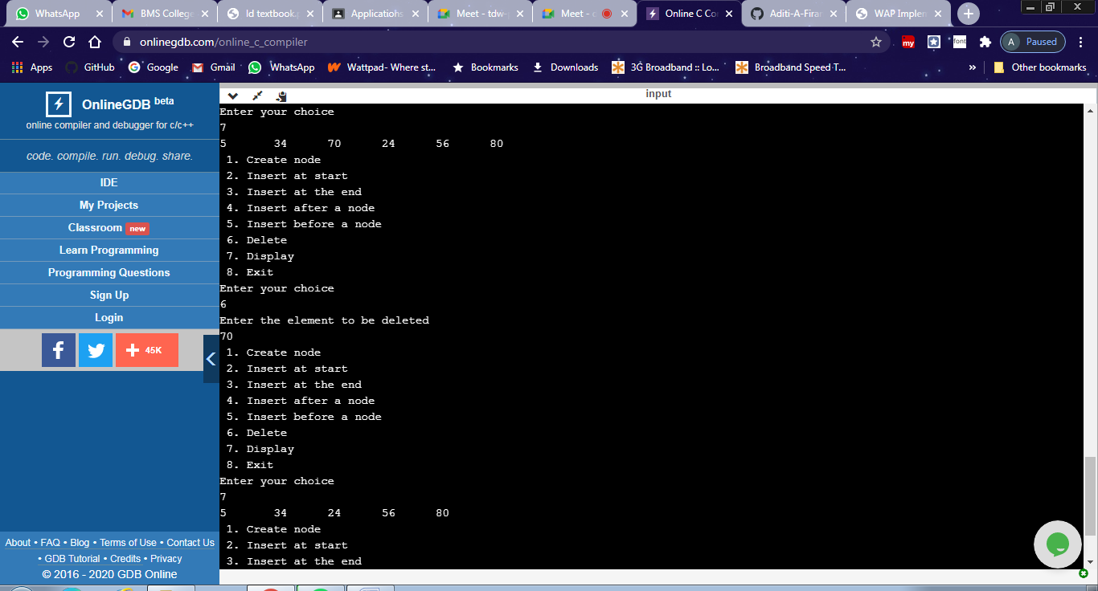
#include<stdio.h>
#include<stdlib.h>
struct node
{
int data;
struct node *next;
struct node *prev;
};
struct node *head=NULL;
void create()
{
struct node *newnode,*temp;
int item;
newnode =(struct node *) malloc (sizeof(struct node));
printf("Enter the data : ");
scanf("%d",&item);
newnode->data=item;
newnode->next=NULL;
newnode->prev=NULL;
if (head==NULL)
{

head=newnode;

}
else
{
temp=head;
while(temp->next!=NULL)
{
temp=temp->next;
}
temp->next=newnode;
newnode->next=NULL;
newnode->prev=temp;

}
}
void insert_beg()
{
struct node *new_node;
new_node=(struct node*)malloc(sizeof(struct node));
printf("Enter the item\n");
scanf("%d",&new_node->data);
new_node->next=NULL;
new_node->prev=NULL;

if(head==NULL)
{
head=new_node;
}
else
{
new_node->next=head;
head->prev=new_node;
head=new_node;
}

}

void insert_end()
{
struct node *new_node,*temp;
new_node=(struct node*)malloc(sizeof(struct node));
printf("Enter the item\n");
scanf("%d",&new_node->data);
new_node->next=NULL;
new_node->prev=NULL;
if(head==NULL)
{
head=new_node;
}
else
{
temp=head;
while(temp->next!=NULL)
temp=temp->next;
temp->next=new_node;
new_node->prev=temp;

}

}
void insert_after()
{
int listele;
struct node *new_node,*temp;
printf("Enter element after which new element should be entered in list\n");
scanf("%d",&listele);
new_node=(struct node*)malloc(sizeof(struct node));
printf("Enter the new node data\n");
scanf("%d",&new_node->data);
new_node->next=NULL;
new_node->prev=NULL;
if(head==NULL)
{
printf("Empty list\n"); return;
}
temp=head;
while(temp->data!=listele)
{
temp=temp->next;
if(temp==NULL)
{
printf("Element is not in the list\n");
return;
}
}
new_node->next=temp->next;
temp->next=new_node;
new_node->prev=temp;
new_node->next->prev=new_node;
}
void insert_before()
{
int listele;
struct node *new_node,*temp;
printf("Enter element before which new element should be entered in list\n");
scanf("%d",&listele);
new_node=(struct node*)malloc(sizeof(struct node));
printf("Enter the new node data\n");
scanf("%d",&new_node->data);
new_node->next=NULL;
new_node->prev=NULL;
if(head==NULL)
{
printf("Empty list\n"); return;
}
temp=head;
while(temp->data!=listele)
{
temp=temp->next;
if(temp==NULL)
{
printf("Element is not in the list\n");
return;
}
}
new_node->prev=temp->prev;
temp->prev=new_node;
new_node->next=temp;
new_node->prev->next=new_node;
}
void del()
{
struct node *temp;
int ele;
if(head==NULL)
{
printf("Empty List \n");
return;
}
printf("Enter the element to be deleted\n");
scanf("%d",&ele);
temp=head;
while(temp->data!=ele)
{
temp=temp->next;
if(temp==NULL)
{
printf("Element is not in the list\n");
return;
}
}
if(temp==head)
{
head=head->next;
}
else if(temp->next==NULL)
{
temp=temp->prev;
temp->next=NULL;
}

else
{
temp->prev->next=temp->next;
temp->next->prev=temp->prev;
}
}
void display()
{
struct node *temp;
temp=head;
while(temp!=NULL)
{
printf("%d\t",temp->data);
temp=temp->next;
}
printf("\n");
}

int main()
{
int choice;

do
{
printf(" 1. Create node\n");
printf(" 2. Insert at start\n");
printf(" 3. Insert at the end \n");
printf(" 4. Insert after a node\n");
printf(" 5. Insert before a node\n");
printf(" 6. Delete \n");
printf(" 7. Display\n");
printf(" 8. Exit\n");
printf("Enter your choice\n");
scanf("%d",&choice);
switch(choice)
{
case 1: create();break;
case 2: insert_beg(); break;
case 3: insert_end();break;
case 4: insert_after();break;
case 5: insert_before();break;
case 6: del(); break;
case 7: display(); break;
case 8: exit(0);
}
}while(choice!=8);
return 0;
}

