Lab 8—Queue implementation using Linked list

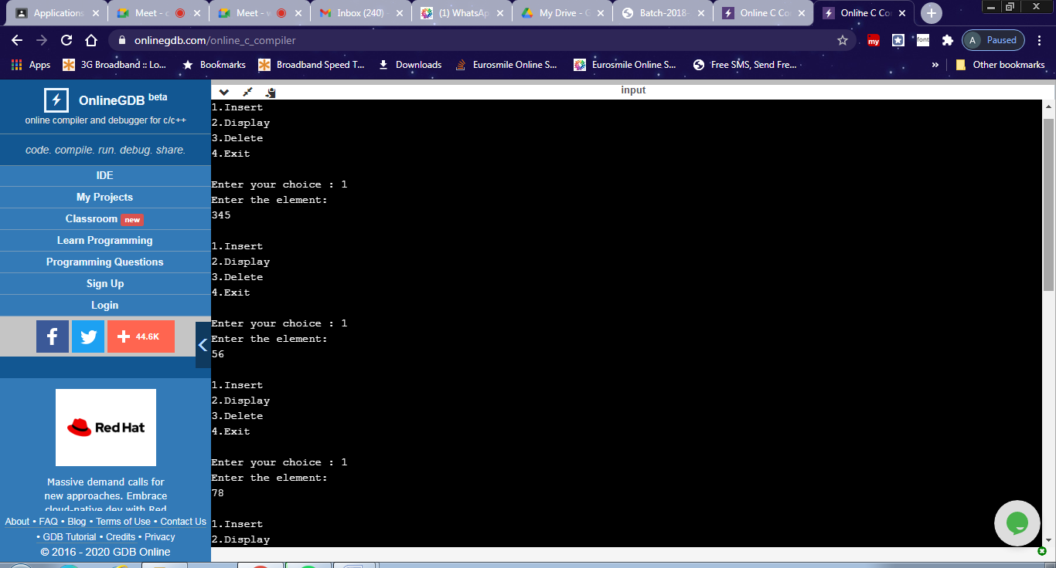
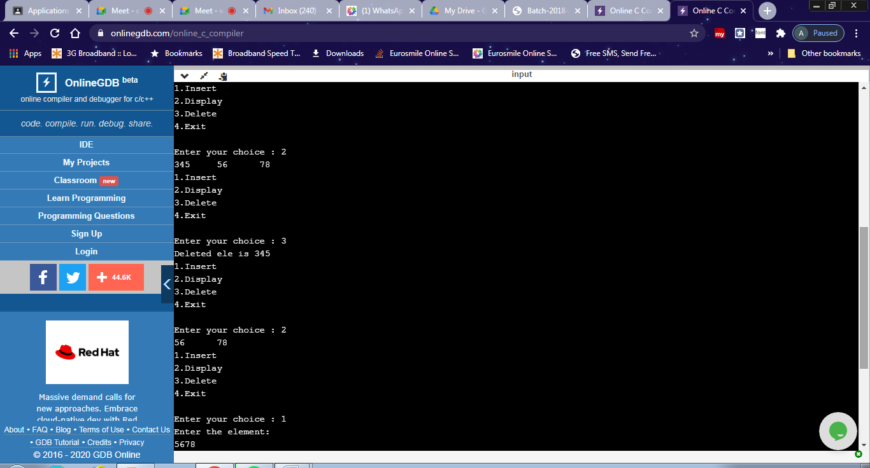
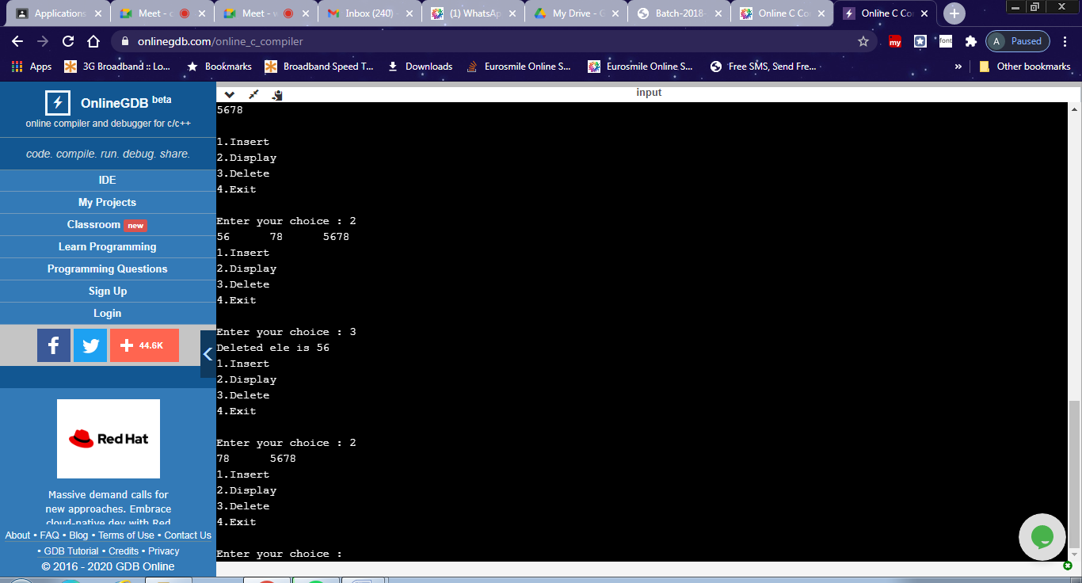
#include <stdio.h>
#include<stdlib.h>
void insert();
void display();
void delete();
struct node
{
int data;
struct node* next;
};
struct node *rear=NULL, *front =NULL;

int main()
{
int choice;
do{
printf("\n1.Insert \n2.Display \n3.Delete \n4.Exit \n");
printf("\nEnter your choice : ");
scanf("%d", &choice);
switch(choice)
{
case 1: insert();
break;
case 2: display();
break;
case 3: delete();
break;
case 4: exit(0);
break;
}
}while(choice!=4);
return 0;
}

void insert()
{
struct node *newnode;
newnode=(struct node *) malloc(sizeof(struct node));
printf("Enter the element:\n");
scanf("%d",&newnode->data);
newnode->next=NULL;

if(rear==NULL)
{
rear=newnode;
front=newnode;

}
else
{
rear->next=newnode;
rear=newnode;
}
}

void delete()
{
if(front==NULL)
{
printf("Queue is empty\n");
return;
}
else
{
printf("Deleted ele is %d ",front->data);
if(front==rear)
{
printf("Queue is empty\n");
front=NULL; rear=NULL;
}
else
front=front->next;
}
}
void display()
{
struct node *temp;
if(front ==NULL)
{
printf("Queue is empty\n");
return;
}
temp=front;
while (temp !=NULL)
{
printf("%d\t",temp->data);
temp=temp->next;
}
}

