Lab 8—Stack implementation using Linked list

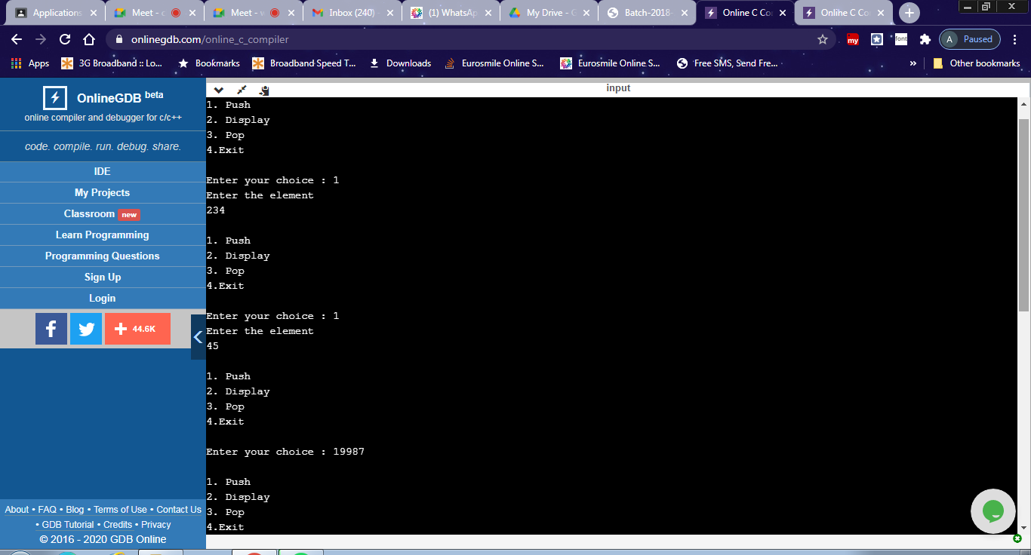
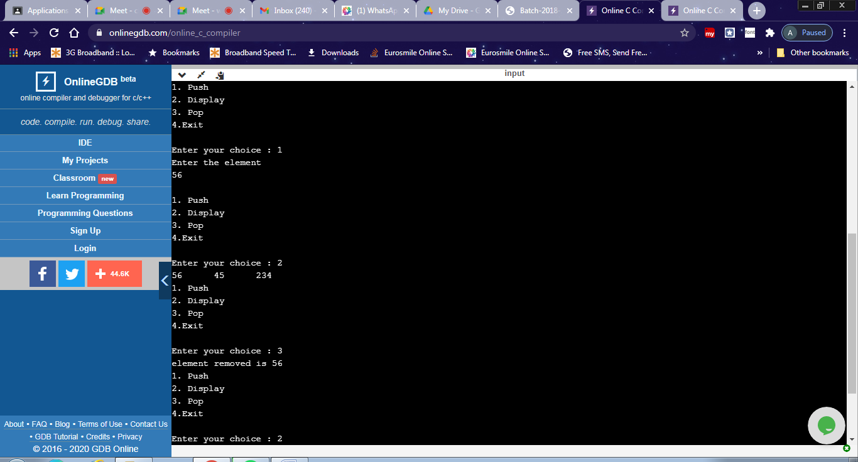
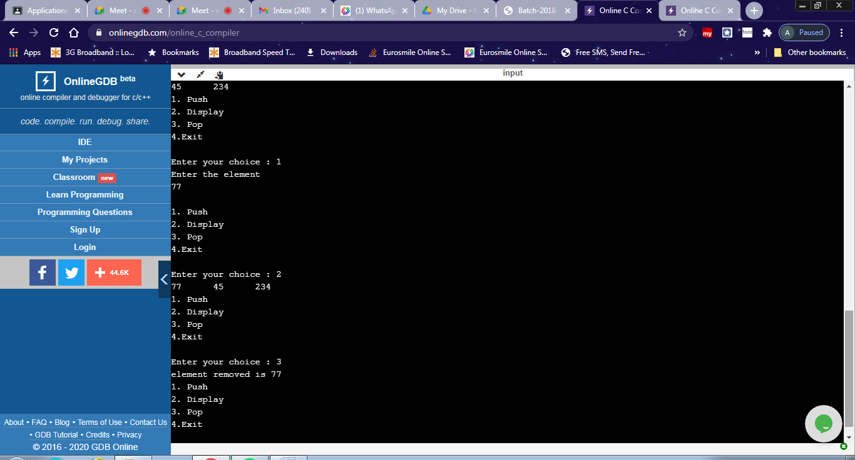

#include <stdio.h>
#include<stdlib.h>
void push();
void pop();
void display();
struct node
{
int data;
struct node *next;
};
struct node *top=NULL;

int main()
{
int choice;
do
{
printf("\n1. Push \n2. Display \n3. Pop \n4.Exit \n");
printf("\nEnter your choice : ");
scanf("%d",&choice);
switch(choice)
{
case 1: push(); break;
case 2: display();break;
case 3: pop(); break;
case 4: exit(0);
}
}while(choice!=4);
}

void push()
{
int item;
struct node *newnode;
printf("Enter the element\n");
scanf("%d",&item);
newnode=(struct node*)malloc(sizeof(struct node));
newnode->data=item;
newnode->next=NULL;
if(top==NULL)
top=newnode;
else
newnode->next=top;
top=newnode;
}

void pop()
{
if(top==NULL)
printf("stack is empty");
else
{
printf("element removed is %d", top->data);
top=top->next;
}
}

void display()
{
struct node *temp;
temp=top;
if(top==NULL)
printf("Stack is empty");
while(temp!=NULL)
{
printf("%d\t",temp->data);
temp=temp->next;
}
}

