**Week3—Extra programs**

1. import java.util.Scanner;

class Sum_odd_even {

public static void main(String[] args) {

int n,i, sumE = 0, sumO = 0;

Scanner sc = new Scanner(System.in);

System.out.println("Enter the number of elements in array:");

n = sc.nextInt();

int a[] = new int[n];

System.out.println("Enter the elements of the array:");

for(i = 0; i < n; i++) {

a[i] = sc.nextInt();

}

for(i = 0; i < n; i++) {

if(i % 2 == 0)

{

sumE = sumE + a[i];

}

else{

sumO = sumO + a[i];

}

}

System.out.println("Sum of Even indices:"+sumE);

System.out.println("Sum of Odd indices:"+sumO);

}

}

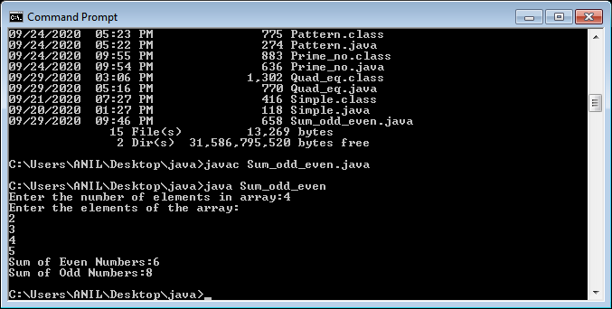

1. import java.util.Scanner;

class p_n_z{

public static void main(String[] args){

Scanner sc = new Scanner(System.in);

int n, i, pos_count=0, neg_count=0, countz = 0;

System.out.println("Enter number of elements in array: ");

n = sc.nextInt();

int a[] = new int[n];

System.out.println(" Enter elements of array: ");

for (i = 0; i < n; i++) {

a[i] = sc.nextInt();

}

for(i = 0; i < n; i++) {

if(a[i] > 0)

{

pos_count++;

}

else if(a[i]<0)

{

neg_count++;

}

else if(a[i]==0)

{

countz++;

}

}

System.out.println("Number of Positive Numbers in array = " + pos_count);

System.out.println("Number of Negative Numbers in array = " + neg_count);

System.out.println("Number of Zeroes in array = " +countz);

}

}

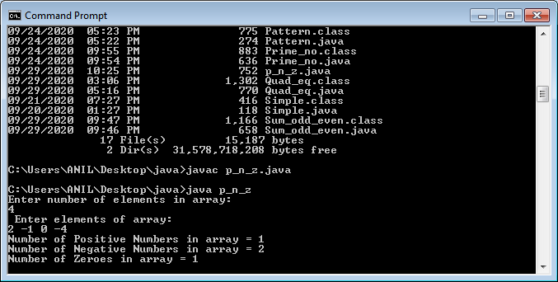

1. import java.util.Scanner;

class discount{

public static void main(String[] args){

Scanner sc = new Scanner(System.in);

int n, i;

double total=0.0, bill=0.0;

System.out.println("Enter num of items: ");

n=sc.nextInt();

double rate[]= new double[n];

int quan[]= new int[n];

for(i=0; i<n; i++) {

System.out.println("Enter the rate and quantity of items purchased: ");

rate[i]=sc.nextDouble();

quan[i]=sc.nextInt();

total=total+ (rate[i]*quan[i]);

}

if(total>=10000) {

bill = 0.95*total;

} else if(total>=7500 && total<10000){

bill = 0.97*total;

} else if(total>=5000){

bill = 0.98*total;

}System.out.println("Total bill before discount: " +total);

System.out.println("Final bill after discount: " +bill);

}

}

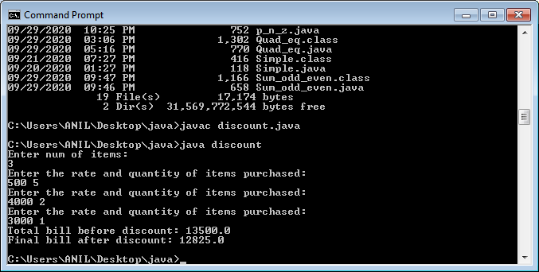

4) import java.util.Scanner;

class extra4{

public static void main(String args[]){

Scanner sc = new Scanner(System.in);

int i, j=0, k=0,n, sum=0, max,min, odd=0, even=0;

double avg=0.0;

System.out.println("Enter the number of elements in array a: ");

n = sc.nextInt();

int a[]= new int[n];

System.out.println("Enter the elements: ");

for(i=0; i<n; i++){

a[i]=sc.nextInt();

if(a[i]%2==0){

even++;

}

else {

odd++;

}

}

int b[]= new int[odd];

int c[]= new int[even];

for(i=0; i<n; i++)

{

if(a[i]%2!=0){

b[j]=a[i];

j++;

}

else {

c[k]=a[i];

k++;

}

}

max = c[0];

min = c[0];

for(i=0; i<even; i++){

sum=sum+c[i];

if(c[i]>max)

max=c[i];

else if(c[i]<min)

min=c[i];

}

avg= (double)(sum/even);

System.out.println("Sum of elements in c array: " +sum);

System.out.println("Average of elements in c array: " +avg);

System.out.println("Max: " +max);

System.out.println("Min: " +min);

}

}

