**Week4—Extra Programs**

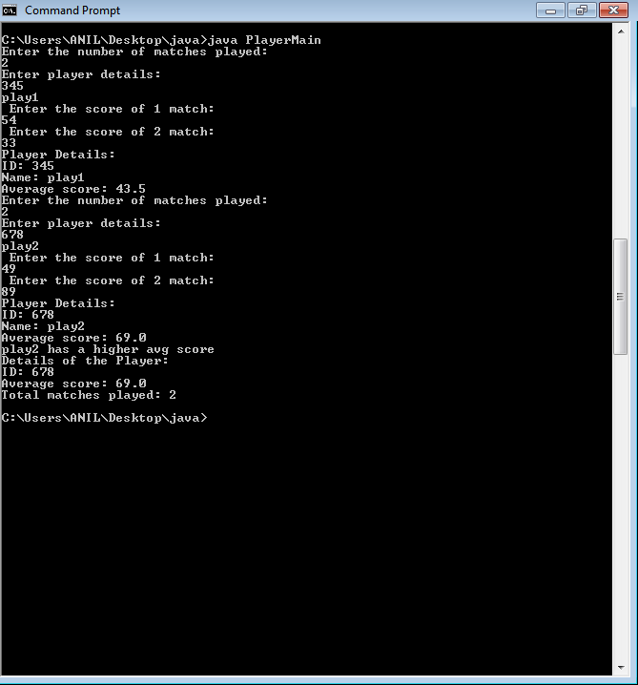

1. import java.util.Scanner;

class Player{

String name;

int id, no_matches_played, sum=0,i;

double avg=0;

int scores[];

Player(){

Scanner sc= new Scanner(System.in);

System.out.println("Enter the number of matches played: ");

no_matches_played= sc.nextInt();

scores = new int[no_matches_played];

}

void getData(){

Scanner sc= new Scanner(System.in);

System.out.println("Enter player details: ");

id=sc.nextInt();

name= sc.next();

for(i=0; i<no_matches_played; i++)

{

System.out.println(" Enter the score of "+(i+1)+" match: ");

scores[i]=sc.nextInt();

}

}

void avg_cal(){

for(i=0; i<no_matches_played; i++){

sum = sum+scores[i];

}

avg = (double) sum/no_matches_played;

}

void printData(){

System.out.println("Player Details: ");

System.out.println("ID: "+id);

System.out.println("Name: "+name);

System.out.println("Average score: "+avg);

}

}

class PlayerMain

{

public static void main(String ss[]){

Player p1= new Player();

p1.getData();

p1.avg_cal();

p1.printData();

Player p2= new Player();

p2.getData();

p2.avg_cal();

p2.printData();

if(p1.avg>p2.avg)

{

System.out.println(p1.name+" has a higher avg score");

System.out.println("Details of the Player: ");

System.out.println("ID: "+p1.id);

System.out.println("Average score: "+p1.avg);

System.out.println("Total matches played: "+p1.no_matches_played);

}

if(p2.avg>p1.avg)

{

System.out.println(p2.name+" has a higher avg score");

System.out.println("Details of the Player: ");

System.out.println("ID: "+p2.id);

System.out.println("Average score: "+p2.avg);

System.out.println("Total matches played: "+p2.no_matches_played);

}

}

}

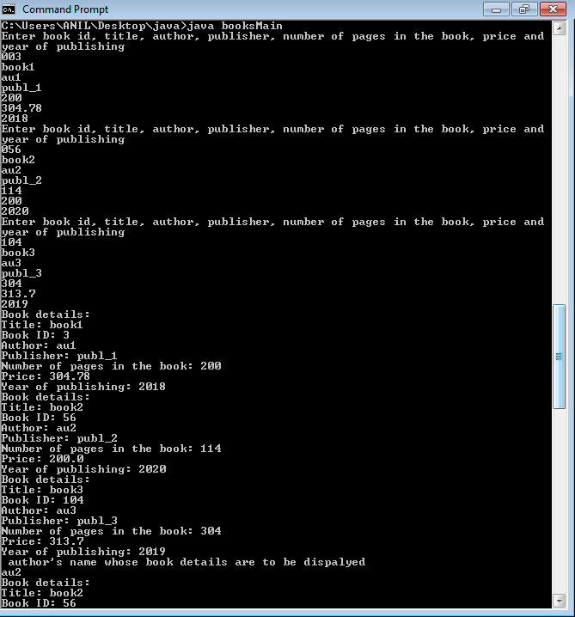

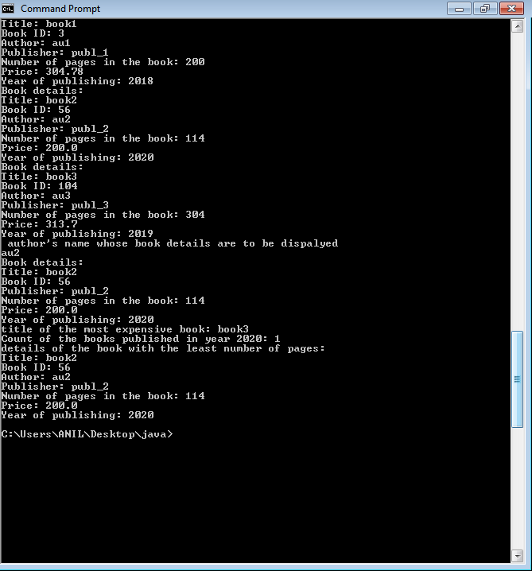

1. import java.util.Scanner;

class books {

String booktitle,author,publisher;

int bookid, no_of_pages,year_of_pub,i;

double price;

void accept() {

Scanner sc=new Scanner(System.in);

System.out.println("Enter book id, title, author, publisher, number of pages in the book, price and year of publishing");

bookid=sc.nextInt();

booktitle=sc.next();

author=sc.next();

publisher=sc.next();

no_of_pages=sc.nextInt();

price=sc.nextDouble();

year_of_pub=sc.nextInt();

}

static void display_mostExpensive(int k,books b[])

{

System.out.println("title of the most expensive book: "+b[k].booktitle);

}

static void display_yr2020(int c)

{

System.out.println("Count of the books published in year 2020: "+c);

}

static void display_least_pages(int l,books b[])

{

System.out.println("details of the book with the least number of pages:");

System.out.println("Title: "+b[l].booktitle);

System.out.println("Book ID: "+b[l].bookid);

System.out.println("Author: "+b[l].author);

System.out.println("Publisher: "+b[l].publisher);

System.out.println("Number of pages in the book: "+b[l].no_of_pages);

System.out.println("Price: "+b[l].price);

System.out.println("Year of publishing: "+b[l].year_of_pub);

}

void display() {

System.out.println("Book details:");

System.out.println("Title: "+booktitle);

System.out.println("Book ID: "+bookid);

System.out.println("Author: "+author);

System.out.println("Publisher: "+publisher);

System.out.println("Number of pages in the book: "+no_of_pages);

System.out.println("Price: "+price);

System.out.println("Year of publishing: "+year_of_pub);

}

static void accept_authorName(books b[]) {

String st;

Scanner sc=new Scanner(System.in);

System.out.println(" author's name whose book details are to be dispalyed");

st=sc.next();

System.out.println("Book details:");

for(int i=0;i<3;i++) {

if(st.equals(b[i].author)) {

System.out.println("Title: "+b[i].booktitle);

System.out.println("Book ID: "+b[i].bookid);

System.out.println("Publisher: "+b[i].publisher);

System.out.println("Number of pages in the book: "+b[i].no_of_pages);

System.out.println("Price: "+b[i].price);

System.out.println("Year of publishing: "+b[i].year_of_pub);

}

}

}

}

class booksMain {

public static void main(String args[]) {

int i,k=0,c=0,l=0;

books b[] = new books[3];

for(i=0;i<3;i++) {

b[i]=new books();

}

for(i=0;i<3;i++) {

b[i].accept();

}

for(i=0;i<3;i++)

{

b[i].display();

}

books.accept_authorName(b);

if(b[0].price>b[1].price && b[0].price>b[2].price)

k=0;

else if(b[1].price>b[0].price && b[1].price>b[2].price)

k=1;

else if(b[2].price>b[1].price && b[2].price>b[0].price)

k=2;

books.display_mostExpensive(k,b);

for(i=0;i<3;i++)

{

if(b[i].year_of_pub==2020)

c++;

}

books.display_yr2020(c);

if(b[0].no_of_pages<b[1].no_of_pages && b[0].no_of_pages<b[2].no_of_pages)

l=0;

else if(b[1].no_of_pages<b[0].no_of_pages && b[1].no_of_pages<b[2].no_of_pages)

l=1;

else if(b[2].no_of_pages<b[1].no_of_pages && b[2].no_of_pages<b[0].no_of_pages)

l=2;

books.display_least_pages(l,b);

}

}

