**Week5—Extra Programs**

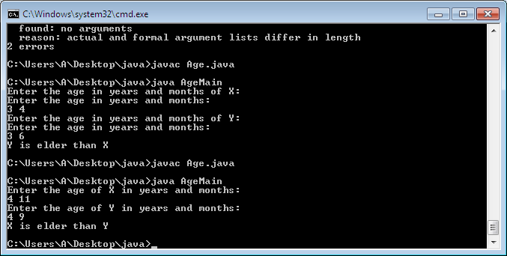

1. import java.util.Scanner;

class Age{

private int years, months;

public Age(){

this.years=years;

this.months=months;

}

public void getAge(){

Scanner sc=new Scanner(System.in);

this.years=sc.nextInt();

this.months=sc.nextInt();

}

public void agecal(Age y){

if(years>y.years)

System.out.println("X is elder than Y");

else if(years<y.years)

System.out.println("Y is elder than X");

if(months>y.months)

System.out.println("X is elder than Y");

else if(months<y.months)

System.out.println("Y is elder than X");

else

System.out.println("X and Y are of same age");

}

}

class AgeMain{

public static void main(String args[]){

int years, months;

Age x = new Age();

Age y = new Age();

System.out.println("Enter the age of X in years and months: ");

x.getAge();

System.out.println("Enter the age of Y in years and months: ");

y.getAge();

x.agecal(y);

}

}

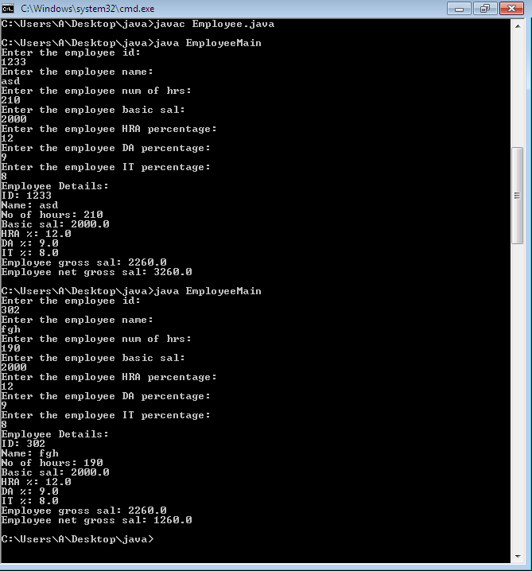

1. import java.util.Scanner;

class Employee

{

private int empid,empnohrs;

private String empname;

private double empbasic, emphra, empda, empit, empgross, empgross1;

Employee(){

empid=0;

empname=" ";

empnohrs= 0;

empbasic= 0.0;

emphra= 0.0;

empda= 0.0;

empit= 0.0;

empgross= 0;

}

void getData()

{

Scanner sc= new Scanner(System.in);

System.out.println("Enter the employee id: ");

empid= sc.nextInt();

System.out.println("Enter the employee name: ");

empname= sc.next();

System.out.println("Enter the employee num of hrs: ");

empnohrs= sc.nextInt();

System.out.println("Enter the employee basic sal: ");

empbasic= sc.nextDouble();

System.out.println("Enter the employee HRA percentage: ");

emphra= sc.nextDouble();

System.out.println("Enter the employee DA percentage: ");

empda= sc.nextDouble();

System.out.println("Enter the employee IT percentage: ");

empit= sc.nextDouble();

}

public String toString()

{

return ("Employee Details: \nID: " +empid+ " \nName: " +empname+" \nNo of hours: " +empnohrs+" \nBasic sal: " +empbasic+" \nHRA %: " +emphra+" \nDA %: " +empda+" \nIT %: " +empit);

}

void calc()

{

empgross= (empbasic + (empbasic*(emphra/100)) + (empbasic*(empda/100)) - (empbasic*(empit/100)));

if(empnohrs>200)

empgross1= empgross+ (empnohrs-200)*100;

else if(empnohrs<200)

empgross1= empgross- (200-empnohrs)*100;

System.out.println("Employee gross sal: "+empgross);

System.out.println("Employee net gross sal: "+empgross1);

}

}

class EmployeeMain {

public static void main(String args[]){

Scanner sc= new Scanner(System.in);

int empid,empnohrs;

String empname;

double empbasic, emphra, empda, empit, empgross, empgross1=0;

Employee e1= new Employee();

e1.getData();

System.out.println(e1);

e1.calc();

}

}

