**Week 9— Extra Program**

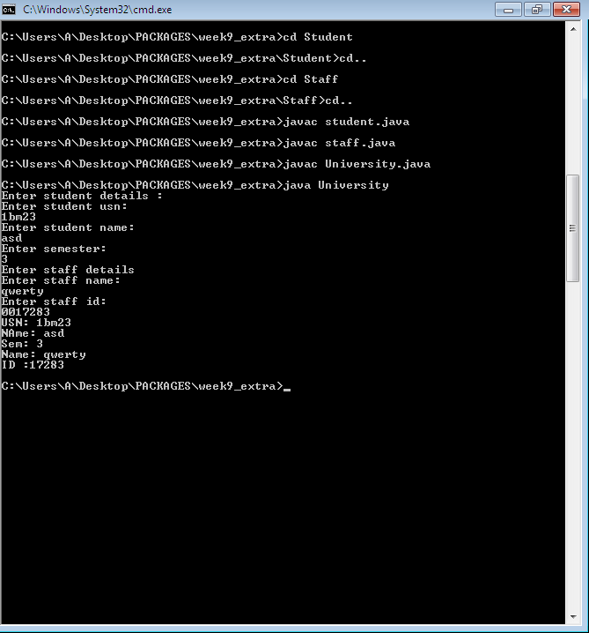

package Student;

import java.util.Scanner;

public class student

{

public String usn,name;

public int sem;

public void getd()

{

Scanner sc=new Scanner(System.in);

System.out.println("Enter student details :");

System.out.println("Enter student usn: ");

usn= sc.next();

System.out.println("Enter student name: ");

name= sc.next();

System.out.println("Enter semester: ");

sem= sc.nextInt();

}

public void dispstd()

{

System.out.println("USN: "+usn);

System.out.println("Name: "+name);

System.out.println("Sem: "+sem);

}

}

package Staff;

import java.util.Scanner;

public class staff

{

public String name;

public int id;

public void getdata()

{

Scanner sc=new Scanner(System.in);

System.out.println("Enter staff details ");

System.out.println("Enter staff name: ");

name= sc.next();

System.out.println("Enter staff id: ");

id= sc.nextInt();

}

public void dispstf() {

System.out.println("Name: "+name);

System.out.println("ID :"+id);

}

}

import Student.*;

import Staff.*;

import java.util.Scanner;

class University {

public static void main(String sss[]){

Scanner sc= new Scanner(System.in);

Student.student sd= new Student.student();

Staff.staff sf=new Staff.staff();

sd.getd();

sf.getdata();

sd.dispstd();

sf.dispstf();

}

}

