**Week 12—Extra Programs**

1. Button

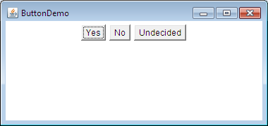

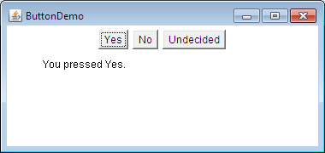

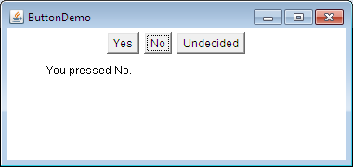

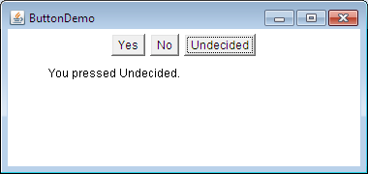

import java.awt.*;

import java.awt.event.*;

public class ButtonDemo extends Frame implements ActionListener {

String msg = "";

Button yes, no, maybe;

public ButtonDemo() {

setLayout(new FlowLayout());

yes = new Button("Yes");

no = new Button("No");

maybe = new Button("Undecided");

add(yes);

add(no);

add(maybe);

yes.addActionListener(this);

no.addActionListener(this);

maybe.addActionListener(this);

addWindowListener(new WindowAdapter() {

public void windowClosing(WindowEvent we) {

System.exit(0);

}

});

public void actionPerformed(ActionEvent ae){

String str = ae.getActionCommand();

if(str.equals("Yes")) {

msg = "You pressed Yes.";

}

else if(str.equals("No")) {

msg = "You pressed No.";

}

else{

msg = "You pressed Undecided.";

}

repaint();

}

public void paint(Graphics g) {

g.drawString(msg, 50, 80);

}

public static void main(String[] args) {

ButtonDemo appwin = new ButtonDemo();

appwin.setSize(new Dimension(380,180));

appwin.setTitle("ButtonDemo");

appwin.setVisible(true);

}

}

2) Text Field

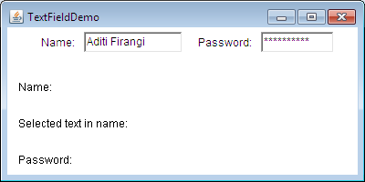

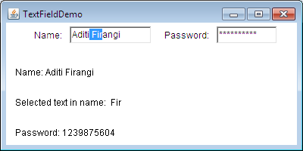

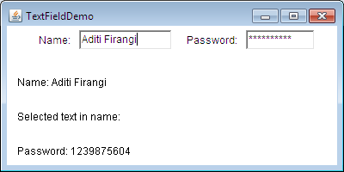

import java.awt.*;

import java.awt.event.*;

public class TextFieldDemo extends Frame implements ActionListener {

TextField name, pass;

public TextFieldDemo() {

setLayout(new FlowLayout());

Label namep = new Label("Name: ", Label.RIGHT);

Label passp = new Label("Password: ", Label.RIGHT);

name = new TextField(12);

pass = new TextField(8);

pass.setEchoChar('*');

add(namep);

add(name);

add(passp);

add(pass);

name.addActionListener(this);

pass.addActionListener(this);

addWindowListener(new WindowAdapter() {

public void windowClosing(WindowEvent we) {

System.exit(0);

}

});

}

public void actionPerformed(ActionEvent ae) {

repaint();

}

public void paint(Graphics g) {

g.drawString("Name: " + name.getText(), 20, 100);

g.drawString("Selected text in name: " + name.getSelectedText(), 20, 140);

g.drawString("Password: " + pass.getText(), 20, 180);

}

public static void main(String[] args) {

TextFieldDemo appwin = new TextFieldDemo();

appwin.setSize(new Dimension(400,200));

appwin.setTitle("TextFieldDemo");

appwin.setVisible(true);

}

}

