**Week 8—Extra Programs**

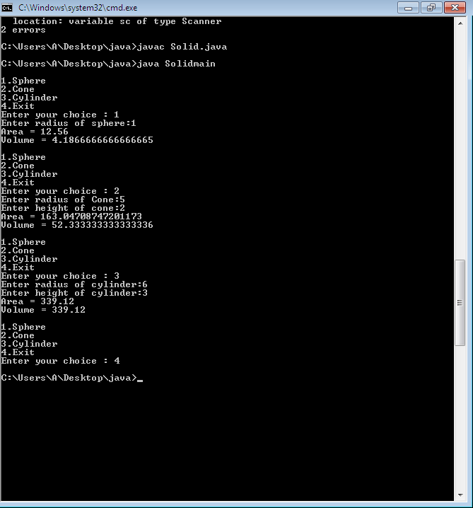

1. import java.util.Scanner;

abstract class Shape {

double r, h;

Shape(double r, double h)

{

this.r = r;

this.h = h;

}

abstract double calcArea();

abstract double calcVolume();

}

class Cylinder extends Shape

{

Cylinder(double r, double h)

{ super(r, h); }

double calcArea()

{

return ( 2*3.14*r*(h+r));

}

double calcVolume()

{

return (3.14*r*r*h);

}

}

class Cone extends Shape

{

Cone(double r, double h)

{ super(r, h); }

double calcArea()

{

return (3.14*r*(r+Math.sqrt(r*r+h*h)));

}

double calcVolume()

{

return ((3.14*r*r*h)/3);

}

}

class Sphere extends Shape

{

Sphere(double r)

{ super(r, 0); }

double calcArea()

{

return (4*3.14*r*r);

}

double calcVolume()

{

return ( (4*3.14*r*r*r))/3);

}

}

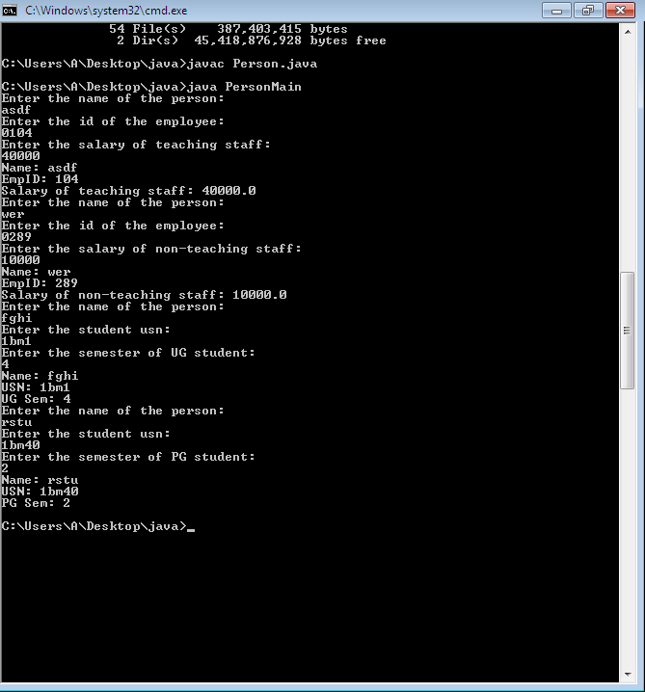

1. import java.util.Scanner;

class Person{

String name;

void acc_person()

{

Scanner sc= new Scanner(System.in);

System.out.println("Enter the name of the person: ");

name=sc.next();

}

void disp_person()

{

System.out.println("Name: "+name);

}

}

class Employee extends Person{

int empid;

void acc_employee(){

Scanner sc= new Scanner(System.in);

System.out.println("Enter the id of the employee: ");

empid=sc.nextInt();

}

void disp_employee(){

System.out.println("EmpID: "+empid);

}

}

class Student extends Person{

String usn;

void acc_student(){

Scanner sc= new Scanner(System.in);

System.out.println("Enter the student usn: ");

usn = sc.next();

}

void disp_student(){

System.out.println("USN: "+usn);

}

}

class Teaching extends Employee{

double sal_teach;

void acc_teaching(){

Scanner sc= new Scanner(System.in);

System.out.println("Enter the salary of teaching staff: ");

sal_teach=sc.nextDouble();

}

void disp_teaching(){

System.out.println("Salary of teaching staff: "+sal_teach);

}

}

class NonTeaching extends Employee{

double sal_nonteach;

void acc_nonteaching(){

Scanner sc=new Scanner(System.in);

System.out.println("Enter the salary of non-teaching staff: ");

sal_nonteach=sc.nextDouble();

}

void disp_nonteaching(){

System.out.println("Salary of non-teaching staff: "+sal_nonteach);

}

}

class UG extends Student{

int ugsem;

void acc_ug(){

Scanner sc= new Scanner(System.in);

System.out.println("Enter the semester of UG student: ");

ugsem= sc.nextInt();

}

void disp_ug(){

System.out.println("UG Sem: "+ugsem);

}

}

class PG extends Student{

int pgsem;

void acc_pg(){

Scanner sc= new Scanner(System.in);

System.out.println("Enter the semester of PG student: ");

pgsem= sc.nextInt();

}

void disp_pg(){

System.out.println("PG Sem: "+pgsem);

}

}

class PersonMain{

public static void main(String args[])

{

Teaching tc= new Teaching();

tc.acc_person();

tc.acc_employee();

tc.acc_teaching();

tc.disp_person();

tc.disp_employee();

tc.disp_teaching();

NonTeaching nt= new NonTeaching();

nt.acc_person();

nt.acc_employee();

nt.acc_nonteaching();

nt.disp_person();

nt.disp_employee();

nt.disp_nonteaching();

UG us= new UG();

us.acc_person();

us.acc_student();

us.acc_ug();

us.disp_person();

us.disp_student();

us.disp_ug();

PG ps=new PG();

ps.acc_person();

ps.acc_student();

ps.acc_pg();

ps.disp_person();

ps.disp_student();

ps.disp_pg();

}

}

