**Week6—Extra Programs**

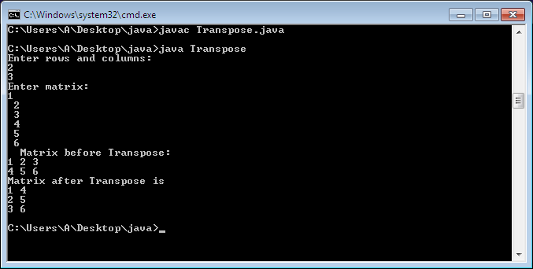

1. import java.util.Scanner;

class Transpose

{

public static void main(String args[]){

int i, j;

System.out.println("Enter rows and columns: ");

Scanner sc = new Scanner(System.in);

int row = sc.nextInt();

int column = sc.nextInt();

int matrix[][] = new int[row][column];

System.out.println("Enter matrix:");

for(i= 0; i<row; i++)

{

for(j= 0; j<column; j++)

{

matrix[i][j] = sc.nextInt();

System.out.print(" ");

}

}

System.out.println(" Matrix before Transpose: ");

for(i = 0; i<row; i++)

{

for(j = 0; j<column; j++)

{

System.out.print(matrix[i][j]+" ");

}

System.out.println(" ");

}

System.out.println("Matrix after Transpose is ");

for(i = 0; i < column; i++)

{

for(j = 0; j < row; j++)

{

System.out.print(matrix[j][i]+" ");

}

System.out.println(" ");

}

}

}

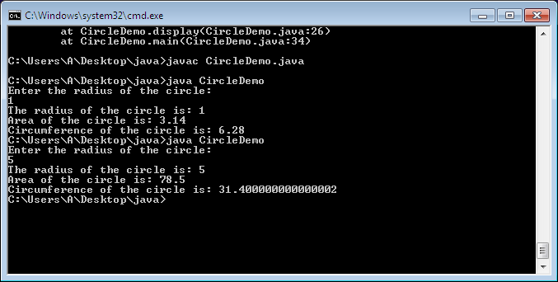

1. import java.util.Scanner;

class CircleDemo

{

Scanner sc= new Scanner(System.in);

public int radius;

public double area, circum;

void accept()

{

System.out.println("Enter the radius of the circle: ");

radius=sc.nextInt();

}

void ar()

{

area= 3.14*radius*radius;

}

void peri()

{

circum=2*3.14*radius;

}

void display()

{

System.out.println("The radius of the circle is: "+radius);

System.out.println("Area of the circle is: "+area);

System.out.printf("Circumference of the circle is: "+circum);

}

public static void main(String args[]){

CircleDemo c1= new CircleDemo();

c1.accept();

c1.ar();

c1.peri();

c1.display();

}

}

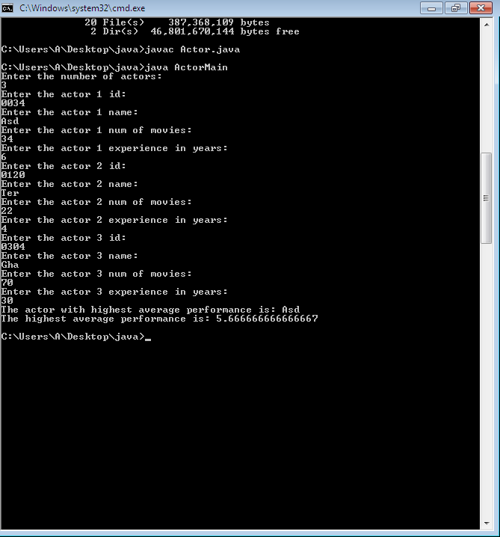

1. import java.util.Scanner;

class Actor

{

int id,no_of_movies,no_of_years_exp, n;

String name;

double avgcalc()

{

double avg_perf=(double)no_of_movies/no_of_years_exp;

return avg_perf;

}

}

class ActorMain

{

public static void main(String[] args){

Scanner sc= new Scanner(System.in);

int i,n;

System.out.println("Enter the number of actors: ");

n=sc.nextInt();

Actor a[]=new Actor[n];

double av[]=new double[n];

for(i=0;i<n;i++)

{

a[i]=new Actor();

System.out.println("Enter the actor "+(i+1)+" id: ");

a[i].id=sc.nextInt();

System.out.println("Enter the actor "+(i+1)+" name: ");

a[i].name=sc.next();

System.out.println("Enter the actor "+(i+1)+" num of movies: ");

a[i].no_of_movies=sc.nextInt();

System.out.println("Enter the actor "+(i+1)+" experience in years: ");

a[i].no_of_years_exp=sc.nextInt();

av[i]=a[i].avgcalc();

}

double max=av[0];

int m=0;

for(i=0;i<n;i++) {

if(av[i]>max) {

max=av[i];

m=i;

}

}

System.out.println("The actor with highest average performance is: "+a[m].name);

System.out.println("The highest average performance is: "+av[m]);

}

}

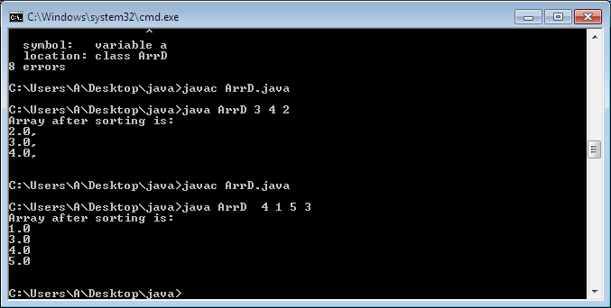

1. import java.util.Scanner;

class ArrD{

public static void main(String args[]){

Scanner sc=new Scanner(System.in);

int n= args.length;

double a[]= new double[n];

for(int i=0;i<n;i++)

{

a[i]= Double.parseDouble(args[i]);

}

double temp;

for(int i=0; i<n; i++) {

for(int j=i+1; j<n; j++) {

if(a[i]>a[j])

{

temp=a[i];

a[i]=a[j];

a[j]=temp;

}

}

}

System.out.println("Array after sorting is: ");

for(int i=0; i<n; i++)

{

System.out.println(a[i]+" ");

}

System.out.println();

}

}

