**Week 12—Lab 10**

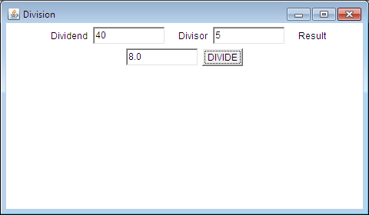

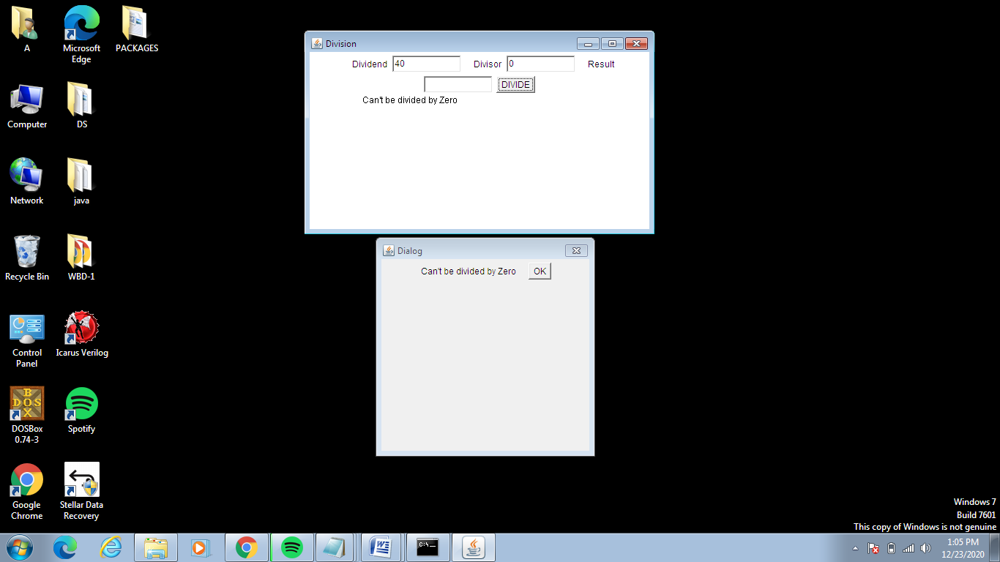

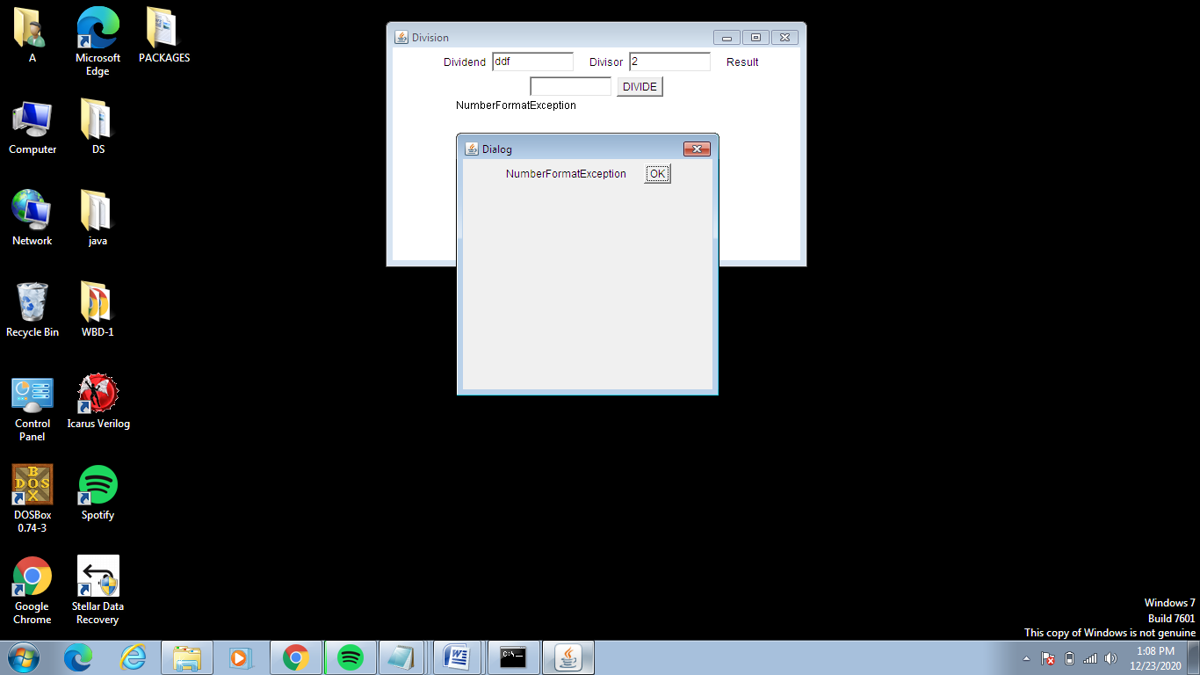

import java.awt.*;

import java.awt.event.*;

public class Division extends Frame implements ActionListener {

public class DialogD extends Frame{

String msg;

DDialog myDialog;

public DialogD() {

myDialog = new DDialog(this, "New Dialog Box", msg);

}

}

String msg;

TextField num1, num2, res;

Label l1, l2, l3;

Button div;

public Division() {

setLayout(new FlowLayout());

l1 = new Label("Dividend",Label.RIGHT);

l2 = new Label("Divisor", Label.RIGHT);

l3 = new Label("Result", Label.RIGHT);

num1 = new TextField(10);

num2 = new TextField(10);

res = new TextField(10);

div = new Button("DIVIDE");

add(l1);

add(num1);

add(l2);

add(num2);

add(l3);

add(res);

add(div);

div.addActionListener(this);

addWindowListener(new MyWindowAdapter());

}

public void actionPerformed(ActionEvent ae) {

int num1 = 0, num2 = 0;

try {

num1 = Integer.parseInt(this.num1.getText());

num2 = Integer.parseInt(this.num2.getText());

double num3 =(double) num1 / num2;

res.setText(String.valueOf(num3));

msg = "Division Successful";

} catch (NumberFormatException e)

System.out.println(e);

res.setText("");

msg = "NumberFormatException ";

DDialog dd = new DDialog(this, "Dialog", msg);

dd.setVisible(true);

return;

}

try {

if(num2==0)

throw new ArithmeticException();

msg = "Can't be divided by Zero";

} catch (ArithmeticException e) {

System.out.println("Can't be divided by Zero" + e);

res.setText("");

msg = "Can't be divided by Zero";

DDialog dd = new DDialog(this, "Dialog", msg);

dd.setVisible(true);

return;

}

}

public void paint(Graphics g) {

g.drawString(msg, 80, 100);

}

public static void main(String[] args) {

Division appwin = new Division();

appwin.setSize(new Dimension(480,280));

appwin.setTitle("Division");

appwin.setVisible(true);

}

}

class MyWindowAdapter extends WindowAdapter {

public void windowClosing(WindowEvent we)

{ System.exit(0); }

}

class DDialog extends Dialog {

DDialog(Frame parent, String title, String msg)

{

super(parent,title,false);

setLayout(new FlowLayout());

setSize(300,300);

add(new Label(msg));

Button b;

add(b = new Button("OK"));

b.addActionListener((ae)->dispose());

addWindowListener(new WindowAdapter() {

public void windowClosing(WindowEvent we)

{

dispose();

}

});

}

}