**Week 10—Lab 7**

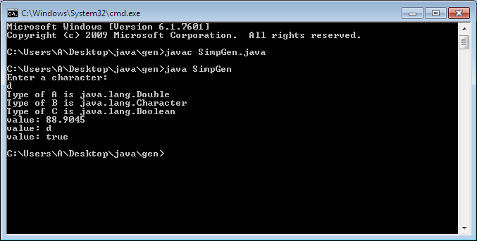

import java.util.Scanner;

class Gen<A,B,C >{

A ob1;

B ob2;

C ob3;

Gen(A o1, B o2, C o3){

ob1 = o1;

ob2 = o2;

ob3 = o3;

}

void showTypes()

{

System.out.println("Type of A is " +

ob1.getClass().getName());

System.out.println("Type of B is " +

ob2.getClass().getName());

System.out.println("Type of C is " +

ob3.getClass().getName());

}

A getob1() {

return ob1;

}

B getob2() {

return ob2;

}

C getob3() {

return ob3;

}

}

class SimpGen

{

public static void main(String args[]) {

Scanner sc=new Scanner(System.in);

System.out.println("Enter a character: ");

char c=sc.next().charAt(0);

Gen<Double, Character, Boolean> gObj =

new Gen<Double, Character, Boolean>(88.9045, c, true);

gObj.showTypes();

double v = gObj.getob1();

System.out.println("value: " + v);

char w = gObj.getob2();

System.out.println("value: " + w);

boolean x = gObj.getob3();

System.out.println("value: " + x);

}

}