**Week 10—Lab 8**

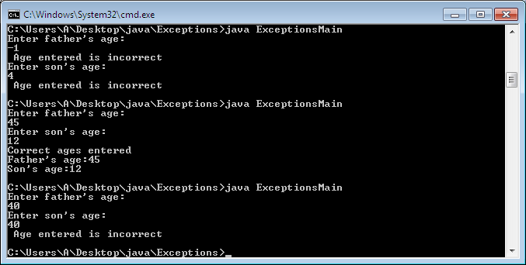

import java.util.Scanner;

class WrongAge extends Exception {

int age;

WrongAge(int x) {

age = x;

}

public String toString() {

return "Age entered is incorrect";

}

}

class father {

int a;

father(int x) {

a = x;

}

void check() throws WrongAge {

if(a<0) {

throw new WrongAge(a);

}

}

}

class son extends father {

int age;

son(int fage, int sage) {

super(fage);

age = sage;

}

void check() throws WrongAge {

if (age >= a || age<0) {

throw new WrongAge(age);

}

else {

System.out.println("Correct ages entered");

System.out.println("Father's age:" + a + "\n" + "Son's age:" + age);

}

}

}

class ExceptionsMain {

public static void main(String args[]) {

Scanner sc = new Scanner(System.in);

System.out.println("Enter father's age:");

int f = sc.nextInt();

father ff = new father(f);

try {

ff.check();

}

catch (WrongAge e) {

System.out.println(" "+e);

}

System.out.println("Enter son's age:");

int s = sc.nextInt();

son ss = new son(f, s);

try {

ss.check();

}

catch (WrongAge e) {

System.out.println(" "+e);

}

}

}