**Week 11 – Lab 9**

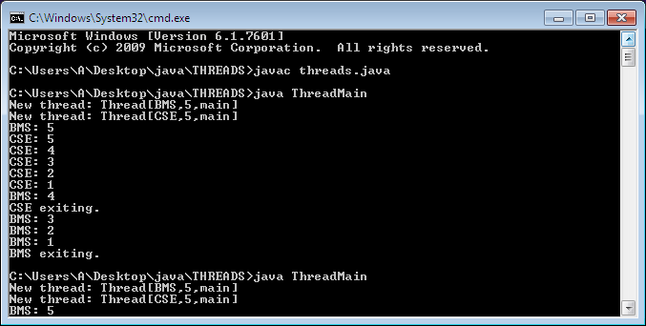

class NewThread implements Runnable {

String name;

Thread t;

int a;

NewThread(String threadname, int time) {

name = threadname;

t = new Thread(this, name);

a = time;

System.out.println("New thread: " + t);

t.start();

}

public void run() {

try {

for(int i = 5; i > 0; i--) {

System.out.println(name + ": " + i);

Thread.sleep(a);

}

} catch (InterruptedException e) {

System.out.println(name + "Interrupted");

}

System.out.println(name + " exiting.");

}

}

class ThreadMain {

public static void main(String args[]) {

new NewThread("BMS", 10000);

new NewThread("CSE", 2000);

}

}