**Week 5—Lab 3**

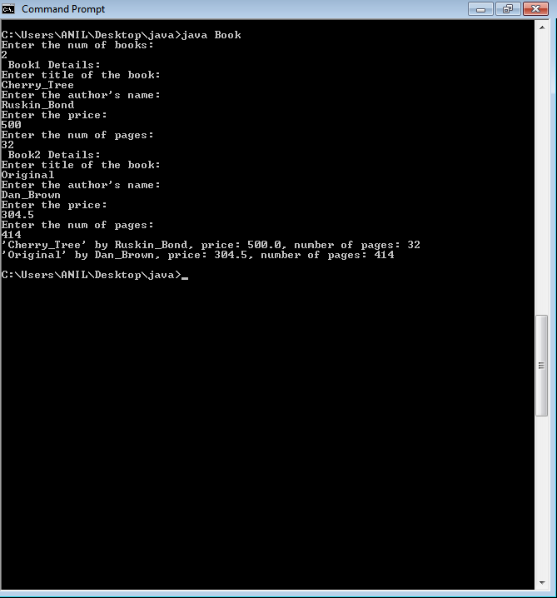

import java.util.Scanner;

class Book {

private String name;

private String author;

private double price;

private int num_pages;

Book(){

name=" ";

author=" ";

price= 0.0;

num_pages=0;

}

void getDetails(){

Scanner sc= new Scanner(System.in);

System.out.println("Enter title of the book: ");

name = sc.next();

System.out.println("Enter the author's name: ");

author = sc.next();

System.out.println("Enter the price: ");

price = sc.nextDouble();

System.out.println("Enter the num of pages: ");

num_pages = sc.nextInt();

}

public String toString()

{

return ("'" +name+"' by " +author+ ", price: " +price+ ", number of pages: "+num_pages);

}

public static void main(String ss[])

{

Scanner sc= new Scanner(System.in);

int i,n;

System.out.println("Enter the num of books: ");

n= sc.nextInt();

Book b[]=new Book[n];

for(i=0; i<n; i++)

{

b[i]= new Book();

System.out.println(" Book" +(i+1)+" Details: ");

b[i].getDetails();

}

for(i=0; i<n; i++){

System.out.println(b[i]);

}