**Week 8—Lab 4**

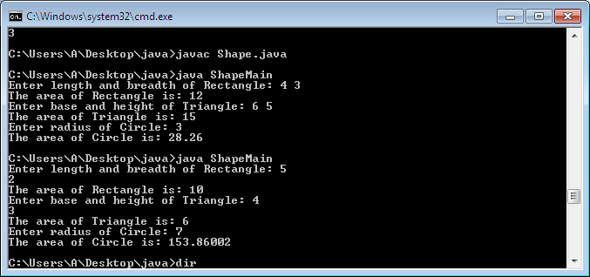

import java.util.Scanner;

abstract class Shape{

int a,b;

Scanner sc = new Scanner(System.in);

abstract void printArea();

}

class Rectangle extends Shape{

void printArea(){

System.out.print("Enter length and breadth of Rectangle: ");

a = sc.nextInt();

b = sc.nextInt();

System.out.println("The area of Rectangle is: "+a*b);

}

}

class Triangle extends Shape {

void printArea() {

System.out.print("Enter base and height of Triangle: ");

a = sc.nextInt();

b = sc.nextInt();

System.out.println("The area of Triangle is: "+(a*b)/2);

}

}

class Circle extends Shape {

void printArea() {

System.out.print("Enter radius of Circle: ");

a = sc.nextInt();

System.out.println("The area of Circle is: " +3.14f*a*a);

}

}

class ShapeMain {

public static void main(String[] args) {

Rectangle rec = new Rectangle();

rec.printArea();

Triangle tri = new Triangle();

tri.printArea();

Circle cir = new Circle();

cir.printArea();

}

}