**Week 8—Lab 5**

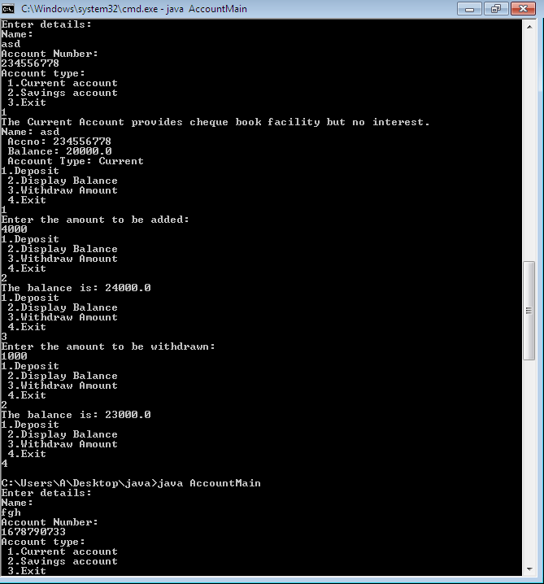

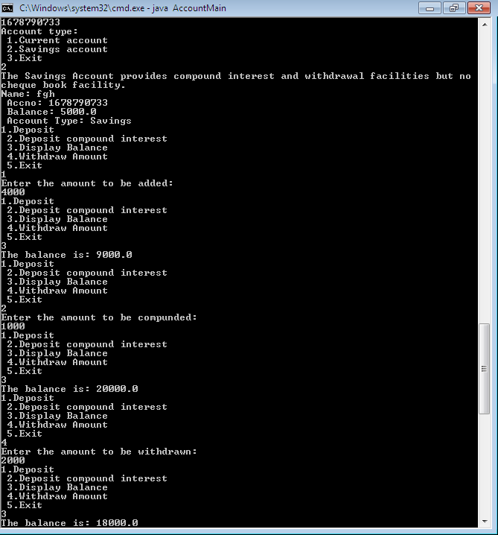

import java.util.Scanner;

abstract class Account

{

String name, acctype;

long accNo;

double bal;

Account(String name, long accNo, double bal, String acctype)

{

this.accNo = accNo;

this.name = name;

this.bal = bal;

this.acctype = acctype;

}

abstract void addBal(double amt);

abstract void displayBal();

abstract void withdrawBal(double amt);

}

class Curr_acct extends Account

{

final double minBal = 1000.0;

Curr_acct(String name, long accNo, double bal)

{

super(name, accNo, bal, "Current");

System.out.println("Name: "+name+"\n Accno: "+accNo+"\n Balance: "+bal+"\n Account Type: "+acctype);

}

void addBal(double amt)

{

this.bal += amt;

}

void displayBal()

{

System.out.println("The balance is: "+this.bal);

}

void checkBal(){

if(this.bal<minBal)

{

System.out.println("Insufficient balance, service charge imposed");

this.bal -= this.bal*0.02;

}

}

void withdrawBal(double amt)

{

this.bal -= amt;

checkBal();

}

}

class Sav_acct extends Account

{

Sav_acct(String name, long accNo, double bal)

{

super(name, accNo, bal, "Savings");

System.out.println("Name: "+name+"\n Accno: "+accNo+"\n Balance: "+bal+"\n Account Type: "+acctype);

}

void addBal(double amt)

{

this.bal+= amt;

}

void addCI(double amt)

{

this.bal+= amt;

addIntr();

}

void addIntr()

{

int tm=2, R=7;

this.bal+= this.bal*(Math.pow((1+(R/100)), tm));

}

void displayBal()

{

System.out.println("The balance is: "+this.bal);

}

void withdrawBal(double amt)

{

this.bal-= amt;

}

}

class AccountMain {

public static void main(String[] args) {

Scanner sc = new Scanner(System.in);

double amt;

System.out.println("Enter details:");

System.out.println("Name:");

String s1=sc.next();

System.out.println("Account Number:");

long s2=sc.nextLong();

while(true) {

System.out.println("Account type:\n 1.Current account\n 2.Savings account\n 3.Exit");

int o=sc.nextInt();

if(o==1){

System.out.println("The Current Account provides cheque book facility but no interest.");

Curr_acct cr = new Curr_acct(s1, s2, 20000);

while(true) {

System.out.println("1.Deposit\n 2.Display Balance\n 3.Withdraw Amount\n 4.Exit");

int ch = sc.nextInt();

switch (ch) {

case 1:

System.out.println("Enter the amount to be added:");

amt = sc.nextDouble();

cr.addBal(amt);

break;

case 2:

cr.displayBal();

break;

case 3:

System.out.println("Enter the amount to be withdrawn:");

amt = sc.nextDouble();

cr.withdrawBal(amt);

break;

case 4:System.exit(0);

default:System.out.println("Invalid choice");

}

}

}

else if(o==2){

System.out.println("The Savings Account provides compound interest and withdrawal facilities but no cheque book facility.");

Sav_acct sv = new Sav_acct(s1, s2, 5000);

while(true) {

System.out.println("1.Deposit\n 2.Deposit compound interest\n 3.Display Balance\n 4.Withdraw Amount\n 5.Exit");

int ch = sc.nextInt();

switch (ch) {

case 1:

System.out.println("Enter the amount to be added:");

amt = sc.nextDouble();

sv.addBal(amt);

break;

case 2:

System.out.println("Enter the amount to be compunded: ");

amt=sc.nextDouble();

sv.addCI(amt);

break;

case 3:

sv.displayBal();

break;

case 4:

System.out.println("Enter the amount to be withdrawn:");

amt = sc.nextDouble();

sv.withdrawBal(amt);

break;

case 5:System.exit(0);

default:System.out.println("Invalid choice");

}

}

}

else if(o==3)

System.exit(0);

else

System.out.println("Invalid choice");

}

}

}