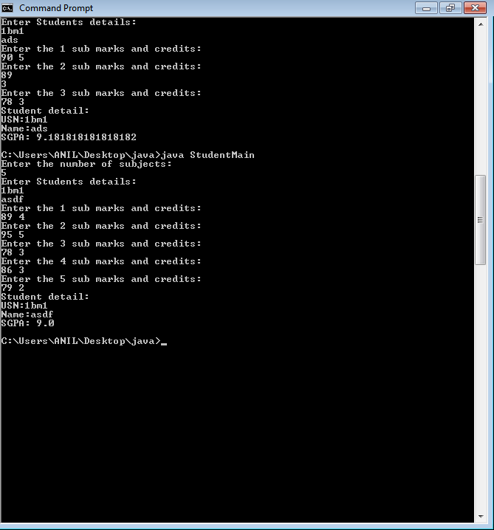

import java.util.Scanner;

class Student

{

private String usn, name;

private double sgpa;

private int n, i, sum=0, cred_sum=0,grade;

double[] marks=new double[n];

int credit[]=new int[n];

Student()

{

Scanner sc=new Scanner(System.in);

System.out.println("Enter the number of subjects: ");

n=sc.nextInt();

}

void getStdData(){

Scanner sc=new Scanner(System.in);

System.out.println("Enter Students details:");

usn=sc.next();

name=sc.next();

for(i=0; i<n; i++){

System.out.println("Enter the "+(i+1)+" sub marks and credits:");

marks[i] = sc.nextDouble();

credit[i]=sc.nextInt();

}

}

void sgpa_cal(){

for(i=0; i<n; i++){

if(marks[i]>=90 && marks[i]<=100)

grade=10;

else if(marks[i]>=80 && marks[i]<90)

grade= 9;

else if(marks[i]>=70 && marks[i]<80)

grade=8;

else if(marks[i]>=60 && marks[i]<70)

grade=7;

else if(marks[i]>=50 && marks[i]<60)

grade=6;

else if(marks[i]>=40 && marks[i]<50)

grade=5;

else if(marks[i]<40)

grade=0;

sum+= grade*credit[i];

}

for(i=0; i<n; i++){

cred_sum+=credit[i];

}

sgpa= (double)sum/cred_sum;

}

void printData()

{

System.out.println("Student detail: ");

System.out.println("USN:"+usn);

System.out.println("Name:"+name);

System.out.println("SGPA: "+sgpa);

}

}

class StudentMain

{

public static void main(String[] args){

Student s1= new Student();

s1.getStdData();

s1.sgpa_cal();

s1.printData();

}

}