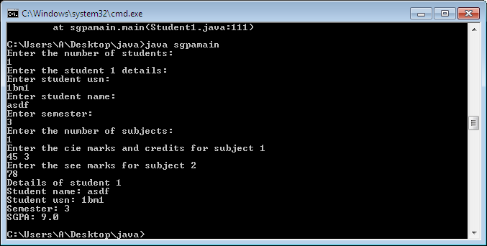

1. import java.util.Scanner;

class Student1

{

String usn,name;

int sem;

void accept1()

{

Scanner sc=new Scanner(System.in);

System.out.println("Enter student usn: ");

usn=sc.next();

System.out.println("Enter student name: ");

name=sc.next();

System.out.println("Enter semester: ");

sem=sc.nextInt();

}

}

class Test1 extends Student1

{

int n,i;

double cie[], cred[];

void accept2()

{

Scanner sc=new Scanner(System.in);

System.out.println("Enter the number of subjects: ");

n=sc.nextInt();

cie=new double[n];

cred=new double[n];

System.out.println("Enter the cie marks and credits for subject "+(i+1));

for(i=0;i<n;i++){

cie[i]=sc.nextDouble();

cred[i]=sc.nextDouble();

}

}

}

class Exam1 extends Test1

{

double see[];

void accept3()

{

Scanner sc=new Scanner(System.in);

System.out.println("Enter the see marks for subject "+(i+1));

see=new double[n];

int i;

for(i=0;i<n;i++)

{

see[i]=sc.nextDouble();

}

}

}

class Result1 extends Exam1

{

double sgpa;

int gp[]=new int[n];

void calc()

{

int i;

double sum=0,cred_sum=0;

for(i=0;i<n;i++)

{

double tot;

tot=cie[i]+(see[i]/2);

if(tot>=90 && tot<=100)

gp[i]=10;

else if(tot>=80)

gp[i]=9;

else if(tot>=70)

gp[i]=8;

else if(tot>=60)

gp[i]=7;

else if(tot>=50)

gp[i]=6;

else if(tot>=40)

gp[i]=5;

else gp[i]=0;

sum+=gp[i]*cred[i];

cred_sum+=cred[i];

}

sgpa=sum/cred_sum;

}

void display()

{

System.out.println("Student name: "+name);

System.out.println("Student usn: "+usn);

System.out.println("Semester: "+sem);

System.out.println("SGPA: "+sgpa);

}

}

class sgpamain

{

public static void main(String[] args) {

System.out.println("Enter the number of students: ");

Scanner sc=new Scanner(System.in);

int a=sc.nextInt();

Result1 r[]=new Result1[a];

int i;

for (i=0;i<a;i++)

{

r[i]=new Result1();

System.out.println("Enter the student "+(i+1)+" details: ");

r[i].accept1();

r[i].accept2();

r[i].accept3();

r[i].calc();

System.out.println("Details of student "+(i+1));

r[i].display();

}

}

}

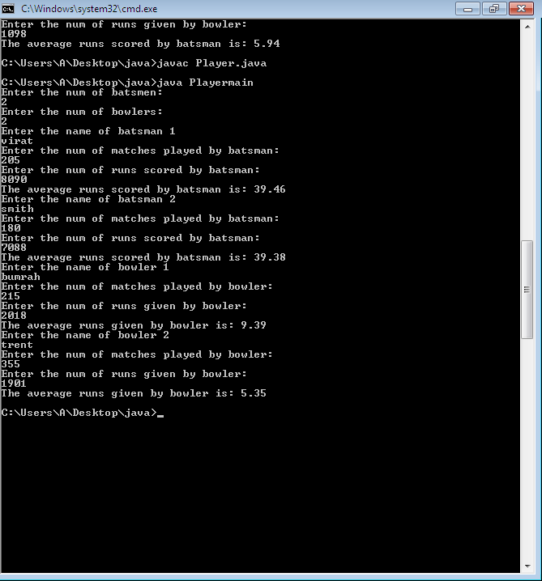

1. import java.util.Scanner;

abstract class Player{

String name;

int matches_played;

double avg;

abstract void cal_average(String na,int mp,int rs);

}

class Batsman extends Player{

int runs_scored;

void cal_average(String na,int mp,int rs)

{

name=na;

matches_played= mp;

runs_scored=rs;

avg= (double)runs_scored/matches_played;

System.out.printf("The average runs scored by batsman is: %.2f\n",avg);

}

}

class Bowler extends Player{

int runs_given;

void cal_average(String na,int mp,int rs)

{

name=na;

matches_played=mp;

runs_given=rs;

avg= (double)runs_given/matches_played;

System.out.printf("The average runs given by bowler is: %.2f\n",avg);

}

}

class Playermain{

public static void main(String args[]){

Scanner sc=new Scanner(System.in);

System.out.println("Enter the num of batsmen: ");

int m=sc.nextInt();

Batsman ba[]= new Batsman[m];

System.out.println("Enter the num of bowlers: ");

int n= sc.nextInt();

Bowler bw[]= new Bowler[n];

for(int i=0; i<m; i++)

{

ba[i]=new Batsman();

System.out.println("Enter the name of batsman "+(i+1));

String ba_na=sc.next();

System.out.println("Enter the num of matches played by batsman: ");

int ba_mp=sc.nextInt();

System.out.println("Enter the num of runs scored by batsman: ");

int ba_rs=sc.nextInt();

ba[i].cal_average(ba_na, ba_mp, ba_rs);

}

for(int i=0; i<n; i++)

{

bw[i]=new Bowler();

System.out.println("Enter the name of bowler "+(i+1));

String bw_na=sc.next();

System.out.println("Enter the num of matches played by bowler: ");

int bw_mp=sc.nextInt();

System.out.println("Enter the num of runs given by bowler: ");

int bw_rs=sc.nextInt();

bw[i].cal_average(bw_na, bw_mp, bw_rs);

}

}

}

