**Automated Hostel Room Allocation System**

**Team Members:**

|  |  |
| --- | --- |
| **Name** | **Roll No.** |
| Aditi Agwan | 05 |
| Alefiya Sanawadwala | 07 |
| Aniruddha Uplenchwar | 09 |
| Ganesh Ronge | 24 |
| Riddhi Hedaoo | 51 |
| Sahil Wadgire | 58 |

# Abstract

The purpose of Hostel Management System is to automate the existing manual system by the help of computerized equipment and full-fledged computer software, fulfilling their requirements, so that their valuable data and information can be stored for a longer period with easy access and manipulation . The required software and hardware are easily available and easy to work.

Hostel Management System, as described above, can lead to error free, secure, reliable and fast management system. It can assist the user to concentrate on their other activities rather to concentrate on the record keeping. Thus it will help organization in better utilization of resources. The organization can maintain computerized records without redundant entries. The project describes how to manage hostel system for good performance and better services for the clients.

# Problem Statement

Allocating students based on preset criteria is a laborious task. The eligibility of pupils should be evaluated based on their given paperwork before categorizing them based on the thresholds. To address these issues, we want to develop a technology that would streamline the allocation procedure for both administration and students.

The Automated Hostel Room Allocation System is designed for use in hostels (like Schools, College, Tuitions, Universities). Allocation of hostels will be subject to present terms and limitations. Administration will cross-check attested application forms collected from students via the internet against the student database. If they are determined to be eligible, the students are assigned to a hostel.

# Literature Survey

We researched for multiple sites for hostel management and came across a few , which were similar to what we needed. We will be able to add to and adjust our project step by step with the help of these surveys. The project has been equally divided amongst all six members of the group.

Based on the need for effective and efficient system for hostels , the following reviews were identified :

* How can information of students be collected and stored for future reference?
* How can the system reduce errors as compared to the manual system?
* How efficiently the system allocates hostel to the students ?

# Proposed Solution

The Automated Hostel Room Allocation System is a web application that automates all of the hostel's functions. The student registers an account on the system and enters information such as grades, category, year of study, gender, and so on. The administrator then verifies the information submitted by the user. The system then assigns students to hostel rooms depending on several parameters and the notification would be sent to the respective students to whom the hostel is allocated . The student must confirm his or her assignment. Once registered , only authorized students can access the facilities provided on the system such as to pay their hostel costs, view mess menu, complain about their discomfort, and various other activities. The admin can add students data to the system , read the lodged complaints and can perform the respective actions .

# Proposed System Architecture

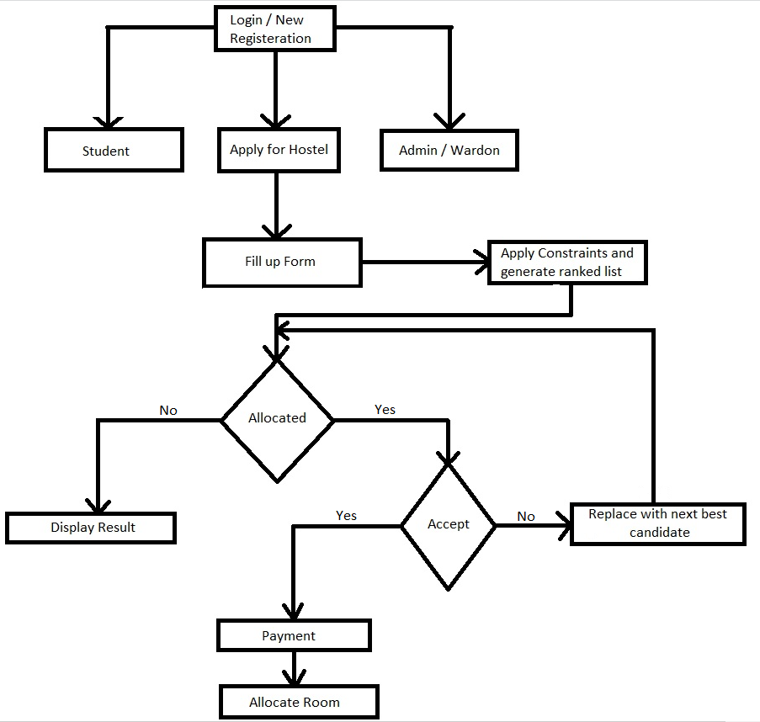

# Future Scope

* Add online hostel fee payment options through credit/debit card, UPI, or other means straight from the website.
* Creating 3D visuals of the rooms so that students can have a better notion of what they're looking at.
* Integrating a chatbot onto the website to help students with their hostel allocation inquiries.