1.Discuss the concept of Counting Sort and implement it to sort the following array in non-decreasing order: A= {4,0,3,1,2,2,1,1,4}

2.Illustrate the operation of HEAP-SORT on the array A= {6, 14, 5, 27, 3, 11, 2, 3, 9}

3. Discuss various properties of Binomial Tree.

4. 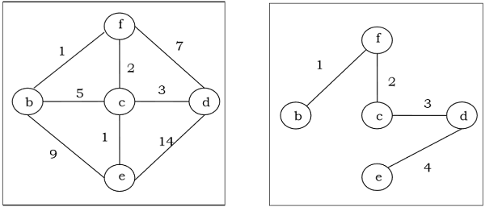Write Prim’s algorithm to generate a minimum spanning tree (MST). Generate MST for the following graph using Prim’s algorithm.

5. Discuss the problem classes P, NP, NP –complete and NP-hard with class relationship.