Assignment -1 on Tableau(.twbx)

Objective of this assignment - To learn basics of Tableau Software

Learnings:-students will learn the following concepts

* Basics of Databases
* Importing into Tableau
* Sorting and filtration
* Grouping and ungrouping
* Formatting etc.

Q1. Import Excel File “Sample Super store” in Tableau.

Q2. Split the “order ID” column into 3 parts with delimiter as “-“

Q3. Split the last section of column “Product ID”. Into separate column.

Q4. Hide the columns “Ship mode”, “Segment” and “Postal code”.

Q5. Prepare the following graph as shown in image (category & subcategory wise total sales)

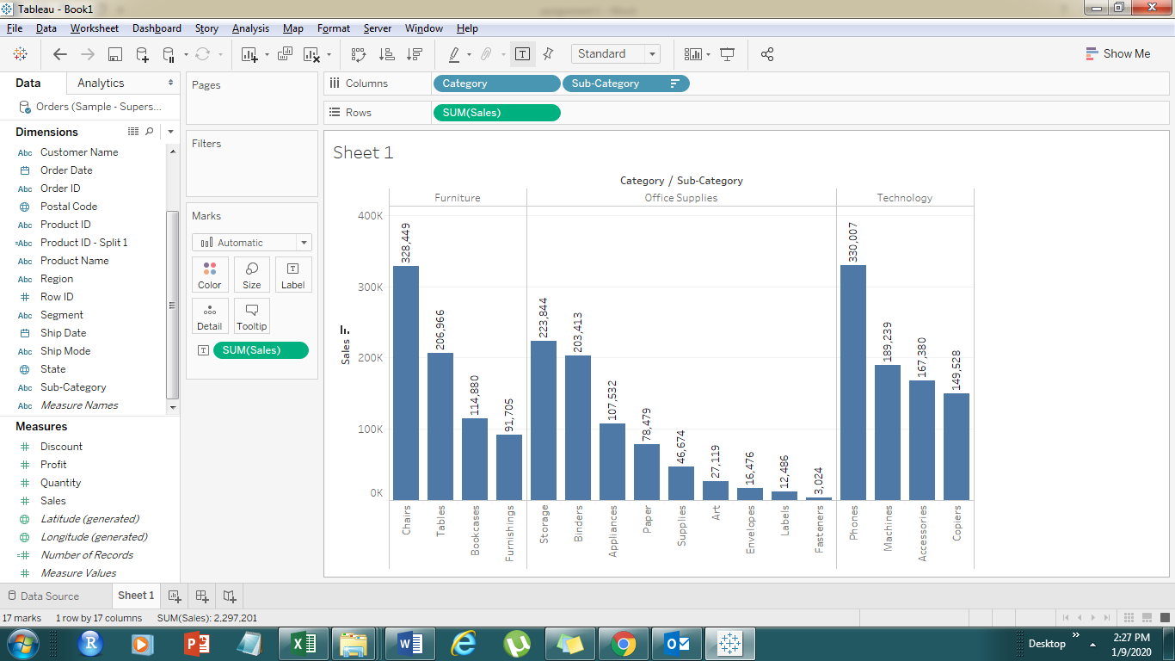

Q6) display total sales of year 2018 and 2019 only

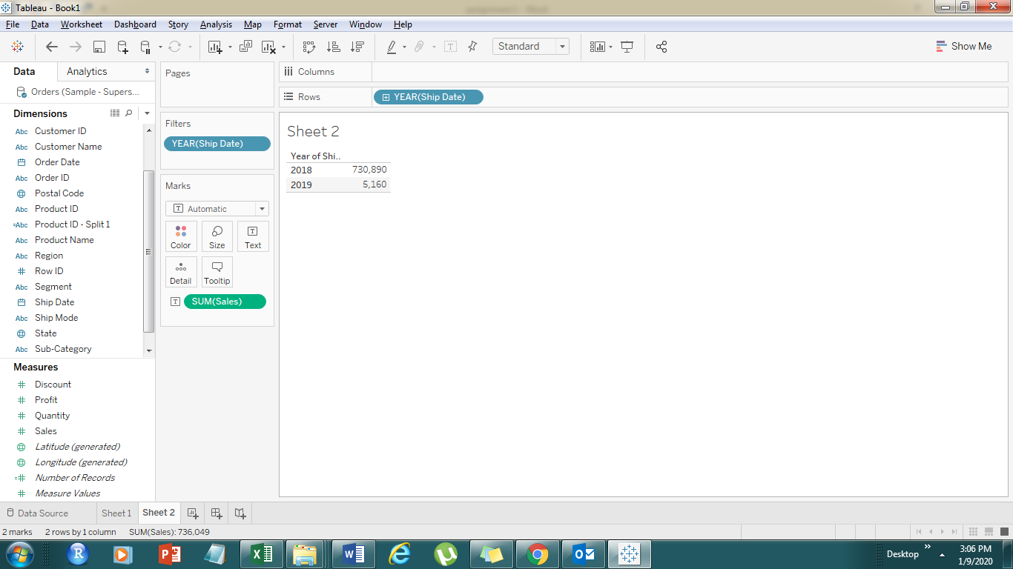

Q7) display year, quarter and month wise total Sales for year 2017 .

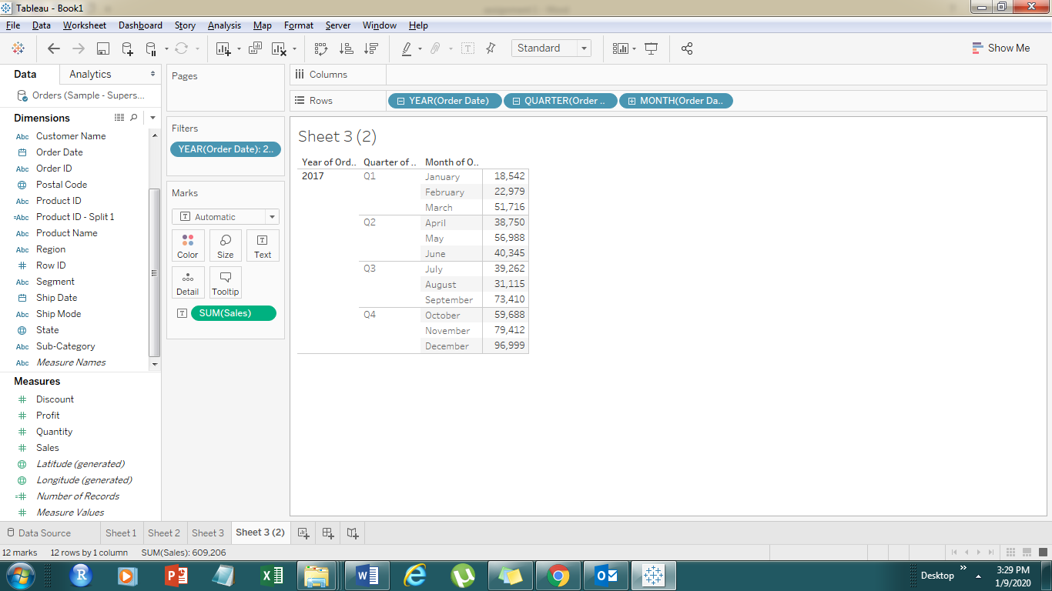

Q8) Create sub category wise Total Sales (accessories in one group as stationary)and create group of paper ,Art, envelopes ,binders,

Q9) Display total sales of region (North & East) and (West & South) by clubbing them in 2 groups .

Q10) Create a graph as shown below:-

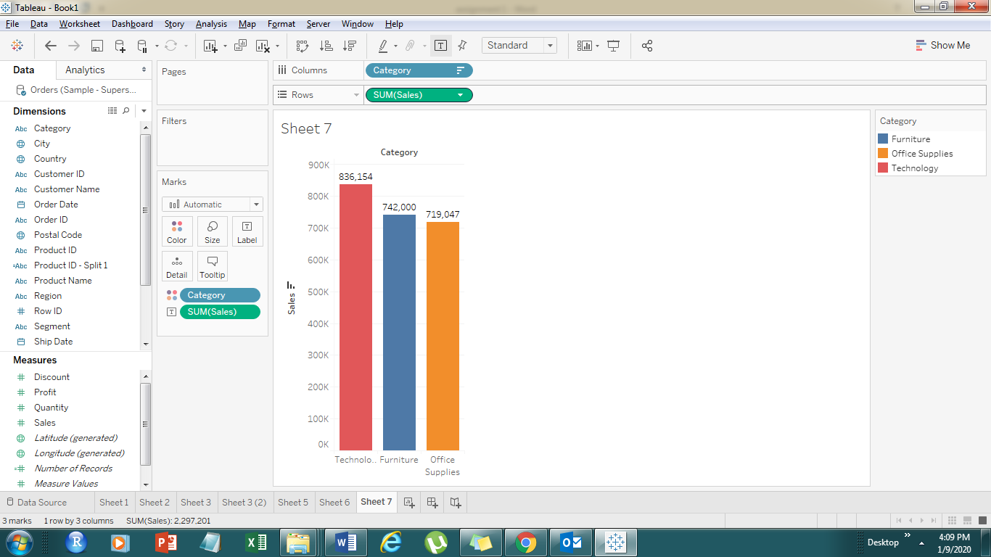

Q11) create graph as shown below :-

