Common source with inductive degeneration

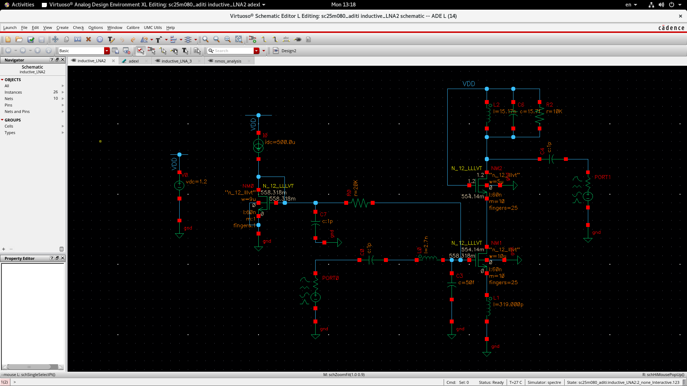

Show that the log-magnitude plot of S11 is below -10 dB at the frequency that you have chosen. What is the input match bandwidth.
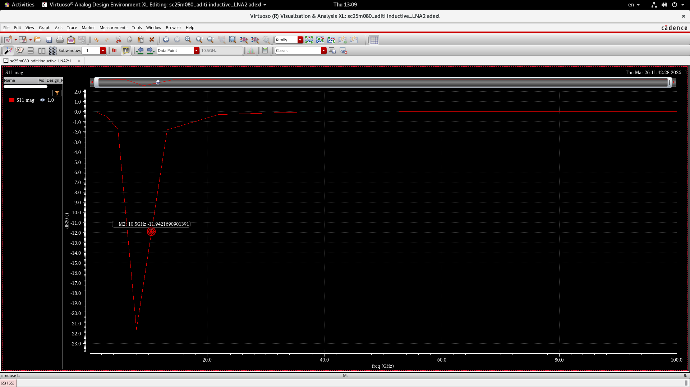
Gain: S21 plot vs frequency. Show the 3-dB bandwidth.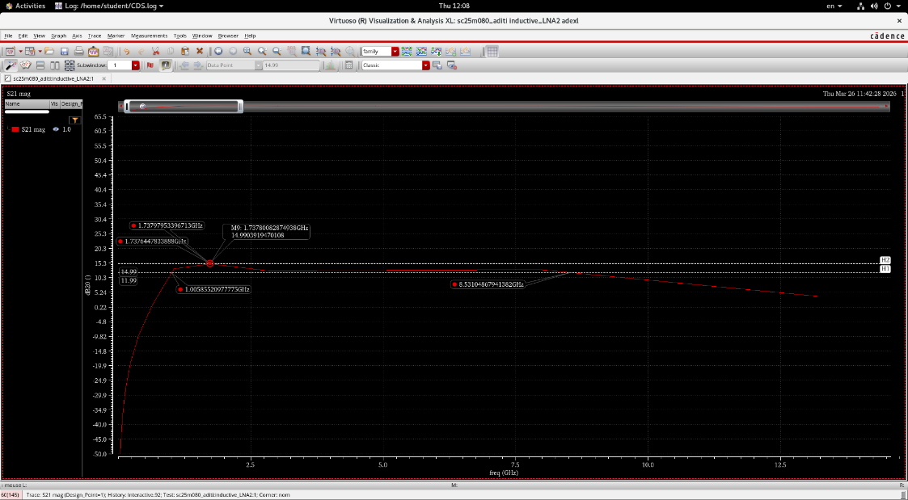
Reverse isolation: S12 plot
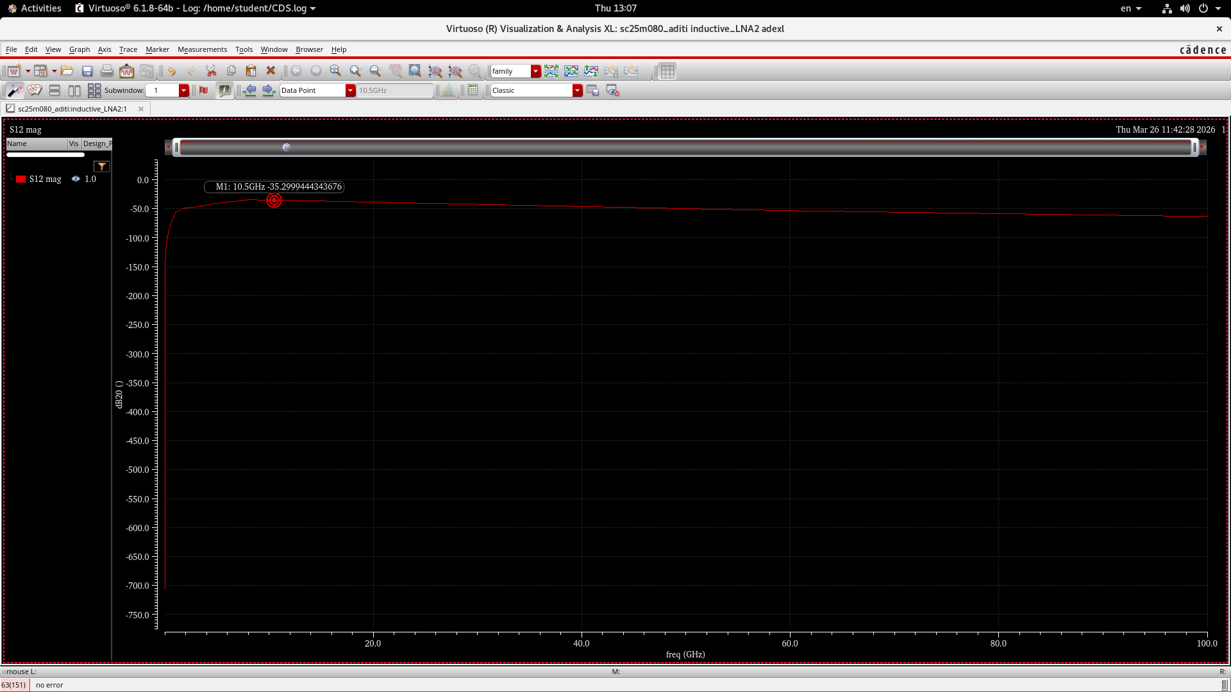

Noise figure plot across frequency.
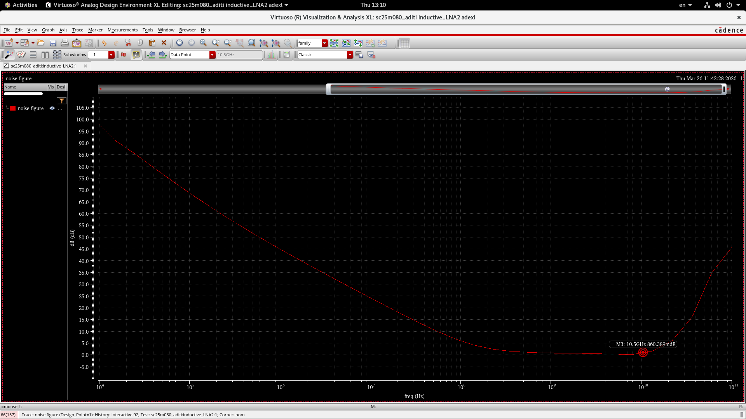
Pout vs Pin plot, 1-dB compression point calculation.
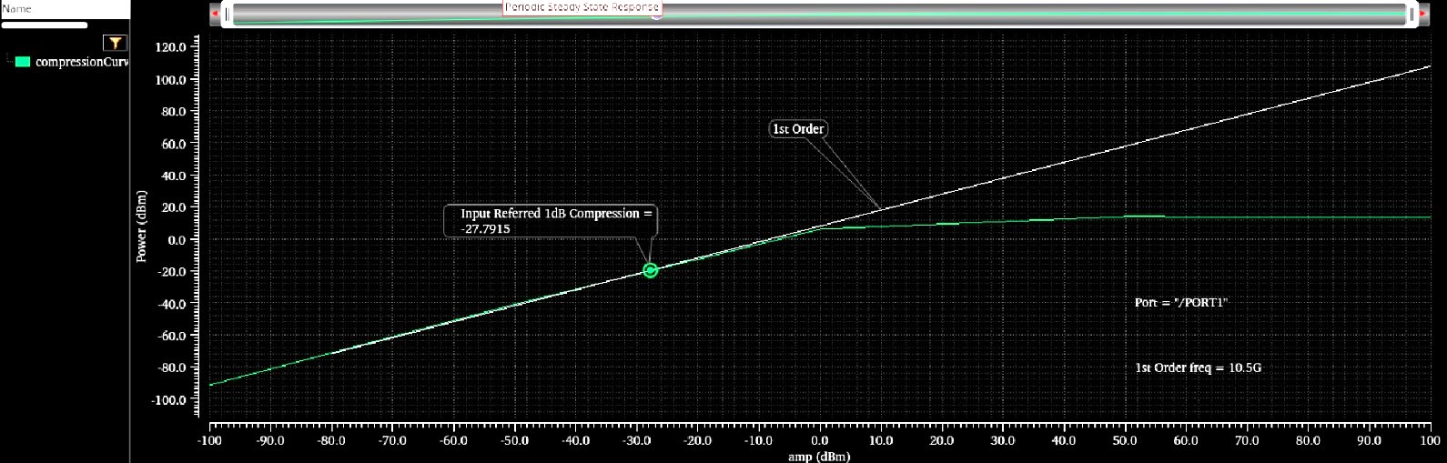
2-tone simulation results, IIP3
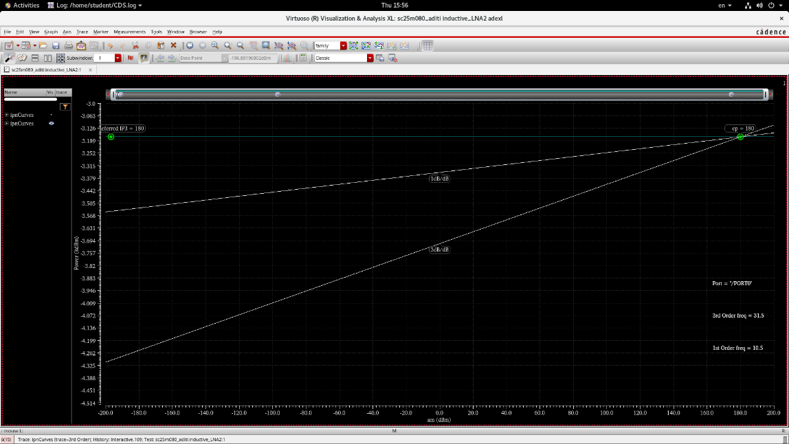
For a -30 dBm input power, what is harmonic distortion? Express in dBc - HD2, HD3
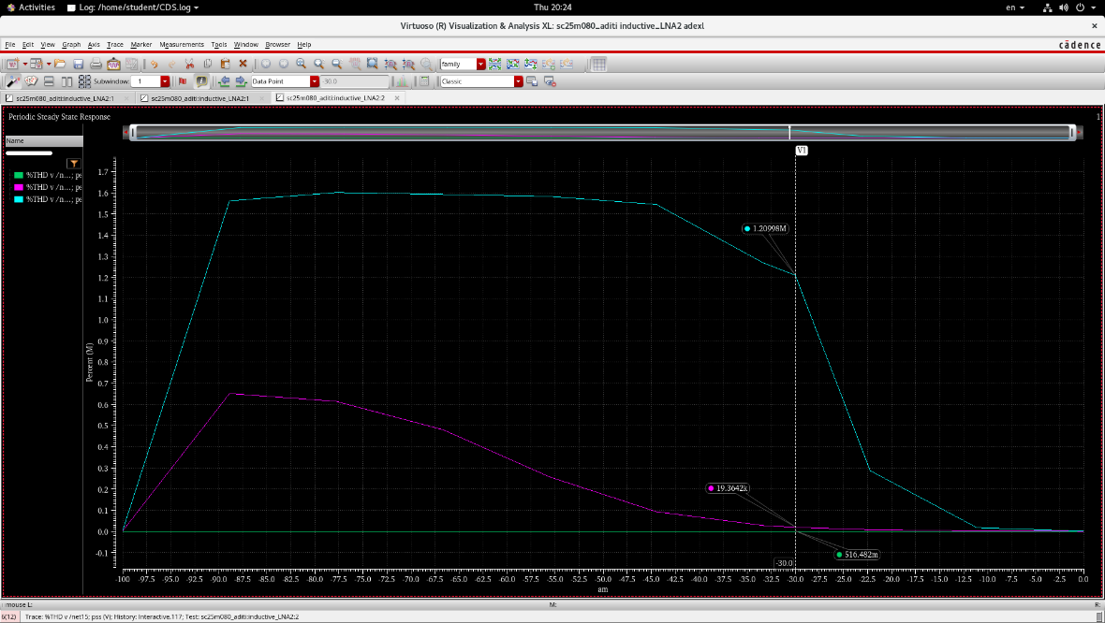
For an input of 2 tones, each with a power level of -50 dBm, what is the level of the intermodulation terms at the output
