Design a strong-arm latch in UMC65nm CMOS process. Add a SR latch at the output so that the output changes for every clock cycle. You can use an ideal clock source with a rise/ fall time of 40 ps. Pass this through an inverter chain of 2 inverters before you connect it to your circuit. Clock frequency: 100 MHz.
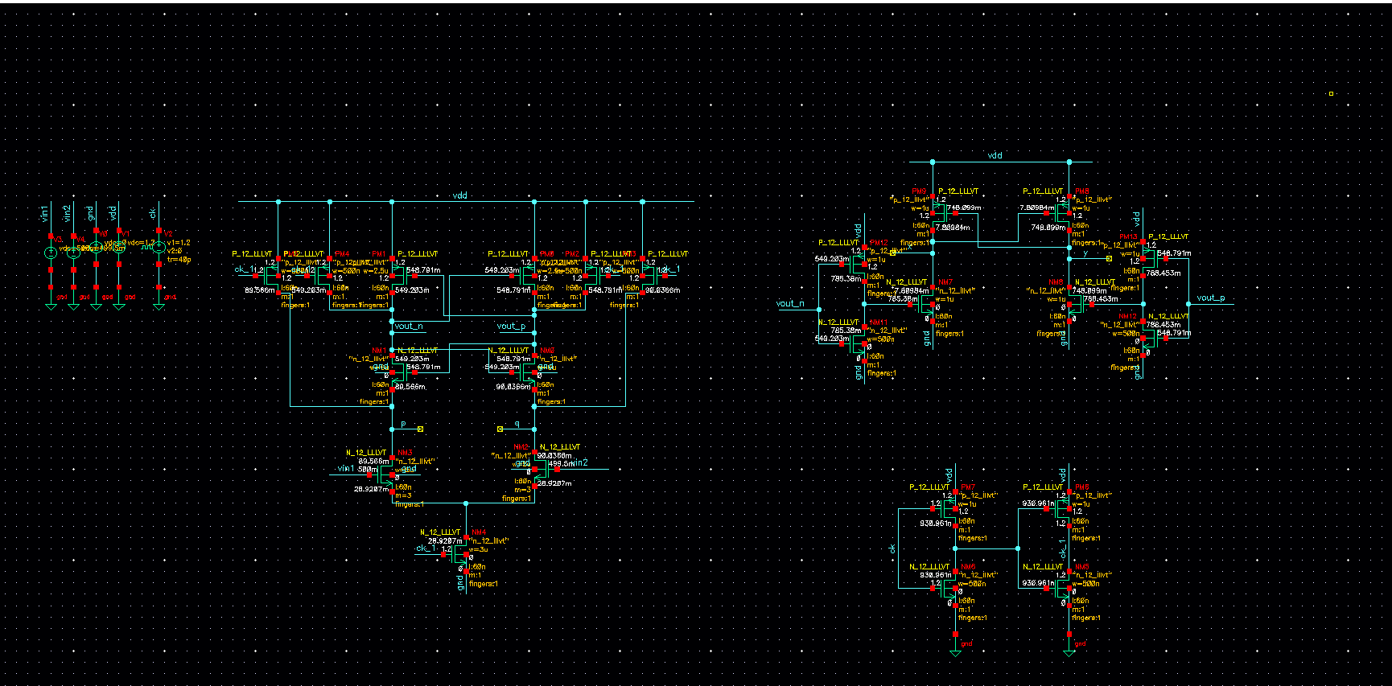
Outputs :
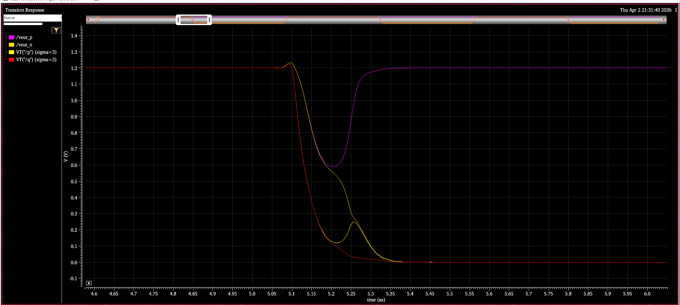

Transient Noise:
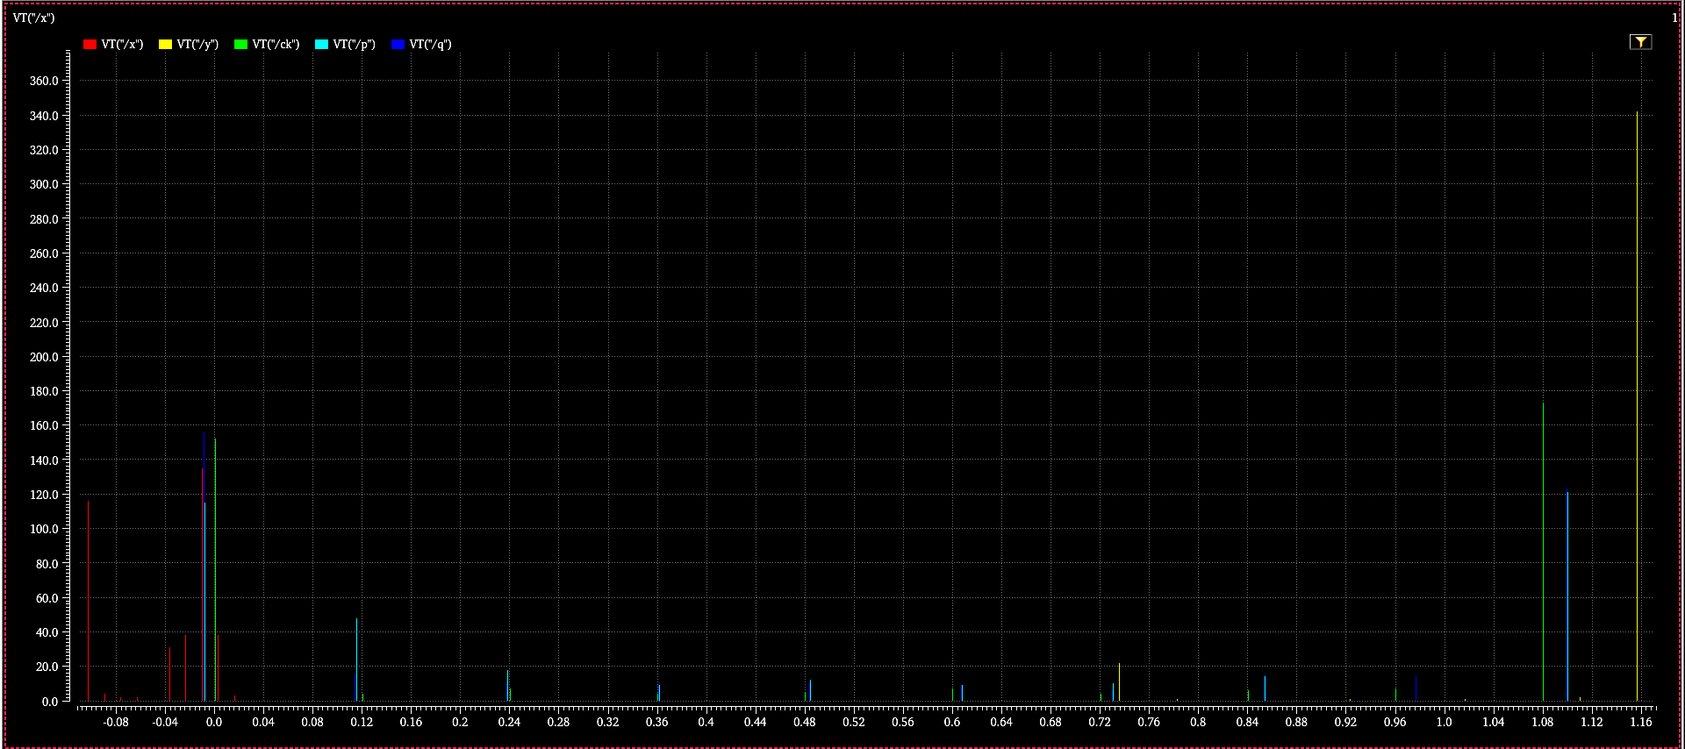

Monte carlo analysis :
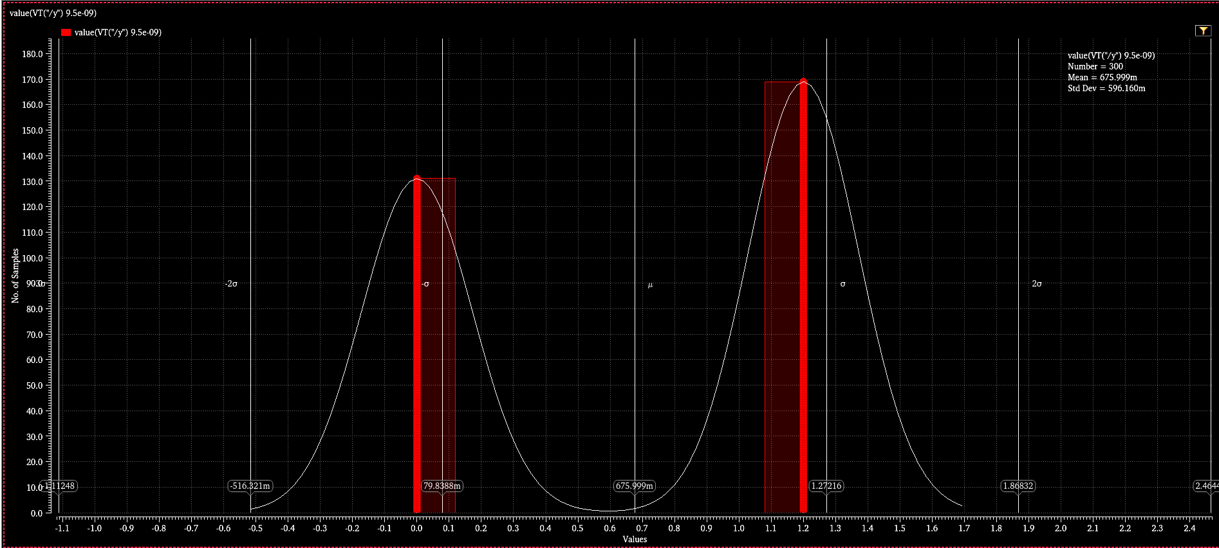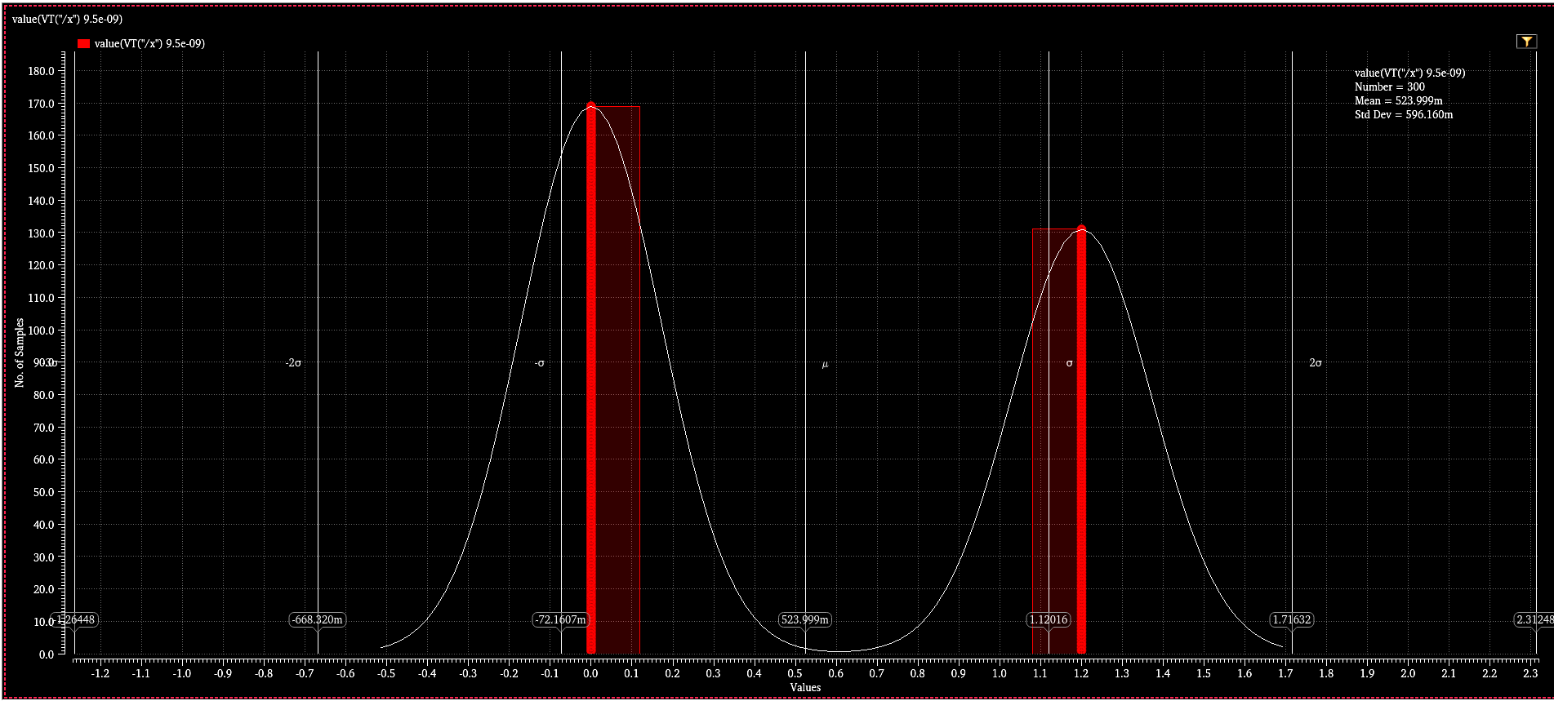

Layout :
