1. Import the dataset and do usual exploratory analysis steps like checking the structure & characteristics of the dataset
2. Data type of columns in a table

select column_name, data_type from `sqlbusinesscase-384615.SQLAssignement.INFORMATION_SCHEMA.COLUMNS`

where table_name = 'customers'

----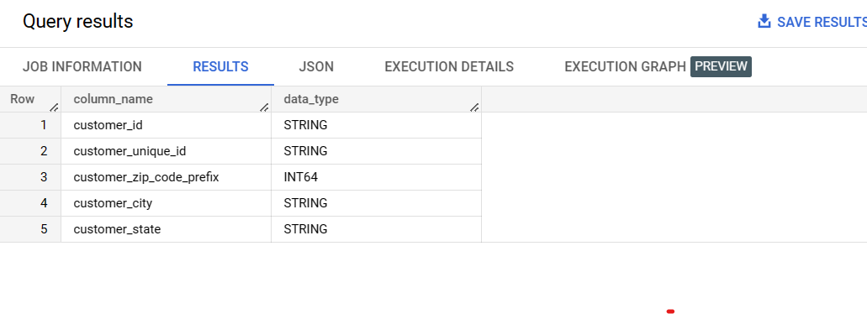

--------------------------------------------------------------------------------------------------------------------------------

select column_name, data_type from `sqlbusinesscase-384615.SQLAssignement.INFORMATION_SCHEMA.COLUMNS` where table_name = 'geolocation'

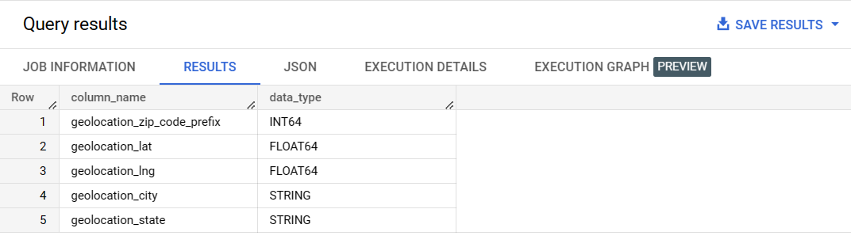

--------------------------------------------------------------------------------------------------------------------------------

select column_name, data_type from `sqlbusinesscase-384615.SQLAssignement.INFORMATION_SCHEMA.COLUMNS`

where table_name = 'order_items'

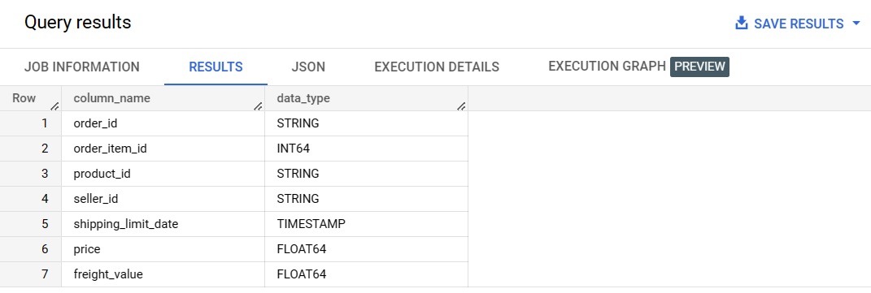

--------------------------------------------------------------------------------------------------------------------------------select column_name, data_type from `sqlbusinesscase-384615.SQLAssignement.INFORMATION_SCHEMA.COLUMNS`

where table_name = 'order_reviews'

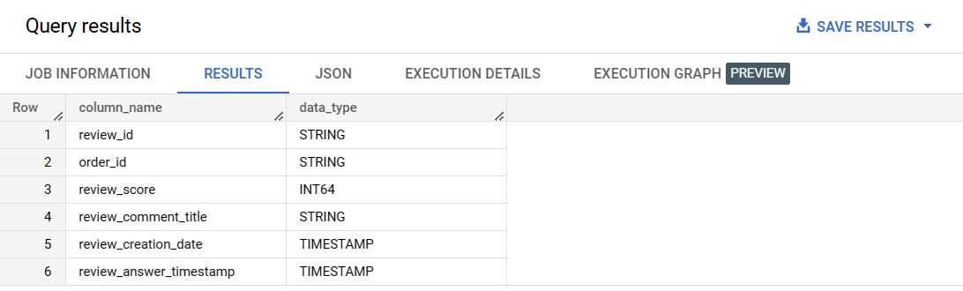

--------------------------------------------------------------------------------------------------------------------------------

select column_name, data_type from `sqlbusinesscase-384615.SQLAssignement.INFORMATION_SCHEMA.COLUMNS`

where table_name = 'orders'

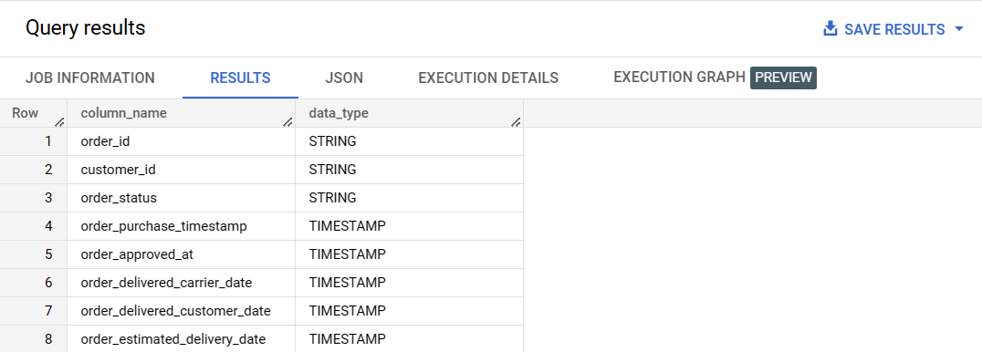

select column_name, data_type from `sqlbusinesscase-384615.SQLAssignement.INFORMATION_SCHEMA.COLUMNS`

where table_name = 'payments'

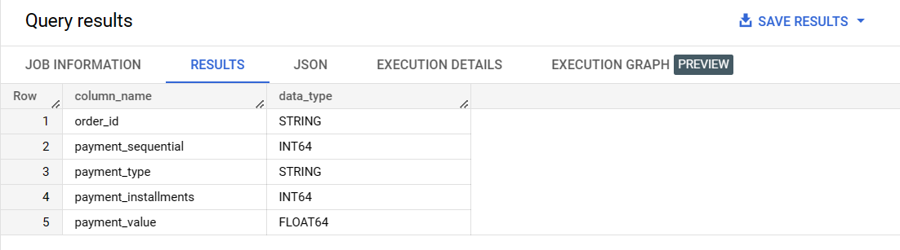

--------------------------------------------------------------------------------------------------------------------------------

select column_name, data_type from `sqlbusinesscase-384615.SQLAssignement.INFORMATION_SCHEMA.COLUMNS`

where table_name = 'products'

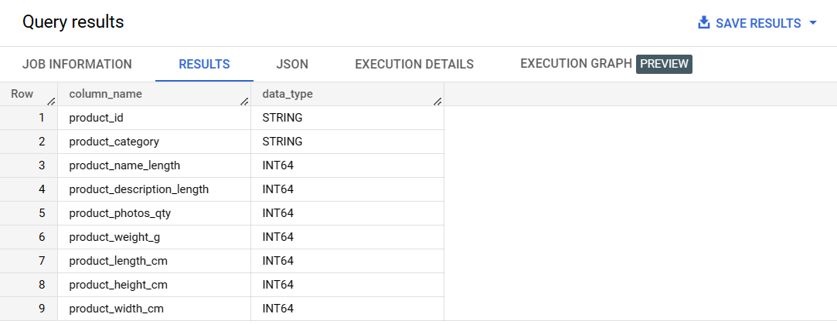

--------------------------------------------------------------------------------------------------------------------------------

select column_name, data_type from `sqlbusinesscase-384615.SQLAssignement.INFORMATION_SCHEMA.COLUMNS`

where table_name = 'sellers'

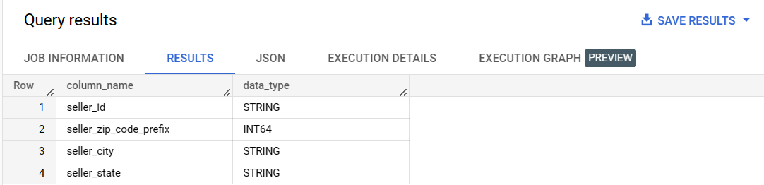

--------------------------------------------------------------------------------------------------------------------------------

1. Time period for which the data is given

select min(order_purchase_timestamp)as start_time, max(order_purchase_timestamp) as end_time

from `sqlbusinesscase-384615.SQLAssignement.orders`

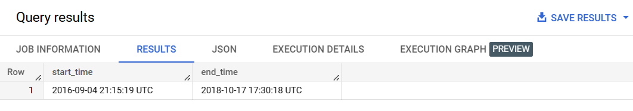

**Insights :**

The time period is calculated based on the data in ‘Orders’ table. start_time and end_time gives the total period for which the data is given.

1. Cities and States of customers ordered during the given period

select c1.customer_city, c1.customer_state from `sqlbusinesscase-384615.SQLAssignement.customers` c1

join

`sqlbusinesscase-384615.SQLAssignement.orders` ord

on c1.customer_id = ord.customer_id

where ord.order_purchase_timestamp  between

(select min(order_purchase_timestamp) from `sqlbusinesscase-384615.SQLAssignement.orders`) and

(select max(order_purchase_timestamp) from `sqlbusinesscase-384615.SQLAssignement.orders`)

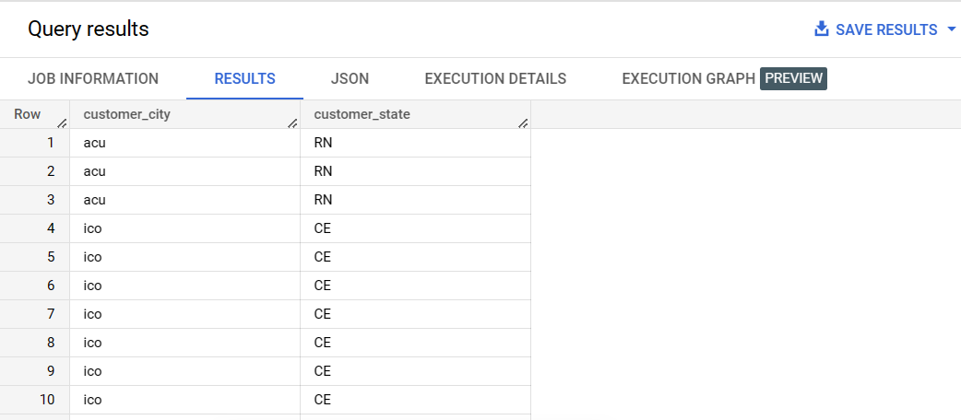

--------------------------------------------------------------------------------------------------------------------------------

1. In-depth Exploration:
2. Is there a growing trend on e-commerce in Brazil? How can we describe a complete scenario? Can we see some seasonality with peaks at specific months?

select  temp.year, temp.month,temp.order_count,rank() over(partition by year order by order_count desc) as order_quantity_rank  from (

select count(order_id) order_count , extract(year from order_purchase_timestamp) as year,

extract(month from order_purchase_timestamp) as month from `sqlbusinesscase-384615.SQLAssignement.orders` o

group by extract(month from order_purchase_timestamp),extract(year from order_purchase_timestamp)) temp

order by temp.year, temp.month

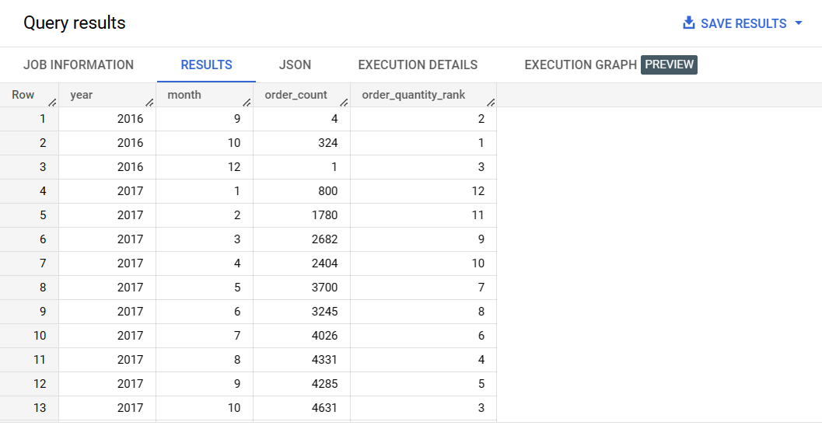

**Insights:**

We can see the trend of orders/purchase frequency above in both columns ‘order_count’ and ‘order_quantity_rank’. The output is based on every month and every year.

--------------------------------------------------------------------------------------------------------------------------------

1. What time do Brazilian customers tend to buy (Dawn, Morning, Afternoon or Night)?

select max(t1), buyTime from

select customer_id,temp.buyTime, count(temp.buyTime) over(partition by temp.buyTime) t1 from

(select customer_id,case

when (extract(hour from order_purchase_timestamp)) between 0 and 6 then 'Dawn'

when (extract(hour from order_purchase_timestamp)) between 7 and 12 then 'Morning'

when (extract(hour from order_purchase_timestamp)) between 13 and 18 then 'Afternoon'

else 'Night'

end  as buyTime

from `sqlbusinesscase-384615.SQLAssignement.orders`) temp) temp1

group by temp1.buyTime;

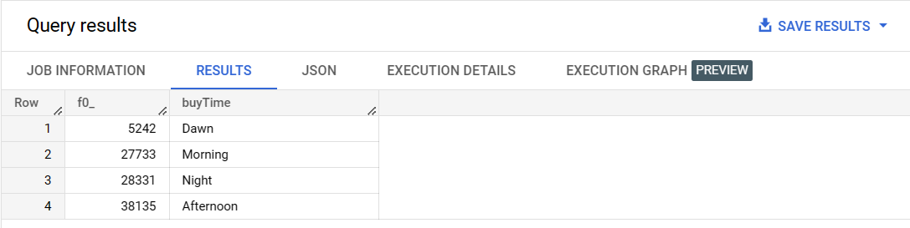

**Insights :** Brazilian customers tend to buy more during ‘Afternoon’

--------------------------------------------------------------------------------------------------------------------------------

1. Evolution of E-commerce orders in the Brazil region:
2. Get month on month orders by states

select * from

(select extract(month from o.order_purchase_timestamp) as month, c.customer_state, count(o.order_id) order_count from `sqlbusinesscase-384615.SQLAssignement.orders` o

join

`sqlbusinesscase-384615.SQLAssignement.customers` c

on o.customer_id = c.customer_id

group by c.customer_state,month) temp

order by temp.month, temp.customer_state

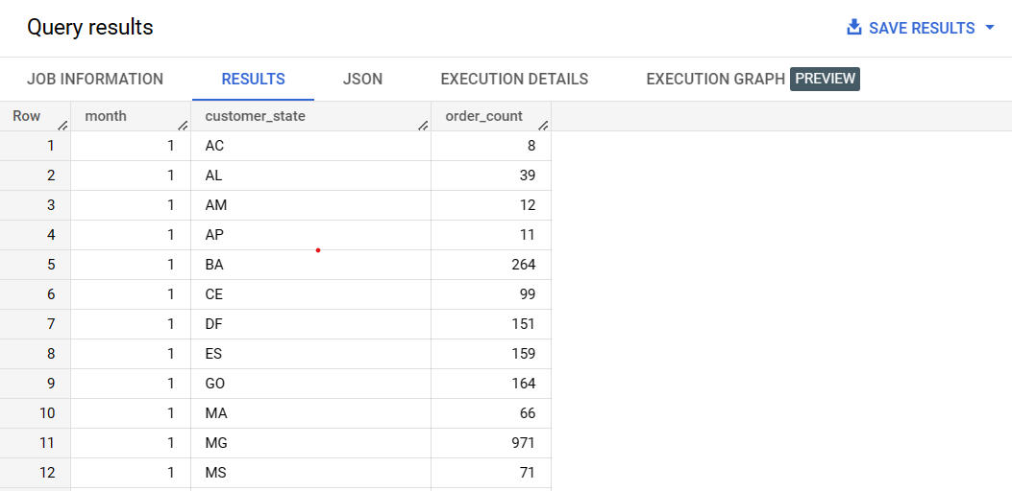

Insights : Month on month orders by states is sorted for month and state in ascending order.

--------------------------------------------------------------------------------------------------------------------------------

1. Distribution of customers across the states in Brazil

select c.customer_state, count(c.customer_id) as customer from `sqlbusinesscase-384615.SQLAssignement.customers` c

group by c.customer_state

order by c.customer_state

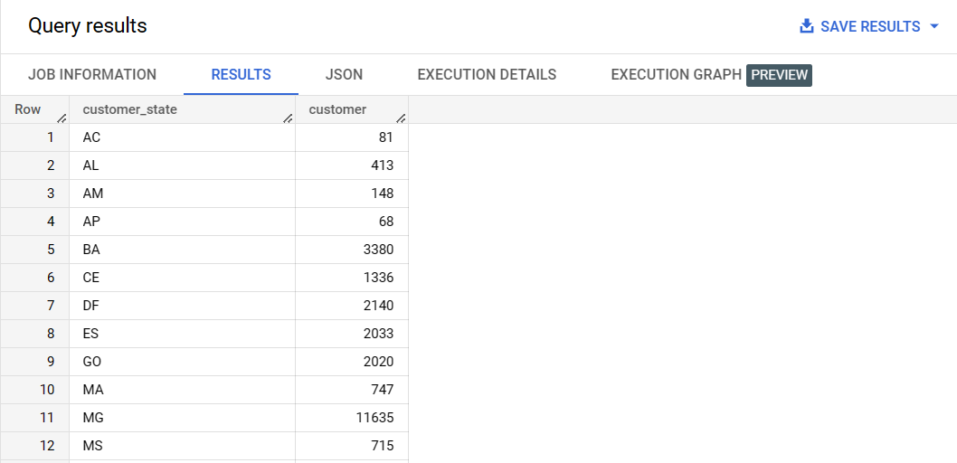

1. Impact on Economy: Analyze the money movement by e-commerce by looking at order prices, freight and others.
2. Get % increase in cost of orders from 2017 to 2018 (include months between Jan to Aug only) - You can use “payment_value” column in payments table

select temp1.*,LAG(order_sum) over(order by temp1.year,temp1.month)as prev_order_sum,

round(((order_sum-LAG(order_sum) over(order by temp1.year,temp1.month))/LAG(order_sum) over(order by temp1.year,temp1.month))*100,2) as percentage_increase from

(select temp.month,temp.year,round(sum(temp.payment_value),0) order_sum from

(select *, extract(month from o.order_purchase_timestamp) as month, extract(year from o.order_purchase_timestamp) as year  from

 `sqlbusinesscase-384615.SQLAssignement.orders` o

join

`sqlbusinesscase-384615.SQLAssignement.payments` p

on p.order_id = o.order_id

where extract(month from o.order_purchase_timestamp) between 1 and 8

order by o.order_purchase_timestamp) temp

group by  temp.year,temp.month

) temp1

order by temp1.year, temp1.month

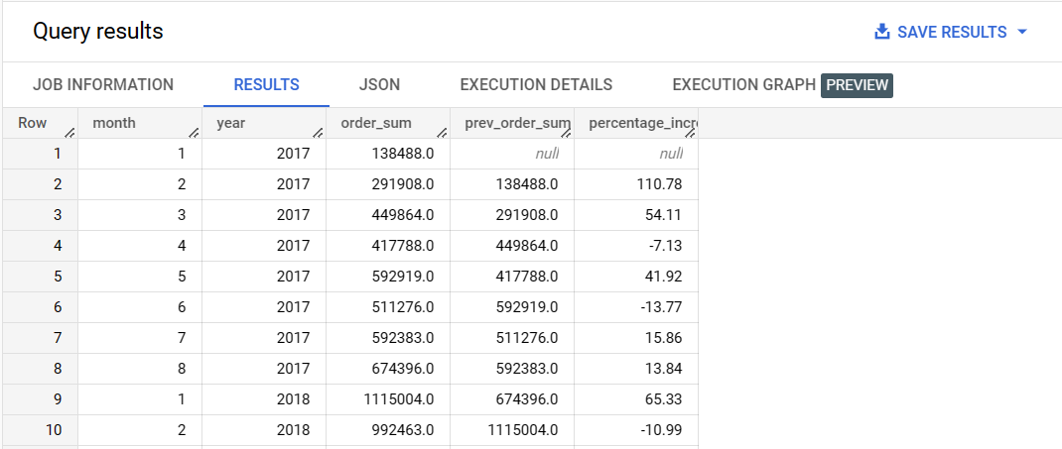

--------------------------------------------------------------------------------------------------------------------------------

1. Mean & Sum of price and freight value by customer state

select c.customer_state,round(sum(i.price),2) price_sum, round(sum(i.freight_value),2) freight_sum,

round(avg(i.price),2) price_mean,

round(avg(i.freight_value),2) freight_mean,

from `sqlbusinesscase-384615.SQLAssignement.customers` c

join

`sqlbusinesscase-384615.SQLAssignement.orders` o

on c.customer_id = o.customer_id

join

`sqlbusinesscase-384615.SQLAssignement.order_items` i

on i.order_id = o.order_id

group by c.customer_state

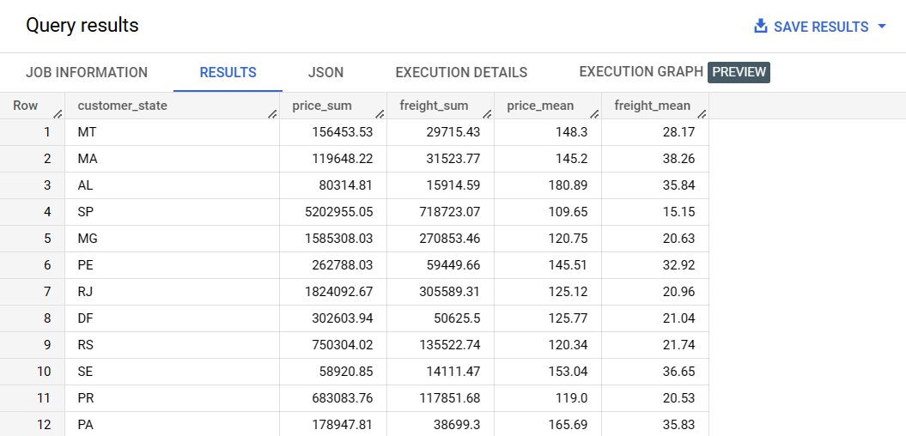

--------------------------------------------------------------------------------------------------------------------------------

1. Analysis on sales, freight and delivery time
2. Calculate days between purchasing, delivering and estimated delivery

select abs(date_diff(order_estimated_delivery_date,order_purchase_timestamp,day)) as purchase_estimated_delivery_diff,

abs(date_diff(order_delivered_customer_date,order_purchase_timestamp,day)) as purchase_delivery_diff,

abs(date_diff(order_delivered_customer_date,order_estimated_delivery_date,day)) as actual_estimated_delivery_diff,

from `sqlbusinesscase-384615.SQLAssignement.orders`

order by purchase_estimated_delivery_diff desc;

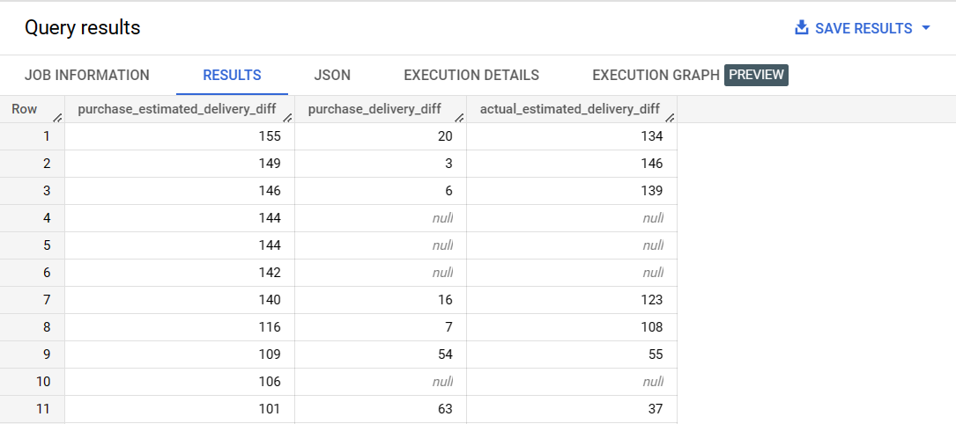

**Insights :** ABS() is used to get the difference(positive) in days. ORDER BY() is included to display values other than NULL as first few rows gave NULL values for ‘purchase_delivery_diff’ and ‘actual_estimated_delivery_diff’

--------------------------------------------------------------------------------------------------------------------------------

1. Find time_to_delivery & diff_estimated_delivery

select abs(date_diff(order_purchase_timestamp, order_delivered_customer_date, day)) as time_to_delivery,

abs(date_diff(order_estimated_delivery_date, order_delivered_customer_date, day)) as diff_estimated_delivery,from `sqlbusinesscase-384615.SQLAssignement.orders`

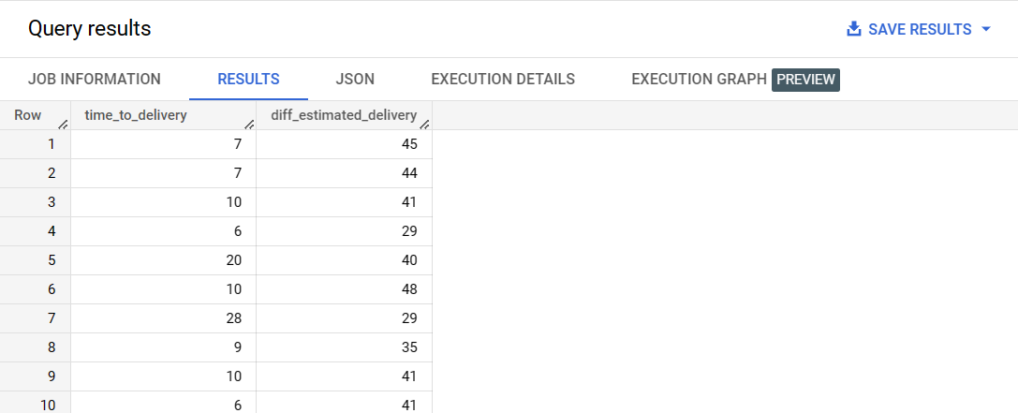

--------------------------------------------------------------------------------------------------------------------------------

1. Group data by state, take mean of freight_value, time_to_delivery, diff_estimated_delivery

(select round(avg(t.freight_value),2) as freight_avg,

round(avg(t.time_to_delivery),2) as time_to_delivery_avg,

round(avg(t.diff_estimated_delivery),2) as diff_estimated_delivery_avg,

t.customer_state from

(select abs(date_diff(order_purchase_timestamp, order_delivered_customer_date, day)) as time_to_delivery,

abs(date_diff(order_estimated_delivery_date, order_delivered_customer_date, day)) as diff_estimated_delivery,

o2.freight_value, c1.customer_state

from `sqlbusinesscase-384615.SQLAssignement.orders` o1 join

`sqlbusinesscase-384615.SQLAssignement.order_items` o2

on o1.order_id = o2.order_id

join

`sqlbusinesscase-384615.SQLAssignement.customers` c1

on o1.customer_id = c1.customer_id) t

group by t.customer_state)

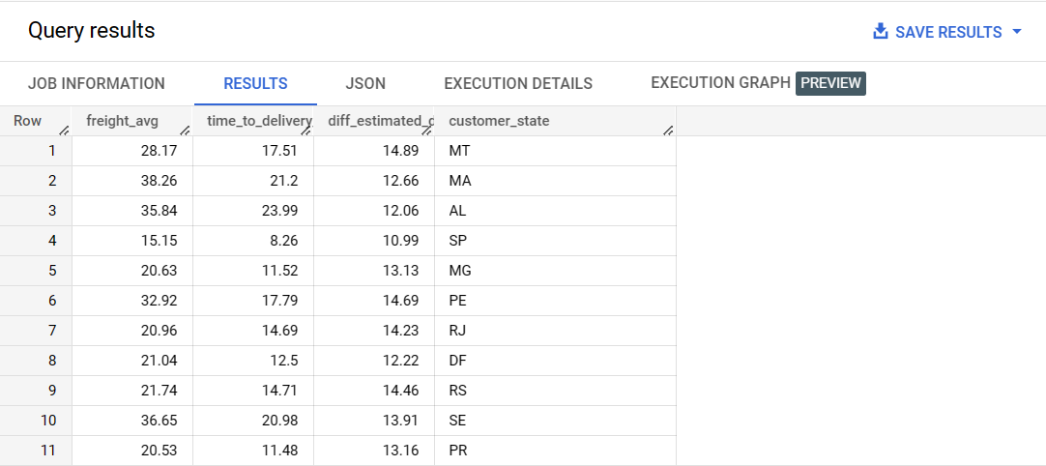

--------------------------------------------------------------------------------------------------------------------------------

1. Top 5 states with highest/lowest average freight value - sort in desc/asc limit 5

**==> Highest 5 average freight value**

select round(avg(t.freight_value),2) as freight_avg,

t.customer_state as state from

(select abs(date_diff(order_purchase_timestamp, order_delivered_customer_date, day)) as time_to_delivery,

abs(date_diff(order_estimated_delivery_date, order_delivered_customer_date, day)) as diff_estimated_delivery,

o2.freight_value, c1.customer_state

from `sqlbusinesscase-384615.SQLAssignement.orders` o1 join

`sqlbusinesscase-384615.SQLAssignement.order_items` o2

on o1.order_id = o2.order_id

join

`sqlbusinesscase-384615.SQLAssignement.customers` c1

on o1.customer_id = c1.customer_id) t

group by t.customer_state

order by freight_avg desc

limit 5;

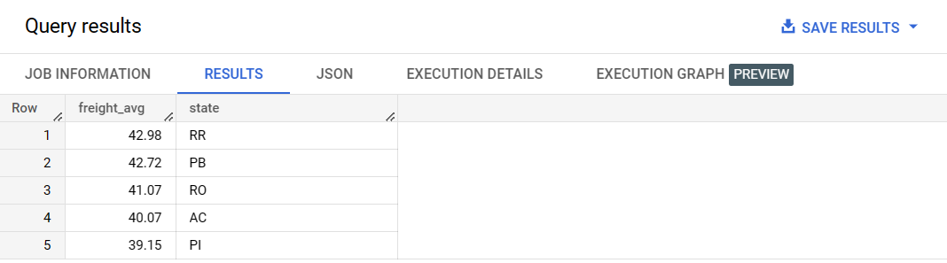

**==> Lowest 5 average freight value**

select round(avg(t.freight_value),2) as freight_avg,

t.customer_state as state from

(select abs(date_diff(order_purchase_timestamp, order_delivered_customer_date, day)) as time_to_delivery,

abs(date_diff(order_estimated_delivery_date, order_delivered_customer_date, day)) as diff_estimated_delivery,

o2.freight_value, c1.customer_state

from `sqlbusinesscase-384615.SQLAssignement.orders` o1 join

`sqlbusinesscase-384615.SQLAssignement.order_items` o2

on o1.order_id = o2.order_id

join

`sqlbusinesscase-384615.SQLAssignement.customers` c1

on o1.customer_id = c1.customer_id) t

group by t.customer_state

order by freight_avg

limit 5;

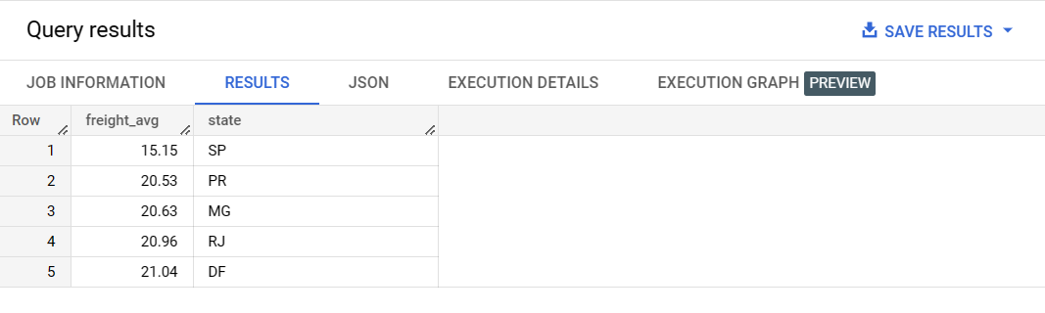

--------------------------------------------------------------------------------------------------------------------------------

1. Top 5 states with highest/lowest average time to delivery

**==> Top 5 states with highest average time to delivery**

select

round(avg(t.time_to_delivery),2) as time_to_delivery_avg,

t.customer_state as state from

(select abs(date_diff(order_purchase_timestamp, order_delivered_customer_date,  day)) as time_to_delivery,

abs(date_diff(order_estimated_delivery_date, order_delivered_customer_date, day)) as diff_estimated_delivery,

o2.freight_value, c1.customer_state

from `sqlbusinesscase-384615.SQLAssignement.orders` o1 join

`sqlbusinesscase-384615.SQLAssignement.order_items` o2

on o1.order_id = o2.order_id

join

`sqlbusinesscase-384615.SQLAssignement.customers` c1

on o1.customer_id = c1.customer_id) t

group by t.customer_state

order by time_to_delivery_avg DESC

limit 5;

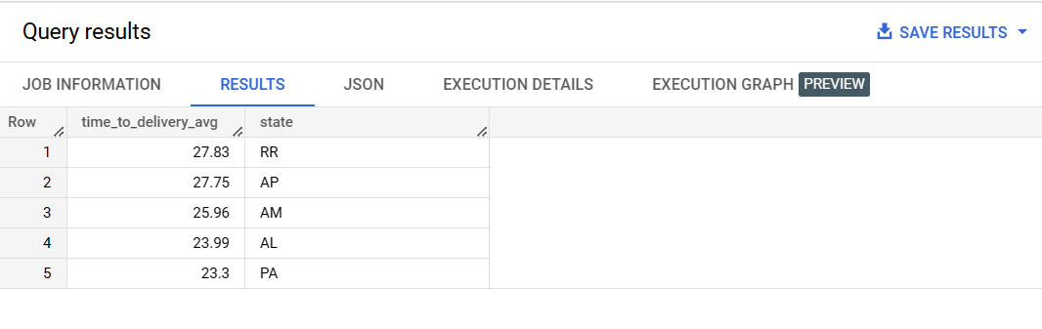

**==> Top 5 states with lowest average time to delivery**

select

round(avg(t.time_to_delivery),2) as time_to_delivery_avg,

t.customer_state as state from

(select abs(date_diff(order_purchase_timestamp, order_delivered_customer_date, day)) as time_to_delivery,

abs(date_diff(order_estimated_delivery_date, order_delivered_customer_date, day)) as diff_estimated_delivery,

o2.freight_value, c1.customer_state

from `sqlbusinesscase-384615.SQLAssignement.orders` o1 join

`sqlbusinesscase-384615.SQLAssignement.order_items` o2

on o1.order_id = o2.order_id

join

`sqlbusinesscase-384615.SQLAssignement.customers` c1

on o1.customer_id = c1.customer_id) t

group by t.customer_state

order by time_to_delivery_avg

limit 5;

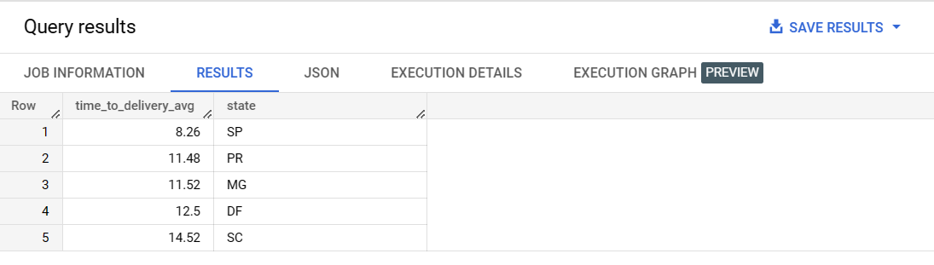

--------------------------------------------------------------------------------------------------------------------------------

1. Top 5 states where delivery is really fast/ not so fast compared to estimated date

**==> Top 5 states where delivery is really fast compared to estimated date**

select

round(avg(t.diff_estimated_delivery),2) as diff_estimated_delivery_avg,

t.customer_state as state from

(select date_diff(order_purchase_timestamp, order_delivered_customer_date, day) as time_to_delivery,

date_diff(order_estimated_delivery_date, order_delivered_customer_date, day) as diff_estimated_delivery,

o2.freight_value, c1.customer_state

from `sqlbusinesscase-384615.SQLAssignement.orders` o1 join

`sqlbusinesscase-384615.SQLAssignement.order_items` o2

on o1.order_id = o2.order_id

join

`sqlbusinesscase-384615.SQLAssignement.customers` c1

on o1.customer_id = c1.customer_id) t

group by t.customer_state

ORDER BY diff_estimated_delivery_avg

LIMIT 5;

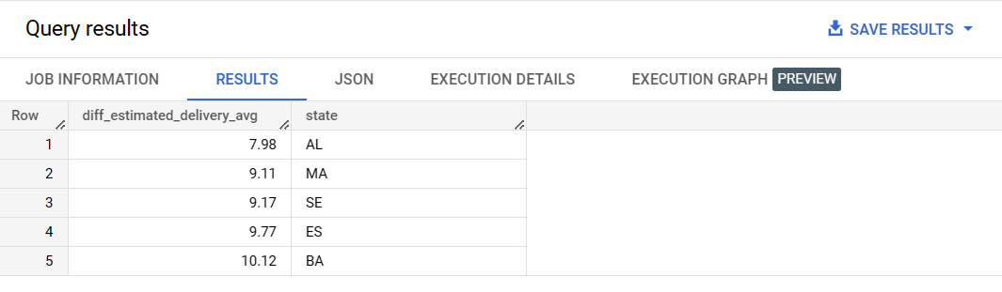

**==> Top 5 states where delivery is really slow compared to estimated date**

select

round(avg(t.diff_estimated_delivery),2) as diff_estimated_delivery_avg,

t.customer_state as state from

(select date_diff(order_purchase_timestamp, order_delivered_customer_date, day) as time_to_delivery,

date_diff(order_estimated_delivery_date, order_delivered_customer_date, day) as diff_estimated_delivery,

o2.freight_value, c1.customer_state

from `sqlbusinesscase-384615.SQLAssignement.orders` o1 join

`sqlbusinesscase-384615.SQLAssignement.order_items` o2

on o1.order_id = o2.order_id

join

`sqlbusinesscase-384615.SQLAssignement.customers` c1

on o1.customer_id = c1.customer_id) t

group by t.customer_state

ORDER BY diff_estimated_delivery_avg desc

LIMIT 5;

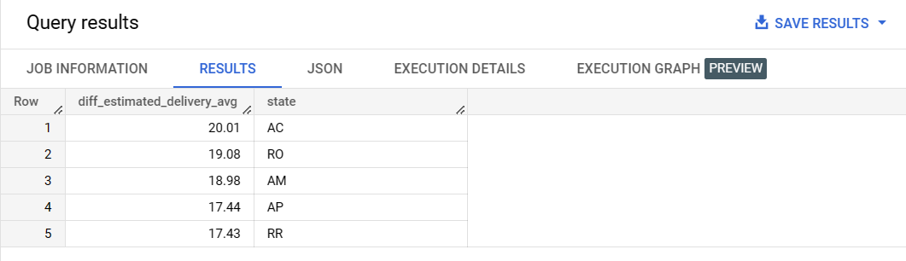

--------------------------------------------------------------------------------------------------------------------------------

1. Payment type analysis:
2. Month over Month count of orders for different payment types

select * from (

select count(o.order_id) as order_count,(extract(month from o.order_purchase_timestamp)) as month, p.payment_type from `sqlbusinesscase-384615.SQLAssignement.orders` o

join

`sqlbusinesscase-384615.SQLAssignement.payments` p

on o.order_id = p.order_id

group by extract(month from o.order_purchase_timestamp),p.payment_type) as temp

order by temp.month, temp.payment_type

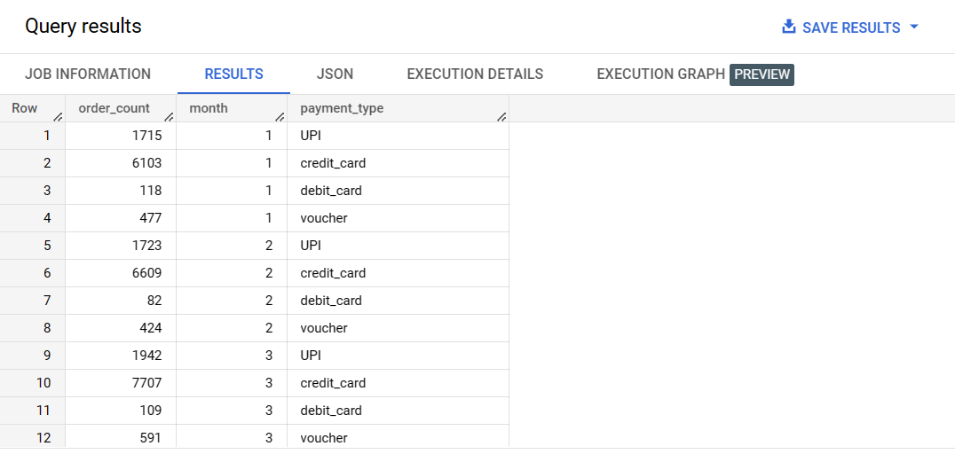

**Insights :** the result shows the total number of orders for every month for every payment mode. Result is sorted on both month wise and payment_type wise in ascending order

--------------------------------------------------------------------------------------------------------------------------------

1. Count of orders based on the no. of payment installments

select count(o.order_id) as order_count, p.payment_installments from `sqlbusinesscase-384615.SQLAssignement.orders` o

join

`sqlbusinesscase-384615.SQLAssignement.payments` p

on o.order_id = p.order_id

group by p.payment_installments

order by p.payment_installments

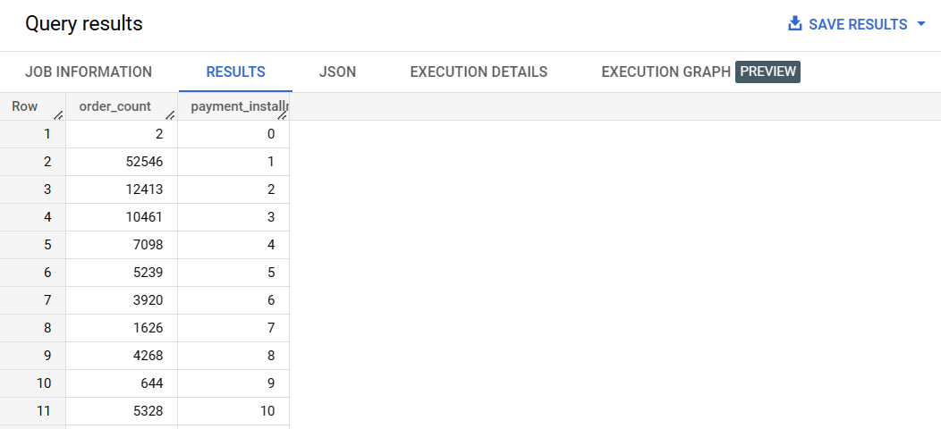

**Insights :** The query result gives the order count based on no of payment installments in ascending order