Reflection Report
on
Imitation of Television Remote Control System using STM32 MCU
Student Credentials
Name |  | PRN |  | Contact No.
Aditi Patil |  | 202301070136 |  | 9545144544
Kanak Panchal |  | 202301070135 |  | 93272 94119
Krushna Yerawar |  | 202301070100 |  | 93598 03722
Key Objectives:
- Implement Push-Button Controls: Enable channel switching, volume adjustment, and power ON/OFF using physical push-buttons.
- Display Channel on 7-Segment Display: Show the current channel number using a 7-segment display for quick visibility.
- Provide Status on LCD Screen: Display detailed system status like “TV ON,” “Channel 5,” and “Volume: 10” on an LCD.
- Simulate Power Control with Relay: Use a relay module to mimic the ON/OFF state of a television.
- Integrate Buzzer for Alerts: Generate sound alerts via a buzzer for power status changes and user interactions.
Intended Outcomes:
- Channel control using push-buttons with 7-segment display feedback.
- Volume adjustment and mute functions with real-time LCD updates
3. Power ON/OFF simulation via relay and status display.
- Audio feedback through buzzer on every valid input.
5. User-friendly interface with clear error messages and smooth control flow.
What real-world situation does this problem relate to?
- • Smart TV remotes that interact with TVs using embedded systems.
- Home automation systems where appliances (TVs, lights, fans) are controlled via microcontrollers
- User-interface development for embedded consumer electronics (using displays, buzzers, and buttons).
- Testing & prototyping remote-control-like behavior before final product development.
Why is this problem important or worth solving?
- Embedded Systems Practice: Helps develop practical skills in microcontroller programming, peripheral interfacing, and real-time system design
- Prototype for Automation: Serves as a foundation for developing smart home automation systems
- Career Skills Development: Builds hands-on experience with STM32, which is valuable for jobs in embedded systems, IoT, and electronics design.
- Hands-On Embedded Systems Learning
It involves working directly with STM32, buttons, LCDs, buzzers, and relays. This practical experience builds strong embedded system skills beyond theory.
What assumptions are made about the scenario?
- User understands basic remote operations – It's assumed the user knows how to operate a TV using channel, volume, and power buttons.
- Push-buttons are the only input method – The system uses physical buttons, not IR, Bluetooth, or touchscreen controls.
- TV states are simulated, not real – The actual television is not controlled; a relay simulates ON/OFF state.
- Channel and volume ranges are predefined – The number of channels and volume levels are limited and fixed in the code.
- Power must be ON for other controls to work – Channel, volume, and mute actions are only allowed when the TV is ON.
- Feedback devices (LCD, buzzer, 7-segment) work correctly – It's assumed that all output components are functioning and properly interfaced with the STM32.
List of Components Used
Name of Component | Specs |  | Quantity | Input/ Output/ Processing Element
STM 32 F4110RB Nucleon Board | 32 bit micro controller |  | 1 | Processing Element
Push Button | Momentary contact, tactile switch |  | 5 | Input
Buzzer | 5V active piezo buzzer |  | 1 | Output
LCD 16*2 | 16 chars, 2 lines, HD44780 |  | 1 | Output
7 Seg Display | Common cathode, 10-pin |  | 1 | Output
LED | 5mm, 2V, 20mA standard |  | 1 | Output
Jumper Wires | Male to male, male to female |  | 30 | Processing Element
System Architecture – Block Diagram
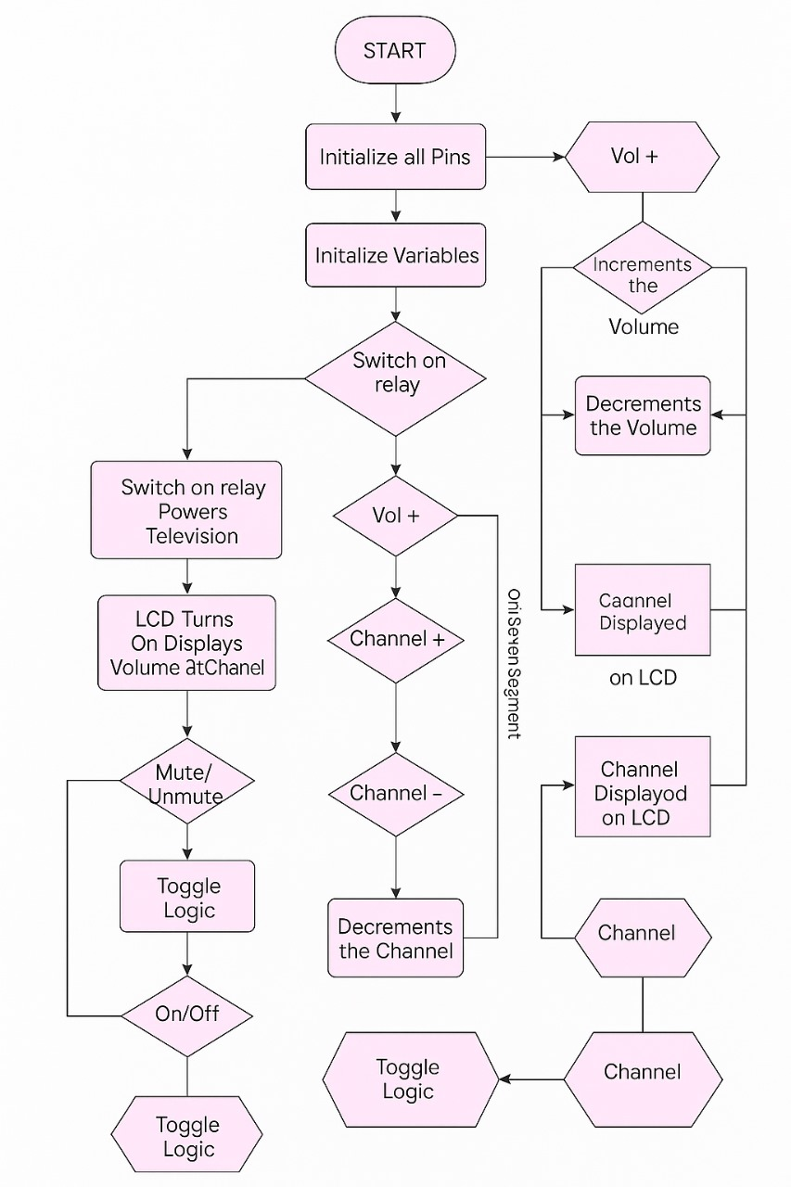
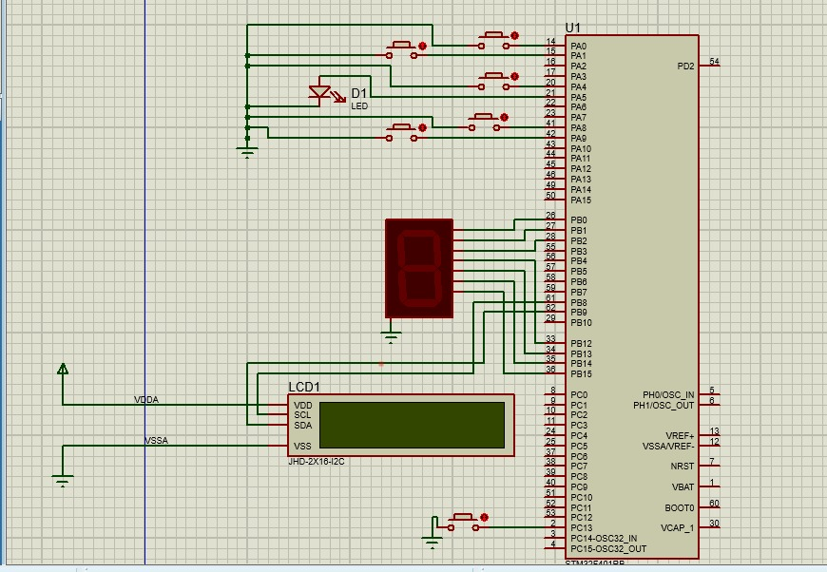
Configured Pin Diagram from STM32 CubeIDE
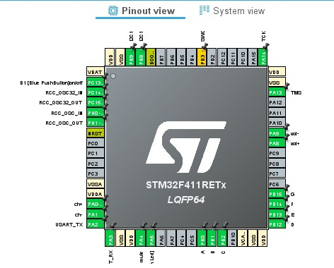
Mention all the settings required to configure peripherals in STM32 CubeIDE
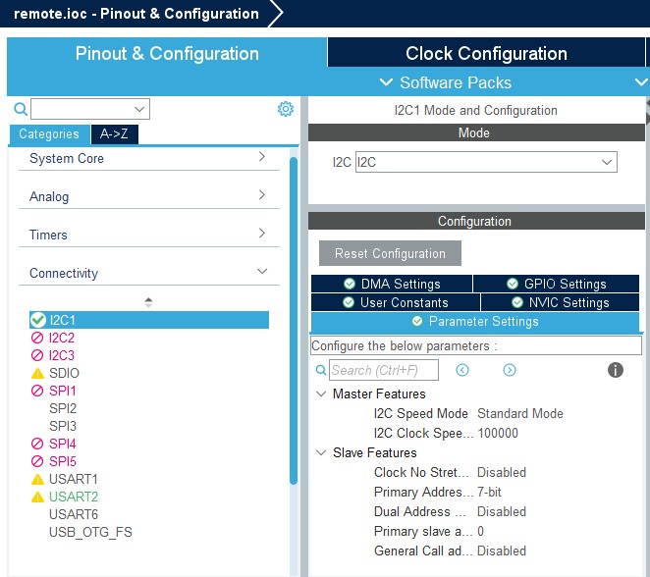

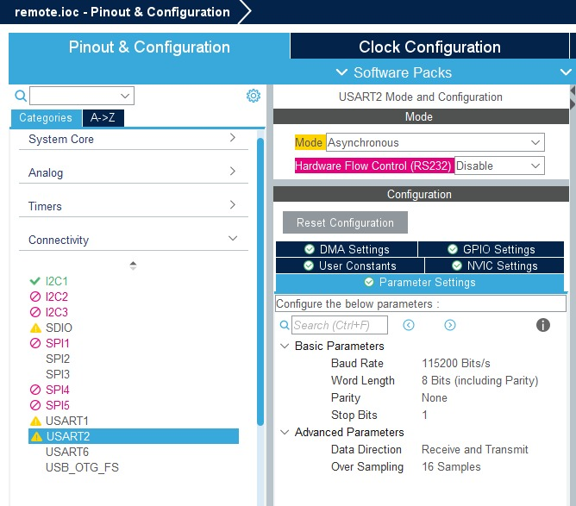

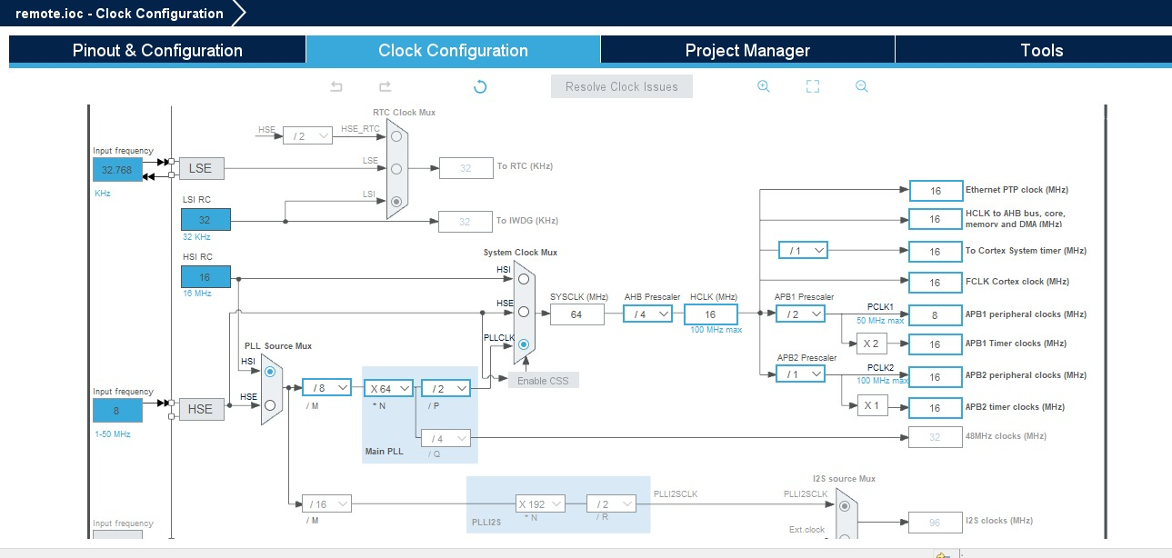

Challenges faced
- STM32 Kit Unavailable: We had to switch platforms due to the unavailability of the STM32 kit.
- Damaged Components: Some sensors and connectors were not working properly, causing delays.
- Less Time: Limited hackathon duration made it difficult to test and refine the solution fully.
Photo Gallery
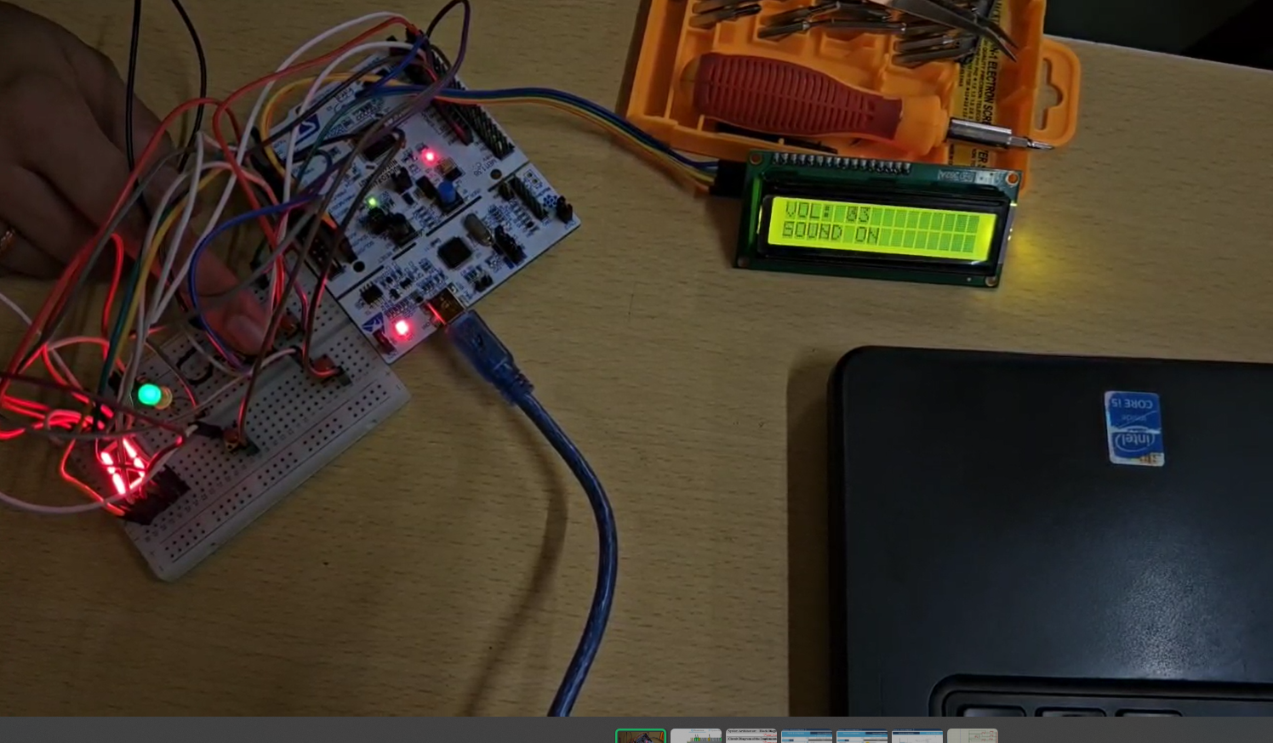

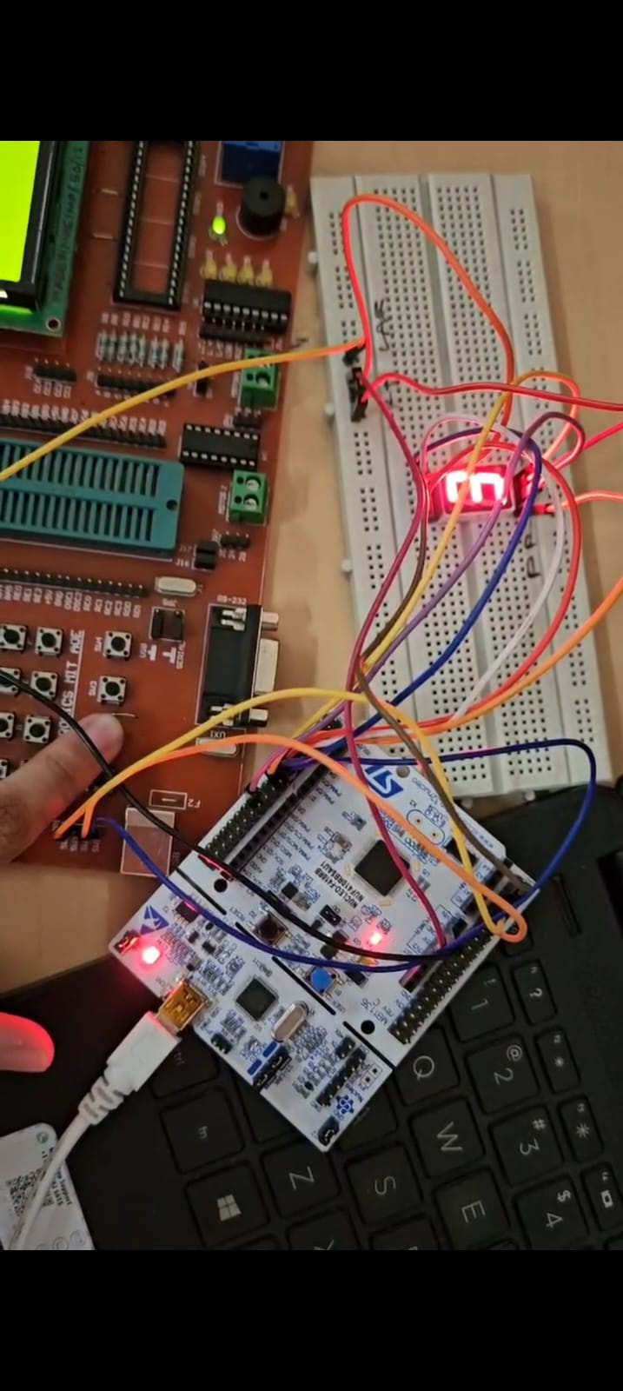
Appendices:
Firmware – Source STM32 CubeIDE
/* USER CODE BEGIN Header */
/**
******************************************************************************
* @file : main.c
* @brief : Main program body
******************************************************************************
* @attention
*
* Copyright (c) 2025 STMicroelectronics.
* All rights reserved.
*
* This software is licensed under terms that can be found in the LICENSE file
* in the root directory of this software component.
* If no LICENSE file comes with this software, it is provided AS-IS.
*
******************************************************************************
*/
/* USER CODE END Header */
/* Includes ------------------------------------------------------------------*/
#include "main.h"
#include "i2c.h"
#include "usart.h"
#include "gpio.h"

/* Private includes ----------------------------------------------------------*/
/* USER CODE BEGIN Includes */
#include "i2c_lcd.h"
#include "stdio.h"
/* USER CODE END Includes */

/* Private typedef -----------------------------------------------------------*/
/* USER CODE BEGIN PTD */

/* USER CODE END PTD */

/* Private define ------------------------------------------------------------*/
/* USER CODE BEGIN PD */
#define SEG_GPIO_PORT GPIOB
#define SEG_A_PIN GPIO_PIN_0
#define SEG_B_PIN GPIO_PIN_1
#define SEG_C_PIN GPIO_PIN_2
#define SEG_D_PIN GPIO_PIN_12
#define SEG_E_PIN GPIO_PIN_13
#define SEG_F_PIN GPIO_PIN_14
#define SEG_G_PIN GPIO_PIN_15

/* USER CODE END PD */

/* Private macro -------------------------------------------------------------*/
/* USER CODE BEGIN PM */

/* USER CODE END PM */

/* Private variables ---------------------------------------------------------*/

/* USER CODE BEGIN PV */
uint8_t isOn = 0;
uint8_t volume = 30;
uint8_t channel = 1;
uint8_t isMuted = 0;
char displayBuffer[16];

const uint8_t segment_digits[10][7] = {
{1,1,1,1,1,1,0}, // 0
{0,1,1,0,0,0,0}, // 1
{1,1,0,1,1,0,1}, // 2
{1,1,1,1,0,0,1}, // 3
{0,1,1,0,0,1,1}, // 4
{1,0,1,1,0,1,1}, // 5
{1,0,1,1,1,1,1}, // 6
{1,1,1,0,0,0,0}, // 7
{1,1,1,1,1,1,1}, // 8
{1,1,1,1,0,1,1} // 9
};
/* USER CODE END PV */

/* Private function prototypes -----------------------------------------------*/
void SystemClock_Config(void);
/* USER CODE BEGIN PFP */

/* USER CODE END PFP */

/* Private user code ---------------------------------------------------------*/
/* USER CODE BEGIN 0 */
void display_digit(uint8_t digit) {
if (digit > 9) return; // Only handle digits 0-9

HAL_GPIO_WritePin(SEG_GPIO_PORT, SEG_A_PIN, segment_digits[digit][0] ? GPIO_PIN_SET : GPIO_PIN_RESET);
HAL_GPIO_WritePin(SEG_GPIO_PORT, SEG_B_PIN, segment_digits[digit][1] ? GPIO_PIN_SET : GPIO_PIN_RESET);
HAL_GPIO_WritePin(SEG_GPIO_PORT, SEG_C_PIN, segment_digits[digit][2] ? GPIO_PIN_SET : GPIO_PIN_RESET);
HAL_GPIO_WritePin(SEG_GPIO_PORT, SEG_D_PIN, segment_digits[digit][3] ? GPIO_PIN_SET : GPIO_PIN_RESET);
HAL_GPIO_WritePin(SEG_GPIO_PORT, SEG_E_PIN, segment_digits[digit][4] ? GPIO_PIN_SET : GPIO_PIN_RESET);
HAL_GPIO_WritePin(SEG_GPIO_PORT, SEG_F_PIN, segment_digits[digit][5] ? GPIO_PIN_SET : GPIO_PIN_RESET);
HAL_GPIO_WritePin(SEG_GPIO_PORT, SEG_G_PIN, segment_digits[digit][6] ? GPIO_PIN_SET : GPIO_PIN_RESET);
}
/* USER CODE END 0 */

/**
* @brief The application entry point.
* @retval int
*/
int main(void)
{

/* USER CODE BEGIN 1 */

/* USER CODE END 1 */

/* MCU Configuration--------------------------------------------------------*/

/* Reset of all peripherals, Initializes the Flash interface and the Systick. */
HAL_Init();

/* USER CODE BEGIN Init */

/* USER CODE END Init */

/* Configure the system clock */
SystemClock_Config();

/* USER CODE BEGIN SysInit */

/* USER CODE END SysInit */

/* Initialize all configured peripherals */
MX_GPIO_Init();
MX_USART2_UART_Init();
MX_I2C1_Init();
/* USER CODE BEGIN 2 */
lcd_init();
/* USER CODE END 2 */

/* Infinite loop */
/* USER CODE BEGIN WHILE */
while (1)
{
/* USER CODE END WHILE */

/* USER CODE BEGIN 3 */
// main
// Check ON/OFF button (PC13)
if (HAL_GPIO_ReadPin(GPIOC, GPIO_PIN_13) == GPIO_PIN_RESET) {
HAL_Delay(200); // debounce
isOn = !isOn;
HAL_GPIO_WritePin(GPIOA, GPIO_PIN_5, isOn ? GPIO_PIN_SET : GPIO_PIN_RESET);
lcd_clear();
HAL_Delay(500);
display_digit(0);
}

if (isOn) {
// Channel UP (PA0)

if (HAL_GPIO_ReadPin(GPIOA, GPIO_PIN_0) == GPIO_PIN_RESET) {
if (channel < 9) channel++;
display_digit(channel);
char msg[10];
int len = sprintf(msg, "CH: %d\n", channel); // convert channel to string
HAL_UART_Transmit(&huart2, (uint8_t*)msg, len, HAL_MAX_DELAY);
HAL_Delay(300); // debounce
}

// Channel DOWN (PA1)
if (HAL_GPIO_ReadPin(GPIOA, GPIO_PIN_1) == GPIO_PIN_RESET) {
if (channel > 1) channel--;
display_digit(channel);
char msg[10];
int len = sprintf(msg, "CH: %d\n", channel); // convert channel to string
HAL_UART_Transmit(&huart2, (uint8_t*)msg, len, HAL_MAX_DELAY);
HAL_Delay(300);
}

// Volume UP (PA8)
if (HAL_GPIO_ReadPin(GPIOA, GPIO_PIN_8) == GPIO_PIN_RESET) {
if (volume < 100 && !isMuted) volume++;
HAL_Delay(300);
}

// Volume DOWN (PA9)
if (HAL_GPIO_ReadPin(GPIOA, GPIO_PIN_9) == GPIO_PIN_RESET) {
if (volume > 0 && !isMuted) volume--;
HAL_Delay(300);
}

// Mute toggle (PA4)
if (HAL_GPIO_ReadPin(GPIOA, GPIO_PIN_4) == GPIO_PIN_RESET) {
isMuted = !isMuted;
HAL_Delay(300);
}

// LCD Display
lcd_put_cursor(0, 0);
sprintf(displayBuffer, "VOL: %d ", isMuted ? 0 : volume);
lcd_send_string(displayBuffer);

lcd_put_cursor(1, 0);
lcd_send_string(isMuted ? "MUTED " : "SOUND ON ");
} else {
lcd_put_cursor(0, 0);
lcd_send_string("System OFF ");
lcd_put_cursor(1, 0);
lcd_send_string("Press ON Btn");
}
}
/* USER CODE END 3 */
}

/**
* @brief System Clock Configuration
* @retval None
*/
void SystemClock_Config(void)
{
RCC_OscInitTypeDef RCC_OscInitStruct = {0};
RCC_ClkInitTypeDef RCC_ClkInitStruct = {0};

/** Configure the main internal regulator output voltage
*/
__HAL_RCC_PWR_CLK_ENABLE();
__HAL_PWR_VOLTAGESCALING_CONFIG(PWR_REGULATOR_VOLTAGE_SCALE1);

/** Initializes the RCC Oscillators according to the specified parameters
* in the RCC_OscInitTypeDef structure.
*/
RCC_OscInitStruct.OscillatorType = RCC_OSCILLATORTYPE_HSI;
RCC_OscInitStruct.HSIState = RCC_HSI_ON;
RCC_OscInitStruct.HSICalibrationValue = RCC_HSICALIBRATION_DEFAULT;
RCC_OscInitStruct.PLL.PLLState = RCC_PLL_ON;
RCC_OscInitStruct.PLL.PLLSource = RCC_PLLSOURCE_HSI;
RCC_OscInitStruct.PLL.PLLM = 8;
RCC_OscInitStruct.PLL.PLLN = 64;
RCC_OscInitStruct.PLL.PLLP = RCC_PLLP_DIV2;
RCC_OscInitStruct.PLL.PLLQ = 4;
if (HAL_RCC_OscConfig(&RCC_OscInitStruct) != HAL_OK)
{
Error_Handler();
}

/** Initializes the CPU, AHB and APB buses clocks
*/
RCC_ClkInitStruct.ClockType = RCC_CLOCKTYPE_HCLK|RCC_CLOCKTYPE_SYSCLK
|RCC_CLOCKTYPE_PCLK1|RCC_CLOCKTYPE_PCLK2;
RCC_ClkInitStruct.SYSCLKSource = RCC_SYSCLKSOURCE_PLLCLK;
RCC_ClkInitStruct.AHBCLKDivider = RCC_SYSCLK_DIV4;
RCC_ClkInitStruct.APB1CLKDivider = RCC_HCLK_DIV2;
RCC_ClkInitStruct.APB2CLKDivider = RCC_HCLK_DIV1;

if (HAL_RCC_ClockConfig(&RCC_ClkInitStruct, FLASH_LATENCY_0) != HAL_OK)
{
Error_Handler();
}
}

/* USER CODE BEGIN 4 */

/* USER CODE END 4 */

/**
* @brief This function is executed in case of error occurrence.
* @retval None
*/
void Error_Handler(void)
{
/* USER CODE BEGIN Error_Handler_Debug */
/* User can add his own implementation to report the HAL error return state */
__disable_irq();
while (1)
{
}
/* USER CODE END Error_Handler_Debug */
}

#ifdef USE_FULL_ASSERT
/**
* @brief Reports the name of the source file and the source line number
* where the assert_param error has occurred.
* @param file: pointer to the source file name
* @param line: assert_param error line source number
* @retval None
*/
void assert_failed(uint8_t *file, uint32_t line)
{
/* USER CODE BEGIN 6 */
/* User can add his own implementation to report the file name and line number,
ex: printf("Wrong parameters value: file %s on line %d\r\n", file, line) */
/* USER CODE END 6 */
}
#endif /* USE_FULL_ASSERT */

Proteus Circuit (if applicable)
“Paste your high-resolution image here”
Proteus Code (if applicable)
“Paste your complete tested code here”

