1. **The Glass House:**

**Algorithm:**

**int** two_digit_num,sum=0,temp;

**print(“Enter 2-digit number”);**

**read two_digit_num;**

**while**(two_digit_num>0)

{

temp=two_digit_num%10;

sum=sum+temp;

two_digit_num=two_digit_num/10;

}

print("Prince must go in path %d to go out of glass house",sum);

**Flowchart:**

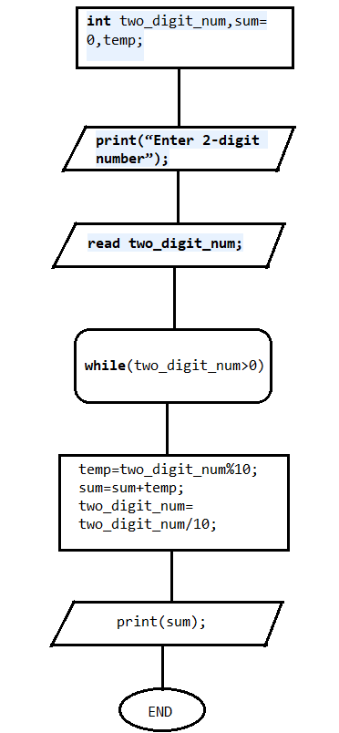

1. **Traffic Congestion- Even Odd rule**

**Algorithm:**

**int** date;

print(“Enter the value of date”);

**if**(date>1 && date<31)

{

**if**(date%2==0)

{

print ("Even numbered vehicle is permitted on the road");

}

**else**

{

print ("Odd numbered vehicle is permitted on the road");

}

}

**else**

print ("Invalid input");

**Flowchart:**

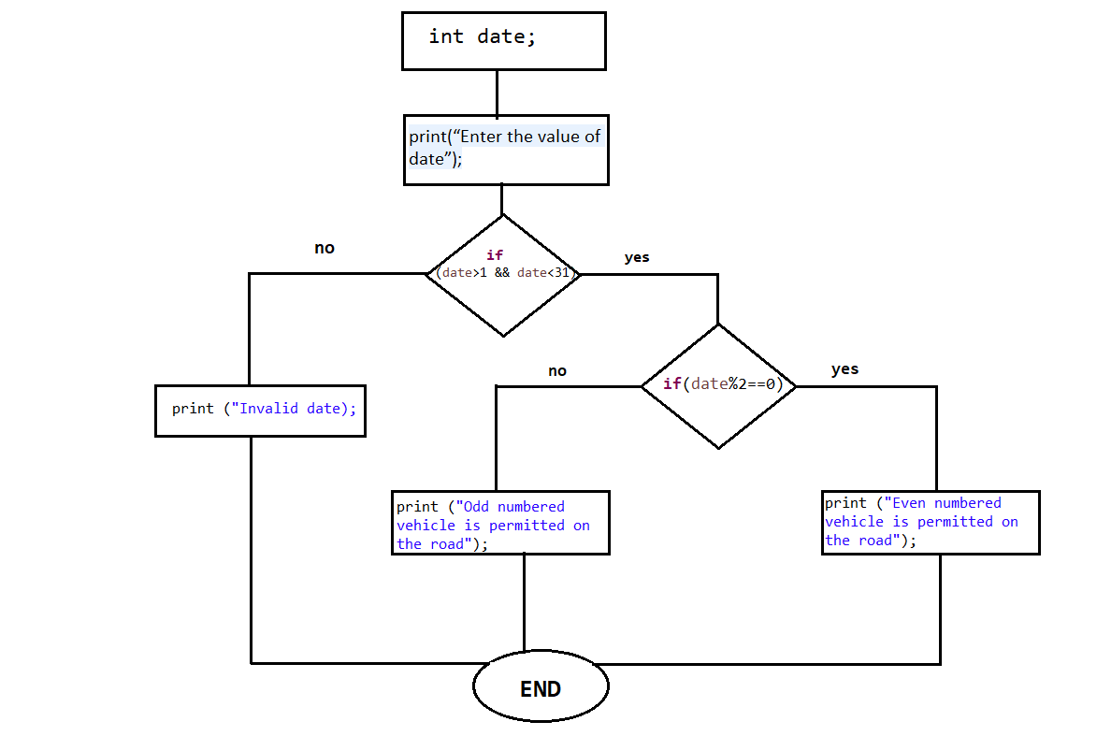

1. **Choosing the Best Horse:**

**Algorithm:**

**int** array_of_Horse[] = **new** **int**[3], i=0, max;

**for**(i=1;i<=3;i++)

{

print ("Weight of first horse %d :",i);

read (array_of_Horse[i-1]);

}

max=array_of_Horse[0];

**for**(i=1;i<3;i++)

{**if**(array_of_Horse[i]>max)

{ max=array_of_Horse[i]; } }

Print(“"The Best horse is: %d",max);

**Flowchart:**

