PYTHON PROJECT DOCUMENTATION

Student Performance
Analytics System
A beginner data analysis project using Python, Pandas and NumPy

PROJECT DETAILS | FILL IN YOUR DETAILS
Student name | Aditi Shaiv
Course / batch | Python with AI
Submission date | 26 october 2026

PROJECT OVERVIEW

Objective and scope
This project organizes student marks in a table and calculates useful summaries. It demonstrates core Python programming and beginner data analysis using a small CSV dataset.

Objective
The objective is to build a Student Performance Analytics System that reads student records, calculates totals and averages, assigns grades, checks pass or fail status, and summarizes class and subject performance. The printed results help a reader quickly identify students who may need support and subjects with stronger average results.

Problem being addressed
When marks are stored as separate values, calculating each student’s result by hand can take time and make comparisons difficult. A structured dataset and a short program make the calculations repeatable. If a mark changes, the dataset can be updated and the analysis run again.

Project scope
- Reads a student dataset into a Pandas DataFrame.
- Uses NumPy and Pandas to calculate totals, averages and summaries.
- Uses a function, a loop and conditions to assign grades and results.
- Displays student results, class statistics, subject averages and top performers.
The program is an educational data-analysis exercise. It does not predict future marks, use machine learning, or make decisions about students. Its conclusions depend on the sample data and the grading rules selected for the project.

Expected outcome
When the program runs, it prints a student data table, a performance table, and a class analysis. The output is designed to be readable in a Colab notebook or terminal and follows the plain-text table style shown in the project example.

DATASET

Data fields and preparation
The project uses a CSV file with 15 example student records. The first five sample rows mirror the marks shown in the reference output; the remaining rows provide a larger dataset for analysis.

Dataset fields
Column | Meaning
Student_ID | Unique numeric identifier for each student
Name | Student name used in the printed summaries
Python, SQL, HTML, CSS, JavaScript | Subject marks, each from 0 to 100
Attendance | Attendance percentage from 0 to 100

Creating the DataFrame in Colab
The beginner workflow can define the records in a Python dictionary and pass that dictionary to pandas.DataFrame(). Each dictionary key becomes a column name and each list contains the values for that column. All lists must contain the same number of entries so each student has a complete row.
After displaying the DataFrame, the project saves it with students_df.to_csv("students.csv", index=False). The index=False option prevents Pandas from adding an extra row-number column to the CSV. Later, the saved file can be read again with pandas.read_csv("students.csv").
TOOLS AND WORKFLOW

Technologies and project structure
The implementation uses standard beginner tools for reading, calculating and presenting tabular data.

Technologies used
Technology | Use in this project
Python | Variables, lists, functions, loops, conditions and program flow
Pandas | DataFrame creation, CSV reading/writing, averages and sorting
NumPy | Array-based totals and averages for subject marks
Google Colab | Browser-based notebook for entering and running cells
CSV | Simple text format for storing rows and columns of student data

Suggested project files
File | Purpose
main.py or Colab notebook | Contains the code that calculates and prints the analysis
students.csv | Contains the student data used by the program
README.md | Explains the project and how to run it
Project_Documentation.docx | Describes the project, implementation, results and learning

Colab execution sequence
- Import Pandas and NumPy, then create the student DataFrame.
- Display the DataFrame and save it as students.csv.
- Calculate totals, averages, grades and pass/fail results.
- Display class statistics, subject averages and top performers.
- Save the final result table as a CSV if a separate results file is needed.

IMPLEMENTATION

Calculations and decision rules
The program uses clear rules to turn subject marks into a total, average, grade and result.

Total and average marks
For each student, Total is the sum of the five subject marks. Average is Total divided by five. The example rounds the displayed average to two decimal places. NumPy can calculate row totals and row averages from the subject columns, while Pandas can calculate the mean for each subject across all students.

Grade rule used in the example
Average mark | Grade
90 and above | A+
80 to below 90 | A
70 to below 80 | B
60 to below 70 | C
40 to below 60 | D
Below 40 | F

Pass or fail rule used in the example
A student passes when every subject mark is at least 40 and attendance is at least 75 percent. If either condition is not met, the student is marked Fail. The code checks the subject marks with a loop and uses conditions to choose the result.

Functions, loops and conditions
- A grade function receives one average and returns the matching grade.
- A loop goes through the student rows and processes them one at a time.
- If/elif/else conditions compare averages to the grade thresholds.
- A pass/fail condition combines the minimum subject mark and attendance checks.

Analysis produced by the program
The final analysis answers basic questions about student and class performance using the loaded dataset.

Student-level results
The performance table displays Student_ID, Name, Total, Average, Grade and Result. This makes it possible to compare each student’s subject scores with their overall result without reading the calculation code.

Class-level results
- Number of students included in the analysis.
- Overall class average, calculated from the student averages.
- Student with the highest average and student with the lowest average.
- Counts of students marked Pass and Fail.

Subject-level results
The program calculates the average mark for each subject across the class. The subject with the largest average is reported as the best subject in this dataset. This describes only the sample records; it does not show that a subject is inherently easier or better.

Top performers
Students are sorted by average in descending order. The first three rows form the top-three list, including each student’s average and grade. If students have equal averages, the sort order may determine which names appear first.

Screenshot
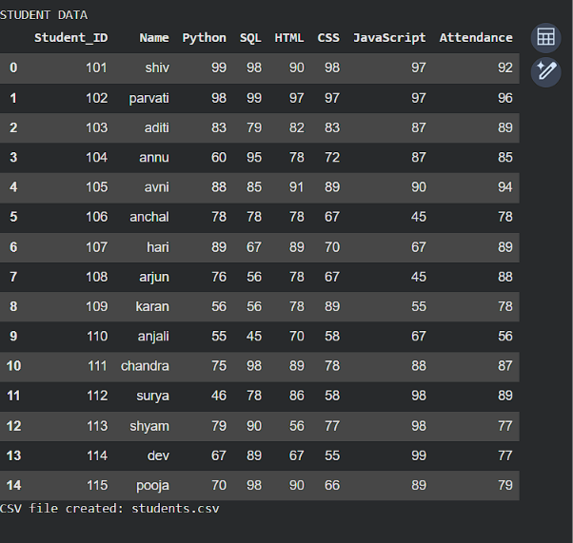
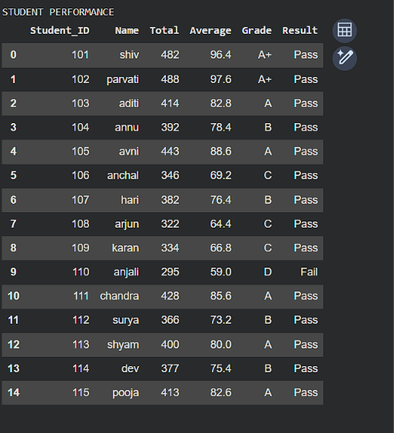

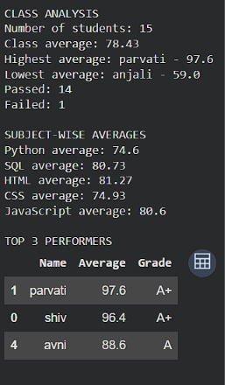

Learning, final outcome
The project demonstrates how a small Python program can turn a table of marks into readable performance summaries.

Final outcome
The completed system reads student information, calculates totals and averages, assigns grades and pass/fail results, and summarizes class and subject performance. The output can be reviewed in Colab and exported as a CSV file for sharing with the project

