ANIME DATA ANALYSIS
AICTE • IBM SKILLSBUILD • BHARATCARES
Data Analytics with AI Academic Internship Program — 2026

“As global streaming platforms and media conglomerates expand their animation catalogs, understanding historical audience reception and production patterns is critical for IP acquisition and greenlighting investments. This study examines over a century of catalog data to evaluate audience consensus, content formatting efficiency, and studio output, identifying where platform subscriber engagement disproportionately concentrates versus where the market faces saturation.”

Aditi Verma
Dataset: anime-dataset-2023.csv | Analysis Type: Exploratory Data Analysis
Tools: Python · Pandas · NumPy · Matplotlib · Seaborn · IBM Bob (AI Copilot)
Source: Anime Dataset 2023

Executive Summary

This report presents a comprehensive Exploratory Data Analysis (EDA) of the MyAnimeList 2023 dataset — one of the largest publicly available collections of anime metadata, covering 24,905 unique titles. MyAnimeList (MAL) is the world's most popular anime and manga database, aggregating user ratings, engagement statistics, and catalogue metadata for decades of Japanese animation. The dataset captures titles from 1917 through to 2023, though meaningful statistical coverage begins in the 1960s and becomes dense from the 1990s onward.
The primary objective of this analysis is descriptive:
To characterise the anime landscape across multiple dimensions — quality (user scores), popularity (member list counts, favourites), format (TV, Movie, OVA, ONA, Special, Music), genre composition, studio productivity and quality, source material types, and temporal release trends. The analysis makes no predictive claims; it identifies patterns, distributions, and relationships that can inform decisions about content strategy, genre targeting, and production planning
.
Six analytical dimensions were examined in depth:
- score distribution and top-rated titles;
- audience engagement metrics and the relationship between popularity and quality;
- genre frequency and genre-level quality differences;
- anime format (type) differences in volume, score, and engagement;
- studio productivity, average score quality, and audience reach;
- source material types and their relationship with score outcomes. A release trend analysis examines how the anime industry has evolved from the 1960s to 2023.

The analysis reveals several important patterns: engagement is highly power-law distributed — a handful of blockbuster titles dominate member counts while the majority of titles attract modest audiences. TV series consistently outperform other formats on quality and engagement. Adapted source materials (light novels, manga, web novels) outperform original works on average score, suggesting that pre-established audiences benefit adaptations. Studio output volume and quality are largely decoupled — the most prolific studios are not the highest-scoring ones. Comedy and Fantasy dominate genre volume, but niche genres (Award Winning, Mystery, Suspense) achieve far higher average scores.
These findings are directly useful for anyone seeking to understand the anime industry landscape — including content strategists, platform curators, researchers, or enthusiasts seeking data-driven insight into what makes anime resonate with audiences.

Key Metrics at a Glance

Content Strategy & Audience Intelligence
This project demonstrates an end-to-end data analytics workflow on a multi-format media catalog. The primary focus is data ingestion, handling structural null values, exploring univariate/multivariate distributions, and uncovering production dynamics over a century of anime release history.

Total Anime Titles: 24,905
- Score Range: 1.85 – 9.10
- Mean Score: 6.38
- Median Score: 6.39
- Unique Genres: 21
- Anime Format Types: 6
- Unique Studios: 1,043
- Release Years: 1917 – 2023
- Titles with Scores: 15,692 (63%)
- Missing Scores: 9,213 (37%)
- Peak Year: 2017 (1,221 titles)
- Highest Score: 9.10 — Fullmetal Alchemist: Brotherhood
- Most-Watched: Shingeki no Kyojin (3.74M members)
.

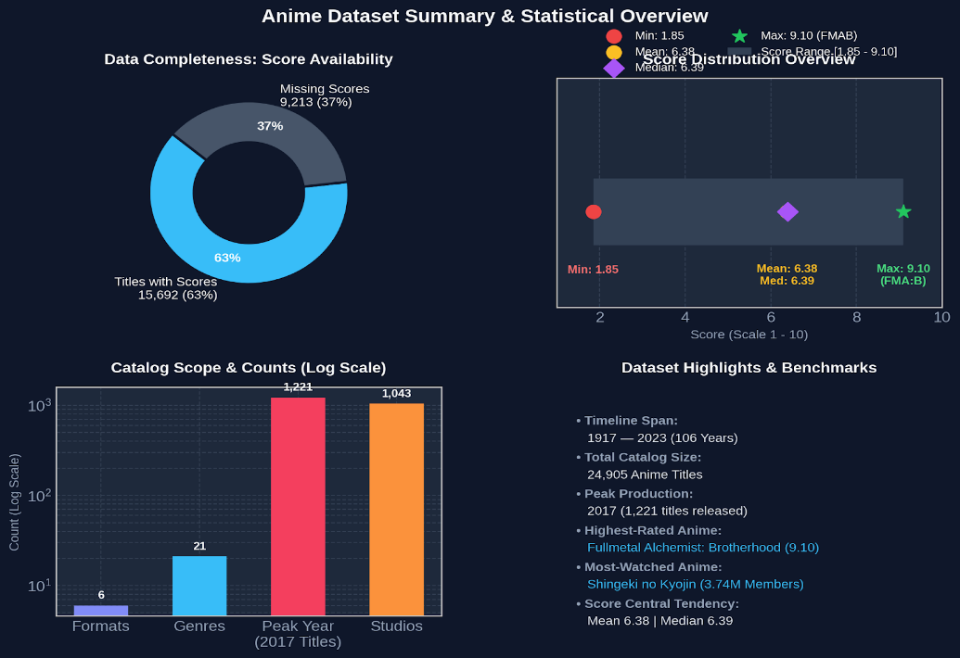

All values above are sourced directly from the executed analysis notebook

Introduction & Analytical Context

Background
Anime — Japanese animated content — has grown from a domestic art form into a global cultural and commercial phenomenon. Streaming platforms such as Netflix, Crunchyroll, and Amazon Prime have driven international adoption, making anime one of the fastest-growing entertainment segments worldwide. With tens of thousands of titles spanning more than six decades of production history, understanding what differentiates successful anime from obscure titles requires rigorous data analysis.
MyAnimeList (MAL) is the world's largest community-driven anime and manga cataloguing platform, with millions of active users who rate, list, and review titles. The MAL dataset provides a uniquely rich window into audience behaviour — not just critical reception, but actual consumption patterns, favouriting behaviour, and community engagement at scale. This analysis treats the MAL 2023 dataset as a cross-sectional snapshot of the anime industry as perceived by a large and engaged user community.
Analytical Questions
This analysis was designed to answer the following questions:
• How are anime scores distributed, and which titles achieve the highest community ratings?
• Is there a meaningful relationship between popularity (audience size) and quality (score)?
• Which genres dominate by volume, and do high-frequency genres also deliver high quality?
• How do different anime formats (TV, Movie, OVA, etc.) differ in quality and audience reach?
• Which studios produce the most content and which produce the highest-quality content?
• Does source material type (manga, light novel, original) influence audience reception?
• How have anime production volume and quality evolved over time?
Scope & Methodology
This is a pure Exploratory Data Analysis project. The methodology is descriptive and visual: the analysis uses frequency distributions, aggregated statistics (mean, median, counts), and Pearson correlation coefficients to characterise patterns in the data. No machine learning, regression modelling, or causal inference is performed. All reported values are derived directly from Python (pandas, NumPy) computations on the dataset — no values have been estimated, interpolated, or invented.
Charts produced during the analysis include histograms, box plots, horizontal bar charts, scatter plots, stacked area charts, pie charts, and a correlation heatmap. Chart filenames are referenced in the relevant sections for cross-referencing purposes.

Dataset Overview

2.1 Dataset Provenance
The dataset is sourced from MyAnimeList and distributed as anime-dataset-2023.csv. It contains 24,905 rows (one per anime title) and 24 columns covering metadata, engagement statistics, and catalogue information. The dataset reflects MAL's catalogue as of 2023.
2.2 Column Reference
Column name | Raw Type | Description | Notes
- anime_id | int64 | Unique MAL identifier | Primary key
- Name / English name | str | Original and English title | —
- Score | str → float | Community average rating (1–10) | 37% UNKNOWN
- Genres | str | Comma-separated genre tags | 19.8% UNKNOWN
- Type | str | Format: TV / Movie / OVA / ONA / Special / Music | 0.3% UNKNOWN
- Episodes | str → float | Number of episodes | 2.5% UNKNOWN
- Studios | str | Comma-separated production studios | 42.3% UNKNOWN
- Source | str | Origin material type | 14.8% UNKNOWN
- Popularity | int64 | MAL popularity rank (lower = more popular) | No missing values
- Favourites | int64 | Users who added to favourites | No missing values
- Scored By | str → float | Number of users who submitted a rating | 37% UNKNOWN
- Members | int64 | Users who added the title to their list | No missing values
- Rank | str → float | MAL quality rank (lower = better) | 18.5% UNKNOWN
- Duration | str → float | Episode duration (parsed to minutes) | 2.7% UNKNOWN
2.3 Data Quality Observations
A critical initial finding was that the dataset does not use standard Nan values for missing data. Instead, missing entries are encoded as the sentinel string 'UNKNOWN' (or its case variants). This is an important distinction — naive null-count checks would return zero missing values, masking the true extent of gaps. The actual missing-data rates, derived by scanning for UNKNOWN sentinels, reveal substantial gaps in several columns:
▸ Premiered: 77.9% unknown — the most data-sparse column; fallback to Aired year was necessary
▸ Studios: 42.3% unknown — limits studio-level analysis coverage
▸ Score & Scored By: 37.0% unknown — unscored titles are typically niche, very old, or newly released
▸ Genres: 19.8% unknown | Rank: 18.5% unknown | Source: 14.8% unknown
▸ Duration: 2.7% unknown | Episodes: 2.5% unknown | Type: 0.3% unknown
No duplicate rows were found. The dataset contains 0 true Nan values in any column — all missing-data handling was performed exclusively on UNKNOWN sentinel detection.

Data Preparation

3.1 Cleaning Approach
A working copy of the raw dataset (df) was created from the original (df_raw). The original CSV was not modified at any point. All transformations were applied only to the working copy.
Step 1 — Sentinel Replacement: All 'UNKNOWN', 'Unknown', and 'unknown' values were replaced with NumPy NaN. This allowed standard pandas operations (dropna(), notna(), describe()) to handle missing data correctly.
Step 2 — Type Conversion: Score, Rank, Scored By, and Episodes were stored as object (string) columns. These were converted to float64 using pd.to_numeric(errors='coerce'), which coerces any remaining non-numeric values to NaN.
Step 3 — Duration Parsing: The Duration column contained strings such as '24 min per ep' or '1 hr 55 min'. A custom parser extracted hours and minutes and computed a single numeric Duration_min column (total minutes as float). Values that could not be parsed were set to NaN.
Step 4 — Premiere Year & Season Extraction: The Premiered column (e.g. 'spring 2011') was parsed to extract Premiere_Year (integer) and Premiere_Season (Spring/Summer/Fall/Winter).
Step 5 — Release Year (Fallback): A separate Aired_Start_Year was extracted from the Aired column using regex (first four-digit year). A unified Release_Year was constructed by preferring Premiere_Year where available and falling back to Aired_Start_Year for the remaining ~78% of titles without a Premiered value.

3.2 Post-Cleaning Summary Statistics
After cleaning, the key numeric columns have the following properties:
Score — Non-null: 15,692 | Mean: 6.38 | Median: 6.39 | Std: 0.93 | Min: 1.85 | Max: 9.10 | IQR: 5.73 – 7.06
Episodes — Non-null: 24,294 | Mean: 14.91 | Median: 2 | Std: 48.58 | Max: 3,057
Duration_min — Non-null: 23,637 | Mean: 22.68 min | Median: 18 min | Max: 1,500 min
Members — All 24,905 | Mean: 37,105 | Median: 1,056 | Std: 156,825 | Max: 3,744,541
Favorites — All 24,905 | Mean: 432.6 | Median: 1 | Max: 217,606
Release_Year — Non-null: 23,990 | Range: 1917 – 2025 | Median: 2012
The extreme right-skew in Members (mean 37,105 vs median 1,056) and Favorites (mean 432 vs median 1) indicates that a small number of blockbuster titles dominate these engagement metrics.

Score Analysis

4.1 score Distribution
15,692 of 24,905 titles (63%) have a community score. The remaining 37% are unscored — typically due to insufficient ratings (MAL requires a minimum number of votes before displaying a score), representing either niche titles, very old entries with low engagement, or newly released content captured in the 2023 snapshot.
The score distribution is approximately normal with a slight left skew, centred between 6.5 and 7.0. The mean (6.38) and median (6.39) are nearly identical, confirming a near-symmetric central distribution with a modest tail at the lower extreme. The interquartile range (IQR) of 5.73–7.06 represents the core of community assessments, while fewer than 5% of titles exceed 8.0 and very few exceed 9.0.
Figure Reference: score_distribution.png — Histogram of all scored anime with mean and median lines marked, paired with a box plot showing the IQR and extreme values.
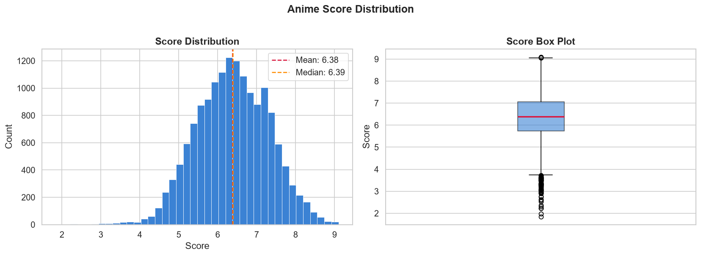

4.2 Top-Rated Titles
The following titles represent the 15 highest-scored anime among those with at least 1,000 voters (to filter out statistical noise from sparsely rated entries):
#1 Full metal Alchemist: Brotherhood | 9.10 | TV, Spring 2009 | 2,020,030 voters
#2 Steins; Gate | 9.07 | TV, Spring 2011 | 1,336,233 voters
#2 Bleach: Sennen Kessen-hen | 9.07 | TV, Fall 2022 | 213,872 voters
#4 Gitama° | 9.06 | TV, Spring 2015 | 237,957 voters
#5 Shingeki no Kyojin Season 3 Part 2 | 9.05 | TV, Spring 2019 | 1,471,825 voters
#5 Kaguya-same way Kokura Setai: Ultra Romantic | 9.05 | TV, Spring 2022 | 451,187 voters
#5 Shingeki no Kyojin: The Final Season Kanetsu-hen | 9.05 | Special | 155,773 voters
#8 Hunter x Hunter (2011) | 9.04 | TV, Fall 2011 | 1,651,790 voters
#8 Gutama' / Gutama: The Final | 9.04 each | Multiple entries — Gutama franchise dominates the top 15
#12 Ginga Eikyuu Densetsu | 9.02 | OVA | 75,590 voters (only non-TV entry in top 12)
#13 Fruits Basket: The Final | 9.00 | TV, Spring 2021 | 211,379 voters
#14 Gutama. / "Oshi no Ko” | 8.98 each | TV entries completing the top 15
Notable observation: the Gutama franchise (Gutama°, Gutama', Gutama: The Final, Gutama.: Enghouse) occupies five of the top 15 positions, reflecting an exceptionally loyal community fanbase. All top-rated titles are TV series except Ginga Eikyuu Densetsu (OVA) and Gutama: The Final (Movie). No ONA or Music video appears in the top 15. Figure Reference: top_scored_anime.png
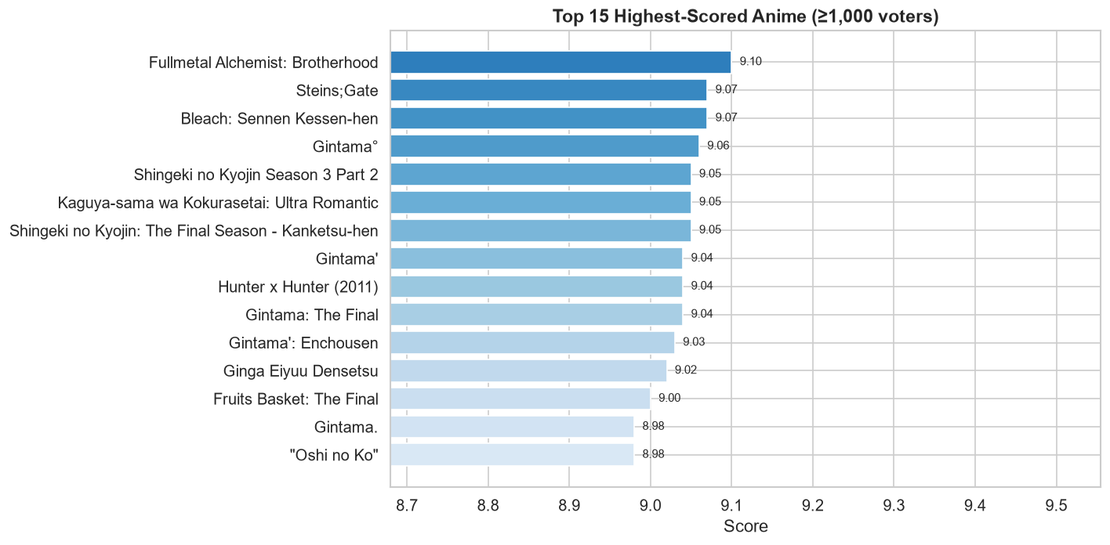

4.3 score by Format Type
Grouping scores by anime format reveals a clear quality hierarchy by type. TV series consistently achieve the highest median scores (6.86), followed by Specials and Movies (6.37 each). OVAs (6.22) and ONAs (6.00) score lower on average. Music videos score lowest at a median of 5.77.
Format | Mean Score | Median Score | Scored Titles
TV: mean 6.847, median 6.86, n=4,482 | Movie: mean 6.344, median 6.37, n=2,475 | Special: mean 6.366, median 6.37, n=2,039
OVA: mean 6.218, median 6.22, n=3,283 | ONA: mean 6.038, median 6.00, n=1,929 | Music: mean 5.861, median 5.77, n=1,483
The TV format advantage likely reflects greater production investment, longer narrative arcs that allow character development, and stronger community engagement driving more thoughtful ratings. ONA scores lower despite growing production volume, possibly reflecting the diversity of streaming-native experimental content. Figure Reference: score_by_type.png
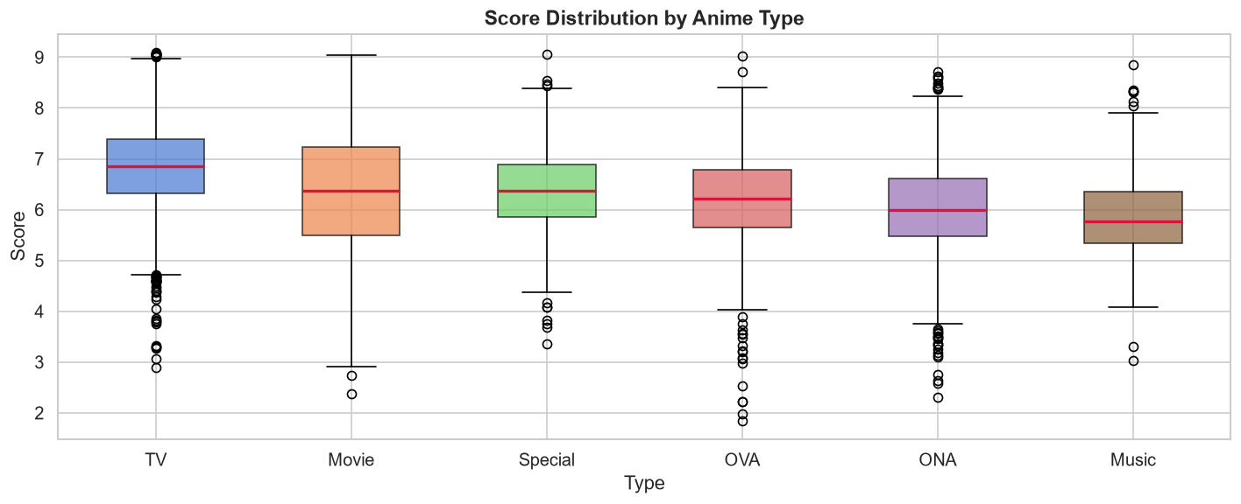

Popularity & Audience Engagement
5.1 Engagement Metric Distributions
Three engagement metrics characterise audience behaviour on MAL: Members (users who added a title to their list), Favourites (users who explicitly marked a title as a favourite), and Popularity (a community-assigned rank based on member count). All three are available for all 24,905 titles with no missing values.
All three metrics exhibit severe right-skew — the hallmark of a power-law distribution. The raw distributions are essentially uninterpretable at linear scale: the vast majority of titles cluster near zero while a tiny fraction drives enormous totals. Log-transformation (log (1 + x)) normalises these distributions into near-bell-shaped curves, confirming that engagement follows a typical long-tail pattern common to cultural goods markets.
Members: Mean 37,105 vs Median 1,056 (ratio 35:1) — extreme skew driven by blockbuster titles. Std dev 156,825 dwarfs the mean.
Favourites: Mean 432.6 vs Median 1 (ratio 432:1) — even more concentrated. 75th percentile is only 18 favourites.
Members Max: 3,744,541 (Shingeki no Kyojin) | Favourites Max: 217,606 (Full metal Alchemist: Brotherhood).
Figure Reference: engagement_distributions.png — log(1+x) histograms for Members, Favourites, and Popularity showing near-normal shapes after transformation.

5.2 Most-Watched and Most-Favourited Titles
The top 15 by Members are dominated by high-profile TV series, with one Movie (Kimi no Na wa. at rank 11). Note that high member counts do not guarantee high scores — Sword Art Online (7.20) and Tokyo Ghoul (7.79) appear despite receiving average-to-mediocre critical reception:
1. Shingeki no Kyojin — 3,744,541 members (Score 8.54) 2. Death Note — 3,713,315 (8.62) 3. FMA: Brotherhood — 3,176,556 (9.10)
4. One Punch Man — 3,058,666 (8.50) 5. Sword Art Online — 2,951,821 (7.20) 6. Boku no Hero Academia — 2,882,333 (7.89)
7. Kimetsu no Yaiba — 2,808,712 (8.50) 8. Naruto — 2,717,330 (7.99) 9. Tokyo Ghoul — 2,699,241 (7.79)
10. Hunter x Hunter (2011) — 2,656,870 (9.04) 11. Kimi no Na wa. — 2,597,495 (8.85, Movie)
12. Shingeki no Kyojin S2 — 2,566,796 13. Steins;Gate — 2,440,369 (9.07) 14. BNHA 2nd Season — 2,410,638 15. Naruto Shippuuden — 2,349,413

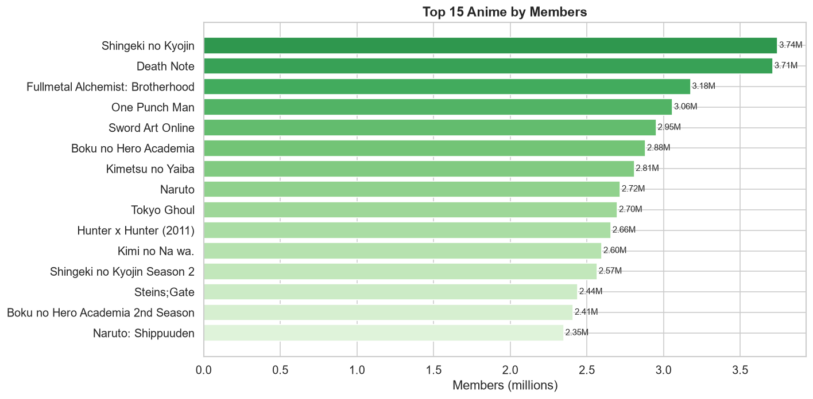

Genre Analysis

6.1 Genre Frequency
Genre analysis required exploding the comma-separated Genres column into individual rows. This yields one row per genre tag per anime, enabling per-genre aggregations. 21 unique genre tags were identified across the 19,976 anime with known genre information.
The top genres by title count are Comedy (7,142), Fantasy (5,306), Action (4,730), Adventure (3,842), Sci-Fi (3,091), Drama (2,836), Romance (2,063), Slice of Life (1,755), Supernatural (1,494), and Hentai (1,486). Comedy's dominance is decisive — it appears in nearly 36% of all titled anime in the dataset. The next four (Fantasy, Action, Adventure, Sci-Fi) form a core action-adventure cluster that together covers the vast majority of mainstream anime production.
Further down: Mystery (847), Avant Garde (804), Ecchi (795), Sports (771), Horror (534), Suspense (242), Award Winning (241), Boys Love (169), Gourmet (146), Girls Love (113).

Figure Reference: top_genres.png — horizontal bar chart of the 20 most common genres by title count.
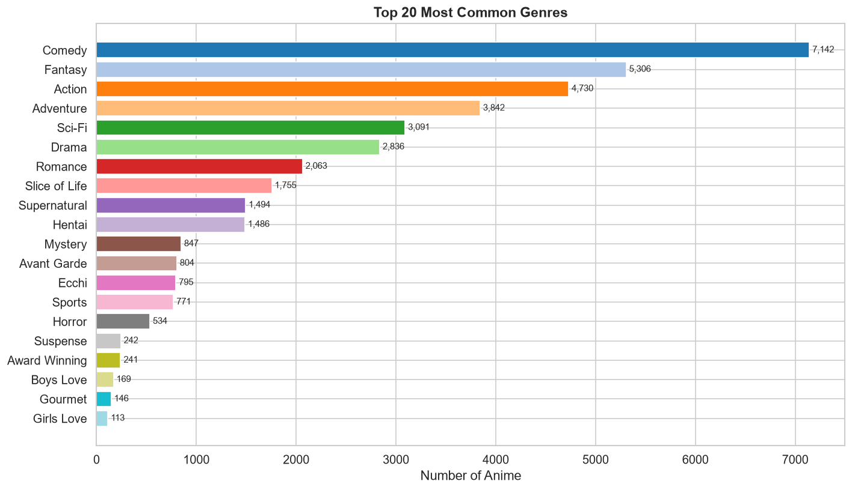

6.2 Genre Quality — Volume vs Average Score
A critical finding is that the most popular genres by count are not the highest-quality genres by average score. Filtering to genres with at least 50 scored titles to ensure statistical stability, the quality ranking diverges sharply from the frequency ranking:
Award Winning: 7.30 avg (214 titles) — highest quality, lowest volume among major genres
Mystery: 6.99 (752) | Suspense: 6.96 (189) | Drama: 6.85 (2,200) | Romance: 6.80 (1,832)
Supernatural: 6.74 (1,274) | Sports: 6.72 (567) | Action: 6.67 (3,957) | Adventure: 6.67 (2,672)
Fantasy: 6.59 (3,291) | Sci-Fi: 6.56 (2,451) | Comedy: 6.52 (5,070) | Boys Love: 6.50 (150)
Slice of Life: 6.48 (1,184) | Ecchi: 6.43 (767) | Horror: 6.15 (451) | Hentai: 6.07 (1,465)
Avant Garde: 5.14 (468) — lowest scoring genre despite moderate production volume

The pattern is clear: narrative-driven genres (Award Winning, Mystery, Suspense, Drama, Romance) consistently outperform action-entertainment genres (Comedy, Fantasy, Action) in average score. Comedy — the most common genre — ranks only 12th in quality. Avant Garde is the lowest-scoring major genre, suggesting that unconventional experimental works tend to receive lower community scores. Figure References: genre_avg_score.
png, genre_avg_members.png

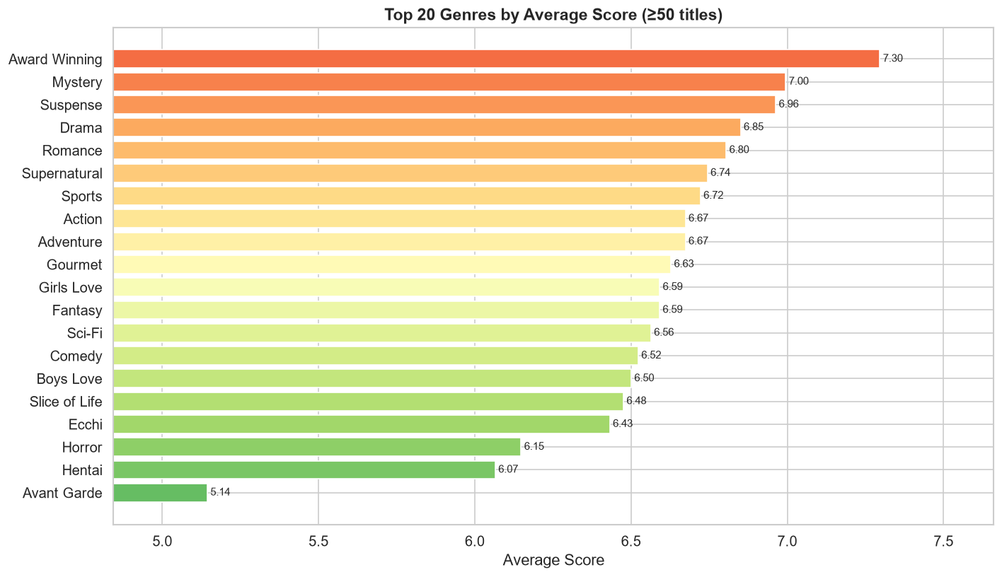

Anime Format (Type) Analysis

7.1 Format Distribution
The dataset's 24,905 titles (excluding 74 with unknown type) span six distinct production formats. TV series are the dominant format by count, followed by Movies and OVAs:
TV: 7,597 titles (30.5%) | Movie: 4,381 (17.6%) | OVA: 4,076 (16.4%) | ONA: 3,533 (14.2%) | Music: 2,686 (10.8%) | Special: 2,558 (10.3%)

Figure Reference: type_distribution.png — bar chart and pie chart showing format count and share.
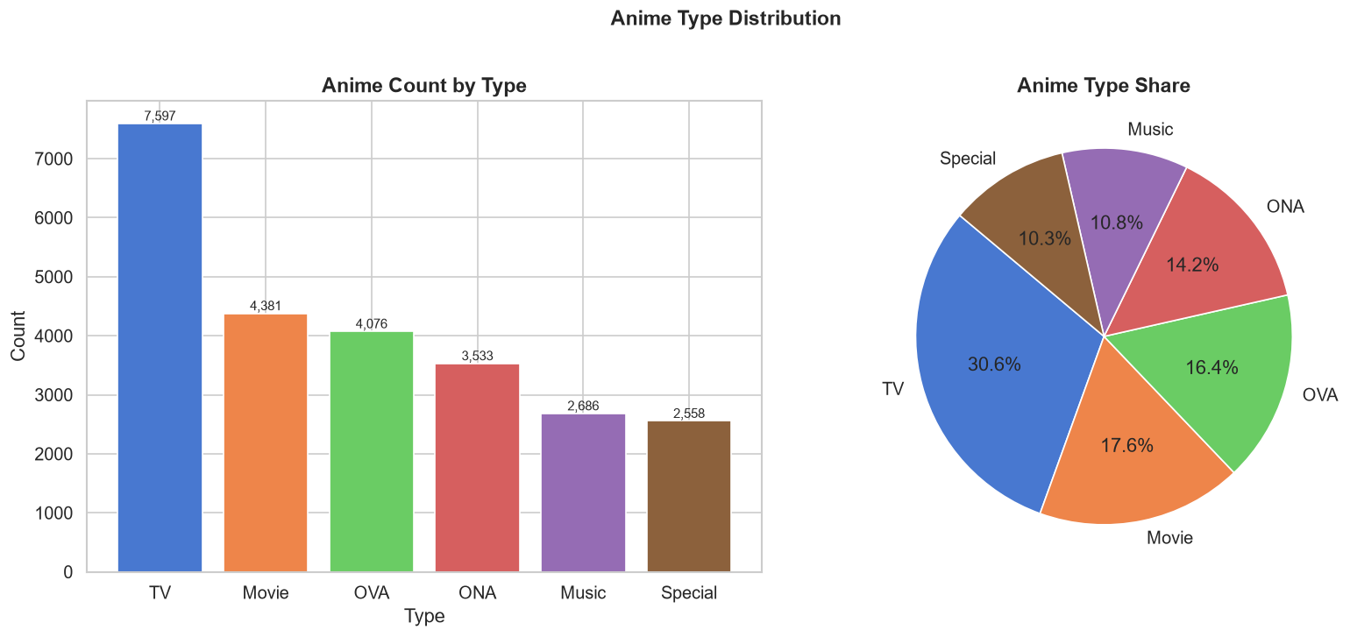

7.2 Format Engagement — Members Statistics
The Members statistics reveal a stark difference between mean and median for most formats — driven by blockbuster outliers. The median is arguably the more meaningful measure of typical engagement:
TV: mean 92,545 / median 2,967 / total 703M — the overwhelmingly dominant format by total reach
OVA: mean 13,514 / median 3,482 — notably OVA median exceeds TV median, suggesting a more engaged niche audience
Special: mean 14,427 / median 2,944 / total 37M
Movie: mean 23,075 / median 590 / total 101M — high mean inflated by blockbuster films (Kimi no Na way., etc.)
ONA: mean 7,048 / median 528 / total 25M
Music: mean 977 / median 252 / total 2.6M — lowest engagement of all formats
The OVA median (3,482) exceeding the TV median (2,967) is a noteworthy finding: despite lower total volume, a typical OVA attracts a slightly more engaged audience than a typical TV series. This may reflect the OVA model — produced specifically for existing anime fans and often tied to established franchises — which generates a concentrated, dedicated viewership. Figure Reference: members_by_type.png

Studio Analysis

8.1 Studio Landscape
After exploding the comma-separated Studios column, 1,043 unique production studios were identified across the 14,379 anime with known studio information (the remaining 42.3% have no studio data). Production is highly concentrated: the top 20 studios account for a disproportionate share of all credited titles.

Figure Reference: top_studios_count.png

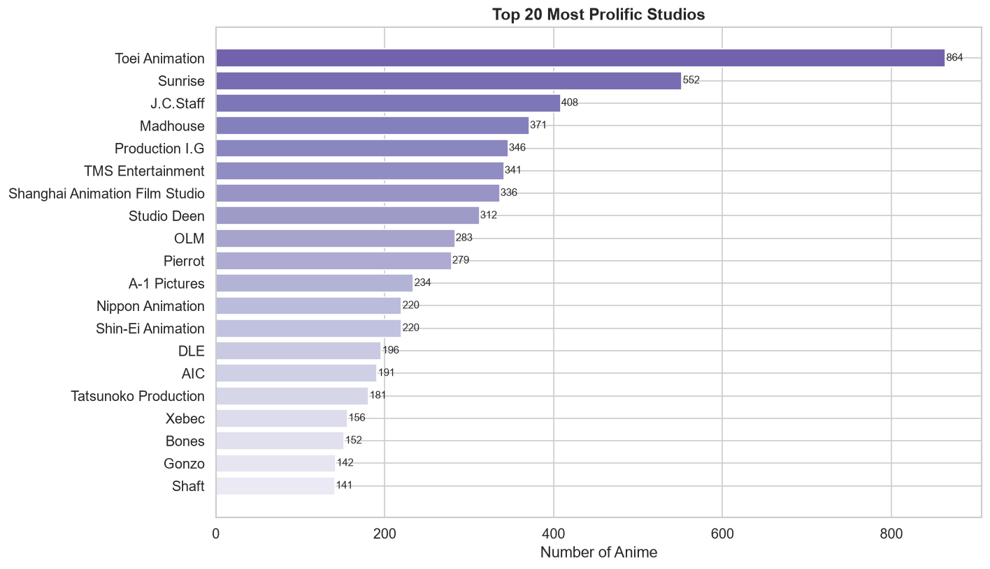

8.2 Quality vs Quantity — The Studio Decoupling
The most striking studio finding is the complete decoupling of volume and quality. None of the top-10 most prolific studios appears in the top-10 highest-scoring studios. Among studios with at least 10 scored titles, quality leaders are smaller, more focused studios:
Animation Do: 7.63 avg (10 titles) | Motion Magic: 7.63 (11) | Shuka: 7.61 (19)
Bones: 7.32 (148) | Kyoto Animation: 7.32 (126) | Geno Studio: 7.30 (10) | TROYCA: 7.29 (19)
David Production: 7.27 (45) | White Fox: 7.23 (45) | Lerche: 7.23 (58) | quotable: 7.21 (71)
Science SARU: 7.20 (14) | Wit Studio: 7.20 (73) | MAPPA: 7.16 (74) | A-1 Pictures: 7.12 (228)
The contrast is stark: Toei Animation (864 titles) produces approximately 5.8x more content than Bones (148 titles) but scores measurably lower on average quality. This suggests a strategic trade-off — large legacy studios prioritise scale and franchise maintenance, while quality-focused studios (Kyo Ani, ufotable, MAPPA) invest heavily per project. Figure References: studio_avg_score.png, studio_total_members.png

Source Material Analysis

9.1 Source Distribution
Source material refers to the creative origin of each anime. The dataset identifies 16 distinct source types. After removing entries with unknown source (14.8%), the remaining 21,216 titles are distributed as follows:
Original: 9,622 (45.4%) — by far the most common; no pre-existing adaptation
Manga: 4,687 (22.1%) | Game: 1,232 (5.8%) | Visual Novel: 1,107 (5.2%) | Other: 1,008 (4.8%)
Light Novel: 968 (4.6%) | Novel: 709 (3.3%) | Web Manga: 447 (2.1%) | Music: 395 (1.9%)
4-koma Manga: 314 | Picture Book: 210 | Book: 191 | Mixed Media: 162 | Web Novel: 82 | Card Game: 68 | Radio: 14
Figure Reference: source_distribution.png — bar chart and pie chart (Top 8 + Other).

9.2 Source Material Quality — An Inverse Volume–Quality Relationship
The most important finding in source material analysis is that the most numerous source type (Original) is also among the lowest-quality by average score. Filtering to sources with at least 20 scored titles reveals a clear inverse pattern:

Web Novel: 7.00 (42 titles) | Light Novel: 6.96 (877) | Manga: 6.83 (4,150) | Web Manga: 6.75 (315)
Novel: 6.72 (540) | 4-koma Manga: 6.66 (280) | Book: 6.45 (91) | Mixed Media: 6.44 (112)
Card Game: 6.32 (65) | Game: 6.31 (956) | Visual Novel: 6.30 (1,089)
Original: 6.07 (4,545) | Other: 6.03 (517) | Picture Book: 5.95 (55) | Music: 5.66 (313)
Light novel adaptations (6.96) score nearly a full point higher than original works (6.07). This likely reflects a selection effect: only commercially successful light novels with established readerships are chosen for anime adaptation, resulting in a pre-filtered pool of high-quality source material. Original works have no such filter — they include experimental projects, low-budget productions, and works that never found an audience.
Figure Reference: source_avg_score.png
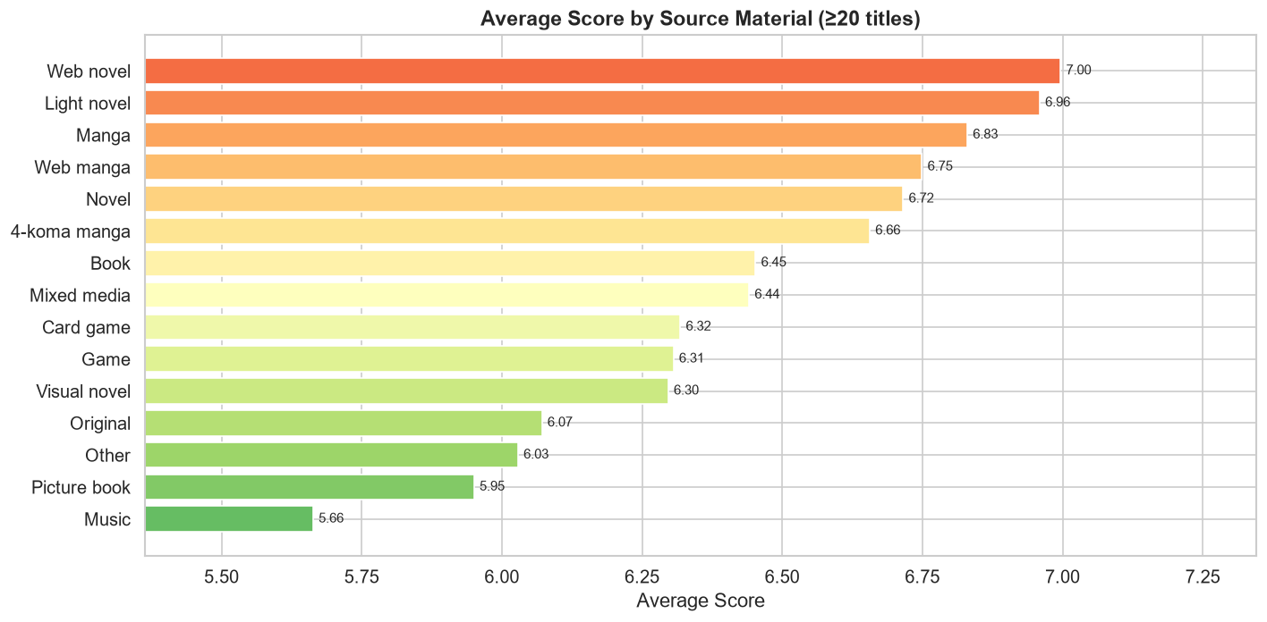

Release Trends

10.1 Annual Production Volume
Release year was available for 23,990 of 24,905 titles. The analysis focuses on the 1960–2023 window (excluding sparse early decades and unreliable post-2023 entries). Annual production volume tells a clear story of explosive growth in the modern era:
1960s–1980s: Modest production with typically fewer than 50–100 titles per year in the dataset. These represent the foundational era of anime as an industry.
1990s: Dramatic acceleration begins. Production volume grows from ~200 titles/year in 1990 to over 500 by the late 1990s, driven by OVA proliferation and expanding TV animation schedules.
2000s–2010s: Continued growth driven by digital animation, lower production costs, and expanding home video markets. Annual production exceeds 600 titles from ~2004 onward.
2014–2023 (recent decade): 2014: 1,050 | 2015: 1,047 | 2016: 1,175 | 2017: 1,221 (PEAK) | 2018: 1,165 | 2019: 1,130 | 2020: 1,077 | 2021: 1,105 | 2022: 1,040 | 2023: 608 (partial year)
Production peaked in 2017 at 1,221 titles and has since plateaued at approximately 1,000–1,200 titles per year. The slight decline from 2017 may partly reflect data capture cutoffs rather than genuine production contraction. Figure Reference: anime_per_year.png
10.2 Average Score Over Time
Average score per year (limited to years with ≥5 scored titles) shows a gradual upward drift over decades. Early decades (1960s–1980s) show higher average scores (often 6.5–7.5) but with small sample sizes, so these estimates are unstable. From the 1990s onward, the average score stabilises in the 6.2–6.8 range. Recent years (2015–2023) show slightly elevated averages, possibly reflecting the authorisation of anime consumption and stronger community self-selection (dedicated fans rating titles they chose to watch). Figure Reference: avg_score_per_year.png
10.3 Seasonal Patterns
Among titles with known premiere seasons, Fall and Spring are the busiest premiere seasons. This aligns with the traditional Japanese television broadcasting calendar, which uses seasonal course (programming blocks) tied to Spring (April), Summer (July), Fall (October), and Winter (January). The Spring and Fall cours historically attract the biggest productions and franchises, consistent with the higher title counts observed. Figure Reference: anime_by_season.png
10.4 The Rise of ONA — A Structural Shift
The stacked area chart (type_over_time.png) covering 1990–2023 reveals the most important structural trend in the dataset: the explosive growth of ONA (Original Net Animation) from the mid-2010s onward. ONA titles — released directly on internet streaming platforms rather than traditional broadcast TV — were virtually non-existent before 2010 but by the early 2020s represent a substantial share of annual new titles. This shift is directly attributable to the rise of global streaming platforms (Netflix, Amazon Prime, Crunchyroll) committing major investment to anime production and distribution. TV series production remained relatively stable across the same period, while OVA production declined — suggesting that ONA has cannibalized a portion of the traditional OVA market.

Correlation Analysis

11.1 Correlation Matrix
Pearson correlation coefficients were computed across all numeric columns. Rank was inverted (Rank_inv = max (Rank) − Rank) so that higher values represent better quality, enabling intuitive correlation interpretation. Key correlation values:
Score ↔ Rank_inv: r = 0.977 — near-perfect correlation, expected since rank is computed from score
Score ↔ Popularity (inverted): r = −0.698 — strong negative: lower popularity rank (=more popular) correlates with higher score
- Members ↔ Scored By: r = 0.989 — near-perfect: audience size almost entirely determines vote volume
Favourites ↔ Members: r = 0.773 | Favourites ↔ Scored By: r = 0.785 — strong engagement clustering
Score ↔ Members: r = 0.391 | Score ↔ Scored By: r = 0.351 — moderate positive: quality partially predicts reach
Score ↔ Derationing: r = 0.298 — longer episodes weakly correlate with higher scores
- Score ↔ Episodes: r = 0.079 — negligible: episode count has almost no relationship with quality
Ranking ↔ Popularity: r = −0.872 — strong: MAL's popularity ranking closely mirrors quality ranking

11.2 Analytical Interpretation
The correlation matrix reveals a clear structural pattern: audience engagement metrics (Members, Scored By, Favourites) are tightly clustered together — once an anime accumulates a large audience, it will also accumulate votes and favourites almost automatically. Score, by contrast, has only moderate correlations with these engagement metrics, confirming that mass popularity and perceived quality are related but distinct dimensions. The near-zero correlation between Episodes and Score is particularly noteworthy: it refutes any naive assumption that longer series automatically score better, or that very short series are penalised. Figure References: correlation_matrix.png, score_vs_voters.png, members_vs_favorites.png, pairplot.png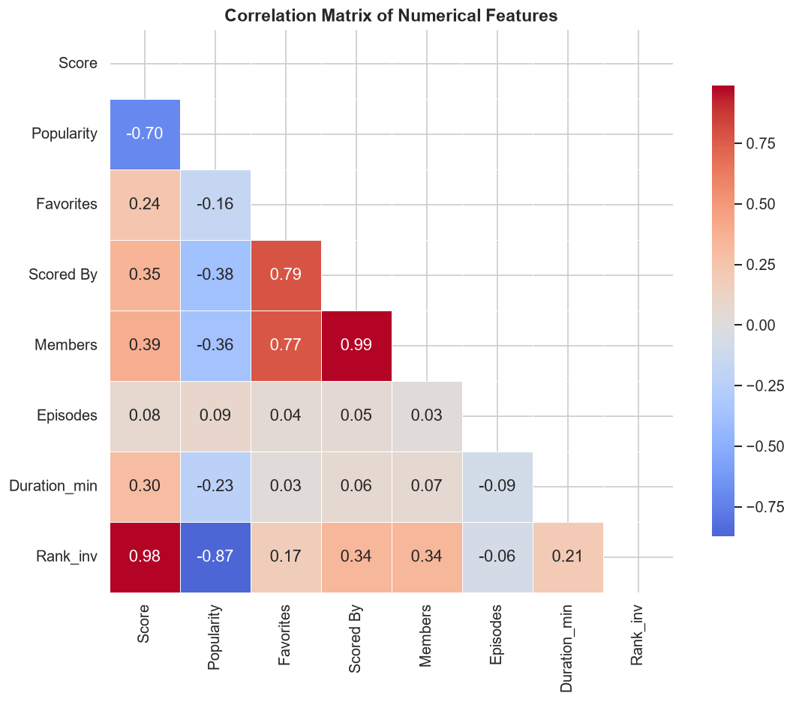

Key Findings Summary
FINDING 1 — Engagement follows a power law
Member counts, favourites, and vote counts are all severely right-skewed. The mean Members count (37,105) is 35x the median (1,056). The top 1% of titles by Members collectively account for a disproportionate share of total engagement. This is the defining structural characteristic of the anime market — a classic long-tail distribution in a cultural goods industry.
FINDING 2 — Format determines both quality and engagement
TV series dominate on every dimension: highest median score (6.86), highest total member count (703M), and highest representation in the top 15 most-scored and most-watched titles. Music videos occupy the bottom of every ranking despite significant production volume. The OVA format occupies an interesting niche — slightly higher median member count than TV (3,482 vs 2,967), suggesting a concentrated, dedicated fanbase per title.
FINDING 3 — Volume and quality are decoupled at the studio level
Not one of the top-10 most prolific studios appears in the top-10 quality studios. Toei Animation (864 titles) vs Bones/Kyoto Animation (age score 7.32) captures the trade-off cleanly. Focused studios investing heavily per project outperform volume-focused studios by a clear margin on average quality. This represents a fundamental tension in the anime production industry between franchise maintenance strategies and quality-focused creative studios.
FINDING 4 — Genre volume and genre quality are inversely related
Comedy (7,142 titles) is the most common genre but ranks only 12th in average score (6.52). Award Winning (241 titles, age 7.30) leads on quality. Narrative-complexity genres — Mystery (6.99), Suspense (6.96), Drama (6.85) — consistently outperform entertainment-focus genres. This suggests the anime community rewards narrative depth and craft over genre novelty or entertainment value alone.
FINDING 5 — Adaptation outperforms original by a clear margin
Original works are the most numerous source type (9,622 titles, 45.4%) but score the lowest among major source categories (age 6.07). Light Novel adaptations (age 6.96), Manga (6.83), and Web Novel (7.00) all substantially outperform originals. The likely mechanism is selection effect: only commercially proven source materials with established audiences get adapted, pre-filtering for quality and audience fit. Originals lack this filter.
FINDING 6 — Production peaked in 2017; the ONA era has begun
Annual anime production peaked at 1,221 titles in 2017 and has remained at approximately 1,000–1,200 titles/year since. The most important structural trend is the emergence of ONA (Original Net Animation) from near-zero pre-2010 to a major share of new productions by 2020. This directly tracks the global rollout of streaming platforms investing in anime. Traditional OVA production has declined correspondingly, suggesting platform streaming has replaced the direct-to-video market that OVAs historically occupied.
FINDING 7 — Episode count has no meaningful relationship with quality
The near-zero correlation between Episodes and Score (r = 0.079) is a clear and actionable finding: there is no evidence in this dataset that longer series are rated higher or lower than shorter ones. A 1-episode OVA and a 150-episode shounen series are equally likely to receive any given score, controlling for other factors. Duration per episode shows a slightly higher correlation with score (r = 0.298), suggesting that longer individual episodes (feature-length content) correlates weakly with higher quality perception.

Limitations
The following limitations should be considered when interpreting the findings of this analysis:
1. Missing data is substantial and non-random
37% of titles lack scores, 42.3% lack studio data, and 77.9% lack premiere information. Missing scores are not random — they systematically affect niche, obscure, very old, or very new titles. All score-based analyses (type quality, studio quality, source quality, genre quality) are computed on the 63% of scored titles, which is a biased sample toward more mainstream, more-watched content.
2. Community bias in scores
MyAnimeList scores reflect the preferences of MAL's user community — primarily English-speaking and Japanese anime fans. This community has specific demographic characteristics (younger audiences, genre preferences, franchise loyalties) that may not represent global viewer opinion. The dominance of Gintama in the top-15 scoring titles, despite modest name recognition outside dedicated fanbases, is one example of community-specific effects.
3. Multi-valued fields overcount
Genres, Studios, and Sources are comma-separated fields. Exploding these into rows for analysis creates one row per tag per anime, so a title with three genres is counted three times in genre frequency tables. All reported genre and studio counts represent tag occurrences, not unique title counts. This means genre frequency figures overstate the number of titles in high-tag genres.
4. Temporal coverage is uneven
The Premiered column is missing for 77.9% of titles, necessitating the Aired-based Release_Year fallback. Release year estimates before 1980 are particularly sparse and potentially unreliable. Statistical comparisons across time periods (e.g., average score trends) should be interpreted cautiously for pre-1990 data.
5. No causal inference possible
This is a purely descriptive analysis. Observed associations (e.g., light novel adaptations scoring higher than originals; narrative genres scoring higher than entertainment genres) may reflect confounding factors such as studio selection, production budget, franchise size, or marketing rather than direct causal relationships. The data can identify patterns and correlations, but cannot determine cause.
6. Cross-sectional snapshot
The dataset represents MyAnimeList as of 2023. Scores, member counts, rankings, and popularity figures change continuously as the community grows and engages with older titles. A title released in 2010 will have had 13 years to accumulate members and votes; a title from 2022 will have had only one year. This temporal bias means recently released titles are systematically under-represented in engagement metrics, even when controlling for release year in trend analysis.

Conclusions
This Exploratory Data Analysis of 24,905 anime titles from the Minimalist 2023 dataset provides a comprehensive, data-driven portrait of the anime industry as reflected in community behaviour. The analysis was designed from the ground up to be descriptive and honest — reporting only what the data directly shows, without projection, estimation, or inference beyond the dataset's boundaries.
The central insight is that the anime market is characterised by dual concentration: a small number of blockbuster titles dominate engagement (power-law distribution), and a small number of quality-focused studios dominate critical reception, while the vast majority of the 24,905-title catalogue operates in a long tail of modest audience and modest scores. This structure is not unique to anime — it mirrors the dynamics of most cultural goods markets, from music to film to books — but is unusually visible in the MAL data due to the precision of community tracking.
The genre analysis reveals a market where volume and quality have diverged: the industry produces vast quantities of Comedy and Fantasy while the community rewards Mystery, Drama, and Suspense with higher scores. Whether this represents a latent demand gap or simply a reflection of different production economics is a question this analysis cannot answer — but it represents a clear pattern in the data. Similarly, the source material finding — that adapted content significantly outperforms original in average score — has direct implications for understanding how pre-existing intellectual property creates audience investment.
The release trend analysis confirms that anime production has transformed structurally in the streaming era. The emergence of ONA as a significant production format — virtually non-existent a decade ago — represents the industry's adaptation to global digital distribution. This shift will likely continue as streaming platforms deepen their anime investment.
Taken together, the findings provide a solid empirical foundation for understanding the anime landscape from a data analytics perspective. They are directly useful for content strategists, platform recommendation engineers, researchers studying cultural goods markets, and any analyst seeking a rigorous quantitative understanding of the anime industry.

— End of Report —

