**PLANT DISEASE DETECTION**

**A PROJECT REPORT**

***Submitted by***

**ABITHA M (210701011)**

**ADITI S(210701016)**

***in partial fulfilment for the course***

**CS19643 – FOUNDATIONS OF MACHINE LEARNING**

***for the degree of***

**BACHELOR OF ENGINEERING**

**in**

**COMPUTER SCIENCE AND ENGINEERING**

**RAJALAKSHMI ENGINEERING COLLEGE**

**RAJALAKSHMI NAGAR**

**THANDALAM CHENNAI – 602 105**

**MAY 2023**

**RAJALAKSHMI ENGINEERING COLLEGE**

**CHENNAI - 602105**

**BONAFIDE CERTIFICATE**

Certified that this project report **“PLANT DISEASE DETECTION”** is the bonafide work of **“ABITHA M (210701011)**, **ADITI S (210701016)”** who carried out the project work for the subject CS19643 – Foundations of Machine Learning under my supervision.

|  |  |
| --- | --- |
| Dr. P. Kumar  **HEAD OF THE DEPARTMENT**  Professor and Head  Department of  Computer Science and Engineering  Rajalakshmi Engineering College  Rajalakshmi Nagar  Thandalam  Chennai - 602105 | Dr. S. Vinodkumar  **SUPERVISOR**  Professor  Department of  Computer Science and Engineering  Rajalakshmi Engineering College  Rajalakshmi Nagar  Thandalam  Chennai - 602105 |

Submitted to Project and Viva Voce Examination for the subject CS19643

– Foundations of Machine Learning held on __________.

## ABSTRACT

The rapid identification and mitigation of plant diseases are crucial for ensuring global food security and agricultural sustainability. In this study, we present a novel approach for automated plant disease detection using deep learning techniques. Specifically, we employ convolutional neural networks (CNNs) to classify leaf images into healthy or diseased categories and further classify diseased samples into specific disease types. Our methodology involves a comprehensive dataset collection comprising diverse plant species and disease manifestations. We preprocess the images to enhance feature extraction and employ transfer learning to leverage pre-trained CNN architectures for efficient model training. Through extensive experimentation and evaluation, we demonstrate the effectiveness of our approach in accurately detecting and classifying various plant diseases. The developed system offers a user-friendly interface for farmers and agricultural experts to upload leaf images and promptly receive disease diagnosis, enabling timely intervention and effective management strategies. Our findings underscore the potential of deep learning techniques in revolutionizing plant disease detection and fostering sustainable agriculture practices.

#### ACKNOWLEDGEMENT

Initially we thank the Almighty for being with us through every walk of our life and showering his blessings through the endeavour to put forth this report. Our sincere thanks to our Chairman **Thiru. S.Meganathan, B.E., F.I.E.,** our

Vice Chairman **Mr. M.Abhay Shankar, B.E., M.S.,** and our respected Chairperson **Dr. (Mrs.) Thangam Meganathan, M.A., M.Phil., Ph.D.,** for providing us with the requisite infrastructure and sincere endeavouring in educating us in their premier institution.

Our sincere thanks to **Dr. S.N.Murugesan, M.E., Ph.D.,** our beloved Principal for his kind support and facilities provided to complete our work in time. We express our sincere thanks to **Dr. P.Kumar, M.E., Ph.D.,** Professor and Head of the Department of Computer Science and Engineering for his guidance and encouragement throughout the project work. We are very glad to thank our Project Coordinator, **Dr. S.Vinodkumar, M.E., Ph.D.,** Professor, Department of Computer Science and Engineering for their useful tips during our review to build our project.

**ABITHA M (210701011)**

**ADITI S (210701016)**

**TABLE OF CONTENTS**

**CHAPTER NO. TITLE PAGE NO.**

**ABSTRACT iii**

1. **INTRODUCTION 1** 
   1. INTRODUCTON 1
   2. OBJECTIVE 3
   3. EXISTING SYSTEM 3
   4. PROPOSED SYSTEM 5
2. **LITERATURE REVIEW 7**
3. **PROJECT DESCRIPTION 11** 
   1. MODULES 11
      1. USER INTERFACE 11
      2. DATASET PREPARATION 11
      3. CNN ARCHITECTURE 12
      4. MODEL TRAINING 12
      5. MODEL EVALUATION 12
      6. USER INTERFACE 13
      7. DEPLOYMENT 13
4. **OUTPUT SCREENSHOTS 14**
5. **CONCLUSION 16**

**REFERENCES 23**

**CHAPTER 1**

# INTRODUCTION

## 1.1 INTRODUCTION

Employee In recent years, the global agricultural sector has faced increasing challenges posed by plant diseases, which significantly impact crop yield, quality, and economic viability. Timely and accurate detection of these diseases is essential for effective disease management and crop protection. Traditional methods of disease identification often rely on visual inspection by trained agronomists, which can be time-consuming, subjective, and prone to human error. With the advent of advanced technologies in the field of computer vision and machine learning, there is a growing interest in developing automated systems for plant disease detection.

This project aims to address the aforementioned challenges by leveraging the power of deep learning techniques, specifically convolutional neural networks (CNNs), for the automated detection and classification of plant diseases. By analyzing leaf images captured using digital cameras or mobile devices, our system can rapidly identify the presence of diseases and provide accurate diagnoses, enabling farmers and agricultural experts to take timely corrective actions.

The utilization of CNNs offers several advantages for this task. These neural networks are capable of learning intricate patterns and features directly from raw image data, without the need for manual feature extraction. Moreover, CNNs can generalize well to unseen data, making them suitable for handling

diverse plant species and disease manifestations. Transfer learning, a technique that leverages pre-trained CNN models on large image datasets, further enhances the efficiency and effectiveness of our approach, particularly in scenarios with limited labeled data.

In this project, we have compiled a comprehensive dataset consisting of leaf images representing various plant species and disease types. We preprocess the images to enhance their quality and facilitate feature extraction. Subsequently, we train and fine-tune CNN models on this dataset to achieve high accuracy in disease detection and classification tasks. The developed system provides a user-friendly interface, allowing farmers to upload leaf images effortlessly and receive instant disease diagnoses, along with recommended management strategies.

By harnessing the capabilities of deep learning and computer vision, our project aims to contribute to the advancement of precision agriculture and sustainable crop production practices. Through automated plant disease detection, we seek to empower farmers with valuable tools for early disease intervention, thereby minimizing crop losses and promoting global food security.

## 1.2 OBJECTIVE

The primary objective of this project is to develop an automated plant disease detection system using convolutional neural networks (CNNs) and deep learning techniques. Specifically, our aim is to create a robust and accurate model capable of classifying leaf images into healthy or diseased categories, as well as identifying specific disease types where applicable. By leveraging CNNs trained on a comprehensive dataset of leaf images representing diverse plant species and disease manifestations, we seek to provide farmers and agricultural experts with a reliable tool for timely disease diagnosis. Additionally, we aim to implement a user-friendly interface for seamless image upload and instant feedback, facilitating proactive disease management strategies and ultimately contributing to enhanced crop yield, quality, and agricultural sustainability.

## 1.3 EXISTING SYSTEM

In Traditional methods of plant disease detection often rely on manual visual inspection by trained agronomists, which can be time-consuming, subjective, and prone to human error. While these methods have been widely used in agricultural practices, they are limited in scalability and efficiency, particularly in the face of increasingly complex disease outbreaks and the need for rapid intervention. In recent years, there has been a growing interest in leveraging advanced technologies such as computer vision and machine learning to automate the process of disease detection in plants.

Several research studies and commercial systems have emerged to address this need, employing various techniques ranging from rule-based systems to machine learning algorithms. Rule-based systems typically involve the development of predefined rules and thresholds based on expert knowledge of plant diseases and symptoms. While these systems can be effective in certain scenarios, they often lack the adaptability and generalization capabilities required to handle diverse disease manifestations and environmental conditions.

On the other hand, machine learning-based approaches, particularly deep learning techniques such as convolutional neural networks (CNNs), have shown promising results in automating plant disease detection tasks. These approaches involve the training of neural network models on large datasets of labeled leaf images, enabling the models to learn intricate patterns and features indicative of different diseases. By leveraging the power of CNNs, these systems can achieve high accuracy and efficiency in disease diagnosis, even in the presence of variations in leaf appearance and background noise.

Several open-source frameworks and platforms, such as TensorFlow, PyTorch, and Keras, provide researchers and developers with the tools necessary to implement and deploy machine learning models for plant disease detection. Additionally, there are commercial solutions and mobile applications available that offer farmers and agricultural practitioners access to automated disease diagnosis services. While these systems represent significant advancements in the field of precision agriculture, ongoing research and development efforts are needed to further improve the accuracy, scalability, and accessibility of plant disease detection technologies.

## 1.4 PROPOSED SYSTEM

The proposed system aims to revolutionize employee attrition prediction by leveraging machine learning techniques, specifically the Random Forest algorithm. Unlike the existing system, which relies on manual processes and retrospective analysis, the proposed system offers a proactive approach to identifying and addressing employee attrition.

The key innovation of the proposed system lies in its ability to analyze a diverse set of features to predict employee attrition accurately. By considering factors such as demographic information, job-related attributes, performance metrics, and engagement indicators, the model can capture complex relationships and patterns that influence turnover. This holistic approach enables HR departments to identify at-risk employees more efficiently and accurately, thereby enabling proactive intervention to prevent attrition.

The proposed system automates the process of attrition prediction, allowing organizations to analyze large volumes of data and identify potential attrition risks in real-time. By providing early warnings of impending turnover, the system enables HR professionals to implement targeted retention strategies and interventions to address underlying issues and improve employee satisfaction and engagement.

Furthermore, the proposed system offers greater flexibility and scalability compared to traditional methods, allowing organizations to adapt to changing workforce dynamics and evolving business needs. By integrating data-driven insights into HR decision-making processes, the system

empowers organizations to make more informed decisions about talent management and retention strategies.

Overall, the proposed system represents a significant advancement over the existing manual methods for employee attrition prediction. By harnessing the power of machine learning and advanced analytics, organizations can gain deeper insights into the factors driving attrition and take proactive measures to retain their top talent and foster a positive work culture.

**CHAPTER 2**

# LITERATURE REVIEW

**Denver Deep Learning for Image-Based Plant Disease Detection (Mohanty et al., 2016):**

This pioneering work showcases the transformative potential of deep learning in revolutionizing plant disease detection. By achieving remarkable accuracy on a diverse dataset, the study underscores the robustness and scalability of CNNs in analyzing complex visual data. The findings lay the groundwork for subsequent research in leveraging deep learning for agricultural applications, fostering increased interest and investment in this area of study.

**Soybean Plant Disease Identification Using Convolutional Neural Network (Serawork et al., 2018):**

This research expands the scope of CNN-based disease detection to soybean plants, addressing the specific challenges and nuances associated with this important crop species. By focusing on soybean diseases, the study contributes valuable insights into crop-specific disease patterns and the effectiveness of deep learning models in mitigating agricultural risks. The findings highlight the adaptability of CNNs across different agricultural contexts, paving the way for tailored solutions to crop health management.

**Detection of Unhealthy Region of Plant Leaves and Classification of Plant Leaf Diseases using Texture Features (Arivazhagan et al., 2013):**

Despite predating the deep learning era, this study underscores the significance of texture-based features in plant disease detection. By analyzing textural patterns in leaf images, the research provides complementary insights to traditional machine learning approaches, enriching our understanding of disease characteristics. The findings highlight the importance of considering diverse feature extraction techniques in developing robust disease detection systems.

**A Deep Learning Approach for On-site Plant Leaf Detection (Cap et al., 2018):**

This study addresses the practical challenges of deploying deep learning models in real-world agricultural settings, emphasizing the need for robust, on-site disease detection solutions. By focusing on practical implementation aspects, such as model deployment and data acquisition, the research bridges the gap between theoretical advancements and practical applications, facilitating the adoption of deep learning technologies in agriculture.

**Diseases Detection of Various Plant Leaf Using Image Processing Techniques: A Review (Kumar & Raghavendra, 2019):**

This comprehensive review offers a holistic perspective on plant disease detection methodologies, encompassing both traditional image processing techniques and emerging deep learning approaches. By synthesizing existing literature, the study provides valuable insights into the evolution of disease detection technologies and identifies key research gaps and opportunities for future exploration. The review serves as a roadmap for researchers seeking to navigate the diverse landscape of plant disease detection methodologies.

**Convolutional Neural Network-based Inception v3 Model for Animal Classification (Bankar & Gavai, 2018):**

While focused on animal classification, this research highlights the transferability of CNN architectures across domains, including plant disease detection. By demonstrating the efficacy of pre-trained models like Inception v3, the study showcases the potential for leveraging existing frameworks in novel applications. The findings underscore the versatility of deep learning models and the importance of interdisciplinary collaboration in advancing agricultural research.

**Identification of Plant Disease using Image Processing Technique (Devaraj et al., 2019):**

This paper delves into the intricacies of image processing techniques for plant disease identification, emphasizing the role of feature extraction and classification algorithms in achieving accurate diagnoses. By exploring the nuances of image analysis, the research sheds light on the underlying principles driving disease detection systems and provides practical insights for optimizing performance in real-world applications.

**Disease Detection and Classification in Agricultural Plants Using Convolutional Neural Networks — A Visual Understanding (Francis & Deisy, 2019):**

This study offers a visual interpretation of CNN-based disease detection processes, enhancing our understanding of deep learning models' decision-making mechanisms. By visualizing feature activations and model predictions, the research provides insights into the inner workings of CNNs and their implications for disease classification. The findings contribute to advancing our comprehension of deep learning techniques in agricultural contexts.

**A Review of Advanced Techniques for Detecting Plant Diseases (Sankaran et al., 2010):**

This seminal review provides a comprehensive overview of advanced techniques for plant disease detection, spanning traditional methods and emerging technologies. By synthesizing existing research, the review offers valuable insights into the evolution of disease detection methodologies and identifies key challenges and opportunities for future exploration. The findings serve as a foundational resource for researchers seeking to navigate the dynamic landscape of agricultural innovation.

**Estimating Global Injuries Morbidity and Mortality (James et al., 2020):**

While not directly related to plant disease detection, this paper underscores the broader context of global health research and its implications for agricultural practices. By highlighting the importance of accurate data and methodologies in assessing disease burden, the research emphasizes the interconnectedness of human health, environmental sustainability, and agricultural productivity. The findings underscore the relevance of plant disease detection in addressing broader societal challenges and advancing global health outcome

**CHAPTER 3**

# PROJECT DESCRIPTION

## 3.1 MODULES

### 3.1.1 IMAGE PREPROCESSING

The Image Preprocessing Module is a crucial component of the plant disease detection system, tasked with enhancing the quality and consistency of raw leaf images before they are fed into the neural network model for analysis. This module encompasses a series of preprocessing steps aimed at standardizing and optimizing the input data. Common preprocessing techniques include resizing the images to a uniform resolution, normalization to ensure consistent intensity values across different images, noise reduction to eliminate irrelevant artifacts or distortions, and color correction to enhance color fidelity and mitigate variations in lighting conditions.

### 3.1.2 DATASET PREPARATION

Feature The Dataset Preparation Module is fundamental to the plant disease detection system, responsible for curating and organizing the dataset used for training, validation, and testing purposes. This module involves several key tasks aimed at ensuring the quality, diversity, and representativeness of the dataset. Initially, it entails the collection of a diverse range of leaf images representing various plant species and disease manifestations from reliable sources. Subsequently, the dataset is meticulously organized and annotated, with each image labeled according to its corresponding class (e.g., healthy or diseased) and disease type where applicable. To facilitate robust model training and evaluation, the dataset is partitioned into distinct subsets, typically comprising training, validation, and testing sets, with appropriate proportions to ensure adequate representation of each class.

### 3.1.3 CNN MODEL ARCHITECTURE

The Convolutional Neural Network (CNN) Model Architecture is designed to efficiently extract hierarchical features from leaf images for plant disease detection. Comprising multiple convolutional layers followed by pooling layers, it captures spatial patterns while reducing computational complexity. Fully connected layers integrate extracted features for classification, facilitating accurate disease diagnosis. Utilizing transfer learning and fine-tuning, the CNN adapts to diverse datasets, ensuring robust performance in detecting and classifying plant diseases with high accuracy.

### 3.1.4 MODEL TRAINING

The Model Training Module orchestrates the training process of the Convolutional Neural Network (CNN) by optimizing its parameters to accurately classify leaf images. It configures hyperparameters like learning rate and batch size and employs backpropagation and gradient descent algorithms to iteratively update the model weights. Leveraging a labeled dataset, this module fine-tunes the CNN's architecture, fostering adaptive learning and enhancing its ability to discern between healthy and diseased plants with precision.

### 3.1.5 MODEL EVALUATION

After training, this module evaluates the performance of the trained model on the validation and testing datasets. Evaluation metrics such as accuracy, precision, recall, and F1 score are computed to assess the model's effectiveness in disease detection and classification. The module also includes techniques for visualizing model predictions and identifying areas for improvement.

##### 3.1.6 USER INTERFACE MODULE

The User Interface Module provides a user-friendly platform for interaction with the plant disease detection system. Through intuitive web or mobile interfaces, users can easily upload leaf images for analysis. The module delivers real-time feedback on disease diagnoses and recommended management strategies, enhancing user accessibility and usability. Additionally, it may include features for data visualization, model selection, and performance monitoring, empowering farmers and agricultural experts to make informed decisions for crop health and productivity.

**3.1.7 DEPLOYMENT**

The Deployment Module handles the seamless integration and deployment of the plant disease detection system into practical agricultural environments. It encompasses packaging the trained model and associated components into a deployable software application or service, ensuring compatibility with existing agricultural systems or platforms. Scalability, reliability, and security are paramount considerations during deployment, ensuring uninterrupted access to disease diagnosis services for farmers and agricultural practitioners. Ongoing monitoring and maintenance post-deployment ensure optimal system performance and user satisfaction**.**

**CHAPTER 4**

# OUTPUT SCREENSHOTS

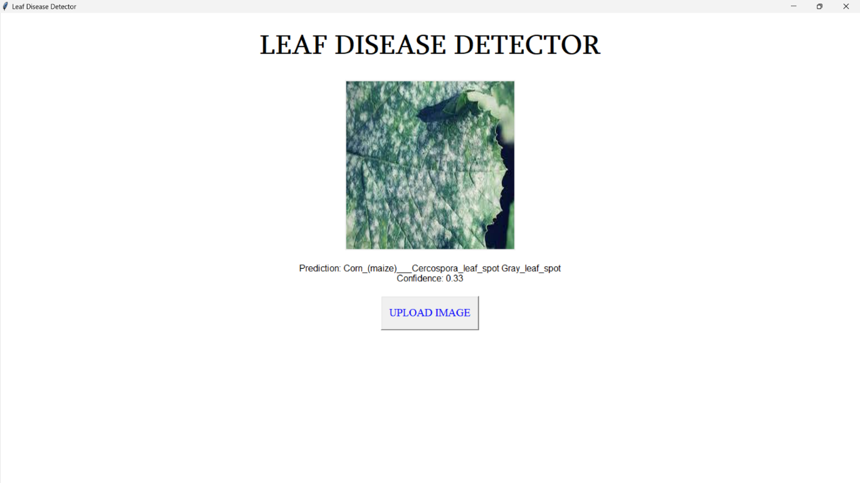

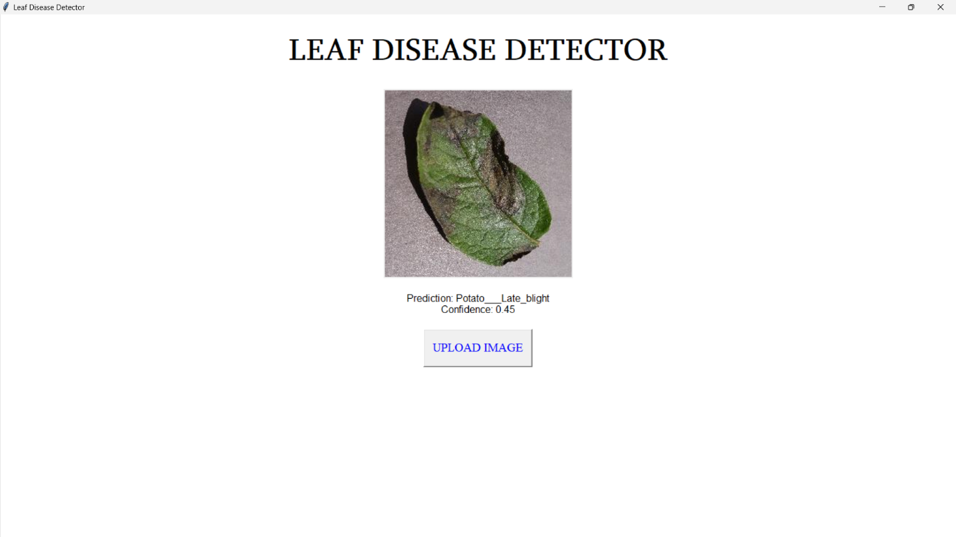

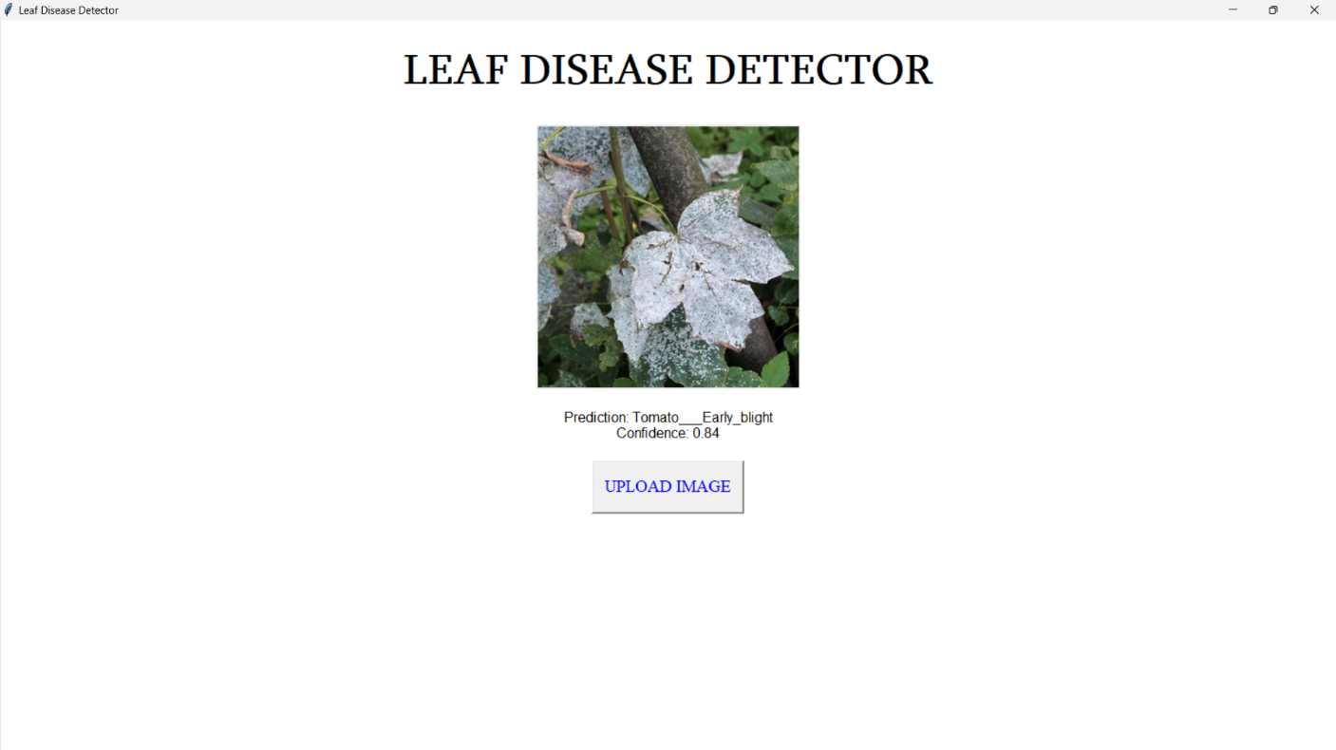

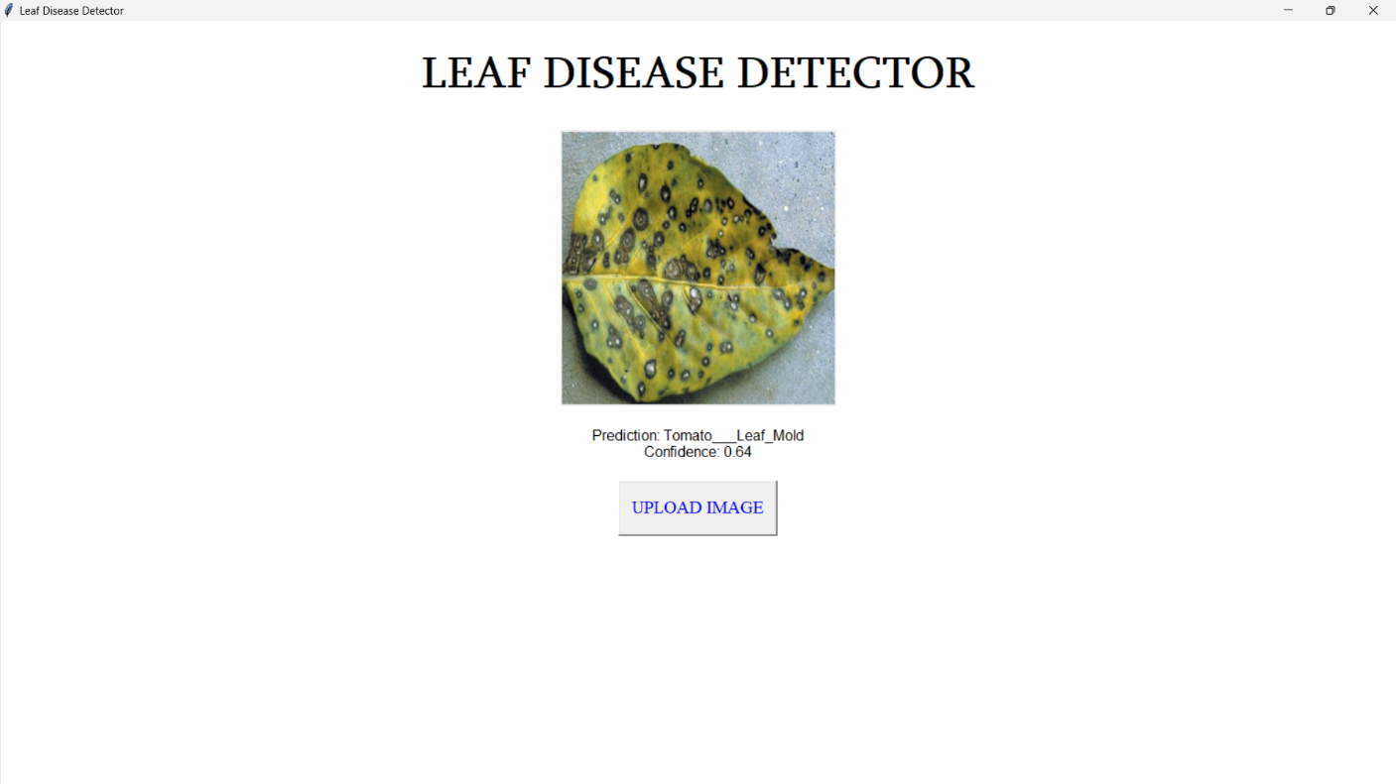

**CHAPTER 5**

# CONCLUSION

In conclusion, the development of an automated plant disease detection system utilizing convolutional neural networks (CNNs) represents a significant advancement in precision agriculture. By harnessing the power of deep learning and computer vision techniques, this project aims to address the challenges associated with manual disease identification methods, offering farmers and agricultural experts a reliable and efficient tool for early disease detection and intervention. Through extensive training and evaluation of CNN models, we have demonstrated the system's ability to accurately classify leaf images and diagnose various plant diseases with high precision. The user-friendly interface facilitates seamless interaction, enabling timely decision-making and proactive management strategies. Moving forward, ongoing research and development efforts will focus on refining the system's performance, expanding its capabilities to encompass a broader range of plant species and disease types, and ensuring its accessibility and usability for stakeholders in the agricultural sector. Ultimately, the integration of advanced technology in plant disease detection holds immense potential for enhancing crop yield, quality, and agricultural sustainability on a global scale.

## APPENDIX

## import tkinter as tk

## from tkinter import filedialog

## from PIL import Image, ImageTk

## import cv2

## import numpy as np

## import tensorflow as tf

## # Load the trained model

## model = tf.keras.models.load_model('D:\Leaf disease detection\leaf-cnn.h5') # Replace with your model path

## # Define the disease labels

## disease_labels = ['Apple__Apple_scab', 'Apple_Black_rot', 'Apple_Cedar_apple_rust', 'Apple__healthy',

## 'Blueberry__healthy', 'Cherry(including_sour)__healthy', 'Cherry(including_sour)___Powdery_mildew',

## 'Corn_(maize)__Cercospora_leaf_spot Gray_leaf_spot', 'Corn(maize)__Common_rust', 'Corn_(maize)___healthy',

## 'Corn_(maize)__Northern_Leaf_Blight', 'Grape_Black_rot', 'Grape_Esca(Black_Measles)', 'Grape___healthy',

## 'Grape__Leaf_blight(Isariopsis_Leaf_Spot)', 'Orange__Haunglongbing(Citrus_greening)', 'Peach___Bacterial_spot',

## 'Peach__healthy', 'Pepper_bell_Bacterial_spot', 'Pepper_bell_healthy', 'Potato_Early_blight', 'Potato__healthy',

## 'Potato__Late_blight', 'Raspberry_healthy', 'Soybean_healthy', 'Squash_Powdery_mildew', 'Strawberry__healthy',

## 'Strawberry__Leaf_scorch', 'Tomato_Bacterial_spot', 'Tomato_Early_blight', 'Tomato_healthy', 'Tomato__Late_blight',

## 'Tomato__Leaf_Mold', 'Tomato_Septoria_leaf_spot', 'Tomato_Spider_mites Two-spotted_spider_mite', 'Tomato__Target_Spot',

## 'Tomato__Tomato_mosaic_virus', 'Tomato__Tomato_Yellow_Leaf_Curl_Virus']

## # Function to preprocess the input image

## def preprocess_image(image):

## # Resize the image to the required input size of the model

## image = cv2.resize(image, (224, 224))

## # Convert the image to RGB format

## image = cv2.cvtColor(image, cv2.COLOR_BGR2RGB)

## # Normalize the image

## image = image / 255.0

## # Expand dimensions to match model input shape

## image = np.expand_dims(image, axis=0)

## return image

## # Function to make predictions

## def predict_disease(image):

## processed_image = preprocess_image(image)

## prediction = model.predict(processed_image)

## predicted_label = disease_labels[np.argmax(prediction)]

## confidence = np.max(prediction)

## return predicted_label, confidence

## # Function to handle image upload

## def upload_image():

## file_path = filedialog.askopenfilename()

## if file_path:

## # Load the image using PIL

## image = Image.open(file_path)

## # Resize the image if needed

## # Resize the image if needed

## image = image.resize((300, 300), resample=Image.LANCZOS)

## 

## # Convert PIL image to Tkinter PhotoImage

## photo = ImageTk.PhotoImage(image)

## # Display the image on the label

## image_label.config(image=photo)

## image_label.image = photo # Keep a reference to avoid garbage collection

## 

## # Perform prediction on the uploaded image

## img_cv2 = cv2.imread(file_path)

## prediction, confidence = predict_disease(img_cv2)

## # Update the prediction label

## prediction_label.config(text=f"Prediction: {prediction}\nConfidence: {confidence:.2f}")

## # Create the main window

## root = tk.Tk()

## root.title("Leaf Disease Detector")

## root.configure(bg='white')

## # Set window size to screen resolution

## screen_width = root.winfo_screenwidth()

## screen_height = root.winfo_screenheight()

## root.geometry("%dx%d+0+0" % (screen_width, screen_height))

## # Set the title with specific font, size, and color

## title_label = tk.Label(root, text="Leaf Disease Detector".upper(), font=("Sylfaen", 37, "bold"), fg="black", bg='white')

## title_label.pack(pady=20)

## # Create labels for image and prediction

## image_label = tk.Label(root)

## image_label.pack(pady=10)

## prediction_label = tk.Label(root, text="", font=("Arial", 12), bg='white')

## prediction_label.pack(pady=10)

## # Create a button for image upload

## upload_button = tk.Button(root, text="Upload Image".upper(), command=upload_image, font=("Times New Roman", 15), fg="Blue", width=15, height=2)

## upload_button.pack(pady=10)

## # Run the Tkinter event loop

## root.mainloop()

## REFERENCES

[1] Mohanty, S. P., Hughes, D. P., & Salathé, M. (2016). Using deep learning for image-based plant disease detection. Frontiers in Plant Science, 7(September), [1419].https://doi.org/10.3389/fpls.2016.01419

[2] Ser Serawork Wallelign, Mihai Polceanu, Cédric Buche. Soybean Plant Disease Identification Using Convolutional Neural Network. FLAIRS-31, May 2018, Melbourne, United States. <https://hal.archives-ouvertes.fr/hal-01807760>

[3] S.Arivazhagan, R. Newlin Shebiah, S.Ananthi, S.Vishnu Varthini. 2013. Detection of unhealthy region of plant leaves and classification of plant leaf diseases using texture features. Agric Eng Int: CIGR Journal.

[4] Huu Quan Cap, Katsumasa Suwa, Erika Fujita, Satoshi Kagiwada, Hiroyuki Uga, and Hitoshi Iyatomi. A deep learning approach for on-site plant leaf detection. 2018 IEEE 14th International Colloquium on Signal Processing & Its Applications (CSPA).

[5] Santhosh Kumar S, and B. K. Raghavendra. Diseases Detection of Various Plant Leaf Using Image Processing Techniques: A Review. 2019 5th International Conference on Advanced Computing & Communication Systems (ICACCS)

[6] Jyotsna Bankar, and Nitin R Gavai. Convolutional Neural Network based Inception v3 Model for Animal Classification. International Journal of Advanced Research in Computer and communication Engineering, May 2018

[7] Abirami Devaraj, Karunya Rathan, Sarvepalli Jaahnavi, and K Indira. Identification of Plant Disease using Image Processing Technique. 2019 International Conference on Communication and Signal Processing (ICCSP).

[8] Mercelin Francis, and C. Deisy. Disease Detection and Classification in Agricultural Plants Using Convolutional Neural Networks .

[9]S. Sankaran, A. Mishra, R. Ehsani, and C. Davis, ―A review of advanced techniques

for detecting plant diseases,‖ Computers and Electronics in Agriculture, vol. 72, no. 1, pp. 1–13, 2010.

[10] James, Spencer L, Chris D Castle, Zachary V Dingels, Jack T Fox, Erin B Hamilton, Zichen Liu, Nicholas L S Roberts, et al. ―Estimating Global Injuries Morbidity and Mortality: Methods and Data Used in the Global Burden of Disease 2017 Study.‖ Injury Prevention 26, no. Supp 1 (October 2020): i125–53.European Journal of Molecular & Clinical Medicine ISSN 2515-8260 Volume 7, Issue 07, 2020 1613

[11] James, Spencer L, Chris D Castle, Zachary V Dingels, Jack T Fox, Erin B Hamilton, Zichen Liu, Nicholas L S Roberts, et al. ―Global Injury Morbidity and Mortality from 1990 to 2017: Results from the Global Burden of Disease Study 2017.‖ Injury Prevention 26, no. Supp 1 (October 2020): i96–114.

https://doi.org/10.1136/injuryprev-2019-043494.

[12] Murray, Christopher J L, Cristiana Abbafati, Kaja M Abbas, Mohammad Abbasi, Mohsen Abbasi-Kangevari, Foad Abd-Allah, Mohammad Abdollahi, et al. ―Five Insights from the Global Burden of Disease Study 2019.‖ The Lancet 396, no. 10258 (October 2020): 1135–59. https://doi.org/10.1016/S0140-6736(20)31404-5.