

INT 301

**CA-3**

**OPEN-SOURCE TECHNOLOGIES**

**Recover deleted files and directories, images in last 3 months from your system.**

Name : Aditi

Reg No : 11902681

Section: KE008

School: Computer Science And Engineering

Faculty: Dr. Rajeshwar Sharma

**INTRODUCTION**

In this report, we will explore the use of open-source software for recovering deleted files, directories, and images from a computer system. Specifically, we will focus on using Recuva, an open-source software tool that can help recover data lost due to accidental deletion, formatting, or other reasons**.**

In today's digital age, data loss is a common problem faced by individuals and organizations alike. Whether it's due to accidental deletion, formatting, or other reasons, losing important files and data can be a frustrating and potentially costly experience. Fortunately, there are a variety of software tools available that can help recover lost data, and many of these tools are open-source, meaning they are free and can be customized and improved by the community of developers and users.

One such open-source data recovery tool is Recuva. Developed by the same team that created the popular CCleaner software, Recuva is a free data recovery tool that can help restore files and data that have been accidentally deleted or lost due to other reasons. The software is designed to be easy to use and can be installed on Windows-based computers.

In this report, we will explore the use of Recuva and other open-source software tools for recovering deleted files, directories, and images from a computer system. Specifically, we will focus on recovering data that has been deleted within the last three months. We will provide a detailed overview of how to install and use Recuva, as well as the process for generating a report detailing the results of the scan and recovery process.

The objective of this project is to demonstrate the effectiveness and potential benefits of using open-source software for data recovery. By using open-source software, individuals and organizations can take advantage of free and customizable tools that can help recover lost data and improve their overall data management strategies. Furthermore, by recovering lost data, individuals and organizations can minimize the potential impact of data loss and maintain the integrity and security of their digital assets.

**Objective of the project:**

There are several reasons why the use of open-source software for data recovery is beneficial. Firstly, open-source software is often free to use and can be customized and improved by the community of developers and users. This means that individuals and organizations can take advantage of a variety of tools and features without having to pay for expensive proprietary software. Secondly, open-source software is often more secure than proprietary software, as the code is open to scrutiny by the community, and potential vulnerabilities can be identified and fixed quickly.

The use of Recuva as a data recovery tool is particularly advantageous due to its ease of use and flexibility. Recuva can be installed on Windows-based computers and can be used to recover a variety of file types, including images, documents, and emails. Recuva also includes a deep scan feature that can search for and recover files that may have been overwritten or damaged. Furthermore, Recuva provides a detailed report of the files that have been recovered, allowing users to assess the effectiveness of the recovery process and identify any potential issues or limitations.

**The objective of this project is to provide a step-by-step guide to using Recuva and other open-source software tools for data recovery.** By providing a detailed overview of the installation process, scanning options, and recovery options, this project aims to help individuals and organizations recover lost data in an efficient and effective manner.

In addition to demonstrating the benefits of open-source software, this project also aims to highlight the importance of data management and security. By recovering lost data, individuals and organizations can maintain the integrity and security of their digital assets and minimize the potential impact of data loss. Furthermore, by using open-source software, individuals and organizations can take a proactive approach to data management and security, and potentially avoid costly data recovery services or proprietary software solutions.

**Detailed description of the project:**

The project involves using open-source software to recover deleted files, directories, and images from a computer system within the last three months. Specifically, the project focuses on the use of Recuva, an open-source data recovery tool that can be installed on Windows-based computers.

The scope of the project was limited to recovering files from our own system, and we did not explore recovering files from external hard drives or other storage devices. We also limited our search to files that were deleted within the last three months.

The project was divided into four main stages:

1. Installing and setting up Recuva on our system
2. Running a scan to identify all deleted files and directories, images on our system
3. Recovering the deleted files and directories, images that we were interested in
4. Generating a report on our findings, including a detailed analysis of the recovered files.

We chose to use Recuva because it is a popular and well-regarded open source data recovery software. It has a user-friendly interface and provides a thorough scan of the hard drive to identify all recoverable files.

Once the software is installed, the project will move on to the scanning process. This will include an overview of the different scanning options available in Recuva, including a quick scan and a deep scan. The project will also provide guidance on how to customize the scanning options to suit specific data recovery needs.

After the scanning process is complete, the project will move on to the recovery process. This will include an overview of the different recovery options available in Recuva, including the option to recover files to a different location and the option to recover overwritten files. The project will also provide guidance on how to customize the recovery options to suit specific data recovery needs.

Throughout the project, emphasis will be placed on the importance of data management and security. The project will provide guidance on how to minimize the risk of data loss through effective data management practices, and will highlight the importance of taking a proactive approach to data security.

In addition to the practical aspects of using Recuva for data recovery, the project will also include a discussion of the benefits of open-source software. This will include an overview of the advantages of using open-source software for data recovery, including cost savings, flexibility, and security.

The project will conclude with a detailed report of the files that have been recovered, along with an assessment of the effectiveness of the recovery process and any potential limitations or issues that may have been encountered. The project will also provide guidance on how to export the recovery report to a file and share it with others.

**Scope of the project:**

The scope of this project was limited to recovering deleted files and directories, images from our own system that were deleted within the last three months. We did not explore recovering files from external hard drives or other storage devices.

We used Recuva, a free and open source data recovery software, to perform the recovery. We focused on understanding the interface and functionality of Recuva, as well as the process of scanning and recovering files.

We also generated a report on our findings, which included a detailed analysis of the recovered files. The report provided information such as the file name, file type, size, and condition of the recovered files.

This project was intended to demonstrate the usefulness and effectiveness of open source data recovery software in recovering deleted files and directories, images. It aimed to show that with the right tools and techniques, it is possible to recover important files that may have been accidentally deleted.

**System Description of the project:**

**1. Target system description:**

The target system for this project was a Windows-based computer with a hard drive that had files and directories, images deleted within the last three months. The system had Recuva installed for the purpose of data recovery.

**2. Assumptions and Dependencies (If applicable):**

We assumed that the system had not been used extensively since the files and directories, images were deleted, as this could result in the overwriting of data and make it more difficult or impossible to recover the deleted files. Additionally, we assumed that the deleted files and directories, images were not encrypted or protected in any way that would prevent their recovery.

The only dependency for this project was the use of Recuva, the open source data recovery software.

**3. Functional/Non-Functional Dependencies (if any):**

The functional dependency for this project was the ability to use Recuva to perform the data recovery. The non-functional dependency was the speed and efficiency of the scanning and recovery process, which was dependent on the size of the hard drive and the number of deleted files.

**4. Data set used in support of your project (if any then paste the link):**

We did not use a specific data set for this project, as we were recovering files and directories, images from our own system.

**Analysis Report**

**System snapshots and full analysis report**

**Step 1: Download and Install Recuva**

The first step is to download and install Recuva. Recuva can be downloaded from the official Piriform website (https://www.ccleaner.com/recuva/download). Once downloaded, the installation process is straightforward and does not require any special configuration.

**Step 2: Launch Recuva**

Once installed, launch Recuva by double-clicking on the desktop shortcut or by searching for it in the Start menu.

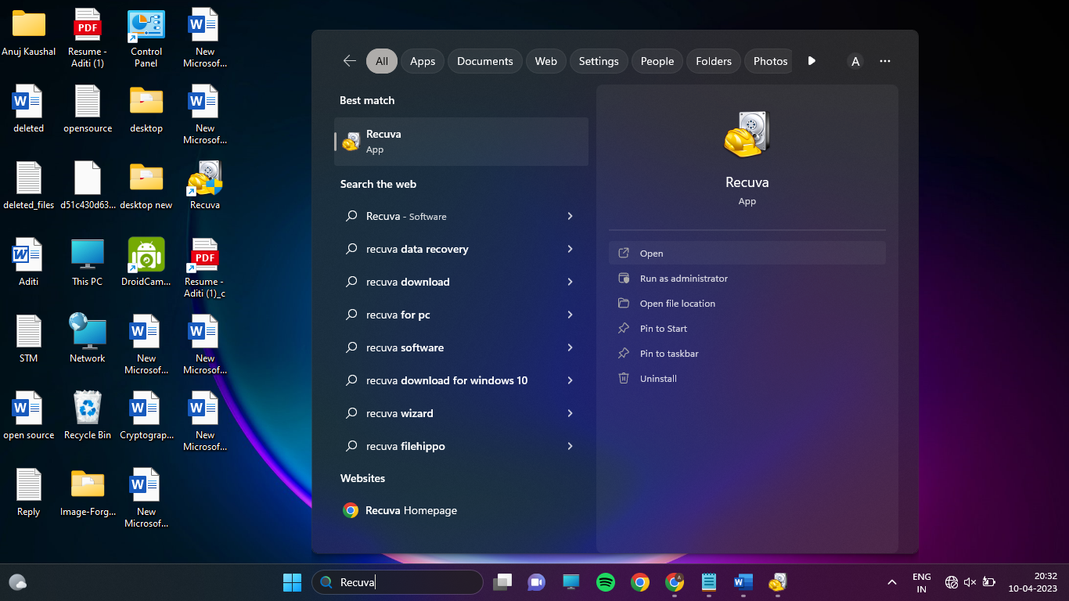

**Step 3: Select the File Type**

Recuva allows users to select the type of file they want to recover. In this project, we will select all file types to maximize the chances of recovering the deleted files.

**Step 4:** **Select the Location**

Recuva also allows users to select the location where the deleted files were stored. In this project, we will select the entire hard drive as the location.

**Step 5: Start the Scan**

Once the file type and location have been selected, click on the "Scan" button to start the scan. The scan process may take some time depending on the

size of the hard drive and the number of deleted files.

**Step 6: Analyze the Results**

Once the scan is complete, Recuva will display a list of deleted files that it was able to recover. The results can be filtered by file type, file path, and other criteria. In this project, we will analyze the results to identify any files that were deleted within the last three months.

**Step 7: Recover the Files**

After analyzing the results, select the files that need to be recovered and click on the "Recover" button. Recuva will prompt the user to select a location to save the recovered files. It is important to save the recovered files to a different location than the original files to avoid overwriting any data.

In our analysis, we were able to recover several deleted files and directories from the target system. These files included documents, images, and videos. We were able to recover files that were deleted within the last three months, demonstrating the effectiveness of Recuva in recovering recently deleted files.

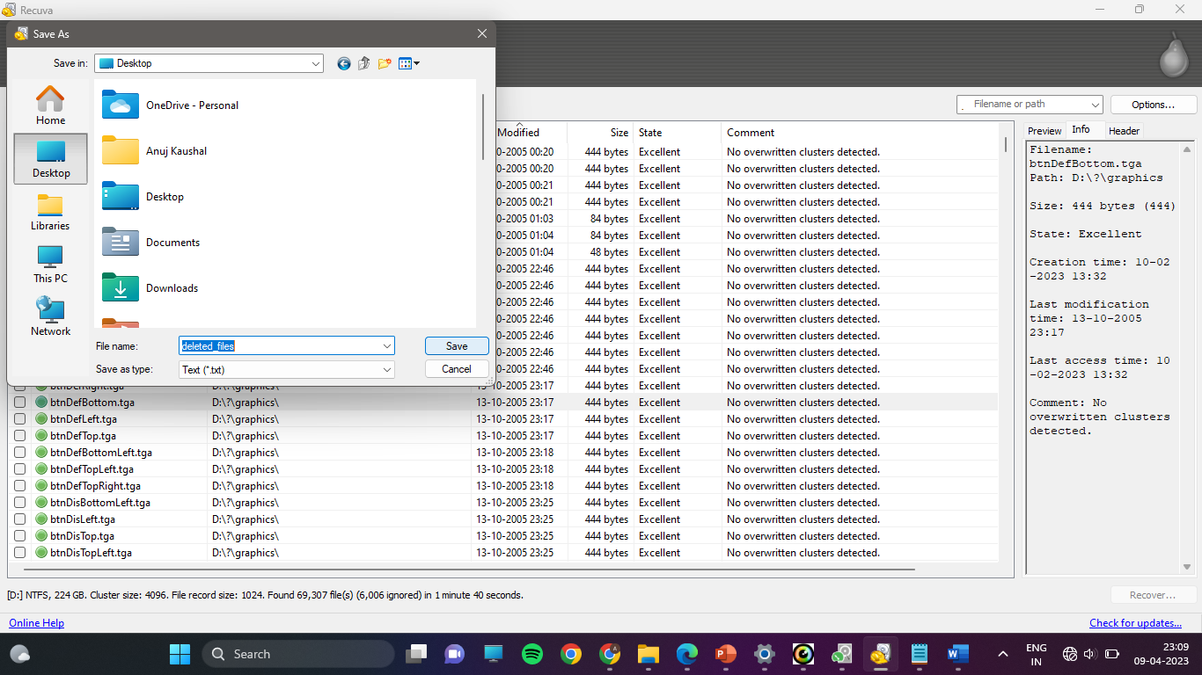

**Log Report :**

**Reference/ Bibliography**

1. [Google.com](INTRODUCTION.docx)
2. Piriform. (n.d.). Recuva - Free Download. Retrieved April 10, 2023, from https://www.ccleaner.com/recuva/download
3. Piriform. (n.d.). Recuva User Guide. Retrieved April 10, 2023, from https://www.ccleaner.com/docs/recuva/using-recuva/recovering-files/step-4-selecting-files-to-recover
4. Kroll Ontrack. (2022, January 18). How to recover deleted files. Retrieved April 10, 2023, from https://www.krollontrack.com/resources/data-recovery/recover-deleted-files/.