## PROJECT PLANNING AND CONTROL

Project planning is an organized and integrated management process, which focuses on activities required for successful completion of the project. It prevents obstacles that arise in the project such as changes in projects or organization's objectives, non-availability of resources, and so on. Project planning also helps in better utilization of resources and optimal usage of the allotted time for a project. The other objectives of project planning are listed below.

* It defines the roles and responsibilities of the project management team members.
* It ensures that the project management team works according to the business objectives.
* It checks feasibility of the schedule and user requirements.
* It determines project constraints.

Project planning should be effective so that the project begins with well-defined tasks. Effective project planning helps to minimize the additional costs incurred on the project while it is in progress. For effective project planning, some principles are followed. These principles are listed below.

* **Planning is necessary:** Planning should be done before a project begins. For effective planning, objectives and schedules should be clear and understandable.
* **Risk analysis:** Before starting the project, senior management and the project management team should consider the risks that may affect the project. For example, the user may desire changes in requirements while the project is in progress. In such a case, the estimation of time and cost should be done according to those requirements (new requirements).
* **Tracking of project plan:** Once the project plan is prepared, it should be tracked and modified accordingly.
* **Meet quality standards and produce quality deliverables:**The project plan should identify processes by which the project management team can ensure quality in software. Based on the process selected for ensuring quality, the time and cost for the project is estimated.
* **Description of flexibility to accommodate changes:** The result of project planning is recorded in the form of a project plan, which should allow new changes to be accommodated when the project is in progress.

Project planning process comprises several activities, which are essential for carrying out a project systematically. These activities refer to the series of tasks performed over a period of time for developing the software. These activities include estimation of time, effort, and resources required and risks associated with the project.

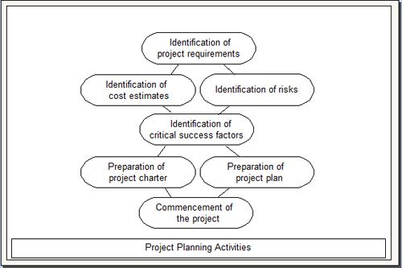

Project planning process consists of the following activities.

* **Identification of project requirements:** Before starting a project, it is essential to identify the project requirements as identification of project requirements helps in performing the activities in a systematic manner. These requirements comprise information such as project scope, data and functionality required in the software, and roles of the project management team members.
* **Identification of cost estimates:** Along with the estimation of effort and time, it is necessary to estimate the cost that is to be incurred on a project. The cost estimation includes the cost of hardware, network connections, and the cost required for the maintenance of hardware components. In addition, cost is estimated for the individuals involved in the project.
* **Identification of risks:** Risks are unexpected events that have an adverse effect on the project. Software project involves several risks (like technical risks and business risks) that affect the project schedule and increase the cost of the project. Identifying risks before a project begins helps in understanding their probable extent of impact on the project.
* **Identification of critical success factors:** For making a project successful, critical success factors are followed. These factors refer to the conditions that ensure greater chances of success of a project. Generally, these factors include support from management, appropriate budget, appropriate schedule, and skilled software engineers.
* **Preparation of project charter:** A project charter provides a brief description of the project scope, quality, time, cost, and resource constraints as described during project planning. It is prepared by the management for approval from the sponsor of the project.
* **Preparation of project plan:** A project plan provides information about the resources that are available for the project, individuals involved in the project, and the schedule according to which the project is to be carried out.
* **Commencement of the project:** Once the project planning is complete and resources are assigned to team members, the software project commences.

**Control -**

Control is an ongoing activity throughout the Software development life cycle. Management of any activity completes after successful control over planned activities. We need to control and measure progress against the plan to compare actual progress against the planned progress, and we should report to the project manager and customer on the current status of testing, including any changes or deviations from the plan. We'll need to take actions where necessary to meet the objectives of the project. Such actions may entail changing our original plan, which often happens. Test control has the following major tasks:

1. Measure and analyze results of reviews and testing.

2. Monitor and document progress, test coverage and exit criteria.

3. Provide information on testing.

4. Initiate corrective actions.

5. Make decisions.

1. Measure and analyze results of reviews and testing - We need to know how many reviews and tests we have done. We need to track how many tests have passed and how many failed, along with the number, severity & priority of the defects reported.

2. Monitor and document progress, test coverage and exit criteria - It is important that we inform the project team how much testing has been done, what the results are, and what conclusions and risk assessment we have made. We must make the test outcome visible and useful to the whole team.

3. Provide information on testing - We should expect to make regular and exceptional reports to the project manager and other key stakeholders to help them make informed decisions about project status. We should also use the information we have to analyze the testing itself.

4. Initiate corrective actions - For example, tighten exit criteria for defects fixed, ask for more effort to be put into debugging or prioritize defects for fixing test blockers.

5. Make decisions - Based on the measures and information gathered during testing and any changes to business and project risks or our increased understanding of technical and product risks, we'll make decisions or enable others to make decisions, to continue or stop testing, to release the software or to retain it for further work.