Game Design Document

Fill up the following document

1. Write the title of your project.

Parkour Ball

1. What is the goal of the game?

All obstacles have to be completed to finsih the game by the ball in order to earn points. If the ball touches the tunnels e one life will be reduced.

1. Write a brief story of your game.

There will be a ball and it will be controlled bythe arrows. We have to complete as mch as mini challenges possible to earn points. The screen will be moving up and as high as it goes the challenges will be a harder.

1. Which are the playing characters of this game?

* Playing characters are the ones who respond to the user based on the input from the user.
* Cars, monkeys, dinos, wizards, etc., are the playing characters in the game.

|  |  |  |
| --- | --- | --- |
| Number | Character Name | What can this character do? |
| 1 | Ball | Complete all the obstacles |
| 2 |  |  |
| 3 |  |  |
| 4 |  |  |
| 5 |  |  |
| 6 |  |  |
| 7 |  |  |
| 8 |  |  |

1. Which are the Non-Playing Characters of this game?

* Non-Playing characters are the ones that don't have an action or behavior when the user interacts with the game.
* Hurdles, stones, bananas, coins, etc., are non-playing characters in the game.

|  |  |  |
| --- | --- | --- |
| Number | Character Name | What can this character do? |
| 1 | The hills | Appearing randomly on the screen |
| 2 | The pyramid | Appearing randomly on the screen |
| 3 |  |  |
| 4 |  |  |
| 5 |  |  |
| 6 |  |  |
| 7 |  |  |
| 8 |  |  |

Draw your imagination of this game. What does this game look like?

* Draw the game either on your computer or on paper.
* Add images of the game scenes to show each of the playing and non-playing characters at least once.

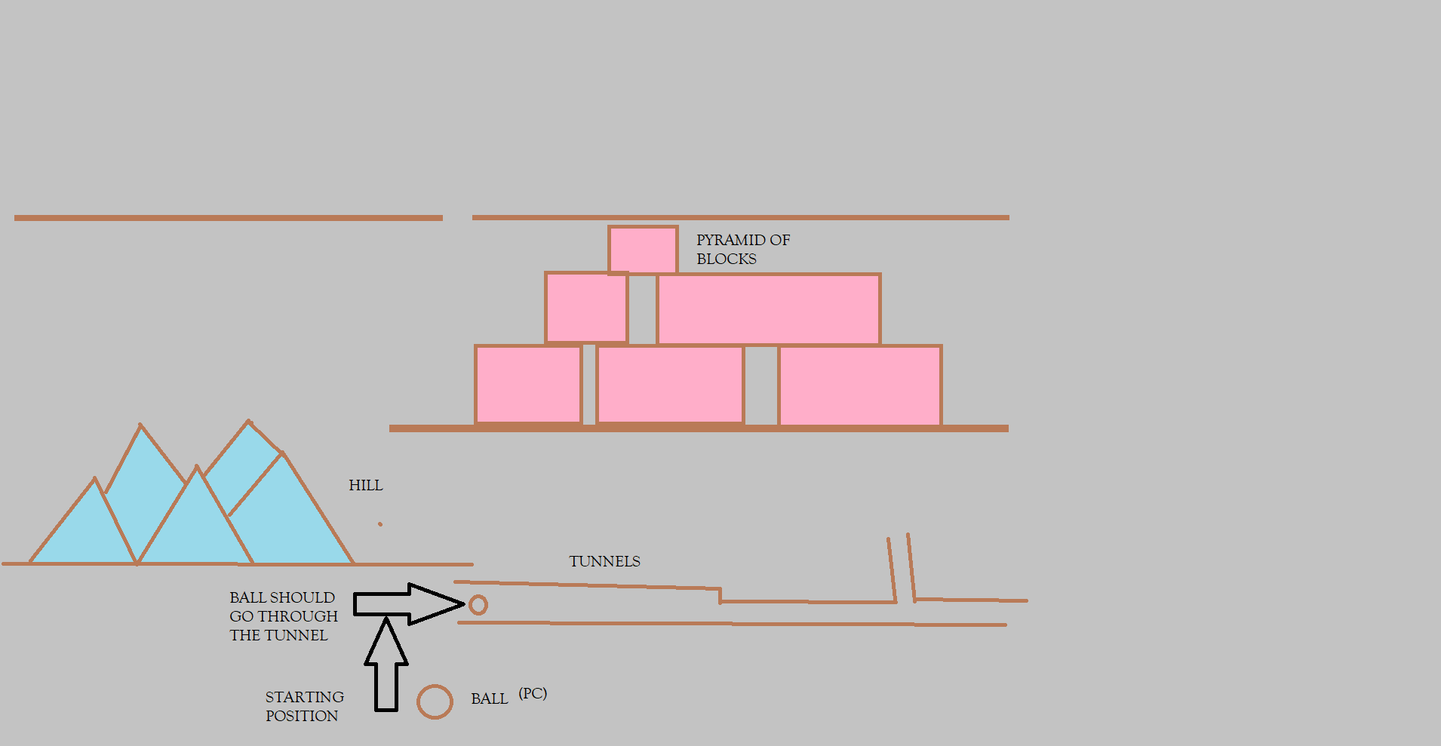

How do you plan to make your game engaging?

There will be two different sounds one when the ball is moving and one when the ball hits any obstacles. Once the ball touches the boxes there will be a disspearing animation. The player will get only two lives. The adaptivity will increase when the ball travels higher. The points will be according to the obstacles ball completes.