WEEK 2 INTERNSHIP REPORT
Data Visualization and Insight Communication using R

Titanic Passenger Survival Analysis

Prepared by: Aditi Sahu
Task: Week 2 – Data Visualization and Insight Communication using R
Tools: R, RStudio, ggplot2, dplyr
Dataset: Publicly available Titanic passenger dataset
Report Type: Virtual Internship Task Submission

This report demonstrates how exploratory data analysis can be converted into clear visual stories for a non-technical audience.

1. Executive Summary and Task Objectives
This Week 2 task focuses on data visualization and insight communication using R. The objective is not only to create charts, but also to explain what each chart means, why the visualization was selected, and how the visual evidence supports a conclusion. For this report, the Titanic passenger dataset is used because it contains a mixture of demographic, travel, fare, family and outcome variables that are suitable for several visualization techniques.
The dataset contains 891 passenger records. The overall survival rate is 38.4%. Average passenger age is 29.7 years and average recorded fare is 32.20. The analysis examines survival from multiple perspectives: sex, passenger class, age, fare, age groups, embarkation port, and the interaction between sex and class.

Task Objectives
- Understand the structure and important variables of a public dataset.
- Prepare variables for meaningful visual analysis using dplyr and base R transformations.
- Create multiple chart types using ggplot2, including bar charts, histogram, scatter plot, line chart, box plot and heatmap.
- Interpret trends, differences and possible anomalies without overstating causation.
- Embed reproducible R code so another person can recreate the analysis.
- Communicate findings in a clear, structured format suitable for a non-technical reader.

Overall Analytical Question
Which passenger characteristics show the strongest relationship with survival, and how can those relationships be communicated visually?

2. Dataset Overview and Data Dictionary
The Titanic dataset represents passenger-level information from the RMS Titanic. Each row represents one passenger and each column describes an attribute such as survival outcome, passenger class, sex, age, family relationships, fare, cabin and embarkation port.
Variable | Meaning | Type | Use in analysis
Survived | 0 = did not survive; 1 = survived | Binary numeric | Outcome variable
Pclass | Passenger class: 1, 2 or 3 | Categorical/ordinal | Class comparison
Sex | Passenger sex | Categorical | Group comparison
Age | Passenger age in years | Numeric | Distribution and age analysis
SibSp | Siblings/spouses aboard | Numeric | Family context
Parch | Parents/children aboard | Numeric | Family context
Fare | Passenger fare | Numeric | Price distribution/scatter
Cabin | Cabin identifier | Categorical/text | Missingness review
Embarked | Port of embarkation | Categorical | Port comparison
Name/Ticket | Passenger identity/ticket information | Text | Reference only

Data Quality Observations
- Age contains 177 missing values, so age-based charts use available ages and explicitly handle missing records.
- Cabin has 687 missing values; it is not used for the main visualizations because missingness is high.
- Survived is a binary outcome and is converted to readable labels for charts.
- Passenger class is treated as an ordered category so that 1st, 2nd and 3rd class remain meaningful.
- FamilySize is derived as SibSp + Parch + 1 to provide an additional behavioral/context variable.
- The analysis is descriptive. A relationship shown in a chart should not automatically be interpreted as proof of causation.

3. Data Preparation, Visualization Strategy and Workflow
The workflow follows a simple data-analysis pipeline: inspect the data, identify missing values, create analysis-friendly variables, summarize groups, visualize patterns, interpret the evidence, and document the reproducible code.

Preparation Steps
- Load the CSV file into R using read.csv().
- Inspect structure with str() and summary().
- Check missing values with colSums(is.na()).
- Create readable survival labels and ordered passenger-class labels.
- Create FamilySize and AgeGroup for additional analysis.
- Use na.rm = TRUE or filter() where missing values would otherwise distort calculations.

Why Multiple Visualizations?
One chart cannot communicate every aspect of a dataset. Bar charts are effective for comparing groups, histograms show distributions, scatter plots show relationships between numeric variables, line charts show ordered movement across categories, box plots compare spread and medians, and heatmaps communicate two-dimensional patterns. Using several complementary charts makes the final narrative more robust.
Stage | Action | Output
1. Import | Read Titanic CSV | Data frame
2. Inspect | Structure, summary, missingness | Data quality notes
3. Transform | Labels, age groups, family size | Analysis variables
4. Summarize | Group-wise survival rates | Summary tables
5. Visualize | Create 8 chart types/views | Figures
6. Interpret | Identify patterns and anomalies | Key insights
7. Communicate | Write narrative and conclusions | Final DOCX report

Reproducibility Principle
All visualizations are paired with R code in this report. The same code can be run in RStudio after placing the Titanic CSV and the R script in the same working folder. This makes the analysis easier to verify, edit and reuse.

4. Visualization 1 – Survival Rate by Sex
Purpose: Compare survival outcomes for female and male passengers.
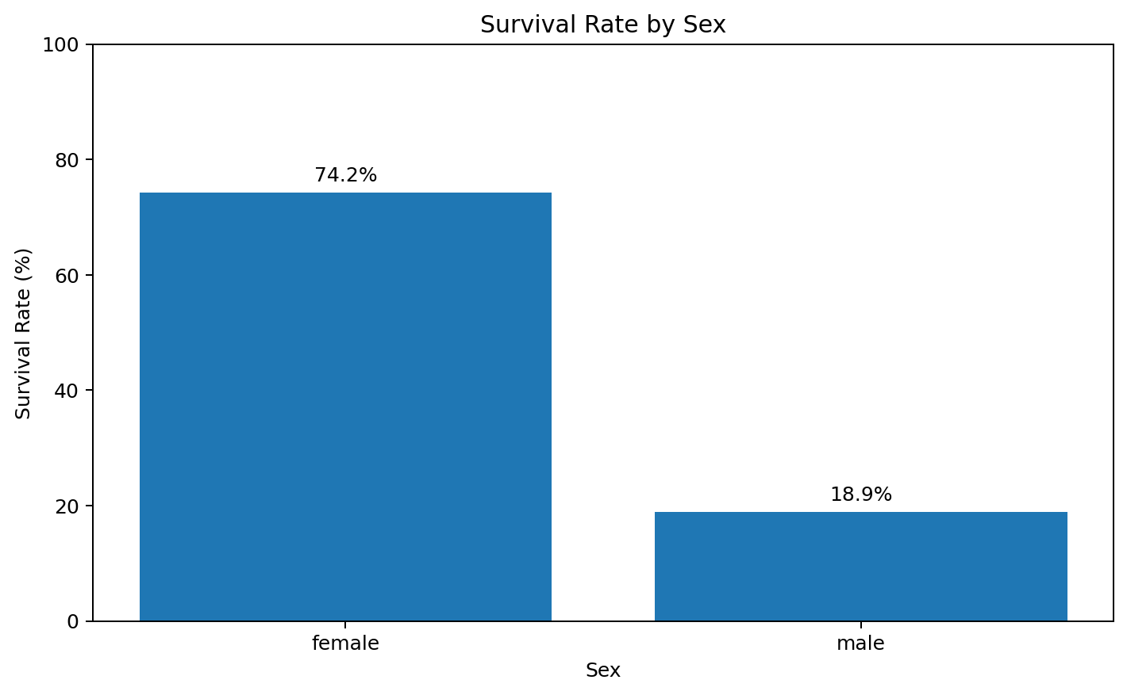

Interpretation
The chart shows a large difference between the two groups. Approximately 74.2% of female passengers survived, compared with 18.9% of male passengers. The difference is visually large and immediately communicates that sex is strongly associated with survival in this dataset. This pattern is consistent with the historical evacuation context, but the chart itself is descriptive rather than causal.

R Code
sex_summary <- titanic %>%
group_by(Sex) %>%
summarise(Survival_Rate = mean(Survived, na.rm = TRUE) * 100)
ggplot(sex_summary, aes(x = Sex, y = Survival_Rate)) +
geom_col() +
labs(
title = "Survival Rate by Sex",
x = "Sex", y = "Survival Rate (%)"
)
Key takeaway: Female survival was 74.2% versus 18.9% for males, a difference of about 55.3 percentage points.

5. Visualization 2 – Survival Rate by Passenger Class
Purpose: Examine whether survival differs across 1st, 2nd and 3rd class passengers.
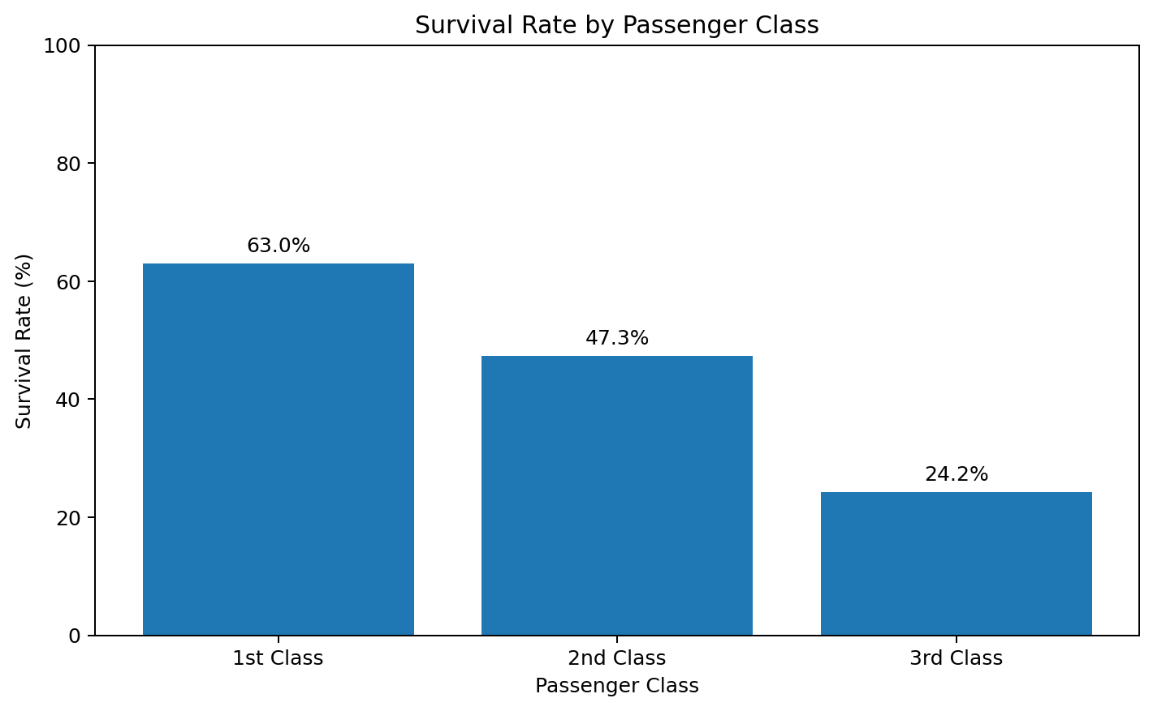

Interpretation
Survival decreases steadily as passenger class moves from 1st to 3rd class. The survival rates are 63.0% for 1st class, 47.3% for 2nd class, and 24.2% for 3rd class. This is a strong ordered pattern and demonstrates why passenger class should be treated as an ordinal variable. Class may also be connected with other factors such as fare, cabin location and access to evacuation routes, so the chart should be interpreted as an association rather than a single-cause explanation.

R Code
class_summary <- titanic %>%
group_by(Class) %>%
summarise(Survival_Rate = mean(Survived, na.rm = TRUE) * 100)
ggplot(class_summary, aes(x = Class, y = Survival_Rate)) +
geom_col() +
labs(
title = "Survival Rate by Passenger Class",
x = "Passenger Class", y = "Survival Rate (%)"
)
Key takeaway: 1st-class survival is about 38.7 percentage points higher than 3rd-class survival.

6. Visualization 3 – Passenger Age Distribution
Purpose: Understand the distribution, concentration and range of passenger ages.
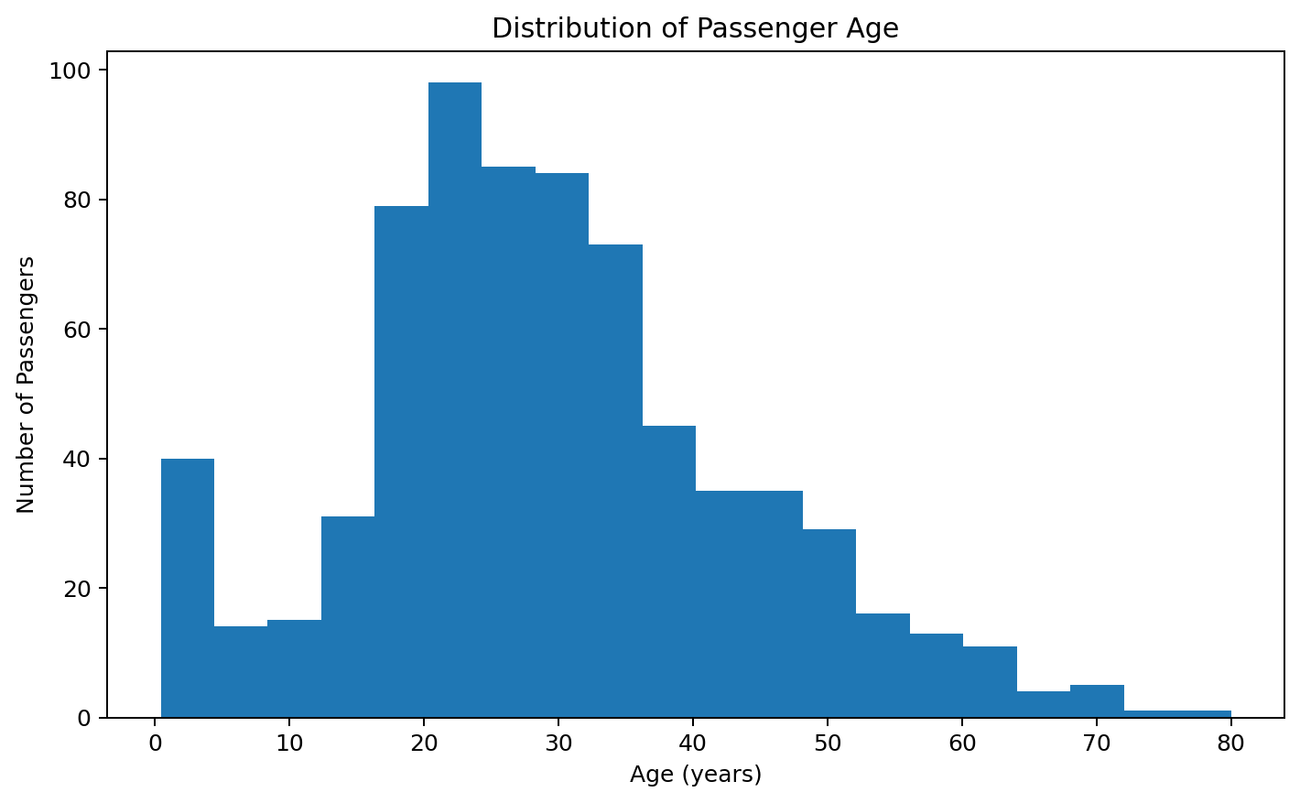

Interpretation
The histogram shows that passengers were distributed across a broad age range, with many observations concentrated roughly between the late teens and middle adulthood. The distribution also contains children and older passengers. There are missing age records, so the histogram is based only on passengers with a recorded age. A histogram is appropriate here because it groups a continuous numeric variable into intervals and makes concentration and spread easier to see than a table.

R Code
ggplot(titanic, aes(x = Age)) +
geom_histogram(bins = 20, na.rm = TRUE) +
labs(
title = "Distribution of Passenger Age",
x = "Age (years)", y = "Number of Passengers"
)
Key takeaway: The recorded ages have a mean of 29.7 years, while the observed range extends from approximately 0.4 to 80 years.

7. Visualization 4 – Age vs Fare Scatter Plot
Purpose: Explore the relationship between passenger age and fare while distinguishing survival status.
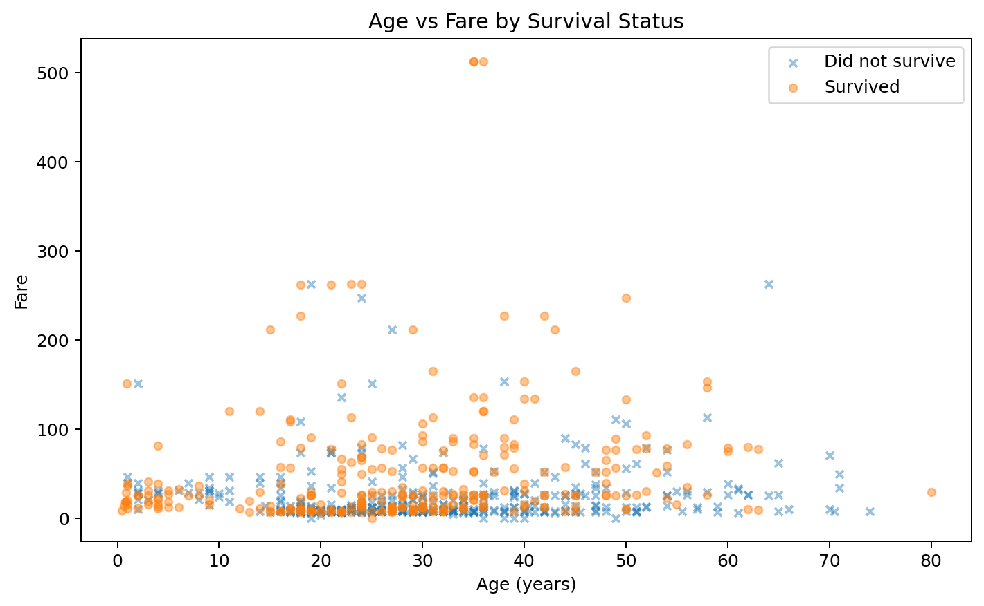

Interpretation
The scatter plot shows that fare values are concentrated at lower levels for many passengers, while a smaller number of passengers paid substantially higher fares. Higher-fare observations are more visible across a range of ages, and survival status is distributed throughout the plot rather than being determined by age alone. The chart is useful because it reveals outliers and the wide spread of fare values that a simple average would hide. Because several variables overlap, this plot should be interpreted as exploratory evidence rather than a predictive model.

R Code
ggplot(
titanic %>% filter(!is.na(Age)),
aes(x = Age, y = Fare, shape = Survival_Status)
) +
geom_point(alpha = 0.5) +
labs(
title = "Age vs Fare by Survival Status",
x = "Age (years)", y = "Fare"
)
Key takeaway: Fare has a strong right-skew with a small number of very high values; age alone does not explain survival outcomes.

8. Visualization 5 – Survival Rate Across Age Groups
Purpose: Show how survival changes across ordered age bands.
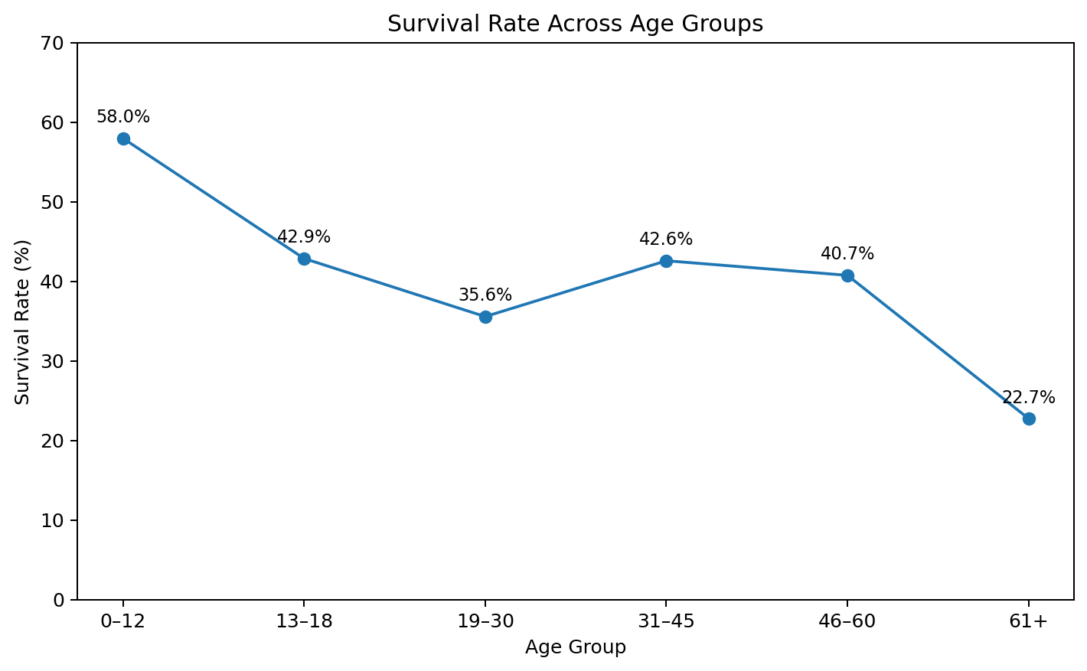

Interpretation
The line chart summarizes survival rates across six ordered age groups. The youngest group (0–12) has a relatively high survival rate, while the 61+ group has the lowest rate among the displayed groups. The middle age groups fluctuate rather than forming a perfectly straight trend. This is an important communication point: age is associated with survival, but the relationship is not simply 'older means lower survival' at every interval. Group size also matters, especially for the oldest group.

R Code
age_summary <- titanic %>%
group_by(AgeGroup) %>%
summarise(Survival_Rate = mean(Survived, na.rm = TRUE) * 100)
ggplot(age_summary, aes(x = AgeGroup, y = Survival_Rate, group = 1)) +
geom_line() +
geom_point() +
labs(
title = "Survival Rate Across Age Groups",
x = "Age Group", y = "Survival Rate (%)"
)
Key takeaway: Age groups show meaningful differences, with children at 57.9% and the 61+ group at about 22.7% survival.

9. Visualization 6 – Fare Distribution by Passenger Class
Purpose: Compare the distribution and spread of fares across passenger classes.
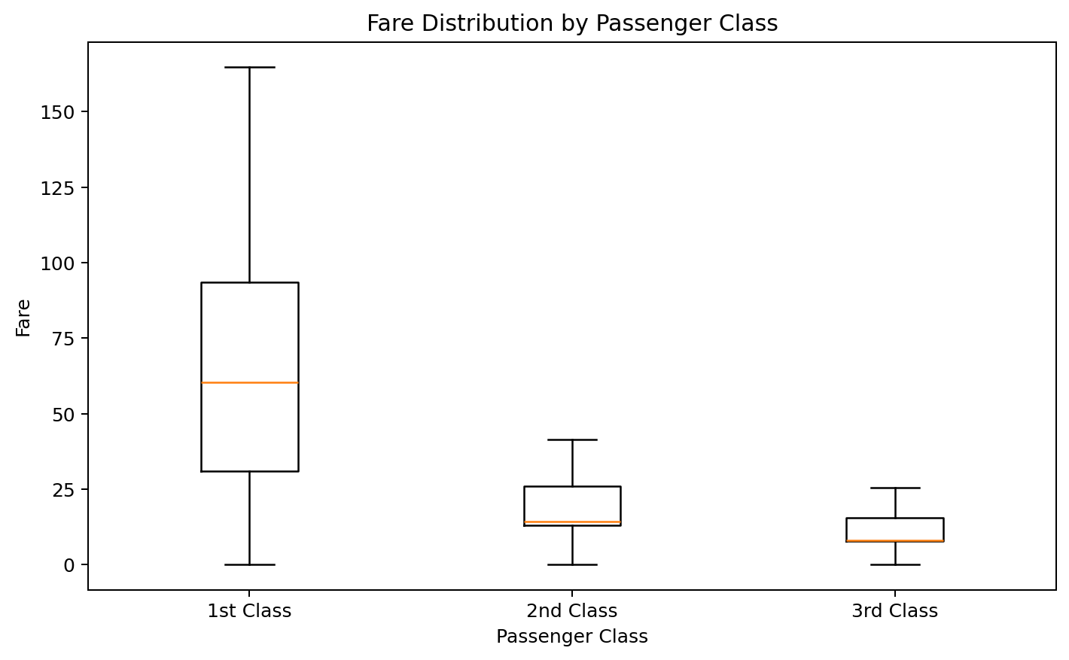

Interpretation
The box plot shows that 1st-class fares are generally much higher than 2nd- and 3rd-class fares. It also shows the median, spread and variability within each class. This visualization adds context to the class-survival chart: passenger class was not just a label; it was strongly associated with the amount passengers paid. The presence of high-fare observations is especially visible in 1st class, demonstrating why a box plot is more informative than a simple mean alone.

R Code
ggplot(titanic, aes(x = Class, y = Fare)) +
geom_boxplot() +
labs(
title = "Fare Distribution by Passenger Class",
x = "Passenger Class", y = "Fare"
)
Key takeaway: Passenger class is strongly associated with fare level: 1st class has the highest median and widest overall fare range.

10. Visualization 7 – Survival Rate by Sex and Class
Purpose: Combine two categorical dimensions to identify interaction-like patterns.
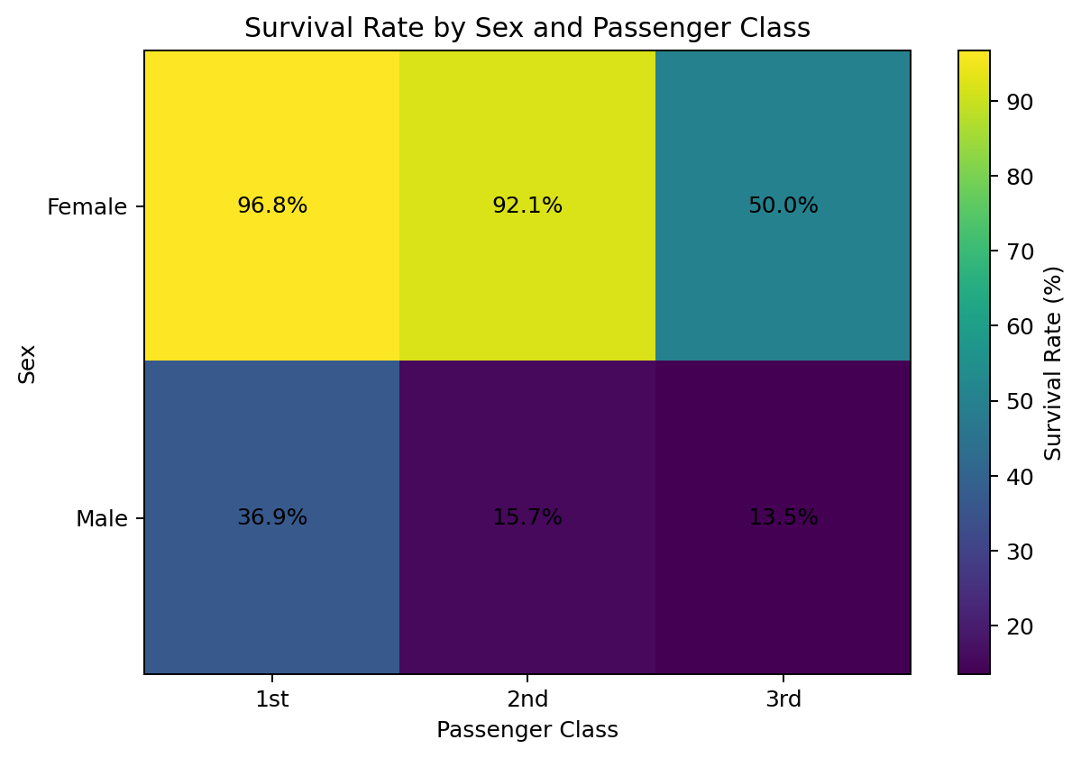

Interpretation
The heatmap provides one of the strongest insights in the analysis because it combines sex and passenger class. Female survival is high across all classes, while male survival is much lower, especially in 2nd and 3rd class. For example, female survival is approximately 96.8% in 1st class and 50.0% in 3rd class, while male survival is approximately 36.9% in 1st class and 13.5% in 3rd class. This shows why examining only one variable at a time can hide important differences between subgroups.

R Code
sex_class_summary <- titanic %>%
group_by(Sex, Class) %>%
summarise(Survival_Rate = mean(Survived, na.rm = TRUE) * 100,
.groups = "drop")
ggplot(sex_class_summary,
aes(x = Class, y = Sex, fill = Survival_Rate)) +
geom_tile() +
geom_text(aes(label = sprintf("%.1f%%", Survival_Rate))) +
labs(
title = "Survival Rate by Sex and Passenger Class",
x = "Passenger Class", y = "Sex", fill = "Survival Rate (%)"
)
Key takeaway: The combination of sex and class provides more detail than either variable alone and highlights major subgroup differences.

11. Visualization 8 – Survival Rate by Embarkation Port
Purpose: Compare survival rates among passengers boarding at different ports.
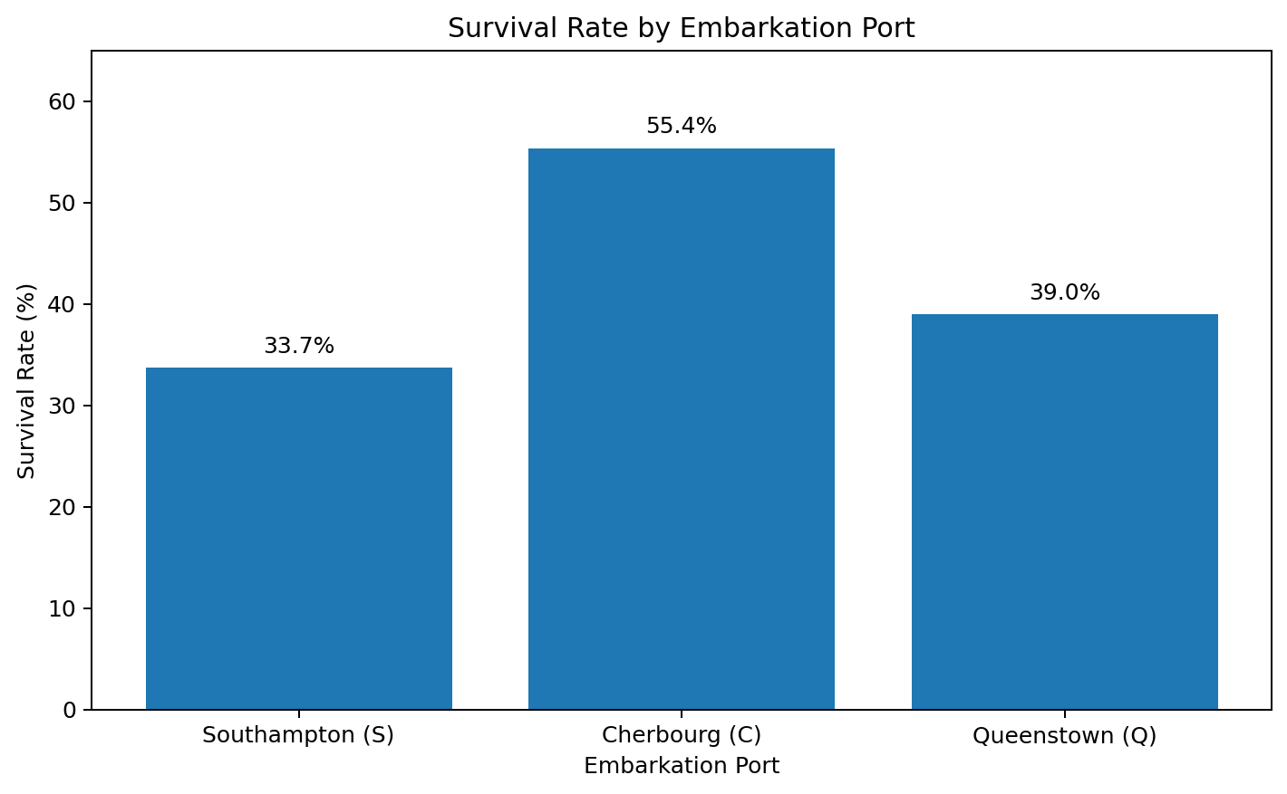

Interpretation
Passengers who embarked at Cherbourg (C) show the highest survival rate among the three ports, followed by Queenstown (Q) and Southampton (S). The rates are approximately 55.4%, 39.0% and 33.7%, respectively. However, embarkation is not necessarily a direct cause of survival. Port of embarkation can be correlated with passenger class, fare and passenger composition. The visualization is therefore best used to identify a pattern that could be explored further.

R Code
embarked_summary <- titanic %>%
filter(!is.na(Embarked)) %>%
group_by(Embarked) %>%
summarise(Survival_Rate = mean(Survived) * 100)
ggplot(embarked_summary, aes(x = Embarked, y = Survival_Rate)) +
geom_col() +
labs(
title = "Survival Rate by Embarkation Port",
x = "Embarkation Port", y = "Survival Rate (%)"
)
Key takeaway: Cherbourg has the highest observed survival rate, but the result should be interpreted alongside class and passenger composition.

12. Consolidated Insights and Insight Communication
The visualizations tell a consistent story: survival was not evenly distributed across the passenger population. The most prominent differences are associated with sex and passenger class, while age, fare and embarkation add useful context. The purpose of this section is to translate the charts into concise findings that a non-technical reader can understand.
Insight | Evidence | Communication meaning
Sex difference | Female 74.2% vs male 18.9% | The gap is large and visually dominant.
Class gradient | 1st 63.0%, 2nd 47.3%, 3rd 24.2% | Survival decreases across class levels.
Age distribution | Mean age about 29.7 years | Most passengers are concentrated in young-to-middle adulthood.
Fare variation | 1st-class fares much higher | Class is closely connected with fare level.
Age-group pattern | 0–12: 57.9%; 61+: 22.7% | Age groups have different survival profiles.
Sex × class | Female 1st-class ≈96.8%; male 3rd-class ≈13.5% | Subgroup analysis reveals stronger differences.
Embarkation | C ≈55.4%; S ≈33.7% | Port differences may reflect passenger composition.

How the Narrative Was Built
- Start with the outcome: overall survival was 38.4%, establishing the baseline.
- Move to the strongest group differences: sex and passenger class.
- Add distributional context: age and fare show how passengers were distributed.
- Use combined variables: the sex-by-class heatmap demonstrates why subgroup analysis matters.
- End with a secondary factor: embarkation identifies a pattern that should be investigated further.
- Avoid causal language unless a formal causal design or statistical model supports it.

Recommended Next Analysis
A logical next step would be a predictive or inferential model such as logistic regression, using survival as the outcome and sex, class, age, fare and family-related variables as predictors. Such a model could test whether class remains important after controlling for other factors. This would extend the descriptive visualization work into statistical analysis.

13. Limitations, Quality Checks and Conclusion

Limitations
- The dataset is historical and should not be generalized to modern transport or emergency situations.
- Several variables contain missing values, particularly Age and Cabin.
- The visualizations describe associations; they do not establish causation.
- Some groups, especially older passengers, contain fewer observations, so their percentages should be interpreted carefully.
- The dataset includes passenger-level records but does not capture every operational detail of the evacuation process.

Quality Checks Performed
- Checked dimensions and variable types before plotting.
- Reviewed missing values before using Age and Embarked.
- Used readable labels for binary and ordinal categories.
- Used group summaries before plotting rates.
- Used multiple visualization types so that distribution, comparison and relationship patterns were all represented.
- Kept chart titles and axis labels explicit so a reader can understand each figure without relying on the surrounding text.

Conclusion
This Week 2 project demonstrates how R can be used not only to create charts but also to communicate evidence. The Titanic dataset provides a clear example of how different visualization types answer different questions. Bar charts highlight group differences, the histogram explains distribution, the scatter plot reveals relationships and outliers, the line chart communicates ordered age-group changes, the box plot explains fare variability, and the heatmap reveals subgroup differences. The strongest overall message is that survival varied substantially by sex and passenger class, while age, fare and embarkation provide additional context.

Final Submission Readiness
- DOCX report contains dataset overview, methodology, eight visualizations, interpretations and embedded R code.
- R script is provided separately for GitHub upload.
- The report is structured for a non-technical evaluator.
- Charts are high-resolution and captioned through explanatory text.
- The report avoids unsupported causal claims.

14. Appendix – Complete Reproducible R Script
Copy the following code into an R script in RStudio. Keep titanic.csv in the same working directory. Install packages once with install.packages(c('ggplot2','dplyr','tidyr')) if they are not already installed.
# Week 2: Data Visualization and Insight Communication using R
library(ggplot2)
library(dplyr)
library(tidyr)
titanic <- read.csv("titanic.csv")
titanic <- titanic %>%
mutate(
Survival_Status = ifelse(Survived == 1, "Survived", "Did not survive"),
Class = factor(Pclass, levels = c(1, 2, 3),
labels = c("1st Class", "2nd Class", "3rd Class")),
FamilySize = SibSp + Parch + 1,
AgeGroup = cut(
Age,
breaks = c(0, 12, 18, 30, 45, 60, Inf),
labels = c("0–12", "13–18", "19–30", "31–45", "46–60", "61+"),
include.lowest = TRUE
)
)
# 1. Survival by sex
sex_summary <- titanic %>%
group_by(Sex) %>%
summarise(Survival_Rate = mean(Survived, na.rm = TRUE) * 100)
ggplot(sex_summary, aes(Sex, Survival_Rate)) +
geom_col() +
labs(title = "Survival Rate by Sex", x = "Sex", y = "Survival Rate (%)")
# 2. Survival by passenger class
class_summary <- titanic %>%
group_by(Class) %>%
summarise(Survival_Rate = mean(Survived, na.rm = TRUE) * 100)
ggplot(class_summary, aes(Class, Survival_Rate)) +
geom_col() +
labs(title = "Survival Rate by Passenger Class",
x = "Passenger Class", y = "Survival Rate (%)")
# 3. Age histogram
ggplot(titanic, aes(Age)) +
geom_histogram(bins = 20, na.rm = TRUE) +
labs(title = "Distribution of Passenger Age",
x = "Age (years)", y = "Number of Passengers")
# 4. Age vs fare scatter
ggplot(titanic %>% filter(!is.na(Age)),
aes(Age, Fare, shape = Survival_Status)) +
geom_point(alpha = 0.5) +
labs(title = "Age vs Fare by Survival Status",
x = "Age (years)", y = "Fare")
# 5. Line chart across age groups
age_summary <- titanic %>%
group_by(AgeGroup) %>%
summarise(Survival_Rate = mean(Survived, na.rm = TRUE) * 100)
ggplot(age_summary, aes(AgeGroup, Survival_Rate, group = 1)) +
geom_line() +
geom_point() +
labs(title = "Survival Rate Across Age Groups",
x = "Age Group", y = "Survival Rate (%)")
# 6. Fare distribution by class
ggplot(titanic, aes(Class, Fare)) +
geom_boxplot() +
labs(title = "Fare Distribution by Passenger Class",
x = "Passenger Class", y = "Fare")
# 7. Sex and class heatmap
sex_class_summary <- titanic %>%
group_by(Sex, Class) %>%
summarise(Survival_Rate = mean(Survived, na.rm = TRUE) * 100,
.groups = "drop")
ggplot(sex_class_summary,
aes(Class, Sex, fill = Survival_Rate)) +
geom_tile() +
geom_text(aes(label = sprintf("%.1f%%", Survival_Rate))) +
labs(title = "Survival Rate by Sex and Passenger Class",
x = "Passenger Class", y = "Sex", fill = "Survival Rate (%)")
# 8. Survival by embarkation port
embarked_summary <- titanic %>%
filter(!is.na(Embarked)) %>%
group_by(Embarked) %>%
summarise(Survival_Rate = mean(Survived) * 100)
ggplot(embarked_summary, aes(Embarked, Survival_Rate)) +
geom_col() +
labs(title = "Survival Rate by Embarkation Port",
x = "Embarkation Port", y = "Survival Rate (%)")
# Export one example figure:
# ggsave("survival_by_sex.png", width = 8, height = 5, dpi = 300)

Suggested GitHub Folder Structure
Week2-Titanic-Data-Visualization/
├── Week2_Titanic_Data_Visualization.R
├── titanic.csv
├── 01_survival_by_sex.png
├── 02_survival_by_class.png
├── 03_age_histogram.png
├── 04_age_fare_scatter.png
├── 05_agegroup_line.png
├── 06_fare_boxplot.png
├── 07_sex_class_heatmap.png
├── 08_embarked_survival.png
└── README.md

