**PROJECT REPORT**

**StockSense - Your Intuitive Stock Trading Platform**

**1. INTRODUCTION**

**1.1 Project Overview**

StockSense is a modern stock trading platform designed to provide users with real-time market insights, seamless trade execution, and portfolio management tools. The platform is built to assist both novice and experienced traders in analyzing stock trends, executing trades efficiently, and managing their financial investments with ease.

**1.2 Purpose**

The purpose of this project is to:

* **Offer traders live market data** for better decision-making.
* **Provide a centralized platform** for stock trading.
* **Integrate smart analytics tools** to enhance trading efficiency.

**2. IDEATION PHASE**

**2.1 Problem Statement**

Stock traders face multiple challenges, such as tracking stocks efficiently, executing trades at the right time, and managing investments due to complex interfaces or outdated trading tools. StockSense offers a user-friendly, secure, and feature-rich trading solution.

**User Personas & Their Challenges**

* **New Traders** → Struggle with understanding stock market trends and need a simple dashboard.
* **Experienced Investors** → Require advanced analytics and portfolio management tools for effective trading.
* **Casual Stock Watchers** → Need price alerts and real-time data tracking.

**2.2 Empathy Map Canvas**

* What traders **hear** → "Stock trading is too complex," "I don’t know when to buy or sell."
* What traders **see** → Outdated trading interfaces with limited data insights.
* What traders **think** → "I need better tools to make smarter trades."
* What traders **feel** → Frustration due to delayed stock updates or inefficient trading systems.

**2.3 Brainstorming**

* Trading dashboard with real-time analytics
* Secure transactions & authentication system
* AI-powered stock recommendations & alerts
* Integration with financial news for market trends

**3. REQUIREMENT ANALYSIS**

**3.1 Customer Journey Map**

**Steps in the Stock Trading Process Using StockSense**

* **Discover the platform** → Learn about its features.
* **Sign up & create a portfolio** → Register securely with JWT authentication.
* **Analyze market trends** → View real-time stock price movements.
* **Execute trades** → Buy/sell stocks efficiently within the interface.
* **Track investment growth** → Analyze trends with visual graphs.

**3.2 Solution Requirement**

**Non-Functional Requirements**

| **Requirement** | **Description** |
| --- | --- |
| **Usability** | User-friendly interface for easy navigation. |
| **Security** | Encrypted transactions & secure authentication. |
| **Reliability** | Consistent performance under peak trading conditions. |
| **Scalability** | Expandable infrastructure for increased usage. |

**3.3 Technology Stack**

| **Component** | **Description** | **Technology Used** |
| --- | --- | --- |
| **Frontend** | UI for stock trading interface | React.js, Tailwind CSS |
| **Backend** | Trade execution & portfolio tracking | Node.js, Express.js |
| **Database** | User details & stock transaction history storage | MongoDB Atlas |
| **Security** | Encrypted authentication with JWT | JWT, bcrypt |
| **Hosting** | Cloud deployment for scalability | IBM Cloud |

**4. PROJECT DESIGN**

**4.1 Problem Solution Fit**

StockSense provides traders with a **user-friendly, analytics-driven trading experience**, replacing manual methods with **automated market analysis tools**.

**4.2 Proposed Solution**

* **Real-time stock tracking dashboard**
* **Secure trade execution & portfolio management**
* **Automated alerts for stock movements**
* **Data-driven investment insights**

**4.3 Solution Architecture**

**Frontend Setup**

* React.js + Tailwind CSS for UI design
* API integration for real-time stock updates
* Authentication & user profile management

**Backend Setup**

* Express.js + MongoDB for trade execution & data storage
* Secure API endpoints for transactions
* JWT-based authentication & authorization

**5. PROJECT PLANNING & SCHEDULING**

**5.1 Sprint-Based Planning**

**Sprint Breakdown**

| **Sprint** | **Task** | **Priority** | **Team Member** |
| --- | --- | --- | --- |
| Sprint 1 | User Authentication Setup | High | Mrunmayee Phadtare |
| Sprint 2 | Stock Trading API Integration | Highs | Aditi Babar |
| Sprint 3 | Trading Dashboard UI | High | Sandeepan Chakraborty |
| Sprint 4 | AI-powered Stock Predictions | High | Ankit Kumar Singh |

**6. RESULTS**

**6.1 Output Screenshots**

1. **Login & Registration Page**

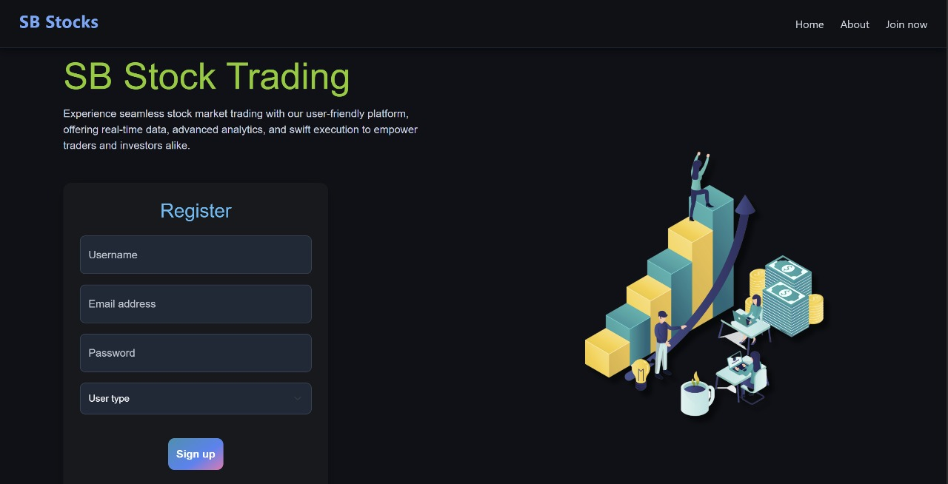

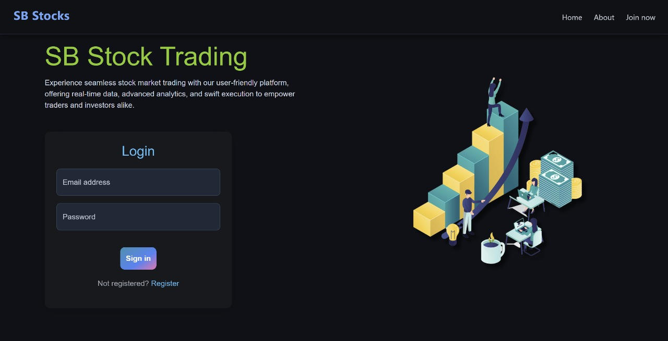

1. **Stock Trading Dashboard**

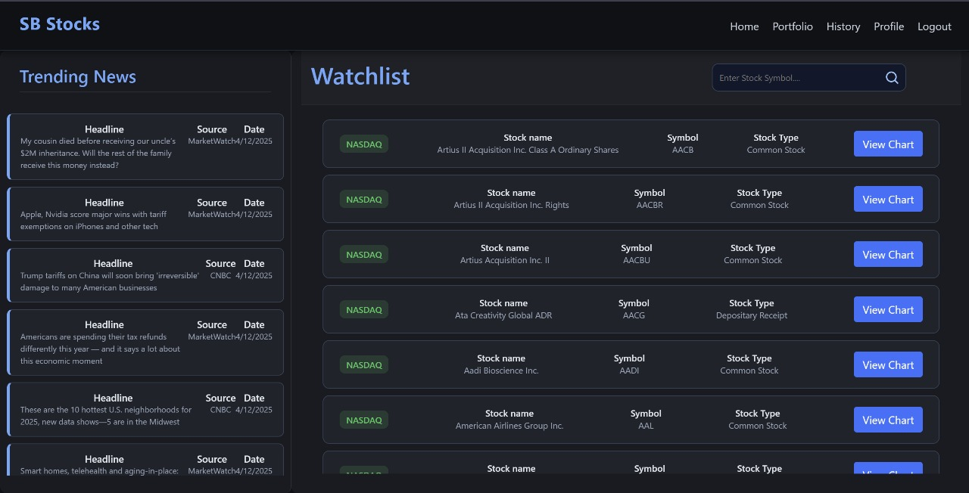

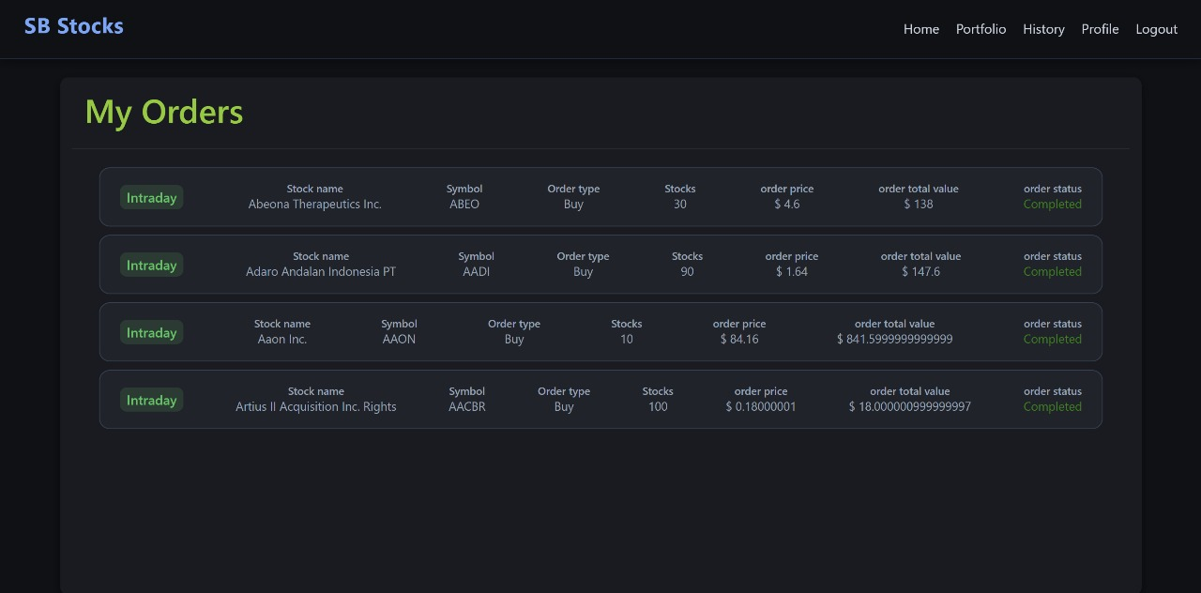

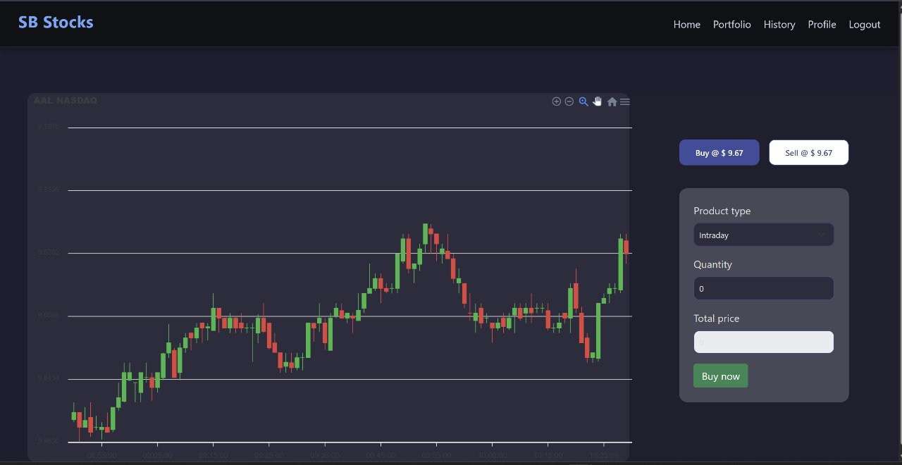

1. **Portfolio Overview & Stock Predictions** 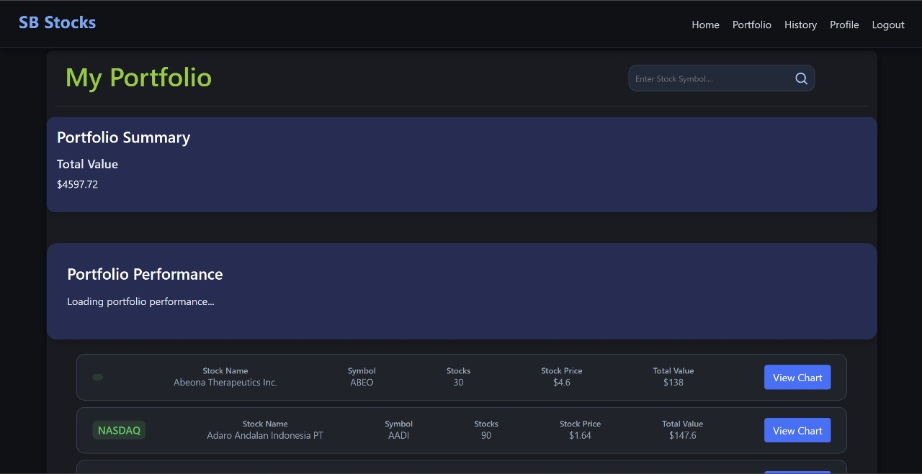

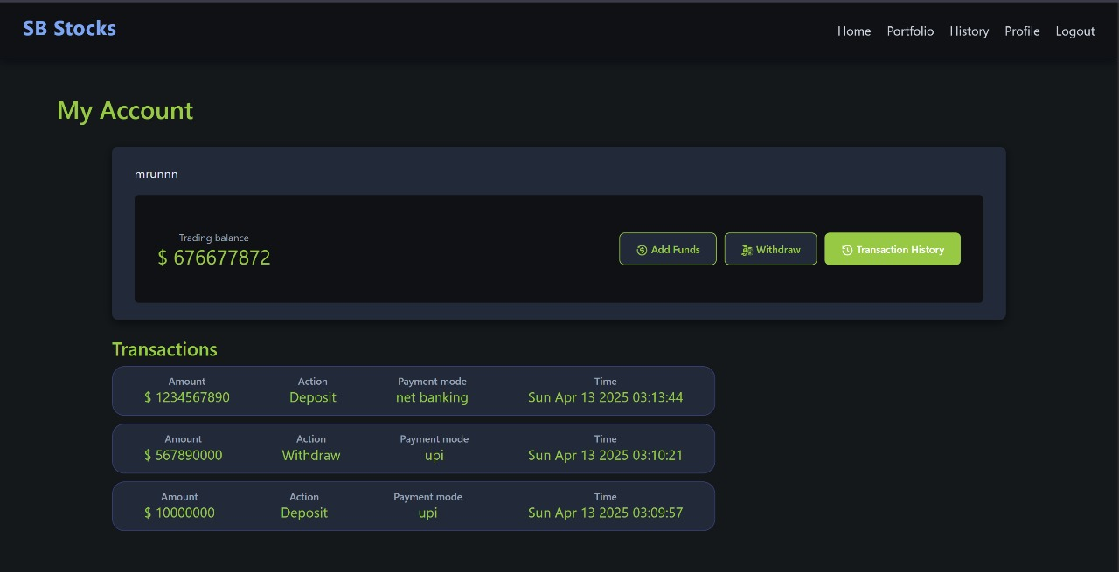

**7. ADVANTAGES & DISADVANTAGES**

**7.1 Advantages**

* **User-friendly trading interface**
* **Real-time stock analytics**
* **Secure authentication & encrypted transactions**
* **Advanced portfolio tracking features**

**7.2 Disadvantages**

* Initial learning curve for new traders
* Dependent on live market data availability
* No offline trading support

**8. CONCLUSION**

StockSense integrates modern stock trading features, secure trade execution, and portfolio management tools to provide a seamless trading experience. With upcoming AI-powered features, StockSense aims to redefine smart trading.

**9. FUTURE SCOPE**

* AI-driven predictive analytics for stocks
* Mobile trading app development using React Native
* Multi-user support for institutional investors
* Integration with financial news for global market tracking

**10. APPENDIX**

**Repository Link** →

<https://github.com/Aditi16-ctrl/Stocks-Trading-MERN.git>

**Demo Video Link** → [*Insert Link Here*](https://drive.google.com/file/d/1dO2ALKxjX7m6cp4LaC7Cq7fcglCOh__S/view?usp=drive_link)