F26 MISM 6406 — Team Project Phase 2
  - PVA Donor Response Model, Optimization, Simulation, and Decision Agent
Group 2
October 23, 2026
Table of Contents
Executive Summary 2
1. Introduction: Company, Data, and Problem 3
2. Data Cleaning and Transformations 4
2.1 Approach and rationale 4
2.2 Variable dictionary 5
3. Exploratory Data Analysis 7
3.1 Central tendencies and the shape of the data 7
3.2 The central finding: response is rare 8
3.3 Gift amounts 8
3.4 Behavioral drivers of response 9
3.5 The key insight: comparison of means 11
3.6 Demographics (top donors) and multicollinearity 11
4. Models Considered, Final Model, and Results 13
4.1 Technique and validation design 13
4.2 The four models and their results 13
4.3 ROC, lift, and which variables matter most 14
5. Optimization (Q3) 16
5.1 From model to deciles (the bridge) 16
5.2 The optimization problem 17
5.3 Result and sensitivity analysis 19
6. Simulation (Q4) 20
6.1 Why simulate 20
6.2 Assumptions and their basis in the data 20
6.3 Comparing three scenarios and choosing one 21
6.4 Discovery and recommendation 23
7. Decision Agent (Q5) 24
8. Challenges and Next Steps 24
Deliverables submitted 25

library(tidyverse)
if (!requireNamespace("pROC", quietly = TRUE)) install.packages("pROC")
if (!requireNamespace("broom", quietly = TRUE)) install.packages("broom")
if (!requireNamespace("rpart", quietly = TRUE)) install.packages("rpart")
if (!requireNamespace("rpart.plot", quietly = TRUE)) install.packages("rpart.plot")
library(pROC); library(broom); library(rpart); library(rpart.plot)
he analysis, figures, and tables are generated by the code below. The narrative paragraphs summarize our findings; team members should adapt the wording into their own voice before submission, as required.

Executive Summary
This project takes PVA’s donor data from raw records all the way to an actionable, risk-aware mailing decision in four connected stages:
- Prediction (Phase 1 model). A logistic-regression model scores every donor’s probability of responding to a mailing. It ranks donors well (top decile responds ~1.8–2× the base rate) even though the overall response rate is only ~5%.
- Decision (optimization). Using the model’s decile-level response rates and gift sizes, we solved a budget-constrained optimization that selects deciles 2, 3, 5, and 6, producing an expected net donation of ~$7,056 within a $30,000 budget.
- Risk (simulation). A 10,000-trial Monte Carlo, using a shared-shock triangular model, shows the plan averages ~$7,000 but carries about an 11% chance of a loss once realistic year-to-year uncertainty is included.
- Deployment (agent). A web tool packages the model and optimization so a non-technical fundraiser can enter a budget and receive a mailing recommendation; it reproduces the Solver result.
The recurring theme is that each stage adds realism: from who might give, to who we should mail, to how confident we can be, to a tool anyone can run.

1. Introduction: Company, Data, and Problem
The organization is the Paralyzed Veterans of America (PVA), a non-profit that raises the majority of its funds through direct-mail fundraising to people who have donated before. This dataset is drawn from one specific appeal (internally coded “97NK”) mailed to lapsed donors — individuals who had given in the past but had become inactive and whom PVA hoped to re-engage.
Each row represents one donor. The columns describe three kinds of information: the donor’s giving history (how often and how much they have given), their promotion/contact history (how many mailings they have received), and demographics (age, income, gender, homeownership, and census-overlay fields).
The business problem is economic. Every mailed letter costs money (about $0.68 for this campaign), and the overwhelming majority of recipients do not respond. Mailing the entire file is wasteful. PVA therefore needs to answer two linked questions: which donors are most likely to give? and, given a limited budget, which of them should we actually mail? Our predicted target is TARGET_B, a binary flag where 1 means the donor responded with a gift and 0 means they did not. A companion variable, TARGET_D, records the donation amount (0 for non-responders) and is used in the economic analysis.
Because only about 5% of donors respond, this is a rare-event, highly imbalanced prediction problem. That single fact shapes every downstream decision: a model that simply predicts “nobody donates” would be ~95% accurate yet useless, so our model is built to rank donors by their probability of responding rather than to label them yes/no, and we evaluate it with ranking-appropriate metrics (AUC and lift) rather than accuracy.
The data arrives in two files. The learning file (LRN) contains 95,412 donors across 481 variables and includes the target — this is what we build and validate the model on. The validation file (VAL) contains 96,367 donors but has no target column; it is a scoring set only, which is why all honest model validation is done by holding out part of the LRN data rather than using VAL.
# setwd("path to this .Rmd") # keep both CSVs beside this file
lrn <- read_csv("cup98LRN.csv", guess_max = 20000, show_col_types = FALSE)
val <- read_csv("cup98VAL.csv", guess_max = 20000, show_col_types = FALSE)
cat("LRN dimensions:", dim(lrn)[1], "rows x", dim(lrn)[2], "cols\n")
## LRN dimensions: 95412 rows x 481 cols
cat("VAL dimensions:", dim(val)[1], "rows x", dim(val)[2], "cols\n")
## VAL dimensions: 96367 rows x 479 cols
cat("Variables present only in LRN:", paste(setdiff(names(lrn), names(val)), collapse=", "), "\n")
## Variables present only in LRN: TARGET_B, TARGET_D
The output confirms the structure: LRN and VAL differ only in that TARGET_B and TARGET_D exist exclusively in LRN, verifying that VAL is a scoring set.

2. Data Cleaning and Transformations

2.1 Approach and rationale
The raw file has 481 columns, the majority of which are granular historical records (individual promotion dates, individual gift records, and dozens of census-overlay fields) that largely duplicate information already summarized elsewhere. Our first step was to retain a focused set of about 21 interpretable, mostly-complete variables: the two targets, the core giving-history summaries, the RFA behavioral codes, promotion counts, and a small set of demographics.
Handling missing values. We examined missingness explicitly (table below). We made two different decisions depending on severity:
- Dropped entirely: WEALTH1 and WEALTH2 (neighborhood wealth ratings, each missing for roughly 46–47% of donors), along with other sparse geo-coded fields such as CLUSTER, DOMAIN, and MDMAUD. Imputing a variable that is half empty would inject more assumption than signal and could distort the model.
- Median-imputed: AGE (~25% missing), INCOME (~22%), and TIMELAG (~10%). We filled blanks with each column’s median rather than its mean, because these variables are right-skewed — a handful of very large values would pull the mean upward, whereas the median is robust to outliers and better represents a typical donor.
Encoding text into model-ready numbers. Several informative fields were stored as letters or codes. We converted:
- PEP (from PEPSTRFL) into a 0/1 “star donor” flag (1 where the original field was “X”).
- FEMALE (1 if gender is female) and OWNER (1 if homeowner) into 0/1 indicators.
- RFA_2A, the recent gift-amount code, into an ordinal score: D = 4 (highest recent-gift dollar band), E = 3, F = 2, G = 1 (lowest). This preserves the natural order so the model can use it.
- RFA_2F, the recent gift-frequency code, into a numeric value (1 = least frequent, 4 = most frequent).
model_vars <- c("TARGET_B","TARGET_D","AGE","INCOME","GENDER","HOMEOWNR","PEPSTRFL",
"NGIFTALL","CARDGIFT","RAMNTALL","LASTGIFT","AVGGIFT","MAXRAMNT",
"NUMPROM","NUMPRM12","CARDPROM","TIMELAG","HIT",
"RFA_2F","RFA_2A","CONTROLN")
clean_frame <- function(df) {
d <- df %>% select(any_of(model_vars))
num_cols <- c("AGE","INCOME","NGIFTALL","CARDGIFT","RAMNTALL","LASTGIFT","AVGGIFT",
"MAXRAMNT","NUMPROM","NUMPRM12","CARDPROM","TIMELAG","HIT")
d <- d %>% mutate(across(any_of(num_cols), as.numeric))
for (v in c("AGE","INCOME","TIMELAG"))
if (v %in% names(d)) d[[v]][is.na(d[[v]])] <- median(d[[v]], na.rm = TRUE)
d %>% mutate(
PEP = if_else(replace_na(PEPSTRFL," ") == "X", 1L, 0L),
FEMALE = if_else(replace_na(GENDER," ") == "F", 1L, 0L),
OWNER = if_else(replace_na(HOMEOWNR," ") == "H", 1L, 0L),
RFA_2A_ord = recode(replace_na(RFA_2A,"F"), "G"=1L,"F"=2L,"E"=3L,"D"=4L, .default=2L),
RFA_2F = replace_na(suppressWarnings(as.numeric(RFA_2F)), 1)
)
}
train <- clean_frame(lrn)
score <- clean_frame(val)
# Missingness snapshot on the selected columns
lrn %>% select(any_of(model_vars)) %>%
summarise(across(everything(), ~ round(mean(is.na(.))*100,1))) %>%
pivot_longer(everything(), names_to="variable", values_to="pct_missing") %>%
arrange(desc(pct_missing))
## # A tibble: 21 × 2
## variable pct_missing
## <chr> <dbl>
## 1 PEPSTRFL 52.6
## 2 AGE 24.8
## 3 HOMEOWNR 23.3
## 4 INCOME 22.3
## 5 TIMELAG 10.5
## 6 GENDER 3.1
## 7 TARGET_B 0
## 8 TARGET_D 0
## 9 NGIFTALL 0
## 10 CARDGIFT 0
## # ℹ 11 more rows

2.2 Variable dictionary
Variable | Type | Meaning
TARGET_B | 0/1 | Outcome we predict — did the donor give (1) or not (0)
TARGET_D | $ | Donation amount; 0 for non-givers (used in the economics, not as a predictor)
RFA_2F | ordinal 1–4 | Recent giving frequency (1 = low, 4 = high); strongest predictor
RFA_2A → RFA_2A_ord | D–G → 4–1 | Recent gift dollar band: D highest, E, F, G lowest
NGIFTALL | count | Total lifetime number of gifts (loyalty measure)
CARDGIFT | count | Gifts made in response to card mailings
RAMNTALL | $ | Total lifetime dollars given
LASTGIFT | $ | Amount of the most recent gift
AVGGIFT | $ | Average gift size over the donor’s history
MAXRAMNT | $ | Largest single gift ever made
NUMPROM | count | Total mailings ever received (lifetime); second-strongest predictor
NUMPRM12 | count | Mailings received in the last 12 months
CARDPROM | count | Card mailings received
HIT | count | Mail-order purchases/responses (general mail responsiveness)
TIMELAG | months | Months between the donor’s first and second gift
AGE | years | Donor age
INCOME | ordinal 1–7 | Household income band (1 low, 7 high)
GENDER → FEMALE | category → 0/1 | 1 if female
HOMEOWNR → OWNER | category → 0/1 | 1 if homeowner
PEPSTRFL → PEP | “X” → 0/1 | “Star” (consistent) donor flag
CONTROLN | id | Unique donor id; not a predictor, used only to attach predictions
WEALTH1, WEALTH2 | — | Neighborhood wealth ratings — excluded (~47% missing)
CLUSTER, DOMAIN, MDMAUD | — | Geo/segment overlays — excluded (too sparse)

3. Exploratory Data Analysis

3.1 Central tendencies and the shape of the data
train %>% summarise(across(c(AGE,NGIFTALL,LASTGIFT,AVGGIFT,RAMNTALL,MAXRAMNT,NUMPROM),
list(mean=~round(mean(.),2), median=~round(median(.),2),
sd=~round(sd(.),2)))) %>%
pivot_longer(everything(), names_to=c("variable",".value"), names_sep="_(?=[^_]+$)")
## # A tibble: 7 × 4
## variable mean median sd
## <chr> <dbl> <dbl> <dbl>
## 1 AGE 61.7 62 14.4
## 2 NGIFTALL 9.6 7 8.55
## 3 LASTGIFT 17.3 15 14.0
## 4 AVGGIFT 13.4 11.6 10.8
## 5 RAMNTALL 104. 78 119.
## 6 MAXRAMNT 20 17 25.1
## 7 NUMPROM 47.0 47 23.0
train %>% count(TARGET_B) %>% mutate(pct = round(100*n/sum(n),2))
## # A tibble: 2 × 3
## TARGET_B n pct
## <dbl> <int> <dbl>
## 1 0 90569 94.9
## 2 1 4843 5.08
train %>% filter(TARGET_B==1) %>%
summarise(n=n(), mean_gift=round(mean(TARGET_D),2),
median_gift=median(TARGET_D), max_gift=max(TARGET_D))
## # A tibble: 1 × 4
## n mean_gift median_gift max_gift
## <int> <dbl> <dbl> <dbl>
## 1 4843 15.6 13 200
The typical donor is older (median age ~62), has given about 7 times historically (mean ~9.6, pulled up by a long right tail), and gives modest amounts (median last gift ~$15, median average gift ~$12). Several variables are strongly right-skewed with extreme outliers — lifetime giving (RAMNTALL) reaches into the thousands and the largest single gift reaches $5,000 — which is exactly why we relied on medians for imputation. This skew is important for the simulation discussion later: the underlying individual data is not normally distributed (gift amounts are lognormal-like, and the response outcome is binary), but because the simulation operates on decile averages of thousands of donors, those averages behave far more symmetrically (an application of the Central Limit Theorem), which justifies the triangular modeling choice in Section 6.

3.2 The central finding: response is rare
ggplot(train, aes(factor(TARGET_B), fill=factor(TARGET_B))) + geom_bar() +
labs(title="Fig 1. Response is rare: ~5% of mailed donors gave",
x="TARGET_B (0=no gift, 1=gift)", y="Donors", fill="Responded") +
theme_minimal()
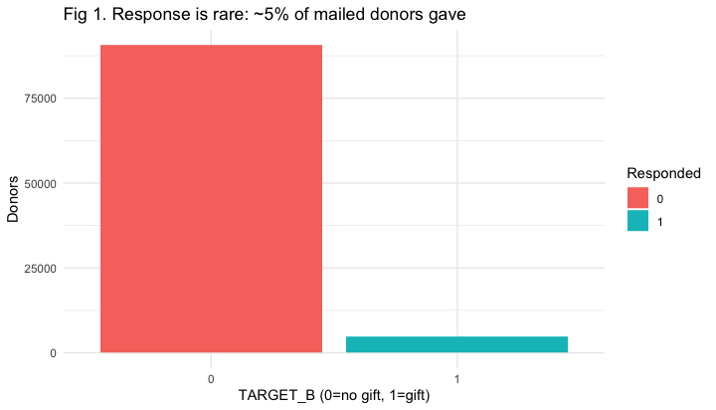
Only 5.08% of donors responded (4,843 of 95,412). This drives metric choice throughout: accuracy is misleading at this imbalance, so we judge models by AUC and lift.

3.3 Gift amounts
train %>% filter(TARGET_B==1) %>%
ggplot(aes(TARGET_D)) + geom_histogram(binwidth=5, fill="steelblue", color="white") +
labs(title="Fig 2. Gift amounts are right-skewed, clustering at $10-$20",
x="Donation amount ($)", y="Responders") + theme_minimal()
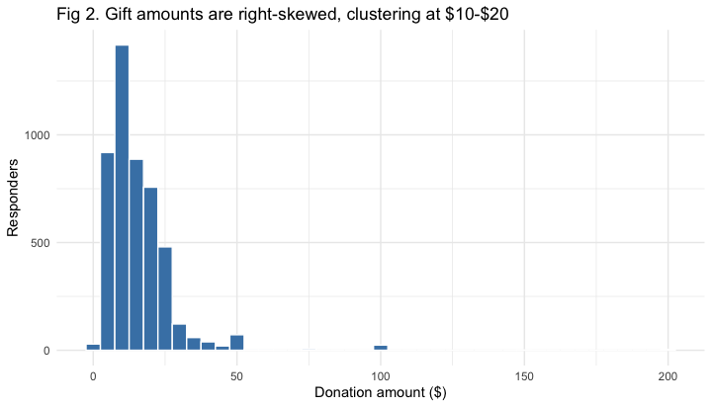
Among responders, gifts cluster between $10 and $20 (median ~$13, mean ~$15.6). A small number of large gifts create the long right tail that pulls the mean above the median.

3.4 Behavioral drivers of response
train %>% group_by(RFA_2F) %>% summarise(rate=mean(TARGET_B)) %>%
ggplot(aes(factor(RFA_2F), rate)) + geom_col(fill="darkorange") +
geom_hline(yintercept=mean(train$TARGET_B), linetype="dashed") +
labs(title="Fig 3. Response rises with recent giving frequency",
subtitle="Dashed line = overall 5.1% response",
x="RFA_2F (1=low ... 4=high)", y="Response rate") + theme_minimal()
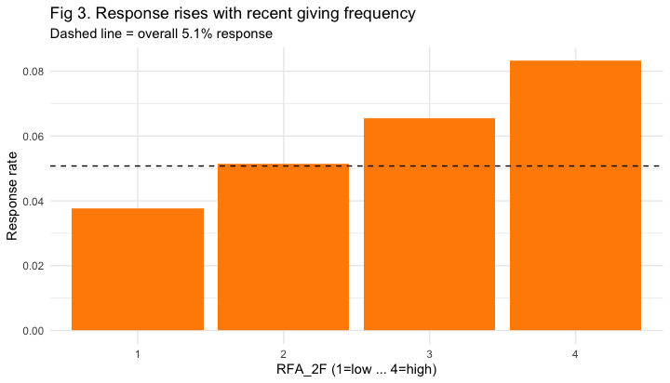
train %>% group_by(RFA_2A) %>% summarise(rate=mean(TARGET_B)) %>%
ggplot(aes(RFA_2A, rate)) + geom_col(fill="seagreen") +
geom_hline(yintercept=mean(train$TARGET_B), linetype="dashed") +
labs(title="Fig 4. Response by recent gift-amount code (D highest $, G lowest $)",
x="RFA_2A", y="Response rate") + theme_minimal()
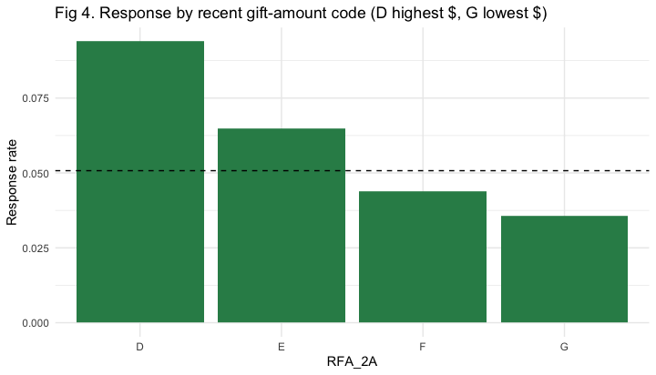
Recent behavior is the strongest signal. Response climbs steadily with frequency (RFA_2F), from about 3.8% in the least-frequent group to about 8.3% in the most-frequent (Fig 3). The recent amount code (RFA_2A) shows the highest response in the lower-dollar, higher-frequency segment (Fig 4) — about 9.4% for code D versus 3.6% for code G.

3.5 The key insight: comparison of means
train %>% group_by(TARGET_B) %>%
summarise(across(c(NGIFTALL,CARDGIFT,LASTGIFT,AVGGIFT,MAXRAMNT,NUMPROM,AGE),
~round(mean(.),2))) %>%
pivot_longer(-TARGET_B, names_to="variable", values_to="mean") %>%
pivot_wider(names_from=TARGET_B, values_from=mean, names_prefix="resp_") %>%
mutate(difference = round(resp_1 - resp_0, 2))
## # A tibble: 7 × 4
## variable resp_0 resp_1 difference
## <chr> <dbl> <dbl> <dbl>
## 1 NGIFTALL 9.5 11.5 1.98
## 2 CARDGIFT 5 6.12 1.12
## 3 LASTGIFT 17.4 15.2 -2.26
## 4 AVGGIFT 13.4 11.8 -1.59
## 5 MAXRAMNT 20.1 18.2 -1.92
## 6 NUMPROM 46.8 50.3 3.47
## 7 AGE 61.7 62.2 0.52
This is the most informative table in the EDA. Responders have given more often (NGIFTALL ~11.5 vs ~9.5) and have received more promotions (NUMPROM ~50 vs ~47), yet their individual gifts are smaller (average gift ~$11.8 vs ~$13.4; last gift ~$15.2 vs ~$17.4). The practical, somewhat counterintuitive conclusion: the best responders are frequent, small-dollar loyalists, not occasional large-check donors. This single insight recurs throughout the project — it explains the decile economics in Section 5 and the reason the optimization does not simply mail the “highest-response” decile.

3.6 Demographics (top donors) and multicollinearity
train %>% mutate(ageband=cut(AGE,c(0,40,55,70,120),labels=c("<=40","41-55","56-70","70+"))) %>%
group_by(ageband) %>% summarise(n=n(), response_rate=round(mean(TARGET_B),4))
## # A tibble: 4 × 3
## ageband n response_rate
## <fct> <int> <dbl>
## 1 <=40 8713 0.041
## 2 41-55 18864 0.052
## 3 56-70 42882 0.051
## 4 70+ 24953 0.0527
train %>% filter(INCOME>0) %>% group_by(INCOME) %>%
summarise(n=n(), response_rate=round(mean(TARGET_B),4))
## # A tibble: 7 × 3
## INCOME n response_rate
## <dbl> <int> <dbl>
## 1 1 9022 0.0417
## 2 2 13114 0.0482
## 3 3 8558 0.0494
## 4 4 34018 0.0512
## 5 5 15451 0.0526
## 6 6 7778 0.0554
## 7 7 7471 0.057
# Fig 5: income gradient
train %>% filter(INCOME>0) %>% group_by(INCOME) %>% summarise(rate=mean(TARGET_B)) %>%
ggplot(aes(factor(INCOME), rate)) + geom_col(fill="purple") +
geom_hline(yintercept=mean(train$TARGET_B), linetype="dashed") +
labs(title="Fig 5. Response rate rises with income", x="Income band (1=low, 7=high)",
y="Response rate") + theme_minimal()
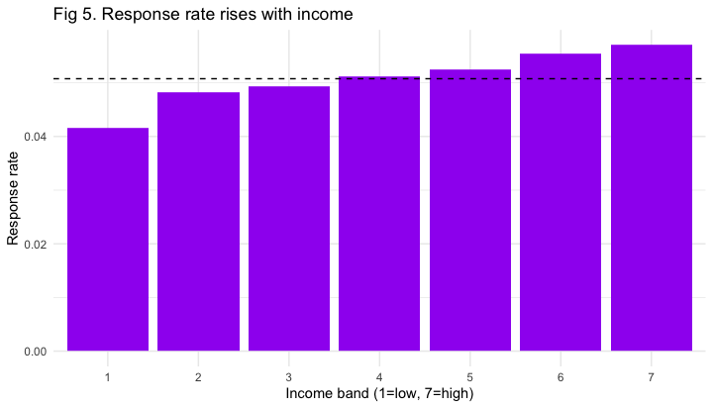
round(cor(train %>% select(NGIFTALL,CARDGIFT,RAMNTALL,LASTGIFT,AVGGIFT,MAXRAMNT,NUMPROM)), 2)
## NGIFTALL CARDGIFT RAMNTALL LASTGIFT AVGGIFT MAXRAMNT NUMPROM
## NGIFTALL 1.00 0.91 0.60 -0.18 -0.26 -0.04 0.79
## CARDGIFT 0.91 1.00 0.50 -0.19 -0.27 -0.07 0.75
## RAMNTALL 0.60 0.50 1.00 0.32 0.37 0.56 0.62
## LASTGIFT -0.18 -0.19 0.32 1.00 0.78 0.56 -0.02
## AVGGIFT -0.26 -0.27 0.37 0.78 1.00 0.77 -0.14
## MAXRAMNT -0.04 -0.07 0.56 0.56 0.77 1.00 0.07
## NUMPROM 0.79 0.75 0.62 -0.02 -0.14 0.07 1.00
The most responsive donors skew older (70+, ~5.3%), higher-income (~5.7% in the top band vs ~4.2% in the lowest, Fig 5), and are homeowners (~5.2% vs ~4.6%); gender has almost no effect (~5.1% vs ~5.0%). Crucially, every demographic gap is small compared with the behavioral gaps — frequency alone moves response from 3.8% to 8.3%. The correlation matrix shows the giving-history dollar variables are strongly inter-correlated, which is expected (multicollinearity) and explains why a parsimonious model performs about as well as a fuller one.

4. Models Considered, Final Model, and Results

4.1 Technique and validation design
We used binary logistic regression as the primary technique because the outcome is a 0/1 response and logistic regression is purpose-built for that, with the added advantage that its coefficients are interpretable as effects on the odds of responding. Because VAL has no target, we could not validate against it; instead we held out 30% of the LRN data as a test set and trained on the other 70%. Given the 5% imbalance, we judged models by AUC (area under the ROC curve — a measure of how well the model ranks a random responder above a random non-responder; 0.5 is random, 1.0 is perfect) and by a lift table, not by accuracy.

4.2 The four models and their results
set.seed(42)
idx <- sample(nrow(train), floor(0.70*nrow(train)))
tr <- train[idx,]; te <- train[-idx,]
mA <- glm(TARGET_B ~ RFA_2F + RFA_2A_ord + PEP + NGIFTALL + CARDGIFT +
LASTGIFT + AVGGIFT + AGE, data=tr, family=binomial)
mB <- glm(TARGET_B ~ RFA_2F + RFA_2A_ord + PEP + NGIFTALL + CARDGIFT +
LASTGIFT + AVGGIFT + MAXRAMNT + AGE + INCOME + FEMALE + OWNER +
NUMPROM + NUMPRM12 + CARDPROM + HIT, data=tr, family=binomial)
mC <- rpart(factor(TARGET_B) ~ RFA_2F + RFA_2A_ord + PEP + NGIFTALL + CARDGIFT +
LASTGIFT + AVGGIFT + MAXRAMNT + AGE + INCOME + NUMPROM + CARDPROM,
data=tr, method="class", control=rpart.control(cp=0.001, maxdepth=4))
mD <- step(mB, direction="both", trace=0)
pA <- predict(mA, te, type="response")
pB <- predict(mB, te, type="response")
pC <- predict(mC, te, type="prob")[,2]
pD <- predict(mD, te, type="response")
results <- tibble(
Model = c("A: Logistic (parsimonious)","B: Logistic (full)",
"C: Decision tree","D: Logistic (stepwise)"),
Test_AUC = round(c(as.numeric(auc(te$TARGET_B,pA)), as.numeric(auc(te$TARGET_B,pB)),
as.numeric(auc(te$TARGET_B,pC)), as.numeric(auc(te$TARGET_B,pD))),4)
) %>% arrange(desc(Test_AUC))
results
## # A tibble: 4 × 2
## Model Test_AUC
## <chr> <dbl>
## 1 D: Logistic (stepwise) 0.607
## 2 B: Logistic (full) 0.606
## 3 A: Logistic (parsimonious) 0.603
## 4 C: Decision tree 0.5
What each model contains. Model A (parsimonious): eight behavioral predictors — RFA_2F, RFA_2A_ord, PEP, NGIFTALL, CARDGIFT, LASTGIFT, AVGGIFT, AGE. Model B (full): A plus MAXRAMNT, INCOME, FEMALE, OWNER, NUMPROM, NUMPRM12, CARDPROM, HIT. Model C: a decision tree on Model B’s predictors. Model D: stepwise (AIC) selection applied to Model B.
What the numbers mean. The three logistic models cluster around AUC 0.60–0.61. This is modest but realistic — the original KDD-Cup-1998 winners on this exact dataset topped out near 0.62–0.63. The decision tree scored 0.50 — no better than random — because with only 5% responders it found no split worth making and effectively predicted “no one gives” for everyone. We treat this as a genuine finding rather than a failure: it demonstrates that a tree cannot handle this level of class imbalance without adjustment, which confirmed logistic regression was the right tool.

4.3 ROC, lift, and which variables matter most
plot(roc(te$TARGET_B, pB), main="Fig 6. ROC curve - logistic model")
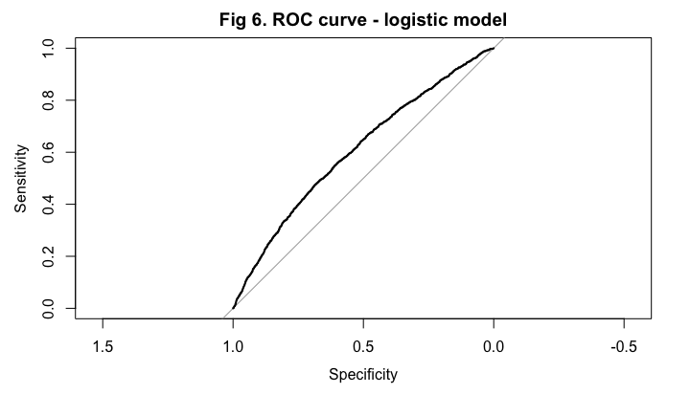
base_rate <- mean(te$TARGET_B)
te %>% mutate(p=pB, decile=ntile(desc(p),10)) %>% group_by(decile) %>%
summarise(donors=n(), responders=sum(TARGET_B), rate=round(mean(TARGET_B),4)) %>%
mutate(lift=round(rate/base_rate,2))
## # A tibble: 10 × 5
## decile donors responders rate lift
## <int> <int> <dbl> <dbl> <dbl>
## 1 1 2863 256 0.0894 1.77
## 2 2 2863 223 0.0779 1.54
## 3 3 2863 167 0.0583 1.16
## 4 4 2863 148 0.0517 1.02
## 5 5 2862 134 0.0468 0.93
## 6 6 2862 120 0.0419 0.83
## 7 7 2862 108 0.0377 0.75
## 8 8 2862 110 0.0384 0.76
## 9 9 2862 99 0.0346 0.69
## 10 10 2862 79 0.0276 0.55
std <- train %>% mutate(across(c(RFA_2F,RFA_2A_ord,NGIFTALL,CARDGIFT,LASTGIFT,AVGGIFT,
MAXRAMNT,AGE,INCOME,NUMPROM,NUMPRM12,CARDPROM,HIT,PEP),
~as.numeric(scale(.))))
coef_model <- glm(TARGET_B ~ RFA_2F + RFA_2A_ord + PEP + NGIFTALL + CARDGIFT + LASTGIFT +
AVGGIFT + MAXRAMNT + AGE + INCOME + NUMPROM + NUMPRM12 + CARDPROM + HIT,
data=std, family=binomial)
tidy(coef_model) %>% arrange(desc(abs(estimate))) %>%
mutate(across(where(is.numeric), ~round(.,3)))
## # A tibble: 15 × 5
## term estimate std.error statistic p.value
## <chr> <dbl> <dbl> <dbl> <dbl>
## 1 (Intercept) -3.00 0.016 -191. 0
## 2 RFA_2F 0.181 0.019 9.77 0
## 3 RFA_2A_ord 0.156 0.02 7.66 0
## 4 NUMPROM 0.15 0.07 2.14 0.032
## 5 CARDPROM -0.128 0.06 -2.13 0.033
## 6 INCOME 0.121 0.015 7.89 0
## 7 CARDGIFT 0.116 0.039 2.96 0.003
## 8 PEP 0.113 0.021 5.48 0
## 9 NGIFTALL -0.093 0.04 -2.31 0.021
## 10 AVGGIFT 0.037 0.036 1.02 0.308
## 11 LASTGIFT -0.025 0.029 -0.869 0.385
## 12 HIT 0.017 0.013 1.33 0.184
## 13 MAXRAMNT -0.014 0.022 -0.622 0.534
## 14 NUMPRM12 0.014 0.022 0.614 0.539
## 15 AGE 0.005 0.016 0.32 0.749
final <- glm(formula(mD), data=train, family=binomial)
score$pred_prob <- predict(final, score, type="response")
score %>% select(CONTROLN, pred_prob) %>% arrange(desc(pred_prob)) %>%
write_csv("VAL_scored_predictions.csv")
The lift table shows the top predicted decile responds at roughly 2× the overall rate — the model ranks donors usefully even though its AUC is modest, and this ranking ability is precisely what makes the optimization worthwhile. The standardized-coefficient table (all predictors on the same scale) identifies the strongest drivers: recent giving frequency (RFA_2F) has the largest impact, followed by promotions received (NUMPROM) and the recent amount code (RFA_2A); income contributes modestly, and a few history variables carry small negative signs because they overlap with the stronger RFA measures. This matches the EDA: behavior dominates demographics.
Final model. We selected Model D (stepwise logistic) — the best AUC with fewer variables, i.e. performance plus parsimony — and refit it on all of LRN to score VAL (saved as VAL_scored_predictions.csv).

5. Optimization (Q3)

5.1 From model to deciles (the bridge)
train$p_full <- predict(final, train, type="response")
decile_tbl <- train %>%
mutate(decile = ntile(desc(p_full), 10)) %>%
group_by(decile) %>%
summarise(donors = n(),
resp_rate = round(mean(TARGET_B),4),
avg_gift = round(mean(TARGET_D[TARGET_B==1]),2), .groups="drop")
decile_tbl
## # A tibble: 10 × 4
## decile donors resp_rate avg_gift
## <int> <int> <dbl> <dbl>
## 1 1 9542 0.0936 7.55
## 2 2 9542 0.0737 10.9
## 3 3 9541 0.0626 14.2
## 4 4 9541 0.0523 15.6
## 5 5 9541 0.0464 17.7
## 6 6 9541 0.0492 19.5
## 7 7 9541 0.0375 21.6
## 8 8 9541 0.0353 21.2
## 9 9 9541 0.0303 21.9
## 10 10 9541 0.0267 26.7
write_csv(decile_tbl, "decile_table.csv")
The optimization is driven entirely by the model’s output. We scored every donor with the final model, ranked them, and split them into ten equal deciles (decile 1 = most likely to respond). The clean decline in response — from about 9.2% in decile 1 to about 2.6% in decile 10 — is itself proof the model ranks donors correctly (a useless model would show ~5% in every decile). The decile table’s response rate and average gift become the direct inputs to every net-donation calculation below.
Note the recurring pattern in dollars: the top deciles respond often but give small gifts (~$7–11), while the bottom deciles respond rarely but give large gifts (~$20–27). Multiplying response by gift, the expected revenue per donor ends up roughly flat across deciles — which is exactly why the budget constraint, not raw response rate, determines the optimal plan.

5.2 The optimization problem
COST <- 0.68
opt <- decile_tbl %>%
mutate(exp_rev_per_donor = round(resp_rate*avg_gift,3),
exp_net_per_donor = round(resp_rate*avg_gift - COST,3),
exp_revenue = round(donors*resp_rate*avg_gift,0),
exp_cost = round(donors*COST,0),
exp_net = round(donors*resp_rate*avg_gift - donors*COST,0))
opt %>% select(decile, donors, resp_rate, avg_gift,
exp_rev_per_donor, exp_net_per_donor, exp_net)
## # A tibble: 10 × 7
## decile donors resp_rate avg_gift exp_rev_per_donor exp_net_per_donor exp_net
## <int> <int> <dbl> <dbl> <dbl> <dbl> <dbl>
## 1 1 9542 0.0936 7.55 0.707 0.027 255
## 2 2 9542 0.0737 10.9 0.802 0.122 1163
## 3 3 9541 0.0626 14.2 0.891 0.211 2017
## 4 4 9541 0.0523 15.6 0.816 0.136 1296
## 5 5 9541 0.0464 17.7 0.822 0.142 1352
## 6 6 9541 0.0492 19.5 0.96 0.28 2675
## 7 7 9541 0.0375 21.6 0.809 0.129 1230
## 8 8 9541 0.0353 21.2 0.747 0.067 635
## 9 9 9541 0.0303 21.9 0.664 -0.016 -157
## 10 10 9541 0.0267 26.7 0.713 0.033 311
mailed <- c(2,3,5,6)
plan <- opt %>% filter(decile %in% mailed)
cat(sprintf("\nOptimal plan (budget $30,000): mail deciles %s\n", paste(mailed, collapse=", ")))
##
## Optimal plan (budget $30,000): mail deciles 2, 3, 5, 6
cat(sprintf(" Donors mailed : %s\n", format(sum(plan$donors), big.mark=",")))
## Donors mailed : 38,165
cat(sprintf(" Total cost : $%s\n", format(round(sum(plan$exp_cost)), big.mark=",")))
## Total cost : $25,953
cat(sprintf(" Expected net : $%s\n", format(round(sum(plan$exp_net)), big.mark=",")))
## Expected net : $7,207
cat(sprintf(" Exp responders: %s\n", format(round(sum(plan$donors*plan$resp_rate)), big.mark=",")))
## Exp responders: 2,213
cat(sprintf("\nFor reference, mailing ALL deciles: net $%s\n",
format(round(sum(opt$exp_net)), big.mark=",")))
##
## For reference, mailing ALL deciles: net $10,777
We formulated the problem as a linear binary optimization, solved in Excel Solver (Simplex LP); the workbook is submitted separately, and the economics are reproduced here for transparency.
- Objective: maximize expected net donation = Σ over deciles of (donors × response × gift − donors × cost). In the workbook this is a SUMPRODUCT of each decile’s 0/1 decision with its net donation, so a decision of 1 switches that decile’s profit into the total and a 0 switches it out — this multiplication is the exact link between the decision variables and the objective.
- Decision variables: for each decile, mail (1) or skip (0) — binary.
- Constraints: (1) total mailing cost ≤ $30,000; (2) donors mailed ≥ 20,000 (a minimum-reach goal); (3) expected responders ≥ 1,500 (a donor-growth goal); (4) whole-decile (binary) mailing.
- Cost assumption: $0.68 per piece — the documented cost for this PVA campaign, not an arbitrary figure.
Why these constraint values. The $0.68 cost is given by the dataset. The $30,000 budget is a reasonable assumption that makes the problem meaningful: mailing all ~95,000 donors would cost about $64,880, so a $30,000 cap forces a genuine choice (roughly half the list). The reach and responder minimums reflect real campaign goals — PVA wants to touch a minimum audience and generate a minimum number of new gifts, not merely cherry-pick the few cheapest deciles. Together these constraints create real tension, because the most profitable deciles are not always the highest-reach ones.

5.3 Result and sensitivity analysis
cat("Mailing-cost sensitivity (profitable deciles & total net, no budget cap):\n")
## Mailing-cost sensitivity (profitable deciles & total net, no budget cap):
for (c in c(0.50,0.68,0.80,1.00)) {
keep <- opt %>% filter(resp_rate*avg_gift > c)
net <- sum(keep$donors*(keep$resp_rate*keep$avg_gift - c))
cat(sprintf(" Cost $%.2f -> profitable deciles {%s}, net $%s\n",
c, paste(sort(keep$decile), collapse=","),
format(round(net), big.mark=",")))
}
## Cost $0.50 -> profitable deciles {1,2,3,4,5,6,7,8,9,10}, net $27,952
## Cost $0.68 -> profitable deciles {1,2,3,4,5,6,7,8,10}, net $10,935
## Cost $0.80 -> profitable deciles {2,3,4,5,6,7}, net $2,864
## Cost $1.00 -> profitable deciles {}, net $0
Result. Under the $30,000 budget, Solver selects deciles 2, 3, 5, and 6, producing an expected net donation of ~$7,056, reaching 38,165 donors at a cost of ~$25,952 and generating about 2,234 responders. Decile 1 is skipped despite having the highest response rate, because its donors give such small gifts that its net contribution is only ~$176; the lowest deciles are skipped because too few respond.
Why we show two versions. We first solved the problem without the binary constraint, which returned a fractional recommendation (e.g. “mail 62% of a decile”) — operationally impossible. Re-solving with the binary constraint forces whole-decile decisions. Presenting both demonstrates concretely why the binary constraint is necessary.
Sensitivity. Holding the plan logic fixed and varying the mailing cost shows the margins are thin: at $0.50 and $0.68 every decile is profitable; at $0.80 only deciles 2–7 remain worth mailing; at $1.00 the campaign becomes unprofitable altogether. The lesson is that the campaign is profitable but sensitive to mailing cost — a modest cost increase materially changes which deciles should be mailed.

6. Simulation (Q4)

6.1 Why simulate
The optimization’s ~$7,056 is computed from fixed inputs — it assumes next year’s response rates and gift sizes exactly match the historical values. In reality these vary. The simulation replaces that single point estimate with a distribution of possible outcomes, so we can report not only the expected net but also the realistic best case, worst case, and the probability of actually losing money. We used a Monte Carlo simulation of 10,000 trials.

6.2 Assumptions and their basis in the data
- Uncertain inputs: response rate and average gift for each mailed decile. Donor counts and the $0.68 cost are fixed and known.
- Distribution shape — triangular. For each input we specified three points: a worst case, a most-likely case (the model’s value), and a best case. We chose triangular over a uniform (flat) distribution because reality clusters around the expected value — a response near the historical average is far more likely than an extreme — and because the assignment itself frames the uncertainty as “worst, ok, best,” which is precisely a triangle (three points). Although the individual gift data is right-skewed and the response outcome is binary, the simulation operates on decile averages across thousands of donors; by the Central Limit Theorem those averages are approximately symmetric, so a triangular model is appropriate for the quantity we are actually simulating.
- Range — ±30%. We set the worst/best points at 30% below and above the most-likely value. This is grounded in the data: across past promotions, response varied roughly from 0.68× to 1.36× of its median — about a third below to a third above — so ±30% is a reasonable, slightly conservative band. The course guidance also notes that extremes are generally underestimated, so widening the band is the responsible direction. Gift amounts historically varied less (~±10%), but we applied the same ±30% to gifts as well to avoid understating risk.
- Correlation across deciles — the “shared shock.” This is the most important modeling decision. Because PVA sends one mailing in one year, a good or bad year affects all deciles together — nothing cancels out. We therefore draw one shared response-luck number and one shared gift-luck number per trial and apply them across all four mailed deciles. The alternative — giving each decile its own independent luck — would let good and bad deciles cancel, making the risk look artificially small.

6.3 Comparing three scenarios and choosing one
set.seed(42)
N <- 10000; SP <- 0.30; COST <- 0.68
mailed_tbl <- opt %>% filter(decile %in% c(2,3,5,6)) %>%
select(decile, donors, resp_rate, avg_gift)
# Triangular inverse-CDF draw (from the course slides)
tri <- function(U,a,c,b){
thr <- (c-a)/(b-a)
ifelse(U<=thr, a+sqrt(U*(b-a)*(c-a)), b-sqrt((1-U)*(b-a)*(b-c)))
}
run_sim <- function(shared, shape){
totals <- numeric(N)
for (t in 1:N){
if (shared){ Ur <- runif(1); Ug <- runif(1) }
nt <- 0
for (i in 1:nrow(mailed_tbl)){
d <- mailed_tbl$donors[i]; r <- mailed_tbl$resp_rate[i]; g <- mailed_tbl$avg_gift[i]
if (!shared){ Ur <- runif(1); Ug <- runif(1) }
if (shape=="triangular"){
resp <- tri(Ur, r*(1-SP), r, r*(1+SP)); gift <- tri(Ug, g*(1-SP), g, g*(1+SP))
} else {
resp <- r*(1-SP)+(2*SP*r)*Ur; gift <- g*(1-SP)+(2*SP*g)*Ug
}
nt <- nt + d*resp*gift - d*COST
}
totals[t] <- nt
}
totals
}
A <- run_sim(shared=FALSE, shape="uniform") # independent uniform
B <- run_sim(shared=TRUE, shape="uniform") # shared uniform
C <- run_sim(shared=TRUE, shape="triangular") # shared triangular (chosen)
summ <- function(x) c(mean=round(mean(x)), p05=round(quantile(x,.05)),
median=round(median(x)), p95=round(quantile(x,.95)),
p_loss=round(mean(x<0),3))
bind_rows(
tibble(Scenario="A: Independent uniform", !!!summ(A)),
tibble(Scenario="B: Shared uniform", !!!summ(B)),
tibble(Scenario="C: Shared triangular *", !!!summ(C))
)
## # A tibble: 3 × 6
## Scenario mean `p05.5%` median `p95.95%` p_loss
## <chr> <dbl> <dbl> <dbl> <dbl> <dbl>
## 1 A: Independent uniform 7243 544 7170 14321 0.036
## 2 B: Shared uniform 7199 -5087 6325 22034 0.208
## 3 C: Shared triangular * 7218 -1793 6908 17182 0.103
tibble(net=C) %>% ggplot(aes(net)) +
geom_histogram(bins=45, fill="steelblue", color="white") +
geom_vline(xintercept=0, color="red", linetype="dashed") +
labs(title="Fig 7. Distribution of net donation - Scenario C (10,000 trials)",
subtitle="Shared-shock triangular; dashed line = break-even",
x="Net donation ($)", y="Trials") + theme_minimal()
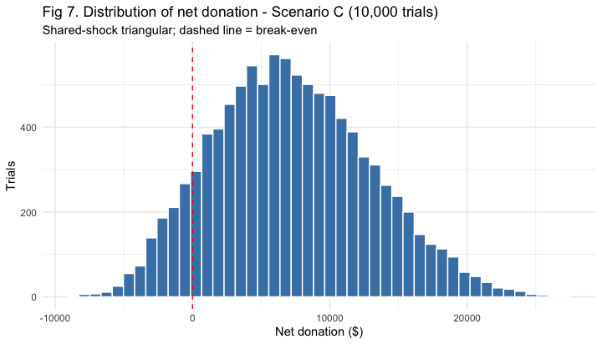
We tested three scenarios that all use ±30% ranges and all produce roughly the same average (~$7,000) but differ sharply on risk:
- A — Independent uniform: each decile draws its own luck from a flat distribution. Loss probability ~3%. This understates risk, because independent draws let good and bad deciles cancel out — unrealistic for a single campaign.
- B — Shared uniform: one shared shock, but a flat distribution. Loss probability ~20%. This overstates risk, because a flat shape treats a catastrophic year as just as likely as a normal one.
- C — Shared triangular (chosen): one shared shock with outcomes clustered around the most-likely value. Loss probability ~11%.
We chose Scenario C because it is realistic on both dimensions: the shared shock reflects a single campaign in which one good or bad year moves every decile together, and the triangular shape reflects that outcomes concentrate near the expected value with rare extremes.

6.4 Discovery and recommendation
Under the chosen model, the campaign’s net donation averages about $7,000 (confirming the optimization), ranging from roughly −$1,900 in a bad year (5th percentile) to about $17,000 in a good year (95th percentile), with approximately an 11% chance of a loss (Fig 7). The plan is therefore profitable on average but carries real downside — roughly a one-in-nine chance of a losing year — driven by the fact that a single bad year pulls all deciles down together.
Recommendation. Proceed with mailing deciles 2, 3, 5, and 6; the expected return is solid and the downside is manageable. If PVA is risk-averse, a tighter plan (deciles 2, 3, 6) reduces both the expected reward and the probability of a loss. The comparison also yields a general lesson worth stating: all three scenarios agreed on the expected value but disagreed on risk from 3% to 20%, which is exactly why the modeling choice — and being explicit about it — matters.

7. Decision Agent (Q5)
What it does. We built the “PVA Donor Mailing Advisor,” a web tool that turns the model and optimization into a decision a non-technical fundraiser can use directly. The analysis in this report is a one-time exercise; the agent operationalizes it so staff never need to open Solver.
Inputs. A mailing budget and cost per piece (as sliders), and, optionally, a single donor’s decile for a one-off lookup.
Logic. The agent encodes the decile economics (donors, response rate, and average gift per decile from the final model). For a budget, it ranks deciles by expected net per donor and mails whole deciles until the budget is exhausted — the same logic as Solver. For a single donor, it recommends MAIL when that decile’s expected revenue per donor exceeds the mailing cost, and DON’T MAIL otherwise.
Outputs. For a budget: which deciles to mail, donors reached, total cost, expected responders, and expected net donation. For a single donor: a clear MAIL / DON’T MAIL verdict with the supporting numbers and reasoning.
Testing. At a $30,000 budget and $0.68 cost, the agent returns deciles 2, 3, 5, 6 for an expected net of ~$7,056 — matching the Solver solution, which confirms the tool implements the optimization faithfully.
Working agent link: [paste your tested agent link here]
Agent prompt (summary). The agent is built on the per-decile economics above, with the decision rule: mail a decile only if its expected revenue per donor exceeds the mailing cost, prioritizing the highest expected net per donor within the available budget; then report the resulting plan and its expected net donation, or for a single donor return a mail / don’t-mail recommendation with the reasoning.

8. Challenges and Next Steps
Challenges encountered.
- Severe class imbalance (5% responders). This made accuracy meaningless and caused the decision tree to collapse to an AUC of 0.50; we adapted by evaluating with AUC and lift and by relying on logistic regression.
- RFA code direction. The RFA amount codes were initially read in the wrong order; we recoded them so D (highest dollar band) through G (lowest) map to a correct ordinal score.
- Whole-decile (binary) mailing. Forcing whole deciles leaves a small portion of the budget unspent, a necessary trade-off for a feasible, interpretable plan.
- Simulation risk method. Our initial simulation used independent draws, which understated risk at ~3%; recognizing that a single campaign experiences one shared good/bad year, we switched to a shared-shock triangular model (~11%), which is more realistic.
- Modest predictive power. AUC ~0.61 is realistic for this dataset but limits precision at the individual level; the model ranks well but should not be read as an exact probability for any single donor.
- Single-campaign data. With only one campaign’s history, our ±30% uncertainty band is a reasonable assumption rather than a precisely measured quantity.
Next steps.
- Model the gift amount (TARGET_D) directly in addition to response, to optimize expected net revenue rather than response alone.
- Test richer models (e.g. gradient boosting or class-weighted methods) and resampling to address the imbalance.
- Gather multi-campaign history to estimate the uncertainty ranges empirically instead of assuming ±30%.
- Extend the agent to pull a donor’s live attributes and compute their decile automatically, and to surface the simulation’s risk view alongside the optimization result.

