.PROJECT REPORT

ON

INDIAN WEATHER RAINFALL



SUBMITTED IN THE PRACTICAL FULFILLMENT OF THE
REQUIREMENTS FOR THE AWARD OF DEGREE FOR

BACHELOR’S OF COMPUTER APPLICATIONS(BCA)
SEMESTER 5TH for Session 2026-27

Submitted By:
Aditi (Roll No: 24049193)
Sanjna (Roll No: 24049269)

Submitted To:
DEPARTMENT OF COMPUTER APPLICATIONS
J.C.D.A.V COLLEGE, DASUYA

Affiliated to
PANJAB UNIVERSITY,
CHANDIGARH

DECLARATION

We do hereby declare that this project work entitled “INDIAN WEATHER RAINFALL” submitted by me for the partial fulfillment of the requirement for the award of “BCA” is a record of my own project work.

This Project report embodies the findings for software development based on subject “PYTHON & DATA SCIENCE” and has not been submitted earlier for the award of any degree to any Institute or University.

ADITI (24049193) SANJNA (24049269)

INTERNSHIP COMPLETION CERTIFICATE

(Industry/Organisation Letter pad)

INTERNSHIP COMPLETION CERTIFICATE

This is to certify that Ms. Aditi, bearing Roll Number 24049193, and Ms. Sanjna, bearing Roll Number 24049269, the students of Python & Data Science, Department of Computer Applications, has successfully completed the Internship for Enhancing Employability (IEE) aspart of the academic requirements.

The internship was undertaken at O7 Services from 01-06-2026 to 18-06-2026, with a total engagement of 120 hours.

During this period, the student was engaged in professional activities thatcontributed to enhancing workplace readiness, communication skills, problem-solving, and industry exposure.

Mr. Haritesh Chauhan
O7 Services
2nd Floor, Badwal Complex,
Near Bus Stand,
Jalandhar, Punjab 144001

 | Department of Computer Applications  Jagdish Chandra D.A.V. College  Dasuya (Distt. – Hoshiarpur) Punjab

REF.No. DATE:

TO WHOM IT MAY CONCERN

This is to certify that Project report entitled “Indian Weather Rainfall” submitted by “Aditi” and “Sanjna” in the partial fulfilment of the requirement for the award of the degree of “BCA 5th Semester” Of Panjab University, Chandigarh, is a Bonafide work carried out by them during the academic Session 2026-27.
The quality of project work fairly fulfills all necessary requirements related to above degree.

Dr. Mohit K. Sharma
Prof. Harjeet Kaur
Dr. Mohit K. Sharma

Project Guide H.O.D

ACKNOWLEDGEMENT

We hereby like to mention our inability of expressing words, the very heartfelt thanks to our respectful, honorable and outstanding “Dr. Mohit K. Sharma” (Head of Department of Computer Applications), J.C.D.A.V. College, Dasuya whom play an indispensable part in providing us their step by step as well as essential guidance for the development of the project (data structure) and also by generating a friendly and free environment to achieve our goals successfully.
Any sustained hereby like to mention our inability of expressing word, the very heartfelt thanks to our respectful, effort by untrained minds in a new work environment require for a successfully accumulation, a guidance hand that shows the ways.
Especially including a very special and heart by thanks to respectful Dr. Mohit K.Sharma and Prof. Harjeet Kaur for cherishing and providing us all those important and indispensable facilities are essential for the development of the proposed project through their advanced with all necessary hardware and software tools to meet the needs of project development environment.

PREFACE
The project report is towards the fulfillment of the project work for student’s desire of qualifying issued by Panjab University, Chandigarh, and the report has been prepared under the following sessions.
- Requirement Specification
- Data Dictionary
- User manual

The software has been development as per the requirement and specification laid by the management of existing system.
I take this opportunity to thanks all those people; guidance suggestions have been instrumental in undertaking and completion of the project. Firstly, I would like to express my sincere thanks to “Dr. Mohit K. Sharma” for giving the opportunity to undertake this project.
We are highly indebted to our project guide “Dr. Mohit K. Sharma” and “Prof. Harjeet Kaur”for sparing her time to provide necessary help and guidance for the successful completion of the project. I am also thankful for her continuous interacting and supply of information during the course of the project.

Table of Contents
PROJECT REPORT 1
ON 1
INDIAN WEATHER 1
RAINFALL 1
CHAPTER 1 1
INTRODUCTION 1
1.1 Problem Definition 1
1.2 Project Objectives 3
1.3 Project Scope 3
1.4 Minimum Requirements 4
1.5 Deliverables 5
1.6 Project Schedule 5
1.7 Relevance to Degree Programme 6
CHAPTER 2 7
PROJECT METHODOLOGY 7
2.1 Introduction 7
2.2 Software Development Life Cycle (SDLC) 7
2.3 DEVELOPMENT PROCESS....................................................................................................... 8
cHAPTER 3.........................................................................................................................................15
PROJECT ANALYSIS..........................................................................................................................15
3.1 SYSTEM OVERVIEW.................................................................................................................15
3.2 EXISTING SYSTEM...................................................................................................................15
3.3 PROPOSED SYSTEM................................................................................................................17
3.4 FEASIBILITY STUDY.................................................................................................................20
3.5 USER REQUIREMENTS............................................................................................................22
3.6 FUNCTIONAL REQUIREMENTS...............................................................................................23
3.7 NON-FUNCTIONAL REQUIREMENTS......................................................................................23
3.8 HARDWARE REQUIREMENTS.................................................................................................24
3.9 SOFTWARE REQUIREMENTS..................................................................................................25
3.10 INPUT DESIGN........................................................................................................................25
3.11 OUTPUT DESIGN....................................................................................................................25
3.12 SUMMARY..............................................................................................................................26
CHAPTER 4.........................................................................................................................................27
SYSTEM DESIGN................................................................................................................................27
4.1 SYSTEM OVERVIEW...............................................................................................................27.
4.2 SYSTEM ARCHITECTURE.......................................................................................................27
4.3 MODULE DESIGN....................................................................................................................29
4.4 DATA FLOW DIAGRAM (DFD)..................................................................................................32
4.5 FLOWCHART............................................................................................................................34
4.6 USE CASE DIAGRAM...............................................................................................................35
4.7 INPUT DESIGN.........................................................................................................................36
4.8 OUTPUT DESIGN.....................................................................................................................37
4.9 USER INTERFACE DESIGN....................................................................................................38
4.10 SUMMARY..............................................................................................................................39
CHAPTER 5.........................................................................................................................................40
PROJECT DEVELOPMENT................................................................................................................40
5.1 INTRODUCTION........................................................................................................................40
5.2 DEVELOPMENT ENVIRONMENT.............................................................................................40
5.3 TECHNOLOGIES USED............................................................................................................40
5.4 DATASET DESCRIPTION..........................................................................................................42
5.5 DASHBOARD MODULES..........................................................................................................43
5.6 DASHBOARD WORKFLOW.......................................................................................................52
5.7 TESTING AND VALIDATION......................................................................................................52
5.8 ADVANTAGES OF THE DEVELOPED SYSTEM.......................................................................53
5.9 CHALLENGES FACED DURING DEVELOPMENT...................................................................53
5.10 SUMMARY...............................................................................................................................53
CHAPTER 6.........................................................................................................................................54
TESTING AND RESULTS....................................................................................................................54
6.1 INTRODUCTION.......................................................................................................................54
6.2 TESTING OBJECTIVES............................................................................................................54
6.3 TYPES OF TESTING PERFORMED..........................................................................................54
6.4 TEST CASES.................................................................................................................55
6.5 RESULTS AND DISCUSSION....................................................................................................55
6.6.................................................................................................................................................... 56
CHAPTER 7..........................................................................................................................................57
IMPLEMENTATION & EVALUATION.................................................................................................57
7.1 INTRODUCTION........................................................................................................................57
7.2 SYSTEM IMPLEMENTATION....................................................................................................57
7.3 DASHBOARD MODULES..........................................................................................................57
7.4 SYSTEM EVALUATION.............................................................................................................58
7.5 ADVANTAGES OF THE IMPLEMENTED SYSTEM...................................................................58
7.6 LIMITATIONS.............................................................................................................................59
7.7 PROJECT OUTCOMES................................................................................................59
7.8 SUMMARY.................................................................................................................................59
CHAPTER 8.........................................................................................................................................60
CONCLUSION & FUTURE SCOPE.....................................................................................................60
8.1 CONCLUSION............................................................................................................................60
8.2 PROJECT ACHIEVEMENTS......................................................................................................60
8.3 FUTURE SCOPE........................................................................................................................61
8.4 FINAL REMARKS.......................................................................................................................61
CHAPTER 9..........................................................................................................................................62
APPENDIX............................................................................................................................................62
9.1 BOOKS.......................................................................................................................................62
9.2 WEB REFERENCES..................................................................................................................62

CHAPTER 1

INTRODUCTION

1.1 Problem Definition
Introduction to the Project

Weather and rainfall play a vital role in agriculture, water resource management, transportation, disaster management, and environmental planning. India experiences diverse climatic conditions due to its geographical location, resulting in significant variations in temperature, rainfall, humidity, and seasonal weather patterns across different states and districts. Accurate analysis of historical weather data is essential for understanding climate trends, predicting rainfall patterns, and supporting informed decision-making in various sectors.

With the rapid growth of digital technologies and the increasing availability of meteorological data, large volumes of weather information are generated every day from weather stations and monitoring systems. This data includes important parameters such as temperature, rainfall, wind speed, air pressure, and seasonal information. However, analyzing such a large amount of data using traditional methods is difficult and time-consuming. Most existing systems provide only static reports or basic charts, making it challenging for users to explore weather patterns, compare regions, and identify long-term climatic trends effectively.

The increasing occurrence of climate change, irregular rainfall, floods, droughts, and extreme weather events has highlighted the need for efficient weather analysis systems. Government agencies, researchers, students, and environmental organizations require interactive tools that can process historical weather data, visualize trends, and provide meaningful insights for planning and decision-making. A user-friendly dashboard capable of presenting weather information through graphical visualizations and statistical summaries can greatly improve the understanding of climatic conditions across different regions of India.

The Indian Weather Rainfall Prediction Dashboard has been developed to address these challenges. It is an interactive data analysis and visualization system that provides centralized access to historical weather and rainfall information collected from different states and districts of India. The dashboard processes the weather dataset and presents important information through Key Performance Indicators (KPIs), interactive charts, statistical summaries, and filtering options. Users can analyze rainfall trends, temperature variations, seasonal weather patterns, and state-wise comparisons using an intuitive graphical interface.

Unlike conventional weather reporting systems, the proposed dashboard enables users to interact with the dataset using filters such as Date Range, State/UT, District, Weather Station, and Season. It provides multiple visualization modules, including rainfall trend analysis, temperature analysis, rainfall distribution, seasonal rainfall comparison, state and district rainfall analysis, and extreme rainfall event identification. The system supports data-driven analysis, improves the understanding of historical weather conditions, and provides a strong foundation for future enhancements such as machine learning-based rainfall prediction and real-time weather forecasting.

Existing Problems
Several challenges exist in conventional data center monitoring systems:
• Traditional weather reports are static and difficult to analyze.
• Historical weather data is scattered across multiple sources.
• Lack of interactive visualization for weather analysis.
• Difficulty in comparing weather conditions across different states and districts.
• Manual analysis of large weather datasets is time-consuming.
• Existing systems provide limited filtering and customization options.
• Identifying long-term rainfall and temperature trends is difficult.
• Limited support for analyzing seasonal weather patterns.
• Difficulty in detecting extreme rainfall events quickly.
• Most systems do not provide an integrated dashboard for comprehensive weather analysis.

Proposed Solution

The proposed system, Indian Weather & Rainfall Intelligence Dashboard, provides a centralized and interactive platform for analyzing historical weather and rainfall data across different states and districts of India. The dashboard enables users to monitor weather conditions, explore rainfall patterns, compare regional climate variations, and gain meaningful insights through interactive visualizations and statistical analysis.
The system performs the following functions:
- Displays important weather Key Performance Indicators (KPIs).
- Analyzes historical rainfall and temperature data.
- Visualizes monthly and yearly rainfall trends.
- Compares rainfall across different States and Districts.
- Displays season-wise rainfall analysis.
- Identifies extreme rainfall events.
- Provides interactive filters for Date Range, State/UT, District, Station, and Season.
- Presents interactive charts, graphs, and statistical summaries.
- Enables users to download filtered weather data.
- Provides an intuitive, responsive, and user-friendly dashboard for weather analysis and decision-making.

Need for the Project

The increasing occurrence of climate change, irregular rainfall patterns, floods, droughts, and extreme weather events has created a need for efficient weather monitoring and analysis systems. Researchers, students, government agencies, and environmental organizations require a platform that can effectively process and visualize large volumes of historical weather data. Traditional methods of analyzing weather information are often time-consuming and lack interactive features for detailed exploration.

The Indian Weather & Rainfall Intelligence Dashboard addresses this need by providing a centralized, interactive, and user-friendly platform for analyzing weather and rainfall data. The dashboard enables users to visualize rainfall trends, compare weather conditions across different states and districts, study seasonal variations, and identify extreme weather events through dynamic charts, KPI cards, and interactive filters. This system supports data-driven analysis, improves understanding of historical weather patterns, and provides a strong foundation for future rainfall prediction and weather forecasting applications.
The project is necessary because:
• Weather data is generated in large volumes and requires efficient analysis.
• Traditional weather reports are difficult to interpret and compare.
• Historical rainfall trends are important for climate and environmental studies.
• Interactive dashboards provide better visualization of weather information.
• Data analytics helps identify rainfall and temperature patterns.
• Researchers and students require an easy-to-use weather analysis platform.
• Government agencies need accurate weather information for planning and disaster management.
• Better weather monitoring supports informed decision-making in agriculture, water resource management, and climate research.
• Interactive filters enable customized analysis based on State, District, Season, and Date Range.
• Graphical visualizations make weather data easier to understand and analyze.

1.2 Project Objectives

The primary objective of the Indian Weather & Rainfall Intelligence Dashboard is to develop an interactive dashboard that enables users to analyze, visualize, and monitor historical weather and rainfall data across different states and districts of India. The dashboard aims to provide meaningful insights into weather patterns, rainfall trends, and temperature variations through interactive visualizations and statistical analysis.

Specific Objectives

• Develop an interactive Indian Weather & Rainfall Intelligence Dashboard.
• Analyze historical weather and rainfall data across different regions of India.
• Display important weather statistics through Key Performance Indicators (KPIs).
• Monitor rainfall and temperature variations over different time periods.
• Compare weather conditions across different States and Districts.
• Analyze monthly and seasonal rainfall patterns.
• Identify extreme rainfall events and weather conditions.
• Provide interactive filters for Date Range, State/UT, District, Station, and Season.
• Generate interactive charts and graphical visualizations for weather analysis.
• Enable users to explore and download filtered weather data.
• Present historical weather information through an intuitive and user-friendly dashboard.
• Support academic research and data-driven decision-making through effective weather data visualization and analysis.

1.3 Project Scope
The scope of the project covers the analysis and visualization of operational and sustainability metrics for data centers using Python and Streamlit.
The system includes the following functionalities:
• Dashboard-based weather monitoring.
• Key Performance Indicator (KPI) visualization.
• Interactive filtering using Date Range, State/UT, District, Station, and Season.
• Rainfall trend analysis.
• Temperature analysis.
• Monthly rainfall analysis.
• Seasonal rainfall analysis.
• Rainfall distribution analysis.
• State-wise rainfall comparison.
• District-wise rainfall comparison.
• Extreme rainfall event analysis.
• Dataset viewer with weather records.
• Interactive charts and graphs.
• Download filtered dataset.
• Weather statistics and summary reports.
• Dynamic dashboard updates based on selected filters.

Out of Scope
• Real-time weather data integration.
• Live weather forecasting.
• Machine learning-based rainfall prediction.
• User authentication and role-based access.
• Automatic weather alerts and notifications.
• Mobile application support.
• Cloud deployment and online data synchronization.
• Integration with IoT weather sensors.
• Satellite imagery and radar visualization.
• Automatic data updates from weather APIs.

1.4 Minimum Requirements

Hardware Requirements
- Intel Core i3 Processor or higher
- 8 GB RAM
- 20 GB Free Disk Space
- Internet Connectivity
- Display Resolution: 1366 × 768 or above
Recommended Hardware
- Intel Core i5/i7 Processor
- 16 GB RAM
- SSD Storage
- Full HD Display
Software Requirements
- Windows 10 / Windows 11
- Python 3.11 or above
- Visual Studio Code
- Streamlit
- Pandas
- NumPy
- Matplotlib
- Plotly
- Jupyter Notebook
- Git (optional)

1.5 Deliverables
The project delivers the following components:
• Complete Streamlit Dashboard.
• Historical Weather & Rainfall CSV Dataset.
• Cleaned and preprocessed dataset.
• Python Source Code.
• Interactive data visualizations and charts.
• Weather analysis and statistical reports.
• Key Performance Indicator (KPI) Dashboard.
• Technical Documentation.
• User Guide.
• Final Project Report.
• Presentation Slides (PPT).

1.6 Project Schedule
The project was completed during a six-week industrial training program. The first two weeks were dedicated to learning Python programming, data analysis, and the libraries required for dashboard development, including Streamlit, Pandas, NumPy, Matplotlib, Seaborn, and Plotly. During this period, the historical weather and rainfall dataset was studied, cleaned, and prepared for analysis.
The remaining four weeks focused on the design, development, testing, and documentation of the Indian Weather & Rainfall Intelligence Dashboard. Various modules such as the Dashboard Home, KPI Dashboard, Rainfall Analysis, Seasonal Analysis, Rainfall Distribution, State & District Rainfall Analysis, and Extreme Rainfall Events were developed and integrated into a single interactive dashboard. Finally, the application was thoroughly tested to ensure accurate data analysis, proper visualization, smooth functionality, and a user-friendly interface before preparing the final project documentation and presentation.

Week | Activity | Outcome/Milestone
Week 1 | Introduction to Python Programming, Basic Syntax, Variables, Data Types, Loops, Functions, and Object-Oriented Programming | Built a strong foundation in Python programming
Week 2 | Learning Python Libraries (Pandas, NumPy, Plotly, Streamlit), Data Handling, Data Visualization, and Exploratory Data Analysis (EDA) | Gained practical knowledge of data analytics and dashboard development
Week 3 | Requirement Analysis, Dataset Collection, Data Cleaning, and Dashboard Design | Project requirements finalized and dashboard layout designed
Week 4 | Dashboard Development, Implementation of KPIs, Filters, Charts, and Sustainability Metrics | Core functionalities of the dashboard developed successfully
Week 5 | Integration of Analytical Features, Testing, Debugging, and Performance Optimization | Dashboard tested, optimized, and analytical modules completed
Week 6 | Documentation, Report Preparation, Final Review, Presentation, and Project Submission | Project completed with final documentation and successful submission
Top of Form
Bottom of Form

1.7 Relevance to Degree Programme
This project is highly relevant to the Bachelor of Computer Applications (BCA) curriculum as it integrates concepts from programming, data analytics, visualization, software development, and project management into a practical application.
The project provides hands-on experience in:
- Python Programming
- Data Analytics
- Data Visualization
- Dashboard Development
- Software Engineering
- Database Handling
- User Interface Design
- Data Preprocessing
- Statistical Analysis
- Problem Solving
- Project Documentation
- Testing and Validation
It also enhances students' analytical thinking, programming proficiency, and ability to develop real-world software solutions using modern technologies.

CHAPTER 2

PROJECT METHODOLOGY

2.1 Introduction
A methodology is a systematic approach followed to plan, develop, implement, test, and maintain a software project. It provides a structured framework that guides developers through each phase of the Software Development Life Cycle (SDLC), ensuring that the final product meets the project objectives within the available time and resources.
Selecting an appropriate software development methodology is essential for the successful completion of any software project. It helps in organizing development activities, managing project resources efficiently, reducing development risks, improving communication, and ensuring the delivery of a reliable and high-quality application.
The Indian Weather & Rainfall Intelligence Dashboard was developed using the Agile Software Development Methodology. Agile supports iterative development, continuous testing, regular feedback, and flexibility in implementing changes throughout the development process. Since dashboard development requires continuous improvements in user interface design, interactive visualizations, and analytical features, Agile proved to be the most suitable methodology for this project.
The project development was carried out through several phases, including requirement analysis, weather dataset collection, data preprocessing, dashboard design, implementation, testing, and documentation. The historical weather and rainfall dataset was cleaned and processed using Pandas and NumPy, while Streamlit was used to develop the interactive dashboard. Matplotlib, Seaborn, and Plotly were used to generate charts and visualizations for rainfall and temperature analysis. Each phase was completed systematically to ensure the development of an efficient, interactive, and user-friendly dashboard for analyzing historical weather and rainfall data across different states and districts of India.

2.2 Software Development Life Cycle (SDLC)
The Software Development Life Cycle (SDLC) is a structured process used to develop high-quality software systems. It consists of several phases that guide developers from project planning to software deployment and maintenance. Following the SDLC helps in reducing project risks, improving software quality, and ensuring that user requirements are fulfilled.
The major phases of the SDLC are:
1. Requirement Analysis

In this phase, the project objectives and user requirements were identified. The requirements for analyzing historical weather and rainfall data, monitoring rainfall and temperature trends, displaying Key Performance Indicators (KPIs), generating interactive visualizations, and providing filters based on Date Range, State/UT, District, Station, and Season were collected and analyzed. These requirements formed the foundation for developing the Indian Weather & Rainfall Intelligence Dashboard.

2. Planning
Project planning involves selecting the technologies, tools, and development methodology. During this phase, Python, Streamlit, Pandas, NumPy, and Plotly were selected as the primary technologies for implementing the dashboard.

3. System Design

In this phase, the layout and structure of the Indian Weather & Rainfall Intelligence Dashboard were designed. The dashboard interface, navigation menu, sidebar filters, KPI cards, interactive charts, tables, and visualization components were planned to provide a simple and user-friendly experience. The overall system architecture was designed to ensure efficient data processing, smooth interaction with the weather dataset, and easy analysis of rainfall and weather patterns.

4. Development
This phase involved coding the application using Python and Streamlit. Various dashboard modules such as KPIs, trend analysis, sustainability scoring, charts, filters, and facility explorer were implemented.

5. Testing
The developed dashboard was tested to verify that all modules were functioning correctly. Functional testing, user interface testing, and performance testing were performed to identify and eliminate errors.

6. Deployment
After successful testing, the application became ready for demonstration and submission. The dashboard could be executed locally using Streamlit and presented as the final project.

7. Maintenance
Although the current Indian Weather & Rainfall Intelligence Dashboard uses a historical weather dataset, future enhancements can include real-time weather data integration, machine learning-based rainfall prediction, weather API integration, and cloud deployment. Additional features such as automatic dataset updates, weather alerts, and advanced forecasting models can further improve the system. Regular maintenance ensures that the dashboard remains accurate, efficient, secure, and compatible with updated datasets and software technologies, providing reliable weather analysis and visualization for users.

2.3 Comparison of Software Development Methodologies

Several software development methodologies are available, each having its own advantages and limitations. Different methodologies are suitable for different types of software projects depending on their requirements, complexity, and development process. The most commonly used software development methodologies include Waterfall, Spiral, Prototype, and Agile. Among these, the Agile methodology was selected for the Indian Weather & Rainfall Intelligence Dashboard because it provides flexibility, supports continuous improvements, and allows easy implementation of changes during the development process.
Waterfall Model
The Waterfall Model is a sequential software development methodology in which each phase is completed before the next phase begins. It is simple to understand and suitable for projects with fixed and well-defined requirements.
Advantages
- Simple and easy to understand.
- Well-defined phases.
- Easy project management.
- Suitable for small projects.
- Proper documentation.
Disadvantages
- Difficult to accommodate changes.
- No working software until the final stages.
- High risk if requirements change.
- Less customer involvement.

Agile Model
The Agile Model is an iterative software development methodology where software is developed in small increments. Each iteration includes planning, development, testing, and review, allowing continuous improvements based on user feedback.
Advantages
- Flexible and adaptable.
- Faster development cycles.
- Continuous testing.
- Improved software quality.
- Frequent user feedback.
- Easy implementation of changes.
- Better risk management.
Disadvantages
- Requires continuous user involvement.
- Documentation may be less comprehensive.
- Difficult to estimate project timelines accurately.

Rapid Application Development (RAD)
The RAD model emphasizes rapid development using reusable components and prototype-based design.
Advantages
- Faster software development.
- High user involvement.
- Easy prototyping.
- Reduced development time.
Disadvantages
- Suitable only for modular projects.
- Requires experienced developers.
- Higher dependency on user feedback.

Spiral Model
The Spiral Model combines iterative development with risk analysis. It is mainly used for large and high-risk projects.
Advantages
- Effective risk management.
- Flexible development.
- Suitable for complex systems.
- Continuous customer feedback.
Disadvantages
- Expensive.
- Complex to manage.
- Requires skilled professionals.

Prototype Model
The Prototype Model involves developing an initial version of the software to gather user feedback before building the final system.
Advantages
- Better understanding of user requirements.
- Improved user satisfaction.
- Early error detection.
- Easy modifications.
Disadvantages
- Frequent changes increase development time.
- Higher development cost.
- Scope may expand unnecessarily.

2.4 Comparison of Methodologies

Methodology | Flexibility | Cost | Risk | User Involvement | Suitable for this Project
Waterfall | Low | Low | Medium | Low | No
Agile | High | Medium | Low | High | Yes
RAD | High | Medium | Medium | High | Partially
Spiral | High | High | Very Low | High | No
Prototype | Medium | Medium | Medium | High | Partially

2.5 Selected Methodology – Agile

After comparing different software development methodologies, the Agile Software Development Methodology was selected for the development of the Indian Weather & Rainfall Intelligence Dashboard.
Agile was chosen because dashboard development requires frequent modifications, continuous testing, and incremental improvements. During the project, various dashboard features, interactive charts, KPI cards, filters, and analytical modules were refined based on testing and feedback. Agile allowed these improvements to be implemented efficiently without affecting the overall system, resulting in a flexible, user-friendly, and high-quality weather analysis dashboard.
Reasons for Selecting Agile
- Flexible development process.
- Easy incorporation of new features.
- Continuous testing and debugging.
- Better project management.
- Faster implementation.
- Frequent improvements in dashboard design.
- Reduced development risks.
- Better user experience.
- Easy maintenance and scalability.
- Suitable for data analytics and visualization projects.

2.6 Development Process
The project development followed the Agile lifecycle consisting of the following phases:
- Python Learning and Technology Training
- Requirement Analysis
- Dataset Collection
- Data Cleaning and Preprocessing
- Exploratory Data Analysis (EDA)
- Dashboard Design
- Dashboard Development
- Data Visualization
- Testing and Debugging
- Documentation
- Final Deployment
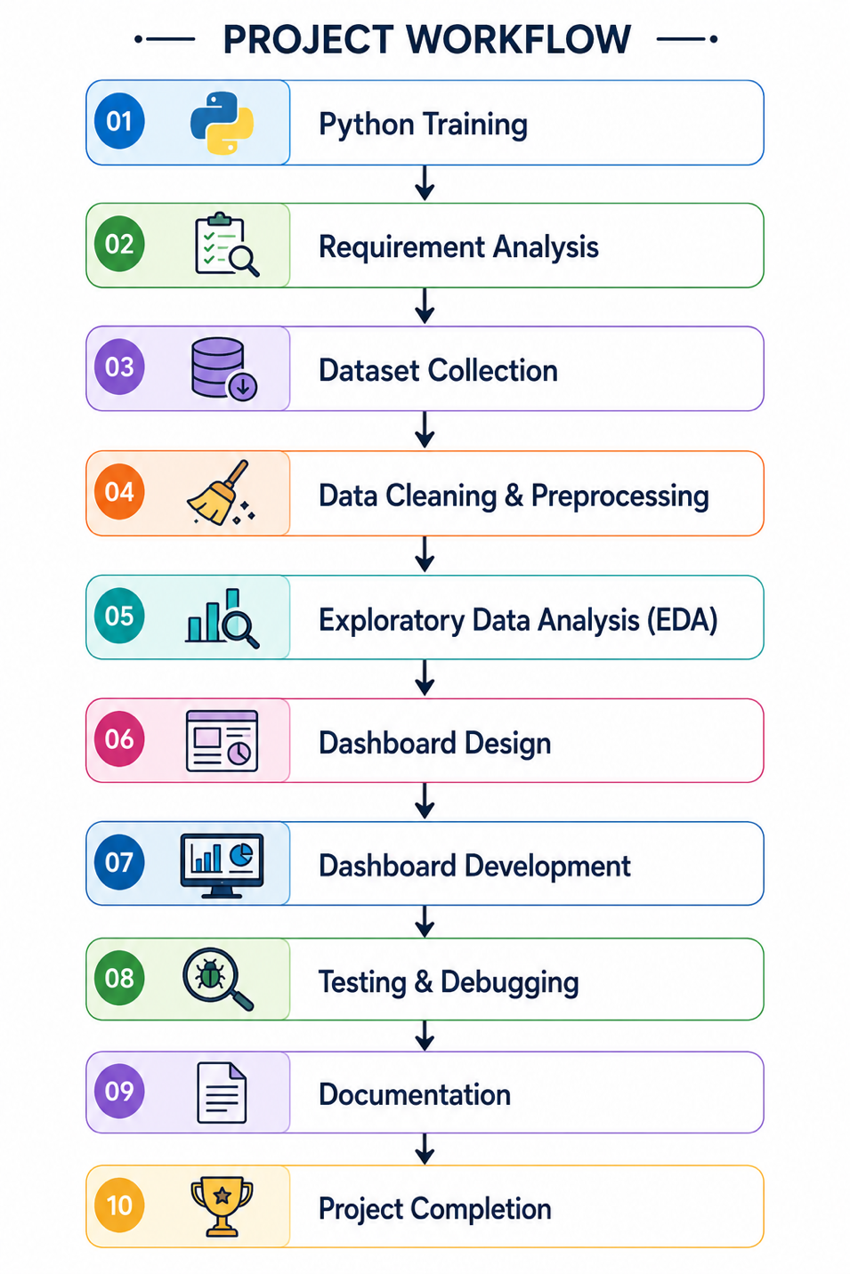

2.7 Summary
The Agile Software Development Methodology provided a flexible and efficient framework for developing the Indian Weather & Rainfall Intelligence Dashboard. By following the Software Development Life Cycle (SDLC) phases systematically, the project was completed successfully within the six-week training period. The methodology supported continuous improvements, effective testing, and the successful implementation of an interactive dashboard capable of analyzing and visualizing historical weather and rainfall data. The completed system provides users with an easy-to-use platform for exploring weather patterns, rainfall trends, temperature variations, and regional comparisons through interactive charts, filters, and Key Performance Indicators (KPIs).

CHAPTER 3

PROJECT ANALYSIS

3.1 System Overview
Weather and rainfall play a vital role in agriculture, water resource management, disaster management, transportation, and environmental planning. India experiences diverse climatic conditions due to its vast geographical area, resulting in significant variations in rainfall, temperature, humidity, and seasonal weather patterns across different states and districts. Understanding these weather patterns is essential for effective planning, research, and decision-making.
Large volumes of weather data are generated every day from weather stations and meteorological departments. This data includes information such as rainfall, temperature, wind speed, air pressure, seasons, and geographical locations. However, analyzing such large datasets using traditional methods is often time-consuming and difficult. Static reports and spreadsheets do not provide users with an efficient way to explore trends, compare regions, or identify weather patterns.
The Indian Weather & Rainfall Intelligence Dashboard was developed to overcome these limitations by providing an interactive data analysis and visualization platform. The system integrates historical weather and rainfall data into a centralized dashboard that enables users to explore important weather parameters through interactive charts, tables, and Key Performance Indicators (KPIs). It allows users to analyze rainfall trends, temperature variations, seasonal rainfall patterns, state-wise and district-wise comparisons, and extreme rainfall events.
The dashboard provides interactive filtering options based on Date Range, State/UT, District, Station, and Season, enabling customized weather analysis. Built using Python, Streamlit, Pandas, NumPy, Matplotlib, Seaborn, and Plotly, the system transforms raw weather data into meaningful insights through dynamic visualizations and statistical analysis. The proposed dashboard offers a simple, efficient, and user-friendly platform for studying historical weather conditions and supports academic research, climate analysis, and data-driven decision-making.

3.2 Existing System
The existing systems for weather and rainfall analysis primarily rely on static reports, spreadsheets, or basic weather applications that provide limited analytical capabilities. Although these systems display weather information such as temperature, rainfall, humidity, and wind speed, they often lack interactive features for detailed exploration and comparison of historical weather data. Users find it difficult to analyze long-term weather trends, seasonal variations, and regional climate patterns using conventional methods.
Weather data is usually collected from multiple sources and stored in large datasets. Analyzing this data manually is time-consuming and increases the possibility of errors. Most traditional systems provide only tabular reports or simple charts, making it difficult to identify rainfall trends, compare weather conditions across different states and districts, or study extreme weather events. Furthermore, these systems offer limited filtering options and do not provide a centralized platform for comprehensive weather analysis.
The Indian Weather & Rainfall Intelligence Dashboard was developed to overcome these limitations by providing an interactive platform that integrates weather data processing, statistical analysis, and visualization into a single dashboard. The system enables users to analyze rainfall trends, temperature variations, seasonal patterns, state-wise and district-wise comparisons, and extreme rainfall events through dynamic charts, KPI cards, and interactive filters, making weather analysis more efficient and user-friendly.
Limitations of the Existing System

The existing weather analysis approaches suffer from several limitations, including:
- Lack of a centralized platform for weather data analysis.
- Dependence on static reports and spreadsheets.
- Manual analysis of large weather datasets.
- Limited graphical visualization of weather information.
- Difficulty in comparing weather conditions across different states and districts.
- Limited support for analyzing seasonal and monthly rainfall trends.
- No interactive filtering for customized weather analysis.
- Time-consuming data interpretation and report generation.
- Increased chances of human errors during manual analysis.
- Difficulty in identifying extreme rainfall events.
- Limited support for historical weather trend analysis.
- Poor visualization of rainfall and temperature patterns.
- Limited scalability for handling large datasets.
- No integrated dashboard for comprehensive weather analysis.
- Limited support for research and data-driven decision-making.

Need for an Improved System
To overcome the limitations of traditional weather analysis methods, there is a need for an intelligent and centralized dashboard that integrates weather data processing, visualization, and analysis into a single platform. Such a system should provide interactive charts, Key Performance Indicators (KPIs), rainfall and temperature trend analysis, state-wise and district-wise comparisons, seasonal analysis, and customizable filtering options to help users explore historical weather data efficiently. It should also present meaningful insights through graphical visualizations, making weather information easier to understand and interpret.
The proposed Indian Weather & Rainfall Intelligence Dashboard addresses these requirements by providing an interactive platform for analyzing historical weather and rainfall data across India. The dashboard simplifies complex weather information using dynamic charts, statistical summaries, and interactive filters based on Date Range, State/UT, District, Station, and Season. It enables users to identify weather patterns, compare regions, analyze rainfall trends, and study extreme weather events, supporting academic research, climate studies, and data-driven decision-making.

3.3 Proposed System
The Indian Weather & Rainfall Intelligence Dashboard is a centralized and interactive platform designed to analyze, monitor, and visualize historical weather and rainfall data across different states and districts of India. Unlike traditional weather reporting systems that provide static reports and limited analysis, the proposed system integrates multiple weather parameters into a single dashboard, enabling users to gain comprehensive insights into weather patterns and rainfall trends.
The dashboard is developed using Python and the Streamlit framework, while Pandas and NumPy are used for data loading, preprocessing, and analysis. Interactive visualizations are created using Matplotlib, Seaborn, and Plotly, allowing users to explore weather data through dynamic charts, graphs, tables, and Key Performance Indicators (KPIs). The system processes the historical weather dataset and presents meaningful information in a simple and user-friendly interface.
The proposed system enables users to analyze important weather parameters such as rainfall, average temperature, minimum temperature, maximum temperature, wind speed, air pressure, and seasonal variations. It also provides interactive filtering options that allow users to customize the analysis based on Date Range, State/UT, District, Station, and Season, making it easier to explore weather conditions for specific regions and time periods.
One of the key strengths of the proposed system is its ability to transform raw weather data into meaningful insights through interactive visualizations. The dashboard helps users identify rainfall trends, compare weather conditions across different states and districts, analyze seasonal weather patterns, and detect extreme rainfall events. These features support better understanding of historical climate data and enable data-driven analysis.
By integrating multiple analytical modules into a single dashboard, the proposed system reduces manual effort, improves accessibility to weather information, and enhances the overall data analysis experience. It serves as an effective tool for students, researchers, and environmental analysts by providing an interactive platform for exploring historical weather and rainfall data across India.

1. Interactive Dashboard
The system provides a centralized dashboard that displays important weather and rainfall information through interactive charts, tables, and graphical reports. Users can easily monitor historical weather patterns and rainfall statistics.

2. Key Performance Indicators (KPIs)
The dashboard displays essential weather indicators, including:
- Total Records
- Average Rainfall
- Average Temperature
- Maximum Rainfall
- Maximum Temperature
These KPIs provide users with a quick overview of the weather dataset.

3. Interactive Filtering
Users can customize the dashboard using filters based on:
- Date Range
- State/UT
- District
- Station
- Season
The charts and KPIs update dynamically according to the selected filters.

4. Rainfall Trend Analysis
The dashboard analyzes rainfall trends over time, allowing users to observe monthly and yearly rainfall variations and identify rainfall patterns.

5. Temperature Analysis
The system analyzes average, minimum, and maximum temperatures, helping users understand temperature variations across different regions and seasons.

6. State & District Comparison
The dashboard compares rainfall across different states and districts, enabling users to identify regions with the highest or lowest rainfall.

7. Seasonal & Rainfall Distribution Analysis
The system provides seasonal rainfall analysis and rainfall distribution charts to help users understand seasonal weather patterns and rainfall variability.

8. Extreme Rainfall Events
The dashboard displays the highest recorded rainfall events along with related weather information such as date, state, district, station, temperature, and wind speed, helping users analyze extreme weather conditions.

Advantages of the Proposed System

The proposed Indian Weather & Rainfall Intelligence Dashboard offers several advantages over traditional weather analysis methods:
- Provides a centralized platform for weather and rainfall analysis.
- Reduces manual data analysis and report generation.
- Presents weather information through interactive dashboards and visualizations.
- Supports faster and more accurate data-driven decision-making.
- Enables comparison of weather conditions across different states and districts.
- Analyzes rainfall and temperature trends efficiently.
- Provides interactive filters for customized weather analysis.
- Helps identify seasonal patterns and extreme rainfall events.
- Improves understanding of historical weather data.
- Easy to use with a simple and intuitive graphical interface.
- Scalable and can be enhanced with real-time weather data and prediction models.
- Supports academic research, climate studies, and environmental analysis.

Comparison Between Existing System and Proposed System

Existing System | Proposed System
Uses static reports and spreadsheets for weather analysis. | Provides an interactive Streamlit dashboard for weather analysis.
Limited data visualization. | Interactive charts, graphs, and KPI cards for better visualization.
Manual analysis of weather data. | Automated data processing and analysis using Python.
Difficult to compare weather across different regions. | Enables state-wise and district-wise weather comparison.
Limited filtering options. | Provides interactive filters for Date Range, State/UT, District, Station, and Season.
Time-consuming report generation. | Generates instant insights through dynamic dashboards.
Difficult to identify rainfall trends. | Displays monthly, seasonal, and yearly rainfall trends.
No centralized weather analysis platform. | Centralized dashboard for complete weather and rainfall analysis.
Limited support for identifying extreme weather events. | Displays Top Extreme Rainfall Events and weather statistics.
Static and less user-friendly interface. | Responsive, interactive, and easy-to-use graphical interface.

3.4 Feasibility Study
A feasibility study determines whether the proposed system can be developed successfully using the available resources. It also evaluates the practicality of implementing the system from different perspectives.
The feasibility analysis for this project includes the following aspects:
- Technical Feasibility
- Economic Feasibility
- Operational Feasibility
- Political Feasibility
3.4.1 Technical Feasibility

Technical feasibility evaluates whether the required technology, hardware, software, and technical expertise are available for developing the proposed system.
The Indian Weather & Rainfall Intelligence Dashboard was developed using Python, Streamlit, Pandas, NumPy, Matplotlib, Seaborn, and Plotly, all of which are open-source technologies. These tools provide excellent support for data processing, statistical analysis, visualization, and interactive dashboard development.
The development environment required only a standard personal computer with Python and the required libraries installed, making the project technically feasible. The selected technologies are reliable, easy to use, and suitable for building an efficient weather and rainfall analysis dashboard.
Technical Feasibility Points

• Python provides powerful programming capabilities.
• Streamlit enables rapid dashboard development.
• Pandas simplifies data loading and manipulation.
• NumPy supports numerical computations and data processing.
• Matplotlib creates statistical charts and graphs.
• Seaborn generates advanced data visualizations.
• Plotly creates interactive charts and dashboards.
• Visual Studio Code provides an efficient development environment.
• No specialized hardware is required.
• The required technologies are open-source and freely available.
• Easy maintenance and future enhancements.

3.4.2 Economic Feasibility

Economic feasibility determines whether the project can be developed within the available financial resources.
The Indian Weather & Rainfall Intelligence Dashboard was developed with very low development costs because all major software tools and libraries used, including Python, Streamlit, Pandas, NumPy, Matplotlib, Seaborn, and Plotly, are open-source and freely available. The project does not require commercial software licenses or expensive hardware, making it a cost-effective solution for weather data analysis and visualization.

Economic Feasibility Points
- Open-source software reduces development costs.
- No licensing fees are required.
- Low hardware requirements for development and execution.
- Low maintenance cost due to open-source technologies.
- Cost-effective implementation using freely available tools.
- Reduces manual effort in weather data analysis and reporting.
- Supports efficient analysis through interactive visualizations.
- Easy to upgrade with future enhancements.
- Suitable for academic and research purposes without additional cost.
3.4.3 Operational Feasibility
Operational feasibility evaluates whether the proposed system can be effectively used by its intended users.
The Indian Weather & Rainfall Intelligence Dashboard provides an intuitive and user-friendly graphical interface with interactive filters, charts, tables, and Key Performance Indicators (KPIs). Users can easily analyze historical weather and rainfall data without requiring advanced programming or technical knowledge. The dashboard enables quick access to weather insights, making it suitable for students, researchers, and analysts for efficient weather data exploration and decision-making.
Operational Feasibility Points
- Easy-to-use graphical interface.
- Interactive dashboard with charts and KPIs.
- Minimal user training required.
- Quick access to weather insights.
- Interactive filters for customized analysis.
- Easy navigation across dashboard modules.
- Supports faster data-driven decision-making.
- Improves efficiency in weather data analysis.
- Reliable performance with large datasets.
- User-friendly interface for students and researchers.
- Accessible without advanced programming knowledge.
- Easy maintenance and future enhancements.

3.4.4 Political Feasibility

Political feasibility examines whether the project aligns with organizational policies, government objectives, and environmental initiatives.
The Indian Weather & Rainfall Intelligence Dashboard supports weather monitoring, climate analysis, and environmental awareness by providing accurate historical weather and rainfall analysis. The system assists researchers, educational institutions, and government organizations in understanding weather patterns and supports data-driven planning related to climate and environmental studies.

Political Feasibility Points
• Supports environmental monitoring.
• Aligns with climate and research objectives.
• Encourages data-driven decision-making.
• Supports weather and rainfall analysis.
• Promotes environmental awareness.
• Assists academic and research activities.
• Supports government planning and disaster management.
• Easy to adopt in educational and research organizations.
• Encourages efficient use of weather data.
• Supports future climate research and analysis.

3.5 User Requirements
The proposed dashboard is designed to meet the requirements of different categories of users.
Administrator Requirements
- Manage weather and rainfall dataset.
- Monitor dashboard KPIs.
- Generate analytical reports.
- Analyze rainfall trends.
- Analyze temperature variations.
- Compare state-wise and district-wise weather data.
- View seasonal weather analysis.
- Monitor extreme rainfall events.
- Manage dashboard filters.
- Ensure data accuracy and system maintenance.

Management Requirements

• View overall weather and rainfall analysis.
• Compare weather across different states and districts.
• Monitor rainfall and temperature trends.
• Analyze seasonal weather patterns.
• Identify extreme rainfall events.
• Support data-driven planning and decision-making.
• Review dashboard reports and visualizations.
• Improve weather data analysis and monitoring.

Analyst Requirements
• Perform weather data exploration.
• Analyze rainfall trends.
• Study temperature variations.
• Compare state-wise and district-wise weather.
• Analyze seasonal weather patterns.
• Identify extreme rainfall events.
• Generate interactive visual reports.
• Export analytical reports.
• Monitor weather KPIs.
• Support research and data analysis.

3.6 Functional Requirements
Functional requirements describe the operations that the system must perform.
The system should:
- Load the weather dataset.
- Process and preprocess weather data.
- Display Key Performance Indicators (KPIs).
- Filter data using Date Range, State/UT, District, Station, and Season.
- Generate interactive charts and graphs.
- Analyze rainfall trends.
- Analyze temperature variations.
- Compare state-wise and district-wise weather data.
- Display seasonal rainfall analysis.
- Identify extreme rainfall events.
- Display statistical summaries.
- Generate analytical reports.
- Allow users to download the filtered dataset.

3.7 Non-Functional Requirements
Non-functional requirements specify the quality attributes of the system.
Performance

• Fast data processing.
• Quick dashboard loading.
• Responsive charts and visualizations.
• Efficient filtering of weather data.
• Smooth navigation between dashboard modules.
• Accurate KPI updates.
• Efficient handling of large datasets.
• Reliable and stable system performance.

Reliability

• Accurate weather data analysis.
• Reliable KPI calculations.
• Stable dashboard performance.
• Consistent analytical results.
• Error-free data processing.
• Reliable chart generation.
• Consistent filter functionality.

Usability

• Simple and user-friendly interface.
• Easy dashboard navigation.
• Interactive dashboard with visualizations.
• Easy-to-use sidebar filters.
• Clear charts and graphs.
• Quick access to weather insights.
• Easy interpretation of weather data.
• Suitable for students, researchers, and analysts.

Scalability

• Supports large weather datasets.
• Easy addition of new dashboard features.
• Supports integration of real-time weather data.
• Future cloud deployment possible.
• Can accommodate additional weather parameters.
• Easy to update and maintain.
• Expandable for advanced analytics and prediction models.
• Scalable for future enhancements.

Security

• Secure local data storage.
• Controlled access to the dashboard.
• Safe handling of weather data.
• Protection against unauthorized access.
• Maintains data integrity.
• Reliable data processing.
• Secure dataset management.
• Supports future authentication features.

3.8 Hardware Requirements
The following hardware configuration is sufficient for the development and execution of the project:
Component | Specification
Processor | Intel Core i3 or higher
RAM | Minimum 8 GB
Storage | 20 GB Free Space
Display | 1366 × 768 or higher
Internet | Required for installation and updates

3.9 Software Requirements

Software | Purpose
Windows 10/11 | Operating System
Python 3.11 | Programming Language
Streamlit | Dashboard Development
Pandas | Data Processing
NumPy | Numerical Computation
Plotly | Data Visualization
Jupyter Notebook | Data Analysis
Visual Studio Code | Code Editor
Git | Version Control (Optional)

3.10 Input Design
The dashboard accepts data from a prepared weather dataset containing information related to:
- Date
- State/UT
- District
- Station
- Season
- Average Temperature
- Minimum Temperature
- Maximum Temperature
- Rainfall
- Wind Speed
- Air Pressure
- Latitude
- Longitude
Users interact with the dashboard through filters for Date Range, State/UT, District, Station, and Season, allowing customized weather and rainfall analysis.

3.11 Output Design
The system presents results through an interactive dashboard consisting of:
- Key Performance Indicators (KPIs)
- Rainfall Trend Analysis
- Temperature Trend Analysis
- Season-wise Rainfall Analysis
- State-wise Rainfall Comparison
- District-wise Weather Comparison
- Top Extreme Rainfall Events
- Weather Distribution Charts
- Interactive Tables
- Downloadable Filtered Dataset
These outputs help users quickly understand historical weather patterns, compare rainfall and temperature across different regions, identify extreme weather events, and support effective weather analysis and decision-making.

3.12 Summary

The project analysis phase provided a comprehensive understanding of the existing weather analysis methods, their limitations, and the requirements of the proposed solution. The feasibility study confirmed that the Indian Weather & Rainfall Intelligence Dashboard is technically, economically, operationally, and politically feasible. Based on the identified requirements, an interactive dashboard was designed to analyze historical weather and rainfall data, provide meaningful visualizations, and support data-driven decision-making through interactive charts, KPIs, and filtering options.

CHAPTER 4

SYSTEM DESIGN

4.1 System Overview
The Indian Weather & Rainfall Intelligence Dashboard is designed as an interactive analytical dashboard that enables users to analyze, monitor, and visualize historical weather and rainfall data across different regions of India. The system integrates data processing, weather analysis, and interactive visualization into a single platform, allowing users to gain meaningful insights from historical weather records.
The architecture of the proposed system follows a modular design approach in which each module performs a specific function. The dashboard first loads the weather dataset, preprocesses the data by handling missing values and preparing it for analysis, and then generates statistical summaries, Key Performance Indicators (KPIs), and interactive visualizations. The processed information is displayed through charts, graphs, tables, and weather reports.
The system has been developed using Python as the programming language, Streamlit as the dashboard framework, Pandas and NumPy for data processing, and Matplotlib, Seaborn, and Plotly for creating interactive visualizations. These technologies work together to provide a responsive and efficient dashboard capable of handling large weather datasets while delivering a smooth user experience.
The overall design emphasizes simplicity, scalability, maintainability, and ease of use. Users can perform customized weather analysis using interactive filters such as Date Range, State/UT, District, Station, and Season without requiring advanced technical knowledge. The dashboard is suitable for students, researchers, environmental analysts, and weather enthusiasts, enabling them to explore rainfall patterns, temperature variations, seasonal trends, and regional weather conditions through an intuitive and interactive interface.

4.2 Objectives of System Design
The main objectives of designing the proposed system are:
• To develop an interactive weather and rainfall analysis dashboard.
• To automate the processing and analysis of weather data.
• To provide meaningful visualizations for better decision-making.
• To analyze rainfall and temperature trends efficiently.
• To monitor seasonal weather patterns across different regions.
• To improve accessibility of weather information through interactive dashboards.
• To reduce manual data analysis and reporting efforts.
• To support state-wise and district-wise weather comparisons.
• To provide a scalable architecture for future enhancements and real-time weather integration.

4.3 System Architecture
The proposed Indian Weather & Rainfall Intelligence Dashboard follows a layered architecture that separates data collection, data preprocessing, weather analysis, visualization, and user interaction into different layers. This modular architecture improves maintainability, scalability, and allows each component to be updated independently without affecting the overall system.
The system first loads the historical weather dataset, preprocesses the data, performs statistical analysis, and generates Key Performance Indicators (KPIs). The processed information is then presented through interactive charts, graphs, and tables. Users can customize the analysis using filters such as Date Range, State/UT, District, Station, and Season, enabling efficient exploration of weather patterns and rainfall trends. This architecture ensures smooth performance, easy maintenance, and supports future enhancements such as real-time weather data integration and predictive analytics.
The architecture consists of the following layers:

User Layer

This layer represents the users interacting with the Indian Weather & Rainfall Intelligence Dashboard. Different users such as administrators, analysts, researchers, students, and weather enthusiasts can access the dashboard to analyze historical weather data, monitor rainfall and temperature trends, compare weather conditions across different states and districts, and generate interactive reports. The user-friendly interface allows users to perform customized analysis through filters and visualizations without requiring advanced technical knowledge.

Presentation Layer
The presentation layer is implemented using Streamlit. It provides an interactive web interface containing KPI cards, charts, filters, navigation panels, and tables. This layer receives user inputs and displays processed information.

Data Processing Layer
This layer is responsible for reading the dataset, validating records, cleaning missing values, transforming attributes, and preparing the data for analysis.
Major activities include:
- Loading CSV dataset
- Removing inconsistencies
- Handling missing values
- Data transformation
- Feature preparation

Analytics Layer
The analytics layer performs all weather and rainfall data analysis.
Major analytical tasks include:
- Average rainfall calculation.
- Average temperature calculation.
- Maximum and minimum temperature analysis.
- Rainfall trend analysis.
- Seasonal weather analysis.
- State-wise and district-wise weather comparison.
- Extreme rainfall event identification.
- Statistical summary generation.
- Weather pattern analysis.
- KPI calculation and reporting.
Visualization Layer
The processed information is converted into interactive charts using Plotly and Matplotlib.
The visualization layer contains:
- Line Charts
- Bar Charts
- Pie Charts
- Scatter Plots
- Heatmaps
- KPI Cards
- Interactive Tables

Data Layer
The project uses a structured CSV dataset that stores historical weather and rainfall information, including date, state/UT, district, station, season, rainfall, average temperature, minimum temperature, maximum temperature, wind speed, air pressure, latitude, and longitude. This dataset serves as the primary source for data processing, weather analysis, KPI generation, and interactive visualizations displayed in the dashboard.

4.4 System Architecture Diagram
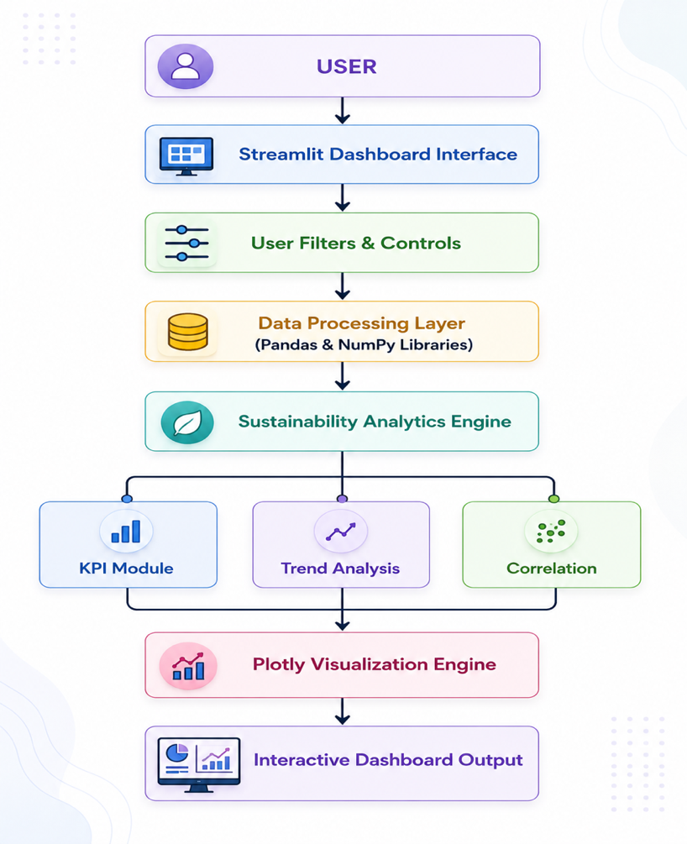

4.5 Module Design
The project consists of several independent modules, each responsible for performing a specific task.
Module 1 – Data Loading Module
Purpose
- Load the CSV dataset.
- Validate the dataset.
- Read records into memory.
Functions
- Import dataset.
- Read CSV file.
- Handle missing values.
- Prepare data.

Module 2 – Data Processing Module
Purpose
• Clean the weather dataset.
• Process and transform weather data.
• Prepare data for analysis.
Functions
• Data cleaning.
• Data preprocessing.
• Missing value handling.
• Rainfall and temperature processing.
• Weather feature extraction.
• Statistical summary generation.
• Data preparation for visualization.

Module 3 – Dashboard Module
Purpose
Display interactive analytics.
Functions
- KPI Cards
- Sidebar Filters
- Dashboard Navigation
- Interactive Components

Module 4 – Visualization Module
Purpose
Generate analytical charts.
Charts Included
• Rainfall Trend Analysis
• Temperature Trend Analysis
• Season-wise Rainfall Analysis
• State-wise Rainfall Comparison
• District-wise Weather Comparison
• Average Temperature by State
• Rainfall Distribution
• Temperature Distribution
• Correlation Heatmap
• Interactive Weather Data Table

Module 5 – Facility Explorer Module
Purpose
Provide facility-level analytics.
Functions
• Weather data search.
• State-wise weather analysis.
• District-wise weather comparison.
• Rainfall analysis.
• Temperature analysis.
• Seasonal weather analysis.
• Historical weather trend analysis.
• View detailed weather records.

4.6 Data Flow Diagram (DFD)

Level 0 DFD

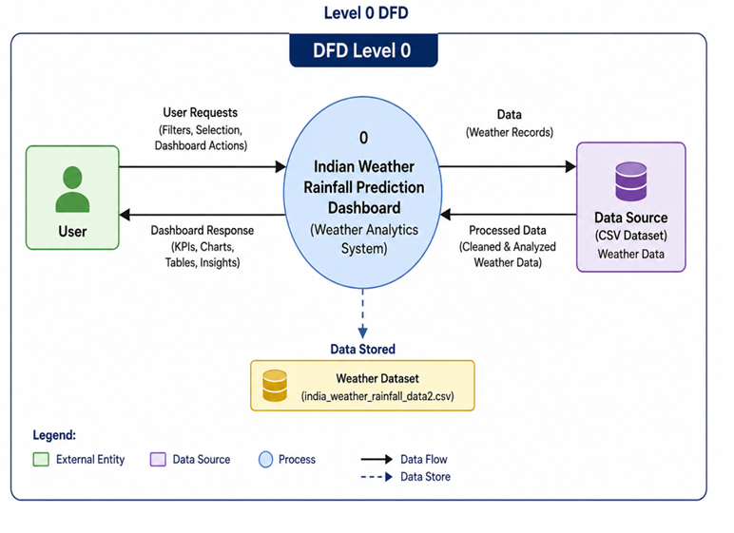

The Level 0 Data Flow Diagram (DFD) illustrates the overall working of the Indian Weather & Rainfall Intelligence Dashboard. The user interacts with the dashboard by selecting filters such as Date Range, State/UT, District, Station, and Season or by requesting weather analysis. The dashboard processes these requests, retrieves the required information from the CSV weather dataset, performs data preprocessing and analytical computations, and generates meaningful insights. Finally, the system displays the results in the form of Key Performance Indicators (KPIs), interactive charts, graphs, tables, and weather reports, enabling users to analyze rainfall patterns, temperature trends, seasonal variations, and extreme weather events efficiently.

Level 1 DFD
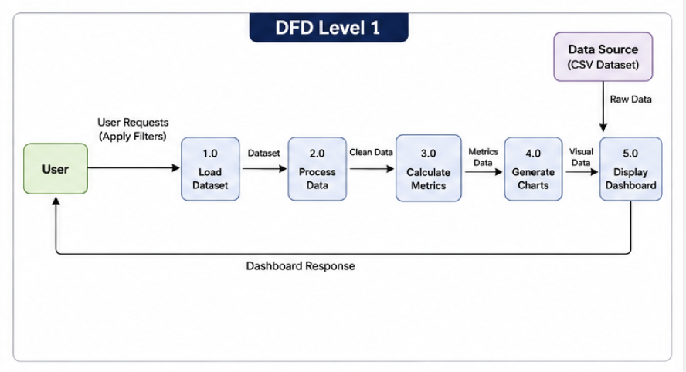
Level 1 DFD provides a detailed view of internal processing.
The major activities include
- Dataset Loading
- Data Cleaning
- KPI Calculation
- Visualization Generation
- Dashboard Display

4.7 Flowchart

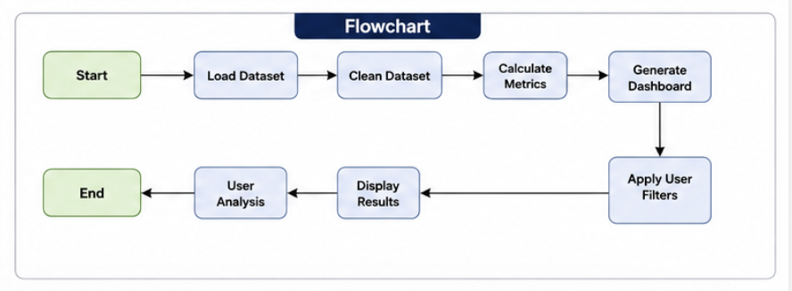
The workflow of the dashboard follows these steps:
- Load Dataset
- Clean Dataset
- Preprocess Data
- Calculate Sustainability KPIs
- Generate Charts
- Apply Filters
- Display Dashboard
- User Analysis
- End Process

4.8 Use Case Diagram

Actors
- Administrator
- Analyst
- Management
Use Cases

• View Dashboard
• Apply Filters
• View KPIs
• Analyze Rainfall Trends
• Analyze Temperature Trends
• Compare States and Districts
• Explore Weather Data
• View Extreme Rainfall Events
• View Interactive Charts and Tables
• Generate Weather Reports

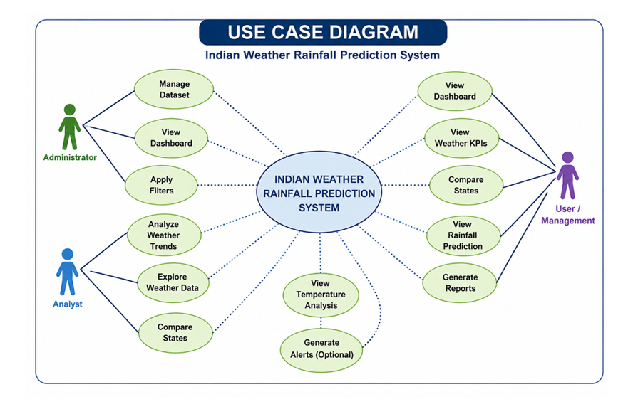

4.9 Input Design

The system accepts structured data from the CSV dataset.
Input Source
- Kaggle Dataset
- CSV File

Input Attributes

Input Field | Description
Date | Date of weather observation
State / UT | State or Union Territory name
District
  District where data is recorded
Station | Weather station name
Season | Season of observation
Average Temperature | Average daily temperature
Minimum Temperature | Minimum daily temperature
Maximum Temperature | Maximum daily temperature
Rainfall | Daily rainfall amount
Wind Speed | Wind speed
Longitude | Longitude of the weather station
Latitude | Latitude of the weather station

Input Validation
The system performs validation by:
- Removing duplicate records.
- Handling missing values.
- Checking data types.
- Standardizing categorical values.
- Verifying numerical ranges.

4.10 Output Design
The dashboard presents analytical results using graphical visualizations.
Major outputs include:

Dashboard Home
Overall dashboard summary.

KPI Cards
Displays key performance indicators.

Rainfall Analysis
Rainfall trend and seasonal analysis.

Temperature & Climate
Temperature trends and climate analysis.

Geographic View
State-wise and district-wise weather comparison.

Extremes & Raw Data
Extreme rainfall events, raw weather records, and data tables.

Correlation Heatmap
Shows relationships among weather variables.

Facility Explorer
Facility-level details.

4.11 User Interface Design
The user interface is designed to be simple, interactive, and user-friendly.

Main Components
- Dashboard Header
- Sidebar Filters
- KPI Cards
- Interactive Charts
- Weather Data Tables
- State & District Analysis
- Weather Insights Panel
- Download Filtered Data

User Interface Features
- Responsive layout
- Easy navigation
- Interactive filtering
- Dynamic charts
- Real-time updates based on selected filters
- Clear graphical representation
- Professional dashboard appearance
- Dark theme with interactive visualizations

4.12 Database Design
Although the project uses a CSV dataset instead of a relational database, the data is organized in a structured tabular format.
Major entities include:
• Weather Information
• Location Information
• Temperature Data
• Rainfall Data
• Wind Speed Data
• Air Pressure Data
• Season Information
• Geographical Coordinates (Latitude & Longitude)
This structured dataset enables efficient data loading, filtering, processing, visualization, and weather analysis within the dashboard.

4.13 Summary
The system design provides a clear blueprint for the development of the Indian Weather & Rainfall Intelligence Dashboard. The modular architecture, well-defined data flow, interactive user interface, and analytical components ensure that the system is scalable, easy to maintain, and efficient. The design enables users to analyze historical weather data, monitor rainfall and temperature trends, compare weather conditions across different states and districts, and make informed decisions through interactive visualizations, KPIs, and comprehensive weather analytics.

CHAPTER 5

PROJECT DEVELOPMENT

5.1 Introduction

The development phase is one of the most important stages of the Software Development Life Cycle (SDLC), where the proposed system design is transformed into a fully functional software application. During this phase, all planned features, modules, and functionalities are implemented using appropriate programming languages, frameworks, and development tools.
The Indian Weather & Rainfall Intelligence Dashboard was developed using Python as the primary programming language and Streamlit as the framework for building the interactive web dashboard. Python was chosen for its simplicity, extensive library support, and powerful capabilities in data analysis, while Streamlit enabled rapid development of an interactive and user-friendly dashboard.
The project also utilizes Pandas and NumPy for data loading, preprocessing, and analysis. Matplotlib, Seaborn, and Plotly are used to create dynamic and interactive visualizations that help users understand historical weather patterns effectively. The development process included dataset loading, data preprocessing, analytical computation, dashboard design, integration of visualization components, testing, and performance optimization.
The final application provides users with a centralized platform for analyzing historical weather and rainfall data across different regions of India. It includes Key Performance Indicators (KPIs), interactive filters, charts, graphs, maps, and data tables that enable users to analyze rainfall trends, temperature variations, seasonal patterns, and regional weather conditions. These interactive features support efficient weather analysis and informed decision-making through an intuitive and responsive dashboard.

5.2 Development Environment
The project was developed using the following software tools and technologies:
Component | Description
Programming Language | Python 3.11
Framework | Streamlit
IDE | Visual Studio Code
Operating System | Windows 11
Data Analysis Libraries | Pandas, NumPy
Visualization Library | Plotly
Dataset Format | CSV
Version Control | Git (Optional)

5.3 Technologies Used

Python
Python is a high-level, interpreted programming language widely used for software development, data science, machine learning, and web applications. It provides a rich ecosystem of libraries that simplify data processing and visualization.
Features of Python
- Easy-to-read syntax
- Cross-platform compatibility
- Extensive library support
- Open-source
- Supports object-oriented programming
- Strong community support

Streamlit
Streamlit is an open-source Python framework used for developing interactive web applications and dashboards. It allows developers to create responsive interfaces with minimal code.
Advantages of Streamlit
- Rapid application development
- Interactive widgets
- Easy deployment
- Automatic page refresh
- User-friendly interface
- Excellent integration with Python libraries

Pandas
Pandas is a Python library used for data manipulation and analysis.
Functions of Pandas
- Reading CSV files
- Data cleaning
- Data filtering
- Data transformation
- Handling missing values
- Data aggregation

NumPy
NumPy provides support for numerical operations and mathematical computations.
Uses of NumPy
- Numerical calculations
- Statistical operations
- Array manipulation
- Mathematical functions

Matplotlib
Matplotlib is a popular Python library used for creating static graphs and charts. It is widely used for data visualization and exploratory data analysis (EDA).
Uses of Matplotlib
- Creates line charts.
- Generates bar graphs.
- Draws histograms.
- Produces scatter plots.
- Visualizes data distribution.
- Helps identify trends and patterns.
- Supports data analysis.
- Saves graphs in various formats.

Plotly
Plotly is an interactive visualization library used to generate professional graphs and charts.
Charts Used
- Line Charts
- Bar Charts
- Scatter Plots
- Pie Charts
- Heatmaps
- Comparative Graphs

5.4 Dataset Description

The dashboard utilizes a structured CSV dataset containing historical weather and rainfall information collected from different locations across India.

Dataset Attributes

Attribute | Description
Date | Date of weather observation
State / UT | State or Union Territory name
District | District where weather data is recorded
Station | Weather station name
Season
  Season of observation
Average Temperature | Average daily temperature
Minimum Temperature | Minimum daily temperature
Maximum Temperature | Maximum daily temperature
Rainfall | Daily rainfall amount
Wind Speed | Wind speed during observation
Latitude | Latitude of the weather station
Longitude | Longitude of the weather station

5.5 Dashboard Modules

The dashboard consists of several functional modules designed to provide comprehensive analysis of weather and rainfall data.

Module 1 – Dashboard Home
Purpose
The Dashboard Home provides a summary of the overall weather and rainfall conditions using Key Performance Indicators (KPIs).
Features
• Total Records
• Average Rainfall
• Average Temperature
• Wettest State
• Hottest Station
• Highest Single-Day Rainfall

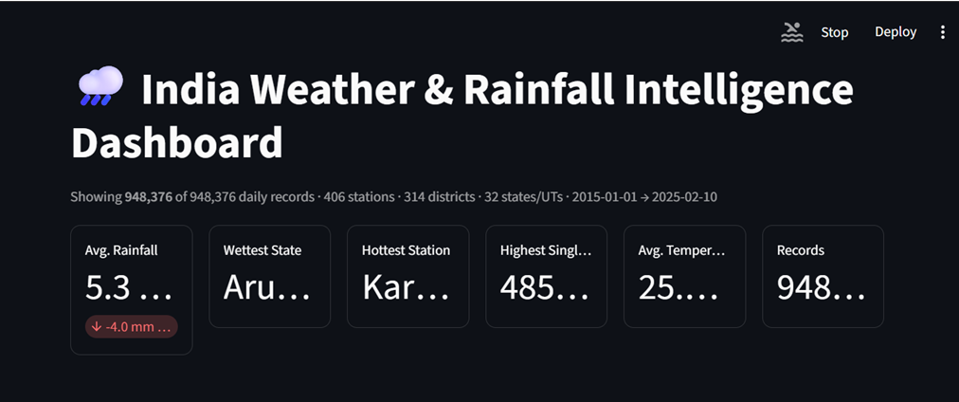
Figure 5.5.1– Dashboard Home Page
Description:
The Dashboard Home is the main interface of the Indian Weather Rainfall Prediction Dashboard. It provides a comprehensive overview of historical weather and rainfall data collected from different states and districts of India. The home page displays important Key Performance Indicators (KPIs) such as Average Rainfall, Wettest State, Hottest Station, Highest Single-Day Rainfall, Average Temperature, and Total Records. These KPIs allow users to quickly understand the overall weather conditions and rainfall distribution across the country.
The dashboard also displays a summary of the available dataset, including the total number of records, weather stations, districts, states/UTs, and the date range covered by the data. Through an interactive and user-friendly interface, users can easily access weather information and gain valuable insights into rainfall patterns and temperature variations. The clean design and dynamic visual presentation make the dashboard suitable for data analysis, academic research, and weather monitoring.

Module 2 – Sidebar Filters

Purpose
The sidebar enables users to customize the dashboard according to their analytical requirements.

Available Filters:
- Date Range
- State / UT
- District
- Season
- Weather Station

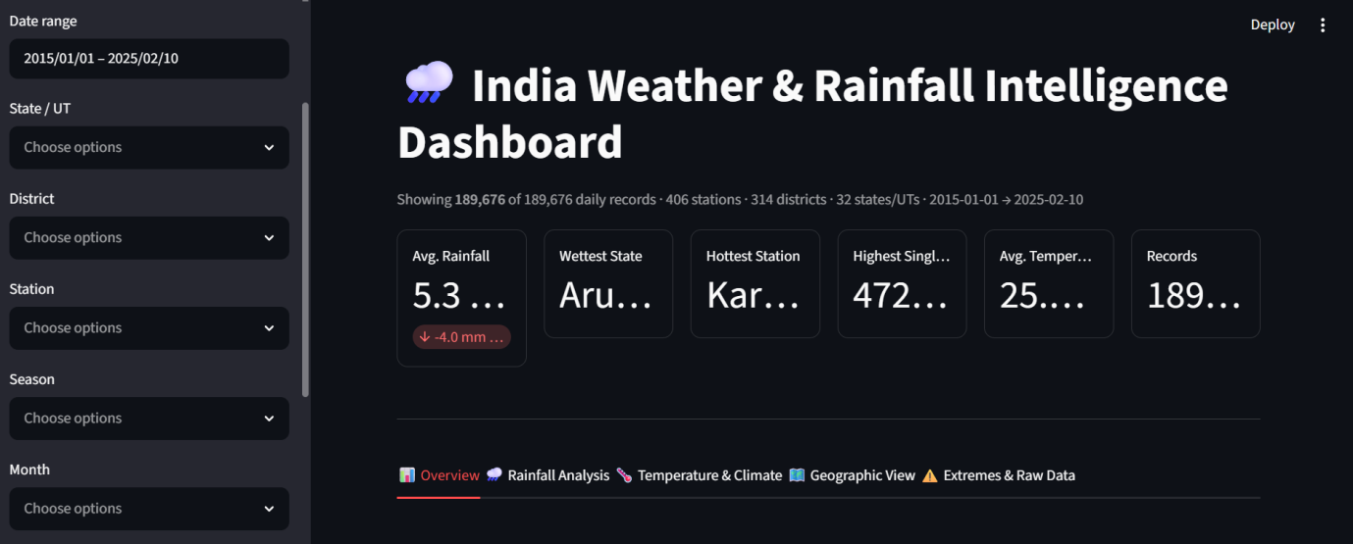
Figure 5.5.2 – Sidebar Filters
Description:
The Sidebar Filters provide an easy and interactive way to refine the weather dataset. Users can select a specific date range, state, district, weather station, season, or month to perform customized analysis. After applying the filters, the dashboard instantly refreshes all visualizations, KPI cards, and reports, enabling efficient exploration of rainfall trends, temperature patterns, and regional weather conditions.

Module 3 – KPI Dashboard
The KPI Dashboard displays important weather and rainfall metrics, providing users with a quick overview of the dataset and current weather statistics.
KPIs Included
- Total Weather Records
- Average Rainfall
- Average Temperature
- Wettest State
- Hottest Station
- Highest Single-Day Rainfall

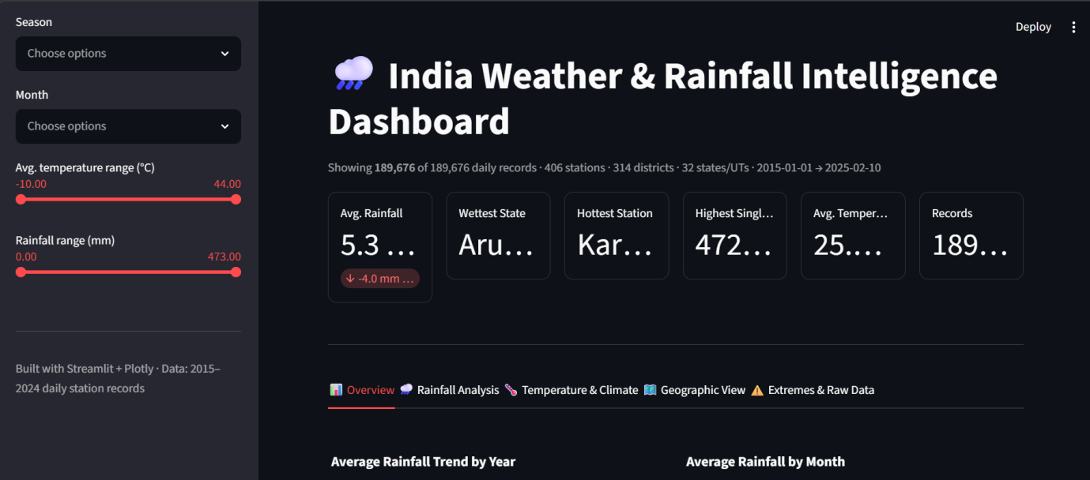
Figure 5.5.3 – KPI Cards
Description:
The KPI Cards display the key performance indicators of the Indian Weather & Rainfall Intelligence Dashboard, including Average Rainfall, Wettest State, Hottest Station, Highest Single-Day Rainfall, Average Temperature, and Total Weather Records. These metrics provide a quick summary of the overall weather conditions and historical rainfall patterns across India. The KPI section updates dynamically based on the selected filters, enabling users to monitor weather statistics, compare regions, and analyze rainfall and temperature trends at a glance.

Module 4 – Rainfall Analysis
This module analyzes rainfall patterns across different regions and time periods.
Features
• Year-wise rainfall trend analysis
• Month-wise rainfall comparison
• Season-wise rainfall analysis
• State-wise and district-wise rainfall comparison

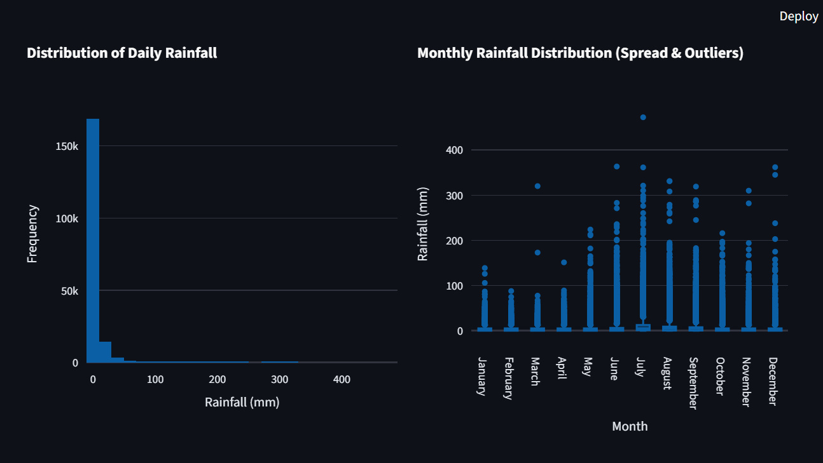

Figure 5.5.4 – Rainfall Analysis
Description:
The Rainfall Analysis module provides a detailed analysis of rainfall patterns using interactive visualizations. It includes a Distribution of Daily Rainfall histogram, which illustrates the frequency of rainfall amounts recorded across the dataset, helping users understand the overall rainfall distribution. The module also features a Monthly Rainfall Distribution (Spread & Outliers) box plot that displays the variation, spread, and extreme rainfall events for each month. These visualizations enable users to identify seasonal rainfall patterns, compare monthly rainfall variability, detect outliers, and gain valuable insights into historical weather trends across different regions.

Module 5 – Temperature & Climate Analysis

This module evaluates temperature patterns and the relationship between different weather variables.
Features
• Average temperature trend analysis
• Minimum and maximum temperature analysis
• Season-wise temperature comparison
• Weather variable correlation heatmap

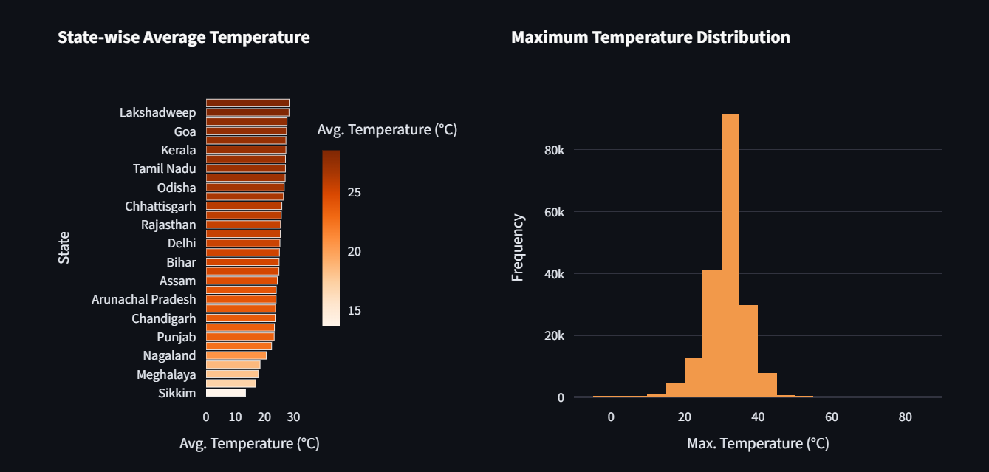

Figure 5.5.5 – Temperature & Climate Analysis
Description:
The Temperature & Climate Analysis module provides insights into historical temperature patterns and climate conditions across different regions. It allows users to analyze average, minimum, and maximum temperatures over time, compare seasonal temperature variations, and explore relationships among weather variables using a correlation heatmap. This module helps users understand climate trends, identify weather patterns, and support weather-related analysis through interactive visualizations.

Module 6 – Extremes & Raw Data
This module identifies significant weather events and provides detailed weather insights.
Features
• Highest Single-Day Rainfall Events
• Extreme Temperature Analysis
• State and District Ranking
• Historical Weather Records Comparison

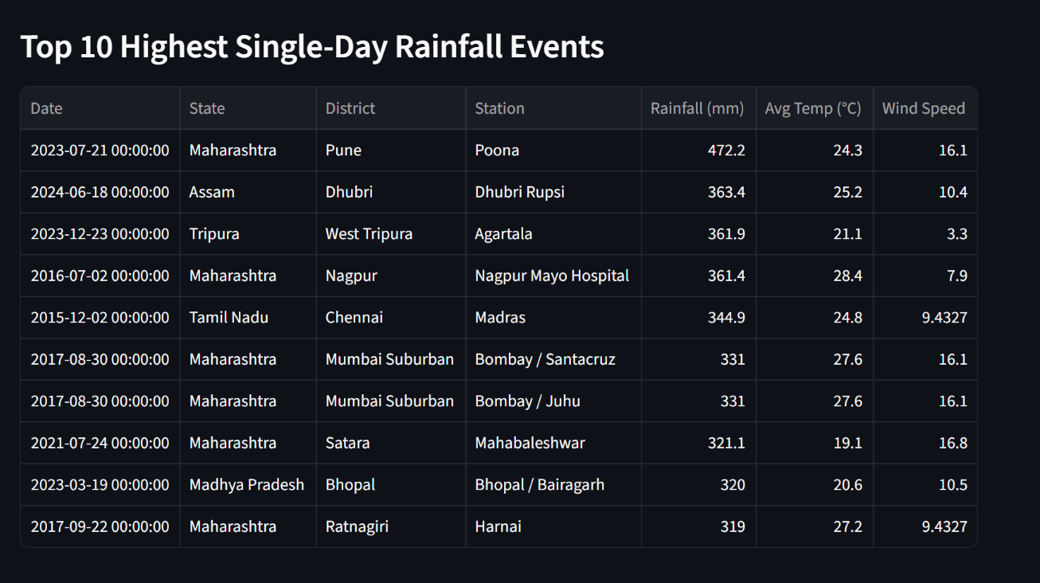
Figure 5.5.6 – Extremes & Raw Data
Description:
The Extremes & Raw Data module helps users identify and analyze significant weather events recorded in the dataset. It highlights the highest rainfall events, extreme temperature observations, and compares weather conditions across different states and districts. The module enables users to study historical weather records, recognize unusual weather patterns, and gain deeper insights into India's weather and rainfall conditions through interactive tables and visualizations.

Module 7 – Correlation Analysis
The correlation module identifies relationships among sustainability indicators.
Features
- Correlation Matrix
- Scatter Plot Analysis
- Heatmap
- Trend Relationships
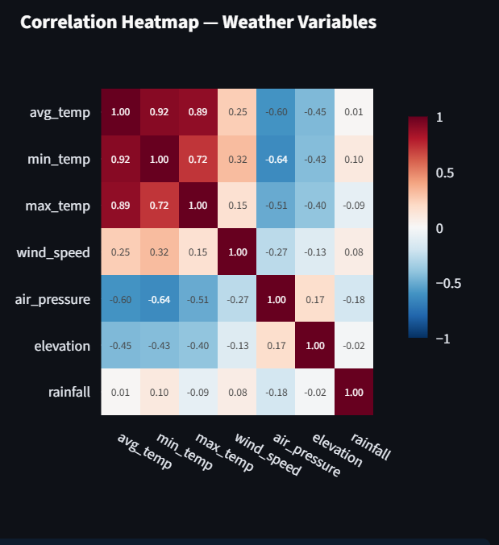
Figure 5.5.7 – Correlation Heatmap
Description:
The Correlation Heatmap illustrates the relationships among key weather variables such as rainfall, average temperature, minimum temperature, maximum temperature, wind speed, and air pressure. It helps users identify positive and negative correlations between different weather parameters, providing valuable insights into rainfall patterns, temperature variations, and overall weather conditions across different regions.

Module 8 – Facility Explorer
The Weather Explorer allows users to view detailed weather information for individual locations and weather stations.
Features
• State-wise Weather Information
• District-wise Weather Details
• Weather Station Search
• Historical Weather Records
• Rainfall and Temperature Details
• Interactive Weather Data Table
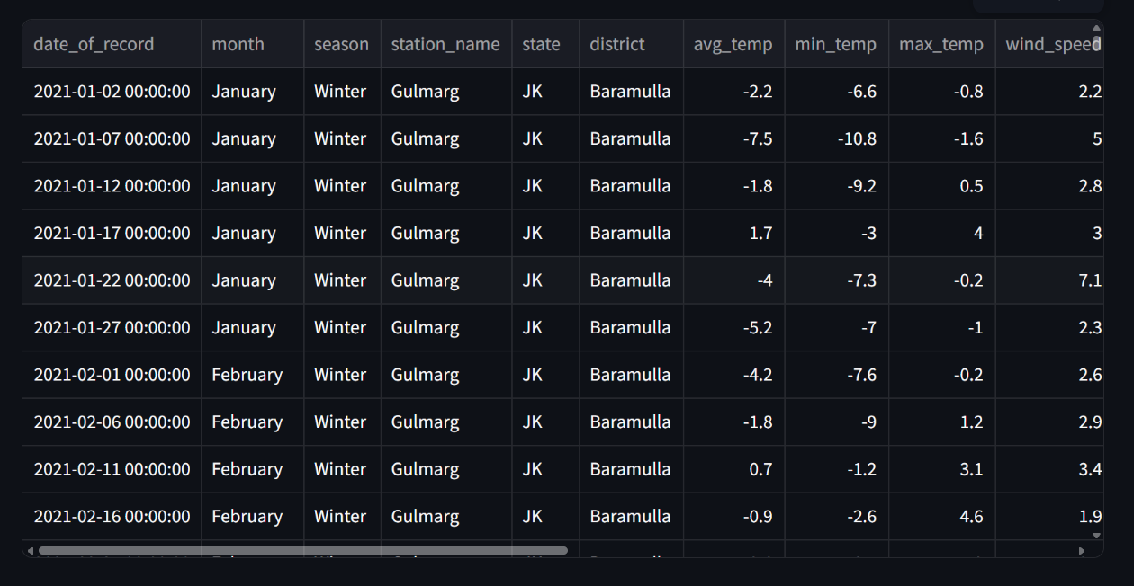
Figure 5.5.8 – Facility Explorer
Description:
The Weather Explorer allows users to explore detailed weather information for specific locations. It provides historical weather records, including rainfall, temperature, season, and weather station details. Users can search and filter data by State/UT, District, Station, Date Range, and Season to perform location-specific analysis. This module helps users compare weather conditions across different regions, examine historical weather patterns, and gain detailed insights through interactive tables and visualizations.

5.6 Dashboard Workflow
The overall workflow of the dashboard is illustrated below.
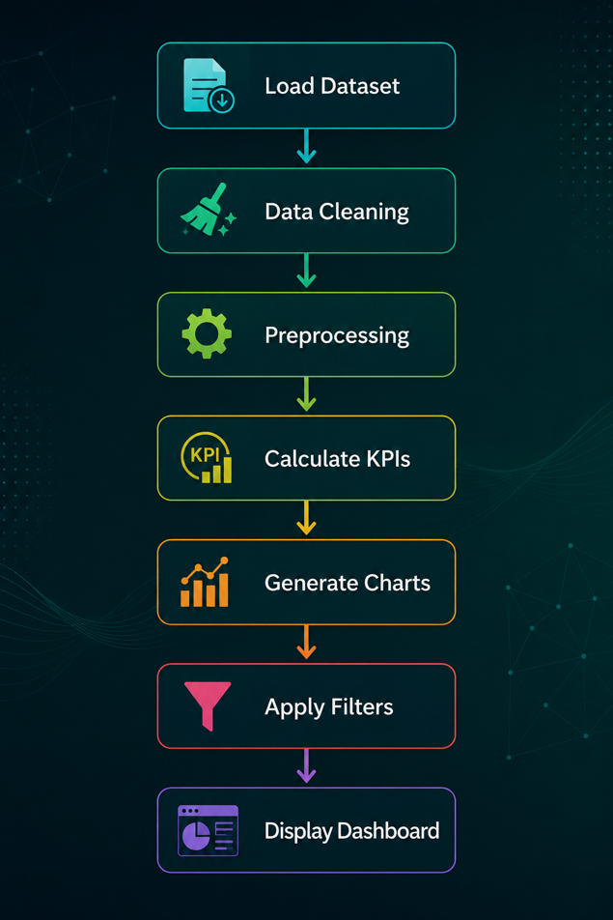

5.7 Testing and Validation
The developed dashboard was tested to ensure that all components function correctly.
Tests Performed
- Dataset Loading Test
- Data Cleaning Test
- KPI Calculation Test
- Chart Rendering Test
- Sidebar Filter Test
- Dashboard Responsiveness Test
- Performance Test
- Error Handling Test
All tests were successfully completed without major issues.

5.8 Advantages of the Developed System
- Interactive dashboard interface
- Easy navigation
- Centralized monitoring
- Accurate sustainability analysis
- Faster decision-making
- Dynamic visualizations
- Reduced manual effort
- Better resource utilization
- Scalable architecture
- User-friendly design

5.9 Challenges Faced During Development
During the development of the project, several challenges were encountered:
- Cleaning and preprocessing the dataset.
- Handling missing or inconsistent values.
- Designing a responsive dashboard layout.
- Integrating multiple visualizations into a single interface.
- Ensuring that dashboard filters updated all charts correctly.
- Optimizing performance for smoother data processing.
- Selecting appropriate KPIs to represent sustainability metrics.
- Maintaining consistency in the user interface.
These challenges were addressed through iterative development, testing, and continuous refinement of the application.

5.10 Summary
The development phase successfully transformed the proposed design into a fully functional Indian Weather & Rainfall Intelligence Dashboard. Using Python, Streamlit, Pandas, NumPy, Matplotlib, Seaborn, and Plotly, the application was developed with multiple analytical modules, interactive visualizations, and user-friendly features. The completed dashboard provides an efficient platform for analyzing historical weather and rainfall data, enabling users to monitor weather patterns, compare regional climate conditions, and make informed decisions through interactive charts, KPIs, and comprehensive weather analytics.

CHAPTER 6

TESTING AND RESULTS

6.1 Introduction
Testing is an essential phase of software development that ensures the application functions correctly and meets the specified requirements. The Indian Weather & Rainfall Intelligence Dashboard was thoroughly tested to verify the accuracy of data processing, dashboard visualizations, filtering functionality, KPI calculations, and overall system performance. The testing process helped identify and eliminate errors, ensuring a reliable, accurate, and user-friendly application for analyzing historical weather and rainfall data across different regions of India.

6.2 Testing Objectives
- Verify the correctness of data processing and KPI calculations.
- Ensure all dashboard visualizations display accurate information.
- Validate the functionality of interactive filters.
- Test navigation between different dashboard modules.
- Check search functionality in the Facility Explorer.
- Ensure smooth execution without runtime errors.
- Verify compatibility across different datasets and filter combinations.
- Evaluate overall system performance and usability.

6.3 Types of Testing Performed

1. Functional Testing
- Verified that all dashboard features work as intended.
- Tested navigation across all dashboard modules.
- Ensured KPIs update correctly after applying filters.
2. Data Validation Testing
- Verified imported dataset accuracy.
- Checked preprocessing results.
- Validated calculated sustainability metrics.
3. User Interface Testing
- Tested dashboard layout and responsiveness.
- Verified readability of charts and tables.
- Checked consistency of colors, fonts, and icons.
4. Performance Testing
- Measured dashboard loading time.
- Tested filtering speed.
- Verified smooth rendering of visualizations.
5. Integration Testing
- Confirmed proper interaction between Streamlit, Pandas, Plotly, and Matplotlib.
- Verified data flow between preprocessing and visualization modules.

6.4 Test Cases

Test Case | Expected Result | Status
Load Dataset | Dataset loads successfully | Passed
Data Cleaning | Missing values handled correctly | Passed
KPI Calculation | Accurate KPI values displayed | Passed
Apply Filters | Dashboard updates dynamically | Passed
Generate Charts | Charts display correct data | Passed
Facility Search | Relevant records displayed | Passed
Dashboard Navigation | Pages load successfully | Passed
Export/Display Results | Results displayed without errors | Passed

6.5 Results and Discussion
The developed Indian Weather & Rainfall Intelligence Dashboard successfully analyzed historical weather and rainfall data using interactive visualizations and key performance indicators. The implemented filters enabled users to explore the dataset based on multiple parameters such as date range, state/UT, district, season, and weather station. All dashboard modules operated correctly, and the visualizations accurately represented the processed weather dataset. The application demonstrated reliable performance, ease of use, and efficient weather data analysis capabilities, fulfilling the objectives defined for the project by providing meaningful insights into rainfall patterns, temperature trends, and regional weather conditions.

6.6 Summary

This chapter presented the testing process carried out for the Indian Weather & Rainfall Intelligence Dashboard. Various testing methods confirmed the correctness, reliability, and usability of the application. The successful test results indicate that the developed dashboard effectively supports weather data analysis, rainfall trend visualization, and climate monitoring through interactive charts, KPIs, and filtering features. The application provides users with accurate insights into historical weather patterns, enabling efficient analysis and informed decision-making.

CHAPTER 7

IMPLEMENTATION & EVALUATION

7.1 Introduction

This chapter describes the implementation of the Indian Weather & Rainfall Intelligence Dashboard and evaluates its overall performance. The project was developed using Python and its data analysis and visualization libraries, with Streamlit serving as the web application framework. The dashboard was designed to provide interactive analysis of historical weather and rainfall data through dynamic charts, Key Performance Indicator (KPI) cards, interactive tables, and filtering options. The evaluation focuses on the system's functionality, usability, performance, reliability, and its ability to meet the defined project objectives by providing accurate weather analysis, rainfall trend visualization, and efficient data exploration.

7.2 System Implementation
The implementation of the dashboard was carried out in a systematic manner to ensure efficient data processing and interactive visualization.
Implementation Steps

• Collected and imported the historical weather and rainfall dataset.
• Performed data cleaning and preprocessing using Pandas and NumPy.
• Calculated key weather statistics and KPI metrics such as average rainfall, average temperature, and highest rainfall.
• Created interactive charts and visualizations using Plotly, Matplotlib, and Seaborn.
• Developed an interactive web dashboard using Streamlit.
• Implemented dynamic filters for Date Range, State/UT, District, Season, and Weather Station.
• Integrated all analytical modules into a single dashboard.
• Tested and optimized the application for improved performance and usability.

7.3 Dashboard Modules
The implemented dashboard consists of the following functional modules:
• Dashboard Home
• Sidebar Filters
• KPI Cards
• Rainfall Analysis
• Temperature & Climate Analysis
• Geographic Analysis
• Correlation Heatmap
• Weather Explorer
• Extreme Weather Analysis
• Interactive Weather Data Table
Each module provides specific analytical insights to help users monitor sustainability and operational efficiency.

7.4 System Evaluation
The developed dashboard was evaluated based on different performance parameters.
Functional Evaluation

• Successfully imports and processes large weather datasets.
• Accurately calculates weather KPIs and statistical metrics.
• Displays interactive visualizations without errors.
• Filters update dashboard elements dynamically.
• Weather Explorer returns relevant weather records based on the selected filters.

Performance Evaluation
- Fast dashboard loading time.
- Smooth interaction with charts.
- Efficient processing of filtered datasets.
- Responsive user interface.
Usability Evaluation
- Simple and intuitive interface.
- Easy navigation between modules.
- Interactive charts improve data interpretation.
- Clear presentation of sustainability metrics.

7.5 Advantages of the Implemented System
- Interactive dashboard for real-time analysis.
- Easy comparison of sustainability metrics.
- Supports informed decision-making.
- User-friendly interface.
- Efficient visualization of large datasets.
- Flexible filtering and search functionality.
- Modular and scalable architecture.
- Easy to maintain and extend.

7.6 Limitations
- Depends on the quality of the input dataset.
- Uses historical data rather than live monitoring.
- No real-time IoT sensor integration.
- Limited predictive analytics.
- Requires internet connectivity for deployment.

7.7 Project Outcomes
The implementation successfully achieved the objectives defined at the beginning of the project.
Achievements

• Developed a fully functional Indian Weather & Rainfall Intelligence Dashboard.
• Visualized key weather and rainfall indicators effectively.
• Implemented interactive filtering and weather data exploration.
• Enabled comparative analysis of weather conditions across different states and districts.
• Improved accessibility of historical weather and rainfall insights.
• Supported data-driven weather analysis and decision-making.

7.8 Chapter Summary

This chapter presented the implementation and evaluation of the Indian Weather & Rainfall Intelligence Dashboard. The developed system successfully integrates weather data processing, visualization, and interactive analysis into a single dashboard. Based on the evaluation, the application demonstrates good performance, usability, and reliability, making it an effective tool for analyzing historical weather conditions, rainfall patterns, temperature trends, and regional climate variations through interactive charts, KPIs, and dynamic filtering.

CHAPTER 8

CONCLUSION & FUTURE SCOPE

8.1 Conclusion

The Indian Weather & Rainfall Intelligence Dashboard was successfully designed and developed to analyze and visualize historical weather and rainfall data through an interactive dashboard. The project integrates data processing, visualization, and weather analysis into a single platform, enabling users to monitor important weather parameters such as rainfall, average temperature, minimum and maximum temperature, seasonal patterns, wind speed, and air pressure.
The application was developed using Python, Streamlit, Pandas, NumPy, Plotly, Matplotlib, and Seaborn, providing a user-friendly interface with interactive charts, KPI cards, filtering options, and detailed weather exploration. The implemented system effectively transforms large weather datasets into meaningful visual insights that support data-driven analysis and better understanding of historical weather patterns.
Overall, the project successfully achieved its objectives by delivering an efficient, scalable, and easy-to-use dashboard for weather and rainfall analysis. It demonstrates how modern data analytics and visualization techniques can help users monitor climate trends, compare regional weather conditions, and gain valuable insights into historical weather data through an interactive and informative platform.

8.2 Project Achievements
The major achievements of the project are:
• Developed an interactive web-based weather and rainfall dashboard.
• Successfully analyzed large-scale historical weather datasets.
• Implemented dynamic filtering and weather data exploration functionality.
• Generated meaningful Key Performance Indicators (KPIs) for weather analysis.
• Created interactive charts, graphs, and visualizations for better understanding of weather patterns.
• Enabled comparative analysis across states, districts, seasons, and weather stations.
• Improved accessibility and interpretation of weather and rainfall data.
• Built a scalable and modular dashboard architecture for future enhancements.
• Provided an efficient platform for historical weather analysis and climate trend visualization.

8.3 Future Scope
• Developed an interactive web-based weather and rainfall dashboard.
• Successfully analyzed large-scale historical weather datasets.
• Implemented dynamic filtering and weather data exploration functionality.
• Generated meaningful Key Performance Indicators (KPIs) for weather analysis.
• Created interactive charts, graphs, and visualizations for better understanding of weather patterns.
• Enabled comparative analysis across states, districts, seasons, and weather stations.
• Improved accessibility and interpretation of weather and rainfall data.
• Built a scalable and modular dashboard architecture for future enhancements.
• Provided an efficient platform for historical weather analysis and climate trend visualization.

8.4 Final Remarks
The Indian Weather & Rainfall Intelligence Dashboard demonstrates the effective application of data analytics and visualization techniques in analyzing historical weather and rainfall data. By combining interactive dashboards with meaningful weather metrics, the system enables users to monitor rainfall patterns, analyze temperature variations, compare weather conditions across different regions, and support data-driven decision-making. With future enhancements such as real-time weather data integration, weather forecasting models, AI-based climate prediction, and cloud deployment, the platform has the potential to evolve into a comprehensive weather analytics and decision-support system for researchers, government agencies, and environmental organizations.

CHAPTER 9

APPENDIX
The appendix contains supplementary information related to the project, including technical references, datasets, software documentation, and additional resources used during the development of the Indian Weather Rainfall.

BIBLIOGRAPHY

9.1 Books

- Wes McKinney, Python for Data Analysis, 3rd Edition, O'Reilly Media, 2022.
- Jake VanderPlas, Python Data Science Handbook, O'Reilly Media, 2016.
- Al Sweigart, Automate the Boring Stuff with Python, 2nd Edition, No Starch Press, 2019.
- Eric Matthes, Python Crash Course, 3rd Edition, No Starch Press, 2023.
- Ian Sommerville, Software Engineering, 10th Edition, Pearson Education, 2016.
- Roger S. Pressman and Bruce R. Maxim, Software Engineering: A Practitioner's Approach, 9th Edition, McGraw-Hill Education, 2019.
- Kenneth E. Kendall and Julie E. Kendall, Systems Analysis and Design, 10th Edition, Pearson Education, 2019.

9.2 Web References

- Python Software Foundation. Python Official Documentation
https://docs.python.org/3/
- Streamlit Inc. Streamlit Documentation
https://docs.streamlit.io/
- Plotly Technologies Inc. Plotly Python Documentation
https://plotly.com/python/
- Pandas Development Team. Pandas Documentation
https://pandas.pydata.org/docs/
- NumPy Developers. NumPy Documentation
https://numpy.org/doc/
- Matplotlib Development Team. Matplotlib Documentation
https://matplotlib.org/stable/
- Kaggle Inc. Kaggle – Data Science and Machine Learning Platform
https://www.kaggle.com/
- Uptime Institute. Power Usage Effectiveness (PUE)
https://uptimeinstitute.com/
- The Green Grid. Data Center Sustainability and Efficiency
https://www.thegreengrid.org/
- Microsoft Learn. Python and Data Analytics Documentation
https://learn.microsoft.com/
- Google Cloud. Data Center Sustainability
https://cloud.google.com/sustainability
- GitHub. Version Control and Project Repository
https://github.com/

